Lesson02 Homework: ASP.NET, CSS3, and HTML5

In this “hands on” activity you will discover more details about creating ASP.NET pages that use CSS3 and HTML5. This activity will take you about 3 to 6 hours, so plan accordingly!

The activity consists of the follow steps:

- Watch the Lesson videos.
- Study web resources.
- Write a document.
- Submit your work to the Canvas site.

Watch the module videos
Please watch the video I created about performing this homework. You will find all the videos posted on the Module page.

- Lesson 2 Overview
- Getting Started with Lesson 02’s Homework
- Creating a Google Blog

Study web resource:
Please familiarize yourself with the following topics.

1) CSS3
http://www.w3schools.com/css/css3_intro.asp

2) HTML5
http://www.w3schools.com/html/html5_intro.asp

Create your own demo
In Lesson 2, you saw a number of web pages provided by your instructor. These pages included aspects of CSS3 and HTML5.

Now that you have seen how others describe and demonstrate these concepts, let’s try out your skills by creating a new ASP.NET page and Word document that demonstrates how to create ASP.NET web pages that use CSS3 and HTML5. Your instructor will provide you with a starting ASP.NET website to use with this homework

1) Open the Instructors ASP.NET website project called “Lesson02Homework.” This website project was downloaded along with the document you are reading ( ).

2) Review the files and understand the code.

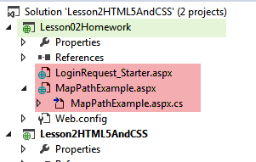

3) Create a new LoginRequest.aspx page using code found it the provided starter page.

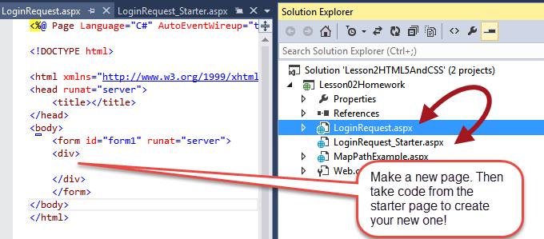

TIP: Make sure the page works before adding more features!!!

4) Add one example of how CSS3 code could be used in this page. Take screenshots of your progress and paste them into a blank Word document.

5) Add one example of how Html5 code could be used in this page. Take screenshots of your progress and paste them into a blank Word document.

TIP: If you need help getting screenshots see this page ( http://m.wikihow.com/Take-a-Screenshot-in-Microsoft-Windows).

Write a document
Create a Word document that outlines how to add CSS3 and HTML5 features to an ASP.NET page. Include screen shots, please. The document should be about 2 pages in length. Please use Microsoft Word or something compatible for your paper.

Submit your work to the Canvas site.
After you complete you your demo, place the resulting files and folders into another folder, both the document and the Visual Studio Solution/Project sub-folder, and turn everything into a single zip file. Then post the zip file on the Canvas website, in the appropriate module under Assignments.
(http://www.wikihow.com/Zip-Files-Together)

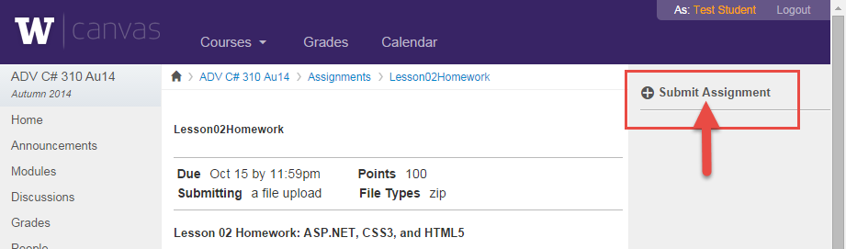

You’re done!!!

