Diff helped me see typos by isolating lines of change

It’s as easy as clicking undo, but even better because it uses versions by integrating them and isolating changes

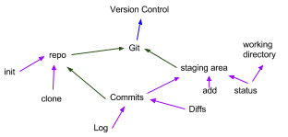

“commit ID”
Author
Date
“user comment”

For using commits, not auto save:
Pros: easier to work iteratively, step by step
Cons: need judgment to be practical

Saving multiple files at once allows the pre-supposeed notion that files are pieces of one pie.
Google docs files don’t rely on each other to function as one. Closest thing is just folders.

Git log: see all commits in a log
Git diff: see difference between versions of 2 commits

Making changes that could break something is as easy clicking undo, but also working more confidently and quickly given that I don’t have to worry about getting lost in a mire of bugs.

I want to use git to get my nanodegree and make real money programming for a loving living. Create real world apps and sites that change the world. Have that power!! Yayah!!

The staging area is like the green room in a playhouse. It’s where files go before they are committed. They can still be changed before the commit. They are everything that will go with the commit.

