**PLP Project:**

**Calendar Scheduler**

### **PREPARED FOR**

JEE Cloud Training Program

Capgemini Technology Services

### 

### **PREPARED BY**

Devang Singh (46001554)

## 

## **Abstract:**

Create a scheduler app for calendar like Outlook calendar. The application can be made either as Web Application, Mobile Application or Desktop Application. There is 1 entity Employee. The Employee can Login into the app and manage and schedule meetings. He can view Reminders and Notifications and respond to meeting requests using these.

The response to meeting requests can be Approve, Maybe or Cancel.

**Scopes:**

Inscope:

Following is the functionality provided by the system:

* Employee should be able to login through app.
* Employee should be able to search other employee by name or email.
* Employee should be able to schedule a meeting with other employees.
* Other employees should receive notification for the meeting.
* Employees should be able to perform action like Attend, Reject, Maybe.
* The response should be send to the organizer employee.
* Set reminder for the employees to attend meeting.

Outscope:

The following functionalities have not been covered under the application:

* Notifications are in app. They cannot be viewed outside the app as device notifications.
* Custom Reminders cannot be added.
* Employees cannot message one another.
* Employees cannot view the profile of other users.

**Class Diagram:**

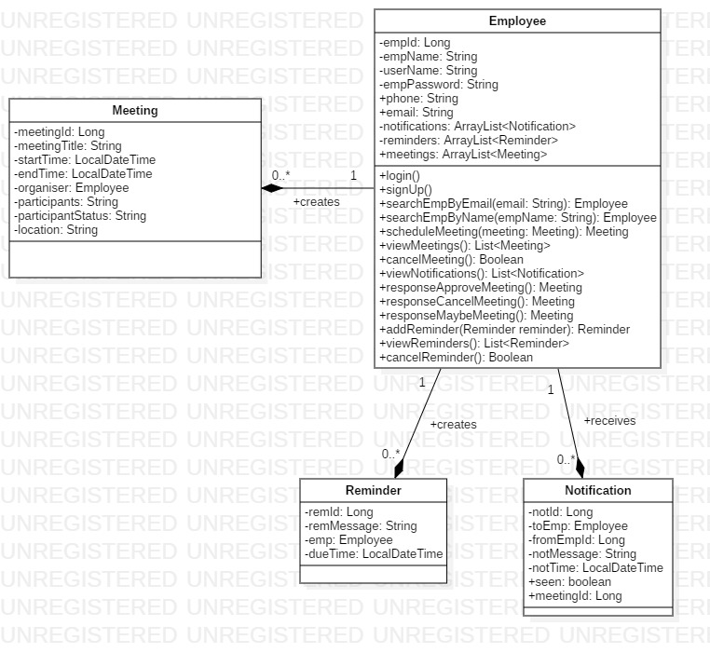

## **Sequence Diagram:**

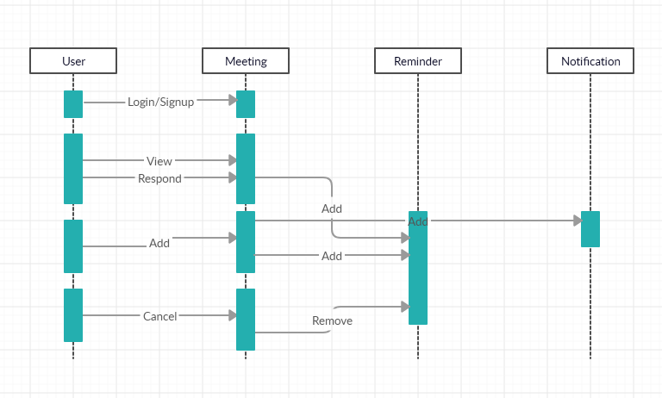

## **Activity Diagram****:**

**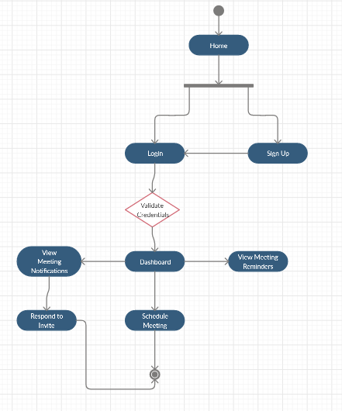****Validations:**

* Employee name can contain only alphabets and spaces.
* Phone Number should be of exactly 10 digits.
* Meeting Start Time cannot be before the end time.
* A meeting should have atleast one participant other than the organizer.
* All ID’s are automatically generated.

## **Assumptions:**

* Invite status can be changed even after employee has responded to an invite.
* There is only one type of user.
* There is no minimum or maximum time for which a meeting can be scheduled.
* No Meeting gets cancelled.

**Technology Stack:**

* Java v1.8
* Spring Boot v2.1.9
* Spring Web v2.1.9
* Spring Security v2.1.9
* Spring Data v2.1.9
* MySQL v5.7
* Angular v6.0.0
* Node: v10.16.3
* Maven: v3.6.1
* JWT v0.9.1
* Amazon EC2 v4.9.3865
* Amazon RDS v2014-10-31