Understanding Input Data Requirements and

Quantifying Uncertainty for Successfully

Modelling Smart Cities

Michael Adcock, Nicolas Malleson, Jonathon Ward, Alison Heppenstall and Daniel Tang

The Alan Turing Institute and Improbable

**Introduction**

Agent-based models (ABMs) are ideally suited to modelling the behaviour and evolution of social systems. However, input data are noisy and sparse, and human behaviour is extremely uncertain. Therefore one of the key challenges facing the discipline relates to the quantification of uncertainty within ABMs. This work presents initial steps towards the development of new methods that will us to better understand uncertainty in ABMs and ultimately, to allow streams of data to be incorporated into models in *real time*.

**Methods**

**Agent Based Model**

An agent based model (StationSim) of a hypothetical train station was created to model crowding (Fig 1). While simple in nature, this model was designed to include stochastic elements and so produced differing results on subsequent runs.

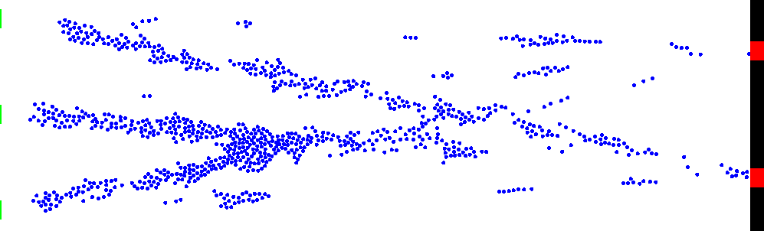

*Fig. 1: A snapshot of the simple, hypothetical model that is used here. Agents arrive from the green entrances on the left and move towards the red exits on the right. During the course of the runtime crowding occurs in different areas.*

StationSim allows for the many parameters to be set including number of entrances and exits, the interval at which people can pass through entrances/exits and the probability that a person from a given entrance will choose a given exit. The parameter used for StationSim in this work is shown in table 1.

|  |  |
| --- | --- |
| Parameter | Value |
| areaWidth | 200.0 |
| areaHeight | 100.0 |
| numPeople | 700 |
| numEntrance | 3 |
| numExits | 2 |
| exitProbs | {{0.2, 0.8}, {0.3, 0.7}, {0.9, 0.1}} |
| exitInterval | 30 |
| entranceInterval | 2 |
| entranceSize | 10 |
| exitSize | 10 |

*Table 1: Parameters used for StationSim for this work*

When StationSim is run people are generated at a given interval and are assigned an exit to move towards. This exit assignment uses probabilities defined in the parameters for each entrance and exit. The maximum speed for the person is chosen from a uniform distribution. When a person starts to approach another person in front of them they slow down. When they collide with a person in front they attempt to move around them by moving on the y axis. When people reach the exit they can pass through at set intervals. The number of people that can pass through an entrance or exit in a given step is also set in the model parameters. An explanation of how StationSim functions is presented as pseudocode in Fig 2.

There are three areas of StationSim with random decisions that give it stochastic nature. These are choice of exits for each person, the choice for maximum speed of a person and the choice of direction and speed a person travels on the y axis when the encounter a person ahead of them.

entranceInterval = How often an entrance will allow people to enter simulation

exitInterval = How often an exit will allow people to pass through an Exit simulation

entranceSize = The number of people who may pass through an entrance in a single step

exitSize = The number of people who may pass through an exit in a single step

toatoalnumPeople = Total number of people that can enter throughout the run of the simulation

equally space entrances along y axis at x

equally space exits along y axis at x

for each entrance:

peopleRemainigForEntrance = totalNumPeople / number of entrances (integer is division used)

for each simulation step:

if step % exitInterval == 0:

for each exit:

allow number of people through exit equal to exitSize

sequencer = All people sorted ascendingly by euclidean distance to their target exit

for each person in sequence:

for i in 0 to slowingDistance:

testPosition = new coordinates calculated by linear interpolation toward exit

if testPosition collides with another person:

reduce speedFactor

break

newPosition = new coordinantes calculated by linear interpolation towards exit

if newPosition does not collide with another person:

current postion = new position

else:

new position = randomly choose direction on y axis and calculate distance

if newPostition does not collide with other people:

currentPosition = newPosition

else:

newPostion = chosse other diection on y axis an calculate distance

if newPosition does not collide with other people:

currentPosition = new Position

if step % entrance interval == 0:

for each entrance:

create number of people equal to entrance size

peopleRemainingForEntrance -= number of people created

for each person:

choose target exit using probailities fom exitChoices

choose maxSpeedFactor from uniform distribution

*Fig. 2: Pseudocode representing simplified version of StationSim*

**Keanu**

To constrain the model the library ‘Keanu’ was used. This is a probabilistic programming library developed by Improbable and at time of writing is in a pre-alpha stage. Keanu allow the user to build Bayesian networks which can be used to make probabilistic predictions about complex problems. The code that utilised Keanu in this work is contained in the ‘Wrapper’ class.

When the main function in wrapper is run the truth data is generated by running StationSim once. StationSim is contained in a function taking a random number generator as an argument and returning model outputs defined by which option is selected in the static class variables. This effectively creates a black box of StationSim as this is the only interaction wrapper may have with the ABM.

The probabilistic programming part of this work is contained in a function called keanu (named after the library it is using). This can be called with different observation intervals with a value of 0 meaning no observations were made. Running this function with no observation was used as a control for our experiments.

When Keanu is called a Bayesian network is constructed of probabilistic variables (this network can be visualised using the GraphViz file that is written out during the run of this function). The truth data is observed with added noise changing the posterior. This is then sampled using Metropolis Hastings. The aim is to essentially estimate the random numbers (or a distribution to draw them from) that were used as the input for StationSim. From the samples draw and certain number (set in class variables) are dropped from the start of sampling and they are then down sampled (also set in class variables).

**Using Wrapper**

To choose which variables to observe and asses contains of the model by use the of option variable. The options are described in the createOptions(). This function creates a map with the key as the option and the value as the length of array that is outputted per step from stationSim. In this output array all elements except the last one per step are observed.

The variables we get out of StationSim is controlled by which method we use from the Analysis class. This is found in the switch statement in run() where each case corresponds to an option. To add a new option add a new case and in that case call a method from analysis (which you will write yourself to give you desired output). Then add the option to createOptions() using the format to describe above (remember the last element is not observed but instead written out in our samples/truth). Finally set your new option in the static class variable ‘option’. The last element is not observed but is use to assess constraint of the model. If you want to observe and assess the same variable (as in option one) then use an array of size 2 with the same value in both positions.

The number of random double created is set in numRandomDoubles, which for this work it is set at 10. This means only random numbers are created and are then reused over and over. We found that as numRandomDoubles is increase Wrapper takes a lot longer to run. The number of samples taken from the posterior is set with numSamples. It is also a good idea to drop some samples which are taken at the start of Metropolis Hastings run and also to down sample (so for example on every third sample is used). These are set with dropSamples and downSample respectively. The sigmaNoise variable sets how noisy the observed values are after adding noise. We found that if this is set too high then we don’t the model isn’t properly constrained. It would be interesting to explore how noisy we can make the data and still see constraint.

In the main function an ArrayList called obIntervals sets which observation intervals will be used (0 is no observations) the Keanu function is called using a parallel stream for these values. The same truth value is used each time along with the same timestamp so we can see the separate files produced are related (and unique form other runs).

The write function is called to write out samples. As discussed previously it is the last value in the output array per step that is written out for both truth and samples. This means that it may or may not be the metric we used for observing depending on the option we have used. The truth data is written out for each observation Interval but it is the same data for each one.

**Results**

Through the use of Improbable’s library, Bayesian inference was used to constrain model output. This was achieved through estimation of the random numbers used within the model when the truth data was generated. Through these methods the model was successfully constrained, allowing us to reduce the uncertainty in predicting outputs from the ABM in respect to the truth data.

The ABM was run to produce truth data from the total number of people in the simulation at each step. This truth data was then observed in the Bayesian network and the posterior was sampled from with Metropolis Hastings. When compared to results generated using the same steps without observation taking place it was found that the model has been successfully constrained (Fig 3).

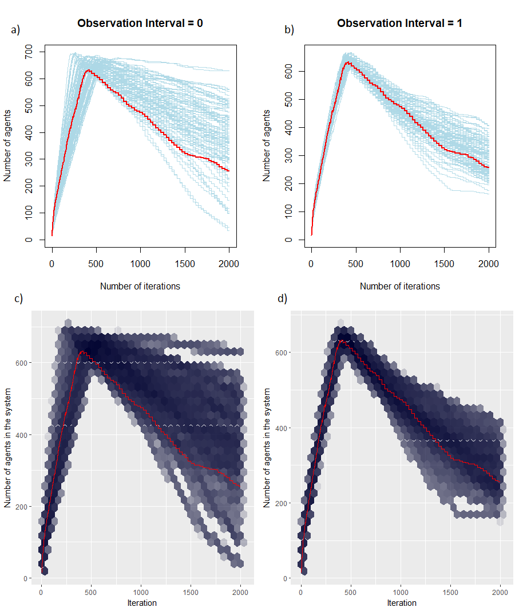

*Fig. 3:* *Results of sampling the posterior without (a and c) and with (b and d) observations. When the ‘truth’ data for the total number of people in the simulation per iteration are used to constrain the posterior distribution, the sampling routine is much better able to estimate the input model state, so the outcomes of the samples are much closed to the ‘truth’ data as measured by the same metric as was observed. Plots a and b show each individual sample. Plots c and d show the density of samples in hex bins.*

As well as assessing the constraint of the model using the same outputs that were observed in the Bayesian network, we also assessed model constraint using an alternate output to find how the model was constrained elsewhere. To achieve this, the truth data was generated for the cumulative number of people that had passed through each entrance and exit per step. This truth data was then observed and the posterior was sampled from again using Metropolis Hastings. Rather than containing the same type of output as the truth data the samples were of the number of people in a particular 10 by 10 grid space of the simulation at each step. This was assessed both by looking at the number of people in a given step in the grid square and by using a cumulative total. Again we found that when compared results generated without observing the truth data the model had been successfully constrained (Figs 4 and 5).

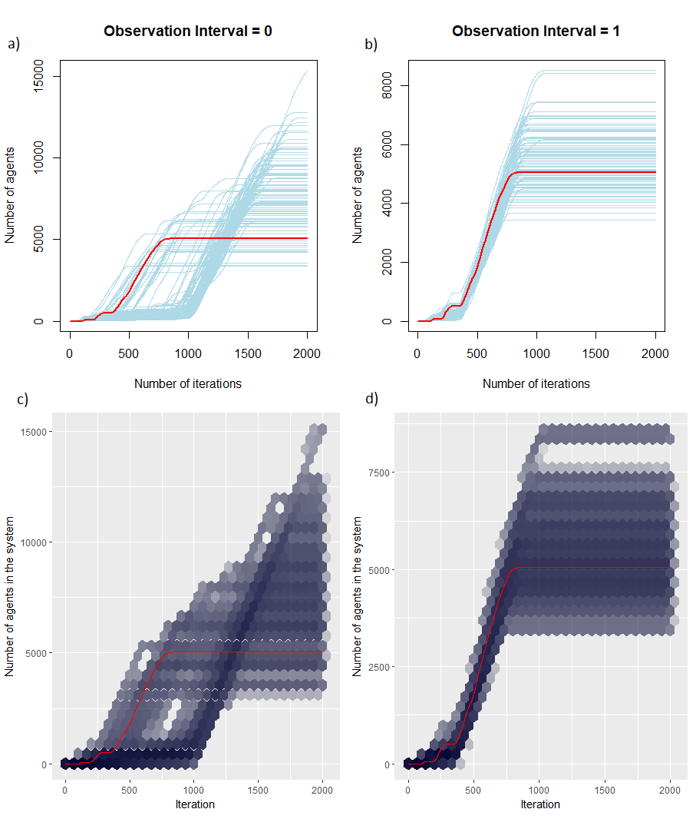

*Fig. 4: Results of sampling the posterior without (a and c) and with (b and d) observations. When the ‘truth’ data of number of people passing through each entrance and exit per iteration are used to constrain the posterior distribution, the sampling routine is much better able to estimate the input model state, this is shown by the model being constrained for the cumulative number of people in a 10 by 10 grid space in the simulation. Plots a and b show each individual sample. Plots c and d show the density of samples in hex bins.*

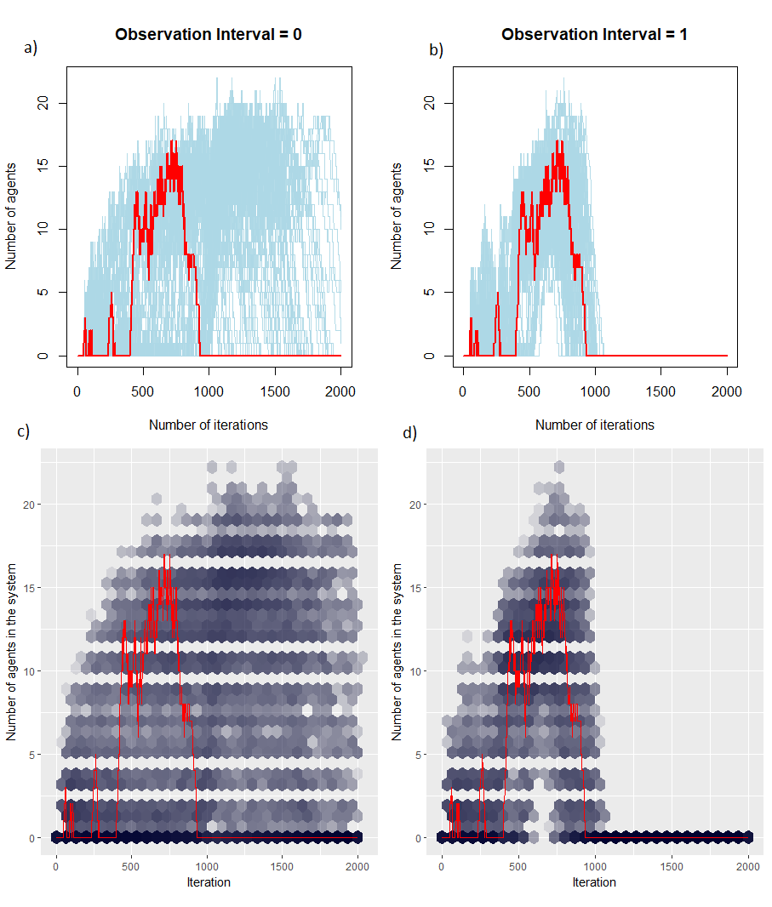

*Fig. 5: Results of sampling the posterior without (a and c) and with (b and d) observations. When the ‘truth’ data of number of people passing through each entrance and exit per iteration are used to constrain the posterior distribution, the sampling routine is much better able to estimate the input model state, this is shown by the model being constrained for the number of people in a 10 by 10 grid space in the simulation per iteration. Plots a and b show each individual sample. Plots c and d show the density of samples in hex bins.*

The interval at which the observation were made from the truth data was carried out at various intervals. However no pattern was found between constraint and observation intervals except of course when no observations were made. (Nick may have new results to dispute this)

**Value of the Research**

This work lays the groundwork for a better understanding about how real data can be used to reduce uncertainty in ABMs. This an important initial step for the application of these methods to smart city modelling. By utilising these methods we can produce more robust agent based models for urban systems that can be of greater use when making policy decisions. Working with Improbable has been mutually beneficial: the LIDA team have gained access to an invaluable probabilistic modelling library, and Improbable have been able to test the library on a real use case with an agent-based model.