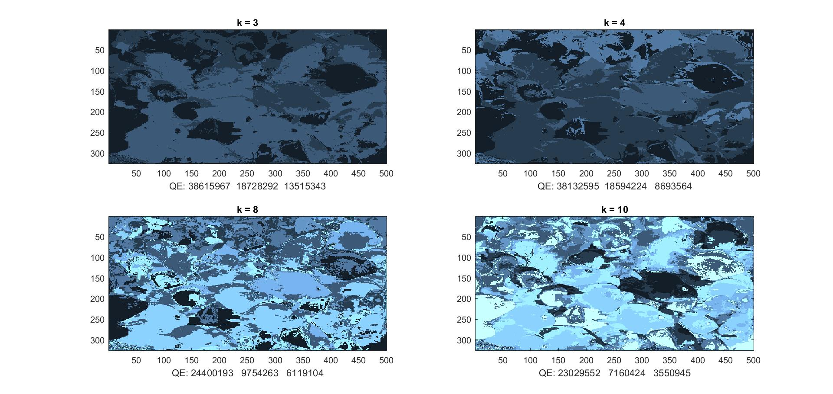

**Part 1**

* The , how?, on why SSD differ based on values of k is that they differ by as k increased the SSD between the original image and quantized image gets smaller. The, why?, is that as these images get a bigger k there are more clusters, and because there are more clusters there is more of a chance that the original image and the quantized image would have close to similar values. If you only have 3 clusters than there could be spots where a color may be blue-green and should fall into blue but falls to green (using colors as cluster example) so the difference between the images would be higher, but if you have more clusters the spot would fall into a more likely matching category making the difference between the images less likely.