Haptic Feedback Glove

Ben Tures

Isaiah Galo

Nicholas Minton

**Functional System Requirements**

REVISION – 0

20 September 2020

Functional System Requirements

for

Haptic Feedback Glove

Prepared by:

Team 64 9/20/2020

_____________________________

Author Date

Approved by:

Nicholas Minton 9/20/2020

_____________________________

Project Leader Date

_____________________________

John Lusher, P.E. Date

_____________________________

Andrew Miller Date

**Change Record**

|  |  |  |  |  |
| --- | --- | --- | --- | --- |
| **Rev.** | **Date** | **Originator** | **Approvals** | **Description** |
| **0** | 9/20/20 | Nicholas Minton | NM BT | Initial Release |

Table of Contents

Table of Contents III

List of Tables IV

List of Figures V

1. Introduction 1

1.1. Purpose and Scope 1

1.2. Responsibility and Change Authority 2

2. Applicable and Reference Documents 2

2.1. Applicable Documents 2

2.2. Reference Documents 2

2.3. Order of Precedence 3

3. Requirements 4

3.1. System Definition 4

3.2. Characteristics 5

3.2.1. Functional / Performance Requirements 5

3.2.2. Physical Characteristics 6

3.2.3. Electrical Characteristics 6

3.2.4. Environmental Requirements 8

3.2.5. Failure Propagation 8

4. Support Requirements 9

4.1.1. System Support Requirements 9

4.1.2. Virtual Reality Requirements 9

Appendix A: Acronyms and Abbreviations 10

Appendix B: Definition of Terms 11

List of Tables

Table 1: Team Subsystem Roles 2

List of Figures

Figure 1. Haptic Glove Core System Interconnect Diagram 1

Figure 2. Block Diagram of System 4

# Introduction

## Purpose and Scope

The haptic feedback glove is a practical tool to emulate real-space object interaction, allowing for greater immersion in virtual environments. It is useful in a wide range of virtual reality applications due to the versatility of the virtual space. The glove has been designed to test the validity of electrostatic braking as a lightweight solution to haptic feedback technology. A design that uses thin metal plates as the electrostatic element is seen in Figure 1.

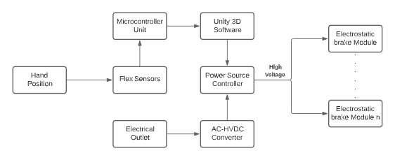

Figure 1. Haptic Glove Core System Interconnect Diagram

Sensors shall record telemetry for the position of the hand and fingers that will be used to locate the user’s hand in the virtual space. The virtual environment shall detect when the user’s hand is interacting with a virtual object and communicate to the MCU the required force to be simulated at each finger. When it is necessary to simulate a force the MCU shall communicate to the power supply what specific voltages will be supplied to the electrostatic brakes. The levels of force the electrostatic brakes simulate should be enough to provide the user with an immersive virtual reality experience.

## Responsibility and Change Authority

Each team member is in charge of their subsystem; however, there will be cooperation between team members on all subsystems. Each member will have their own responsibilities and deadlines he/she will be required to meet. The project manager Nicholas Minton will make sure that each of the member’s deadlines and the team’s deadlines are met. Since our project is a faculty-sponsored project, any changes must be approved by the majority of the team and the sponsor (Andrew Miller).

|  |  |
| --- | --- |
| Name | Subsystem |
| Nicholas Minton | MCU & Hand tracking |
| Isaiah Galo | Glove Assembly |
| Ben Tures | GUI |

Table : Team Subsystem Roles

# Applicable and Reference Documents

## Applicable Documents

The following documents, of the exact issue and revision shown, form a part of this specification to the extent specified herein:

[1] “IEEE Standard for High-Voltage Testing Techniques”. In: IEEE Std 4-2013 (Revision of IEEE Std 4-1995) (May 2013), pp. 1–213. doi: 10.1109/IEEESTD.2013.6515981.

[2] “IEEE Recommended Practices for Safety in High-Voltage and High-Power Testing”. In: ANSI/IEEE Std 510-1983 (1983), pp. 1–19. doi: 10.1109/IEEESTD.1983.81973.

[3] U. Nanda and S. K. Pattnaik. “Universal Asynchronous Receiver and Transmitter (UART)”. In: 2016 3rd International Conference on Advanced Computing and Communication Systems (ICACCS). Vol. 01. 2016, pp. 1–5.

[4] “IEEE Draft Standard for a Smart Transducer Interface for Sensors and Actuators - Transducer to Microprocessor Communication Protocols and Transducer Electronic Data Sheet (TEDS) Formats”. In: IEEE P1451.2/D20, February 2011 (2011), pp. 1–28.

## Reference Documents

The following documents are reference documents utilized in the development of this specification. These documents do not form a part of this specification and are not controlled by their reference herein.

[5] Laura Sbernini Giovanni Saggio Francesco Riillo and Lucia Rita Quitadamo. “Resistive flex sensors: a survey”. In: (2015).

[6] MSP432P401R, MSP432P401M SimpleLink™ Mixed-Signal Microcontrollers. Texas Instruments. 2019.

[7] MPU-6000 and MPU-6050 Register Map and Descriptions Revision 4.0. InvenSense. 2012.

[8] N. Waghamare and R. Argelwar. “High Voltage Generation by using Cockcroft-Walton Multiplier”. In: International Journal of Science, Engineering and Technology Research Volume 4 (Issue 2 Feb. 2015).

[9] System Requirements. <https://docs.unity3d.com/Manual/system-requirements.html>, last accessed on 09/19/20.

[10] System Requirements.

<https://www.vive.com/us/support/wireless-adapter/category_howto/vive-wireless-system-requirements.html> last accessed on 09/19/20.

## Order of Precedence

In the event of a conflict between the text of this specification and an applicable document cited herein, the text of this specification takes precedence without any exceptions.

All specifications, standards, exhibits, drawings or other documents that are invoked as “applicable” in this specification are incorporated as cited. All documents that are referred to within an applicable report are for guidance and information only, except ICDs that have their relevant documents considered to be incorporated as cited.

# Requirements

## System Definition

The purpose of the Haptic Feedback Glove is to complete development from the previous designed glove. The Haptic Feedback glove aims to borrow and optimize the design from last year’s senior design team. The Haptic Glove will integrate electrostatic brakes at sensors to allow a user to interact with a virtual environment. The goal of this system is to track the motion of the user's hand and finger positions while providing kinesthetic feedback based on interactions in the virtual environment.

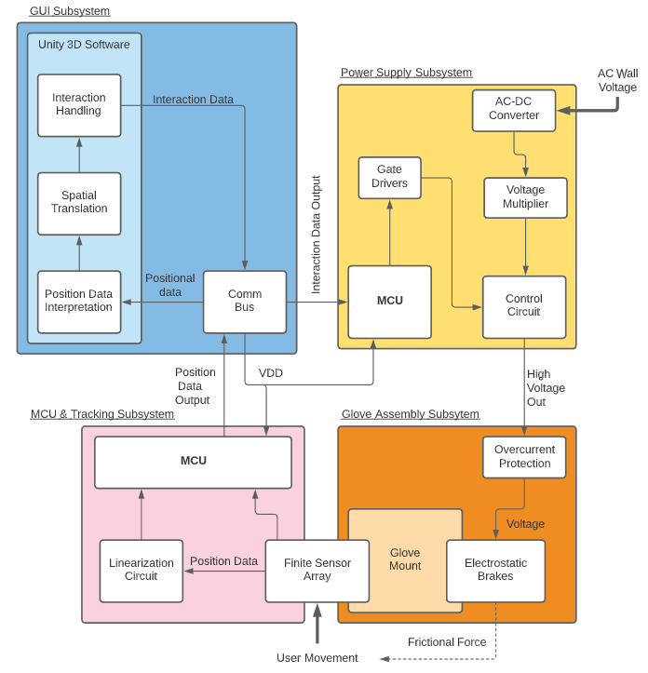

Figure 2. Block Diagram of System

The haptic feedback glove solution consists of the following four subsystems: Glove Assembly, MCU & Hand Tracking, Virtual Environment, and Power Supply. The primary input to our system is the movement of the user’s right hand. That movement is interpreted by the finite sensor array and MCU. The positional data outputted by the MCU shall inform the GUI subsystem of the hands position along with the finger movement. The GUI shall handle the positional data and classify the interaction in the virtual environment. The interaction classification will determine the amount of voltage the power supply applies to the electrostatic brakes. The system can be thought of as a feedback loop. The output (force applied by the electrostatic brakes) affects the input (the user’s movement).

## Characteristics

### Functional / Performance Requirements

#### Electrostatic Brake

The electrostatic brakes shall provide at least 9 newtons (N) of force to the larger, lower finger joint, and at least 4 N of force to the tip of the finger. The braking system will have 10 points of force feedback; 2 for each finger of the right hand.

*Rationale: To achieve the goal of immersion in the virtual environment we need multiple points of force feedback on each finger.*

#### Finger Tracking

The flex sensors shall detect finger movement at the metacarpophalangeal (MCP) and distal interphalangeal (DIP) joint. These joints shall be tracked with an accuracy of ±5°. For wrist and hand movement, the IMU shall measure acceleration, velocity, and orientation with an accuracy of ±2.5°.

#### Graphical User Interface

The Haptic Feedback Glove GUI shall classify each finger as being in one of three modes: Interacting with soft objects, interacting with hard objects, and in standby. This hardness classification shall determine the level of force applied to the finger.

*Rationale: The classification of individual fingers will allow for the user to interact with the environment in a more realistic way. e.g. Only applying force to two fingers when the user picks up an object between their index finger and thumb.*

#### Glove Exoskeleton

The Haptic Feedback Glove shall retain structure under forces from electrostatic brakes listed in 3.2.1.1 of these documents. To retain structure, each point where force is applied shall have rigid attachment between glove and electrostatic brake.

*Rationale: One area where our team is focusing on improving from last year is giving the glove a more rigid structure so that it can withstand more force without deforming.*

#### Power Supply

The power supply shall provide an adjustable high voltage of at least 4 volts (V) and not exceeding 1360 V by utilizing a high voltage rail generated by a Cockcroft-Walton voltage multiplier configuration [8]. These voltages shall be individually controlled and applied to each of the 10 points of force feedback. The power dissipation of the supply shall not exceed 3 watts (W), and the maximum current draw across any singular output to a control point shall not be greater than 80 microamps (µA).

### Physical Characteristics

#### Mass Located on Hand

The mass of the glove assembly, electrostatic brakes, and hand tracking subsystems combined shall be no more than 170 grams (g).

Rationale: 30 (10 brakes x 3strips each) stainless steel strips weigh approximately 42.2 g. Wax paper dielectric will weigh approximately 20 g. The 12 flex sensors will weigh 16 g. The IMU will weigh 4 g. An additional 80 g is reserved for the 3D printed glove exoskeleton.

#### Mass Located off Hand

The mass of the hand tracking system shall be no more than 70 g. The mass of the power supply shall be no more 1.5 kg.

Rationale: Mass of the HTC VIVE, both PCB’s and MCU’s, and power supply.

#### Size

The Size from fingertip thimble to base of electrostatic brakes should be between 17 cm and 20 cm

#### Mounting

The mounting information for the Haptic Feedback Glove shall be captured in the Haptic Feedback Glove ICD.

### Electrical Characteristics

#### Inputs

* The presence or absence of any combination of the input signals in accordance with ICD specifications applied in any sequence shall not damage the Haptic Feedback Glove, reduce its life expectancy, or cause any malfunction, either when the unit is powered or when it is not.
* No sequence of command shall damage the Haptic Feedback Glove, reduce its life expectancy, or cause any malfunction.

Rationale: By design, should limit the chance of damage or malfunction by user/technician error.

##### Supply Voltage Level

The input voltage level for the Haptic Feedback Glove shall be +120 V from a wall outlet and +5 V from computer/device connecting to the MCUs. The minimum voltage required to operate the flex sensors and the IMU device is 2.7 V with a maximum of 3.3 V.

Rationale: This is a requirement specified by our customer due to constraints of their system in which the Search and Rescue System is integrating.

##### Communication Protocols

The system will communicate between separate subsystems with already established serial communication protocols: I2C, Serial Peripheral Interface (SPI), and Universal Asynchronous Receiver Transmitter (UART). This will be detailed in the Haptic Feedback Glove ICD

##### Power Consumption

(a) The power supply shall consume no more than 3 W in order to ensure very low heat and low current operation. The maximum current flowing through any given output voltage branch will not exceed 500 µA.

Rationale: The low voltage controls of the power supply will be protected from the high voltage rail via a designated power MOSFET gate driver to ensure no rush current is seen by the microprocessor. Because of this, the MOSFET transistor resistance, and current limiting resistance will be the only resistances seen by the power supply.

(b) The maximum power of the braking system shall be equal to or less than 625 milliwatts (mW), assuming an initial overlap area of 11 cm2 and an initial distance between electrodes of 13 µm.

Rationale:

$$I_{leakage}=\frac{Q}{kP}$$

$$k=3.4$$

$$ρ=1.5×{10}^{17}Ω*cm$$

$$C_{strip}=\frac{ϵ_{r}ϵ_{o}A}{d}=\frac{3.4*\left(8.85×{10}^{12}\frac{F}{m}\right)*(11{ cm}^{2})}{13μm}=25.461 μF$$

$$Q=CV=25.461 μF*\left(1250 V*10\right)=0.318 C$$

$$I_{leakage}=\frac{0.318 C}{3.4*1.5×{10}^{17} Ω*cm}=6.24×{10}^{-19}A$$

$$P=6.24×{10}^{-19} A*12500 V=7.8×{10}^{-15} W$$

(c) The maximum power consumption of the hand tracking subsystem shall not be more than 25 mW.

Rationale: The IMU with 3.3 V input and all sensors enabled will consume 12 mW. The Flex resistors have an input of 3.3 V and at maximum flex will consume 13 mW.

#### Outputs

##### Force Output

The force feedback output shall apply a minimum of 4 N of force to the tip of each finger. The force feedback output shall also apply a minimum of 9 N of force on the lower distal joint of finger each finger. This force feedback shall vary in magnitude depending on the virtual object’s hardness classification.

### Environmental Requirements

The Haptic Feedback Glove shall be designed for indoor use. Testing shall occur in what is considered typical operating conditions.

Rationale: The intended user of VR equipment is someone with a computer and access to power. This will be indoors in typical operating conditions for nearly all situations.

#### Pressure (Altitude)

The Haptic Feedback Glove shall be able to function properly at all altitudes ranging from sea level to 20,000 ft.

#### Thermal

The maximum range of operation for this device shall be 80ºC, though performance

may become unstable at such temperatures. The device shall be verified in typical operating conditions of 24 ±1ºC.

*Rationale: All components are rated for at least the above value, but since this device is not intended for use in extreme conditions, testing will occur in typical conditions.*

#### External Contamination

The haptic feedback glove shall be resistant to normal indoor contaminants (dust, particles, etc.), though occasional cleaning may be necessary in order to maintain the dexterity of the glove. The device should be kept away from water or any other liquids. This device is not rated for any water resistance. This device contains high voltage electronics that, if exposed to water, may pose a risk of serious injury to the user and to others. Do not expose this device to water under any circumstance.

### Failure Propagation

The power supply shall have overcurrent protection to ensure all outgoing current returns through the wall outlet. This will provide protection against short circuits throughout the system. Additionally, there shall be over current protection on the braking system to ensure there is not a dangerous amount of current near the user’s hand.

Rationale: Having over current protection on both subsystems is a safety precaution. There would need to be two concurrent failures for a dangerous situation to occur.

# Support Requirements

### System Support Requirements

The system requirements for supporting the software to interface with the Haptic Feedback Glove are as follows: [9]

* Operating System (OS): Windows 7 SP1+, macOS 10.12+, Ubuntu 16.04+
* CPU: SSE2 instruction set support.
* Graphics card with DX10 (shader model 4.0) capabilities.

### Virtual Reality Requirements

The system shall include support for a virtual reality scene utilizing the HTC VIVE and a VIVE Tracker. The system requirements for the Haptic Feedback Glove to operate in a virtual reality environment are as follows: [10]

* Graphics: NVIDIA® GeForce® GTX 1060 or AMD Radeon™ RX 480, equivalent or better
* Processor: Intel® Core™ i5-4590 or AMD FX™ 8350, equivalent or better
* Memory: 4 GB RAM or more
* Video out: HDMI 1.4, DisplayPort 1.2 or newer
* USB ports: 1x USB 2.0 or better port
* OS: Windows 7 SP1, Windows 8.1, Windows 10 or later

# Appendix A: Acronyms and Abbreviations

MCU Microcontroller Unit

UI User Interface

GUI Graphical User Interface

IMU Inertial Measurement Unit

ICD Interface Control Document

MCP Metacarpophalangeal

DIP Distal Interphalangeal

SPI Serial Peripheral Interface

UART Universal Asynchronous Receiver Transmitter

VR Virtual Reality

mA Milliamp

*μ*A Microamp

mW Milliwatt

V Volts

N Newton

ft Feet

cm Centimeter

lbs Pounds

*μ*m Micrometer

Hz Hertz

# Appendix B: Definition of Terms

**Fingers** In this document, fingers refer to each of the five jointed parts of the hand. This includes the thumb