Haptic Feedback Glove

Ben Tures

Nicholas Minton

**Execution and Validation Plan**

REVISION – 1

11 November 2020

Execution and Validation Plan

for

Haptic Feedback Glove

Prepared by:

Team 64 09/20/1998

_____________________________

Author Date

Approved by:

Nicholas Minton 09/20/1998

_____________________________

Project Leader Date

_____________________________

John Lusher, P.E. Date

_____________________________

T/A Date

**Change Record**

|  |  |  |  |  |
| --- | --- | --- | --- | --- |
| **Rev.** | **Date** | **Originator** | **Approvals** | **Description** |
| **0** | 9/20/2020 | Nicholas Minton | NM BT | Rev 0 |
| **1** | 11/24/2020 | Nicholas Minton | NM BT | End of Semester status |
|  |  |  |  |  |

Table of Contents

Table of Contents III

List of Tables IV

List of Figures V

No table of figures entries found. V

1. Fall 2020 Execution Plans 1

1.1. Fall 2020 High Level Execution Schedule 1

1.2. Subsystem Execution Schedule 2

2. Validation Plans 3

2.1. Glove Assembly 3

2.2. MCU and Hand Tracking 3

2.3. Graphical User Interface 4

List of Tables

Table 1: Fall 2020 Execution Schedule 1

Table 2 Glove Assembly Schedule 2

Table 3: Virtual Environment Subsystem Schedule 2

Table 4: MCU Subsystem Schedule 2

Table 5: Glove Assembly Validation Plan 3

Table 6: MCU Validation Plan 3

Table 7: GUI Validation Plan 4

List of Figures

# No table of figures entries found.

# Fall 2020 Execution Plans

## Fall 2020 High Level Execution Schedule

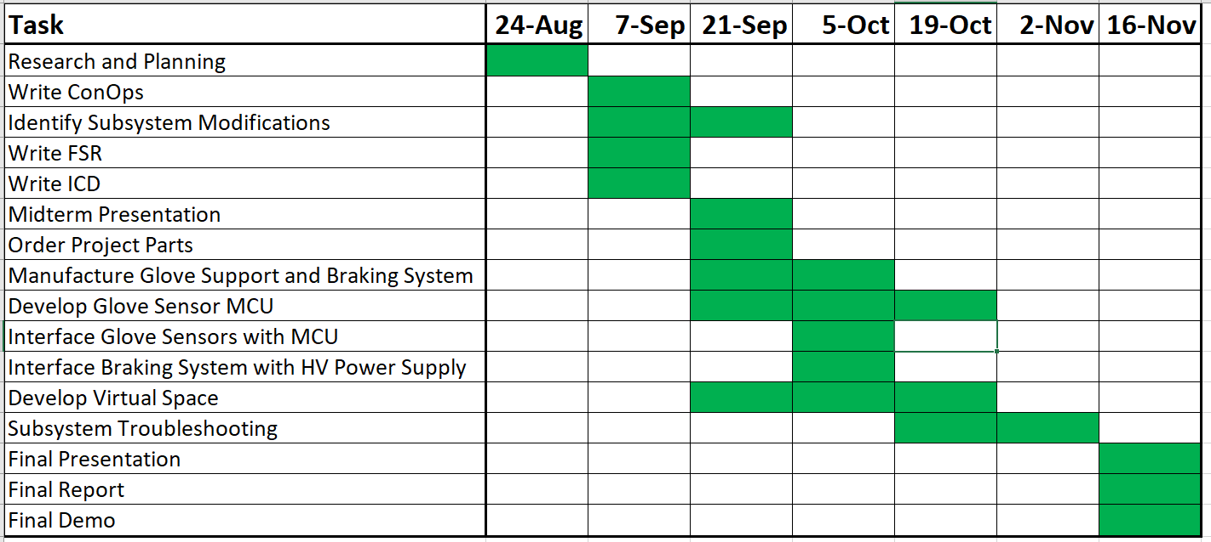

Table 1: Fall 2020 Execution Schedule

## Subsystem Execution Schedule

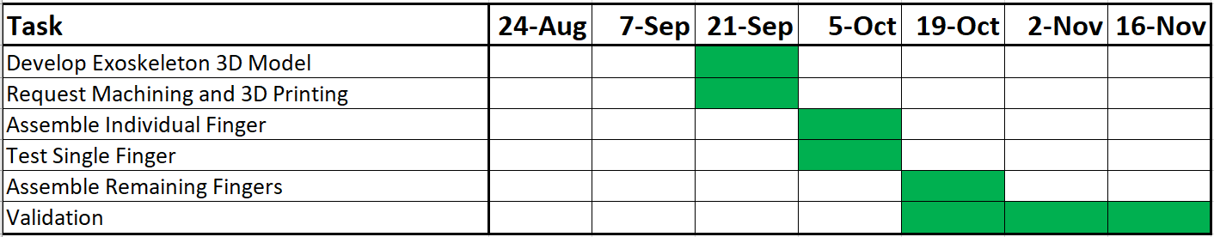

Table 2 Glove Assembly Schedule

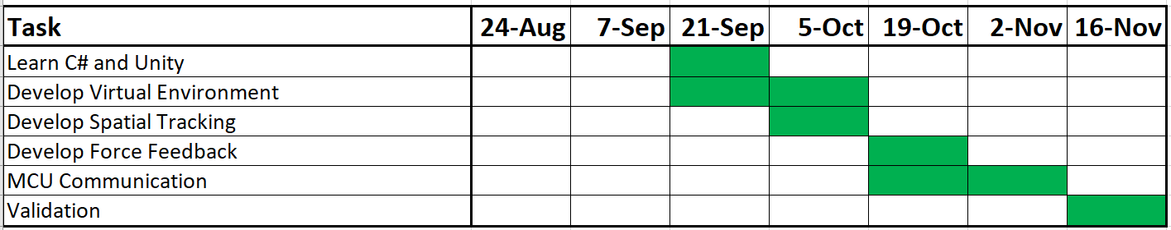

Table 3: Virtual Environment Subsystem Schedule

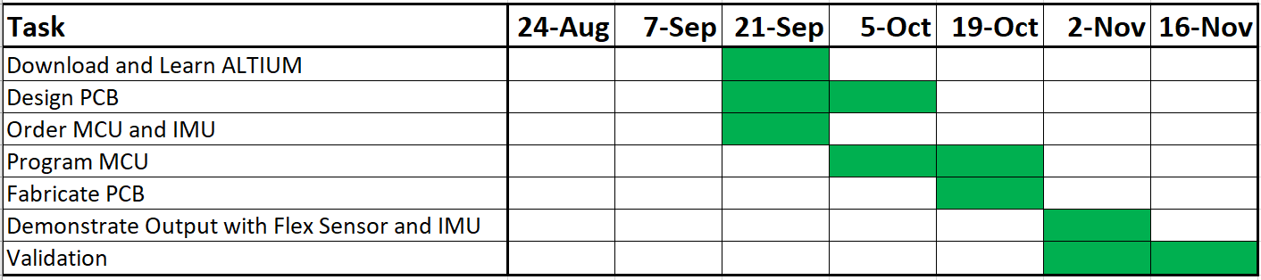

Table 4: MCU Subsystem Schedule

# Validation Plans

## Glove Assembly

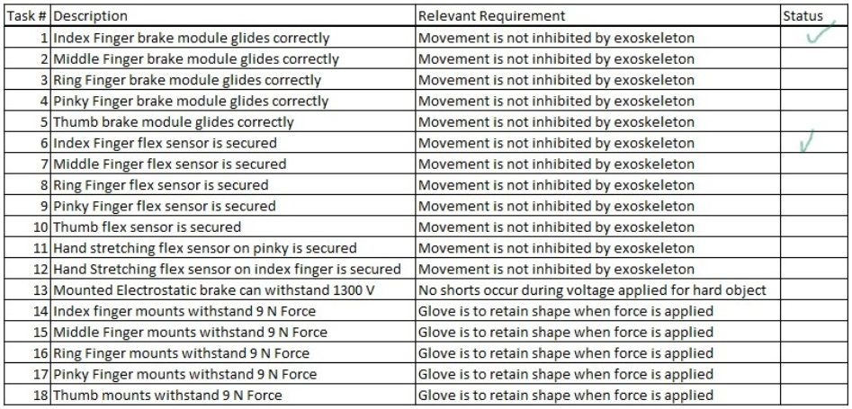

Table 5: Glove Assembly Validation Plan

## MCU and Hand Tracking

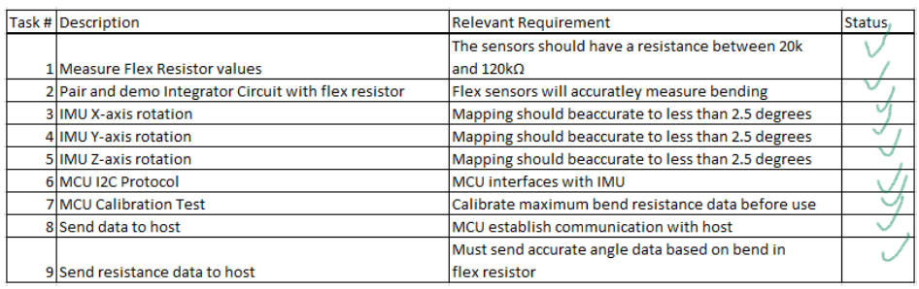

Table 6: MCU Validation Plan

## Graphical User Interface

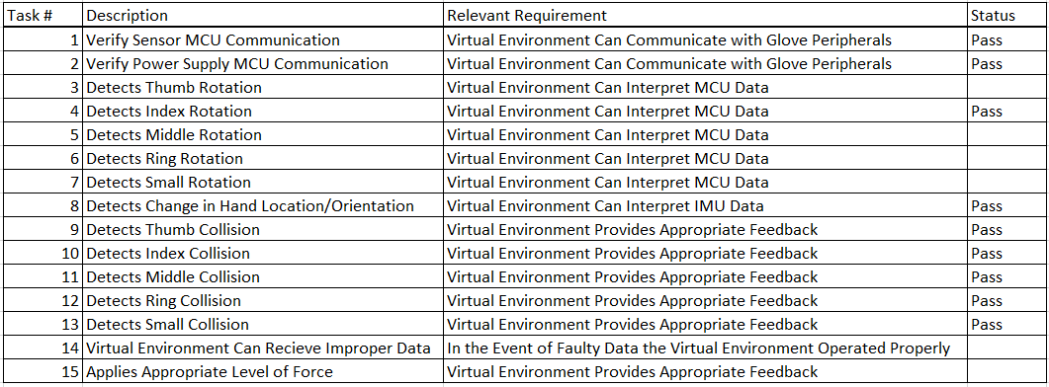

Table 7: GUI Validation Plan