

Safety Plan Lane Assistance

**Document Version: 1.0**

**Template Version 1.0, Released on 2017-06-21**



# Document history

|  |  |  |  |
| --- | --- | --- | --- |
| Date | Version | Editor | Description |
| 11/5/2017 | 1.0 | Nicholas Moellers | First Submission |
|  |  |  |  |
|  |  |  |  |
|  |  |  |  |
|  |  |  |  |

# Table of Contents

**[Instructions: We have provided a table of contents. If the table of contents is not showing up correctly in your word processor of choice, please update it. The table of contents should show each section of the document and page numbers or links. Most word processors can do this for you. In** [**Google Docs**](https://support.google.com/docs/answer/116338?co=GENIE.Platform%3DDesktop&hl=en)**, you can use headings for each section and then go to Insert > Table of Contents.** [**Microsoft Word**](https://support.microsoft.com/en-us/help/285059/how-to-create-a-table-of-contents-by-marking-text-in-word) **has similar capabilities]**

Document history

Table of Contents

Introduction

Purpose of the Safety Plan

Scope of the Project

Deliverables of the Project

Item Definition

Goals and Measures

Goals

Measures

Safety Culture

Safety Lifecycle Tailoring

Roles

Development Interface Agreement

Confirmation Measures

# Introduction

## Purpose of the Safety Plan

This document is meant to provide a plan which will ensure that risks for this autonomous vehicle feature are within the acceptable boundaries for our society. The responsibilities of all team members will be documented, as will the function of the critical components which will ensure vehicle and passenger safety.

## Scope of the Project

For the lane assistance project, the following safety lifecycle phases are in scope:

Concept phase

Product Development at the System Level

Product Development at the Software Level

The following phases are out of scope:

Product Development at the Hardware Level

Production and Operation

## Deliverables of the Project

The deliverables of the project are:

Safety Plan

Hazard Analysis and Risk Assessment

Functional Safety Concept

Technical Safety Concept

Software Safety Requirements and Architecture

# Item Definition

The item in question is a lane assistance feature, designed to keep the car driving in the ego lane.

The two main functions of the lane assistance feature are lane departure warning and lane keeping assistance:

1. Lane departure warning notifies the driver that the car is drifting out of the lane by imparting a vibration to the steering wheel and displaying a warning on the in car display.
2. Lane keeping assistance will apply a torque to the steering wheel to return the car back to the center of the lane.

The main subsystems involved in this feature are the camera sensor subsystem, the car display subsystem, and the electronic power steering subsystem. The camera sensor will take video of the lane and the camera sensor eco will process that the sensor data to determine the distance from the center of the lane and will transfer that information to both the car display and electronic power steering subsystems. The car display subsystem will display a warning if the car is leaving the lane. The electronic power steering subsystem will vibrate the wheel if the car is leaving the lane and apply a mild torque to the steering wheel to return the car to the ego lane. The feature will deactivate if the drive has signaled a lane change or if the drive is relying on the feature for fully autonomous driving.

All other subsystems are outside the scope of this safety plan, namely the steering wheel:

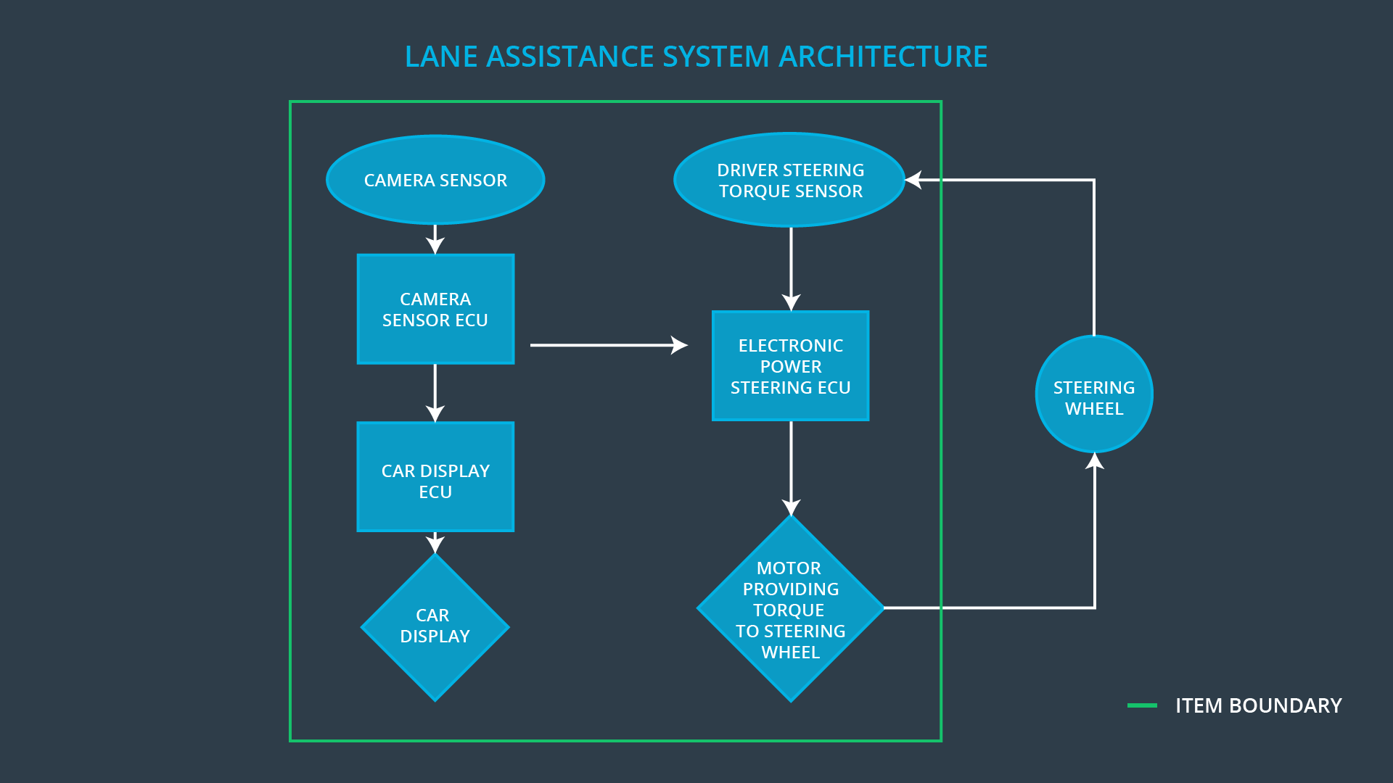

**OPTIONAL**

**Optionally, include information about these points as well. These were not included in the lectures, but you might be able to find this information online:**

* **Operational and Environmental Constraints. This could especially be limited to camera performance; lane lines are difficult to detect in snow, fog, etc**
* **Legal requirements in your country for lane assistance technology**
* **National and International Standards Related to the Item**
* **Records of previously known safety-related incidents or behavioral shortfalls**

**]**

# Goals and Measures

## Goals

The goal of this project is to ensure that the lane assistance function is delivered in line with society’s expectation of safety.

## Measures

|  |  |  |
| --- | --- | --- |
| Measures and Activities | Responsibility | Timeline |
| Follow safety processes | All Team Members | Constantly |
| Create and sustain a safety culture | Safety Manager | Constantly |
| Coordinate and document the planned safety activities | Safety Manager | Constantly |
| Allocate resources with adequate functional safety competency | Project manager | Within 2 weeks of start of project |
| Tailor the safety lifecycle | Safety Manager | Within 4 weeks of start of project |
| Plan the safety activities of the safety lifecycle | Safety Manager | Within 4 weeks of start of project |
| Perform regular functional safety audits | Safety Auditor | Once every 2 months |
| Perform functional safety pre-assessment prior to audit by external functional safety assessor | Safety Auditor | 3 months prior to main assessment |
| Perform functional safety assessment | Safety Assessor | Conclusion of functional safety activities |

# Safety Culture

At our company, safety is always the highest priority. By rewarding activities that promote safety and penalizing unsafe practices, we ensure that we deliver a safe product. Such activities are well documented in our safety process handbook, which our employees must review monthly. We have internal safety teams and contract out external safety assessors to ensure we are unbiased in our safety assessment.

# Safety Lifecycle Tailoring

The following safety lifecycle phases are in scope:

Concept phase

Product Development at the System Level

Product Development at the Software Level

The following phases are out of scope:

Product Development at the Hardware Level

Production and Operation

# Roles

|  |  |
| --- | --- |
| Role | Org |
| Functional Safety Manager- Item Level | OEM |
| Functional Safety Engineer- Item Level | OEM |
| Project Manager - Item Level | OEM |
| Functional Safety Manager- Component Level | Tier-1 |
| Functional Safety Engineer- Component Level | Tier-1 |
| Functional Safety Auditor | OEM or external |
| Functional Safety Assessor | OEM or external |

# Development Interface Agreement

A developer interface agreement defines the responsibilities between companies involved in developing a product. It is necessary to ensure that work was done according to the agreement and ultimately, in compliance with ISO 26262.

The OEM will be supplying a functioning lane assistance system. Our company will analyze and modify the various sub-systems from a functional safety viewpoint.

Confirmation measures exist to confirm that the safety project conforms to ISO 26262 and that it really does make the vehicle safer.

The confirmation review will ensure that the project complies with ISO 26262. This will be done by an independent person to ensure independence.

The functional safety audit will ensure that the implementation actually does conform to the safety plan.

The functional safety assessment will confirm that the designs and products actually do achieve functional safety.