

Functional Safety Concept Lane Assistance

**Document Version: 1.0**

**Template Version 1.0, Released on 2017-06-21**



# Document history

|  |  |  |  |
| --- | --- | --- | --- |
| Date | Version | Editor | Description |
| 11/2/17 | 1.0 | Nicholas Moellers | First submission |
|  |  |  |  |
|  |  |  |  |
|  |  |  |  |
|  |  |  |  |

# Table of Contents

Document history

Table of Contents

Purpose of the Functional Safety Concept

Inputs to the Functional Safety Analysis

Safety goals from the Hazard Analysis and Risk Assessment

Preliminary Architecture

Description of architecture elements

Functional Safety Concept

Functional Safety Analysis

Functional Safety Requirements

Refinement of the System Architecture

Allocation of Functional Safety Requirements to Architecture Elements

Warning and Degradation Concept

# Purpose of the Functional Safety Concept

The purpose of this document is to refine the safety goals into functional safety requirements and allocate those requirements to the appropriate parts of the system diagram. Specifically, we will look at the ASIL levels of components, the fault tolerant time intervals, and the safe state. This document will look at safety from a high level; the next document will go into the technical details.

# Inputs to the Functional Safety Concept

## Safety goals from the Hazard Analysis and Risk Assessment

|  |  |
| --- | --- |
| **ID** | **Safety Goal** |
| Safety_Goal_01 | The oscillating torque feedback from the lane departure warning function shall be limited in both frequency and amplitude. |
| Safety_Goal_02 | The lane keeping assistance function shall be time limited. |
| Safety_Goal_03 | The lane keeping assistance function shall not activate unless the driver has explicitly enabled the feature. |
| Safety_Goal_04 | The lane keeping assistance function shall deactivate when the lane lanes are undetectable. |

## Preliminary Architecture

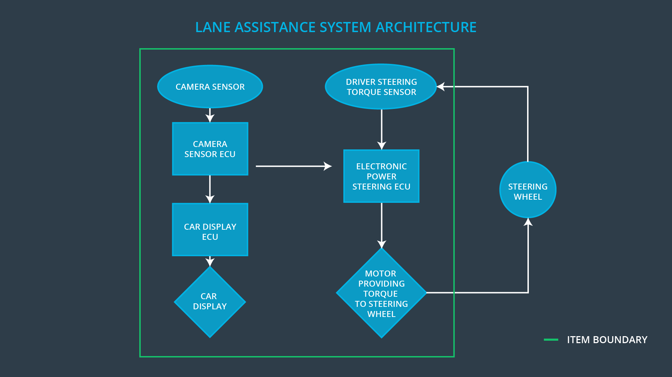

### Description of architecture elements

|  |  |
| --- | --- |
| **Element** | **Description** |
| Camera Sensor | Responsible for providing image data about the lane lines to the Camera Sensor ECU |
| Camera Sensor ECU | Responsible for detecting lane lines and determining when the vehicle leaves the lane by mistake |
| Car Display | Responsible for displaying the image date from the Car Display ECU |
| Car Display ECU | Responsible for calculating the appropriate image to send to the Car Display, based on the determination of the Camera Sensor ECU |
| Driver Steering Torque Sensor | Responsible for measure the torque on the Steering Wheel provided by the driver |
| Electronic Power Steering ECU | Responsible for calculating the appropriate amount of torque for the motor to apply based on data from the Driver Steering Torque Sensor and from the Camera Sensor ECU |
| Motor | Responsible for applying torque to the Steering Wheel as determined by the Electronic Power Steering ECU |

# Functional Safety Concept

The functional safety concept consists of:

* Functional safety analysis
* Functional safety requirements
* Functional safety architecture
* Warning and degradation concept

## Functional Safety Analysis

|  |  |  |  |
| --- | --- | --- | --- |
| **Malfunction ID** | **Main Function of the Item Related to Safety Goal Violations** | **Guidewords (NO, WRONG, EARLY, LATE, MORE, LESS)** | **Resulting Malfunction** |
| Malfunction_01 | Lane Departure Warning (LDW) function shall apply an oscillating steering torque to provide the driver a haptic feedback | The lane departure warning is giving MORE torque than what is safe | The lane departure warning function applies an oscillating torque with very high torque amplitude (above limit) |
| Malfunction_02 | Lane Departure Warning (LDW) function shall apply an oscillating steering torque to provide the driver a haptic feedback | The lane departure warning is giving MORE torque than what is safe | The lane departure warning function applies an oscillating torque with very high torque frequency (above limit) |
| Malfunction_03 | Lane Keeping Assistance (LKA) function shall apply the steering torque when active in order to stay in ego lane | The lane keeping assistance has NO time limit | The lane keeping assistance function is not limited in time duration which leads to misuse as an autonomous driving function |

## Functional Safety Requirements

Lane Departure Warning (LDW) Requirements:

|  |  |  |  |  |
| --- | --- | --- | --- | --- |
| **ID** | **Functional Safety Requirement** | **ASIL** | **Fault Tolerant Time Interval** | **Safe State** |
| Functional  Safety  Requirement  01-01 | The lane keeping item shall ensure that the lane departure oscillating torque amplitude is below Max_Torque_Amplitude | C | 50 mS | Set vibration torque to zero |
| Functional  Safety  Requirement  01-02 | The lane keeping item shall ensure that the lane departure oscillating torque frequency is below Max_Torque_Frequency | C | 50 mS | Set vibration torque to zero |

Lane Departure Warning (LDW) Verification and Validation Acceptance Criteria:

|  |  |  |
| --- | --- | --- |
| **ID** | **Validation Acceptance**  **Criteria and Method** | **Verification Acceptance**  **Criteria and Method** |
| Functional  Safety  Requirement  01-01 | The Max_Torque_Amplitude is sufficiently small that drivers really can keep control of the vehicle | the system really does turn off if the lane departure warning vibrations every exceeded Max_Torque_Amplitude |
| Functional  Safety  Requirement  01-02 | The Max_Torque_Frequency is sufficiently small that drivers really can keep control of the vehicle | the system really does turn off if the lane keeping assistance ever exceeded Max_Torque_Frequency |

Lane Keeping Assistance (LKA) Requirements:

|  |  |  |  |  |
| --- | --- | --- | --- | --- |
| **ID** | **Functional Safety Requirement** | **ASIL** | **Fault Tolerant Time Interval** | **Safe State** |
| Functional  Safety  Requirement  02-01 | The lane keeping item shall ensure that the lane keeping assistance torque is applied for only Max_Duration | B | 500 mS | Lane keeping item is disabled |

Lane Keeping Assistance (LKA) Verification and Validation Acceptance Criteria:

|  |  |  |
| --- | --- | --- |
| **ID** | **Validation Acceptance**  **Criteria and Method** | **Verification Acceptance**  **Criteria and Method** |
| Functional  Safety  Requirement  02-01 | the max_duration chosen really did dissuade drivers from taking their hands off the wheel | the system really does turn off if the lane keeping assistance ever exceeded max_duration. |

## Refinement of the System Architecture

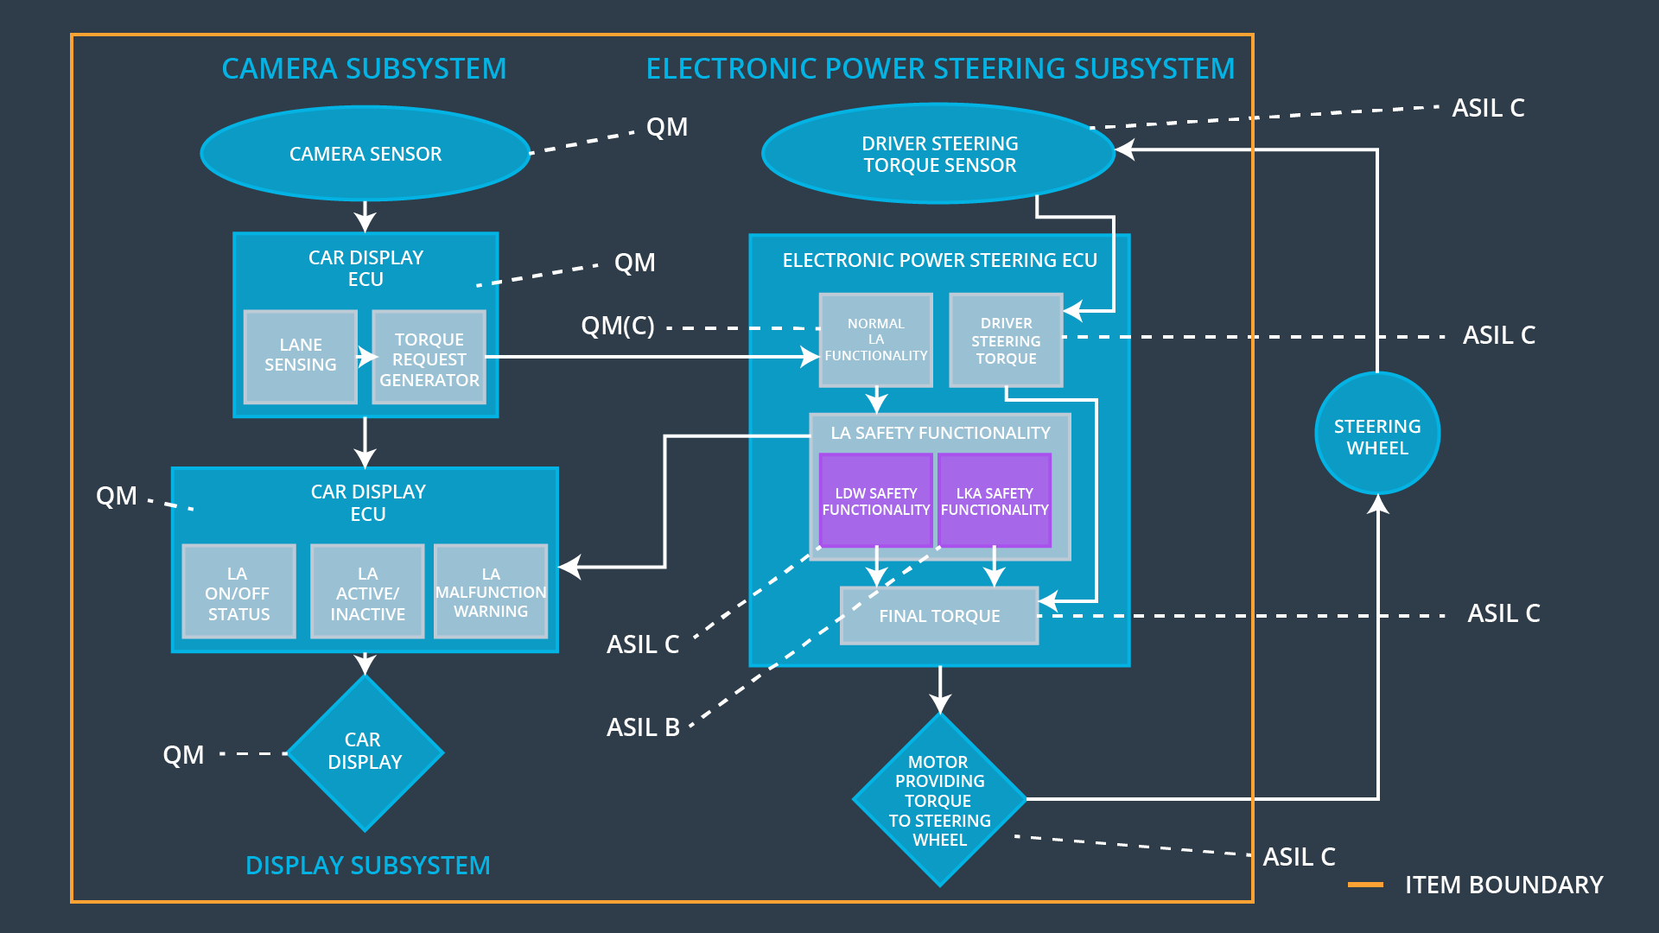

## Allocation of Functional Safety Requirements to Architecture Elements

|  |  |  |  |  |
| --- | --- | --- | --- | --- |
| **ID** | **Functional Safety Requirement** | **Electronic Power Steering ECU** | **Camera ECU** | **Car Display ECU** |
| Functional  Safety  Requirement  01-01 | The Electronic Power Steering ECU shall ensure that the lane departure oscillating torque amplitude is below Max_Torque_Amplitude | **X** |  |  |
| Functional  Safety  Requirement  01-02 | The Electronic Power Steering ECU shall ensure that the lane departure oscillating torque frequency is below Max_Torque_Frequency | **X** |  |  |
| Functional  Safety  Requirement  02-01 | The Electronic Power Steering ECU shall ensure that the lane keeping assistance torque is applied for only Max_Duration | **X** |  |  |

## Warning and Degradation Concept

|  |  |  |  |  |
| --- | --- | --- | --- | --- |
| **ID** | **Degradation Mode** | **Trigger for Degradation Mode** | **Safe State invoked?** | **Driver Warning** |
| WDC-01 | Lane keeping assistance mode is disabled | Lane keeping assistance torque has been applied for some time greater than Max_Duration | Yes | Lane keeping mode has been disabled because the functionality is not meant for autonomous driving, and the driver maintains responsibility for the safe operation of the vehicle. |
| WDC-02 | Lane departure warning mode is disabled | The departure warning vibrations have exceeded either Max_Torque_Amplitude or Max_Torque_Frequency | Yes | Lane departure warning mode is disabled to ensure that the driver can maintain control of the vehicle |