

Technical Safety Concept Lane Assistance

**Document Version: 1.0**

**Template Version 1.0, Released on 2017-06-21**



# Document history

|  |  |  |  |
| --- | --- | --- | --- |
| Date | Version | Editor | Description |
| 11/2/17 | 1.0 | Nicholas Moellers | First Draft |
|  |  |  |  |
|  |  |  |  |
|  |  |  |  |
|  |  |  |  |

# 

# Table of Contents

Document history

Table of Contents

Purpose of the Technical Safety Concept

Inputs to the Technical Safety Concept

Functional Safety Requirements

Refined System Architecture from Functional Safety Concept

Functional overview of architecture elements

Technical Safety Concept

Technical Safety Requirements

Refinement of the System Architecture

Allocation of Technical Safety Requirements to Architecture Elements

Warning and Degradation Concept

# Purpose of the Technical Safety Concept

**[Instructions: Answer what is the purpose of a technical safety concept?]**

**The Technical Safety Concept is more concrete than the Function Safety concept and gets into the details of the item’s technology. In this document, the functional safety requirements will be translated into technical safety requirements and allocated to the system architecture.**

# Inputs to the Technical Safety Concept

## Functional Safety Requirements

|  |  |  |  |  |
| --- | --- | --- | --- | --- |
| **ID** | **Functional Safety Requirement** | **ASIL** | **Fault Tolerant Time Interval** | **Safe State** |
| Functional  Safety  Requirement  01-01 | The lane keeping item shall ensure that the lane departure oscillating torque amplitude is below Max_Torque_Amplitude | C | 50 mS | Set vibration torque to zero |
| Functional  Safety  Requirement  01-02 | The lane keeping item shall ensure that the lane departure oscillating torque frequency is below Max_Torque_Frequency | C | 50 mS | Set vibration torque to zero |
| Functional  Safety  Requirement  02-01 | The lane keeping item shall ensure that the lane keeping assistance torque is applied for only Max_Duration | B | 500 mS | Lane keeping item is disabled |

## Refined System Architecture from Functional Safety Concept

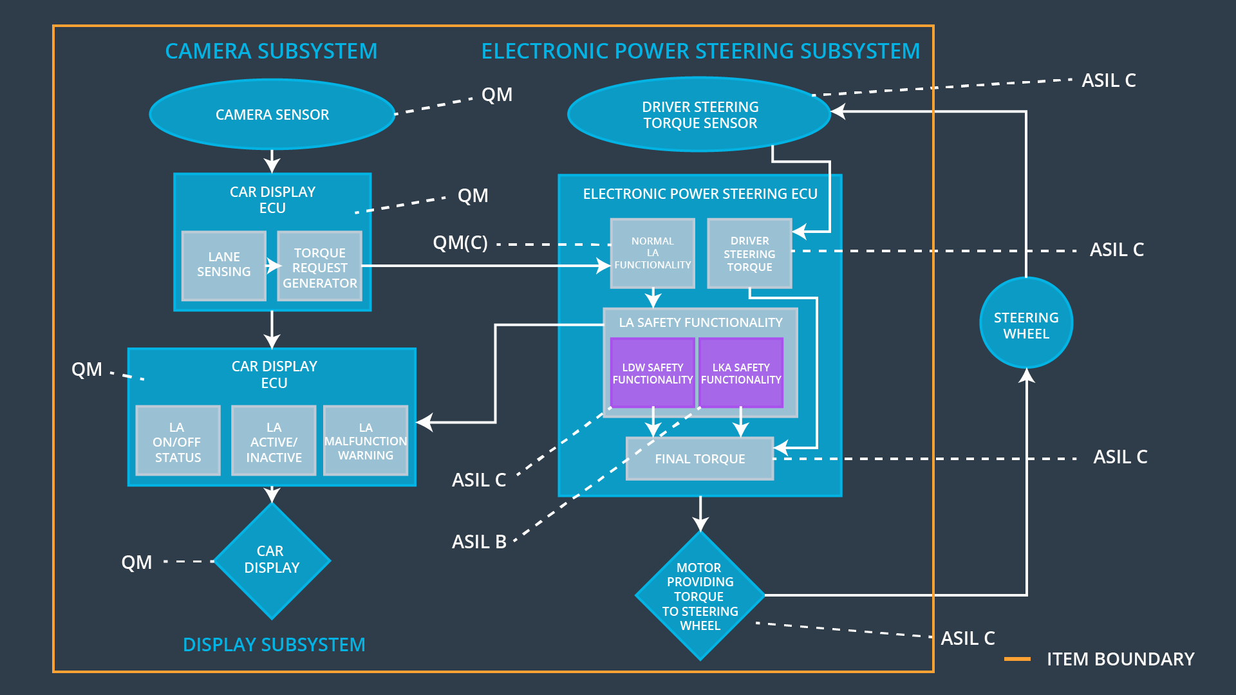

### Functional overview of architecture elements

**[Instructions: Provide a description for each functional safety element; what is each element's purpose in the lane assistance item? ]**

|  |  |
| --- | --- |
| **Element** | **Description** |
| Camera Sensor | Provide image data of roads to camera sensor ECU |
| Camera Sensor ECU - Lane Sensing | Detect lane lines in camera sensor data |
| Camera Sensor ECU - Torque request generator | Calculate torque to apply to steering wheel |
| Car Display | Display lane assistance information to driver |
| Car Display ECU - Lane Assistance On/Off Status | Calculate the on/off status of the lane assistance feature |
| Car Display ECU - Lane Assistant Active/Inactive | Calculate the active/inactive status of the lane assistance feature |
| Car Display ECU - Lane Assistance malfunction warning | Determine if the driver needs to be warned of malfunction in the lane detection warning and lane keeping systems |
| Driver Steering Torque Sensor | Detect torque input and send to EPS ECU |
| Electronic Power Steering (EPS) ECU - Driver Steering Torque | Calculate torque input being applied by driver |
| EPS ECU - Normal Lane Assistance Functionality | Send lane departure warnings and lane keeping torque request to safe lane assistance functionality |
| EPS ECU - Lane Departure Warning Safety Functionality | Ensure that the lane departure warnings are safe and controllable by driver |
| EPS ECU - Lane Keeping Assistant Safety Functionality | Ensure that the lane keeping assistance feature is not abused by the drive |
| EPS ECU - Final Torque | Send the torque application request to the steering wheel |
| Motor | Apply torque to the steering wheel |

# Technical Safety Concept

## Technical Safety Requirements

**[Instructions: Fill in the technical safety requirements for the lane departure warning first functional safety requirement. We have provided the associated functional safety requirement in the first table below. Hint: The technical safety requirements were discussed in the lesson videos. The architecture allocation column should contain element names such as LDW Safety block, Data Transmission Integrity Check, etc. Allocating the technical safety requirements to the "EPS ECU" does not provide enough detail for a technical safety concept.]**

**Lane Departure Warning (LDW) Requirements:**

Functional Safety Requirement 01-01 with its associated system elements

(derived in the functional safety concept)

|  |  |  |  |  |
| --- | --- | --- | --- | --- |
| **ID** | **Functional Safety Requirement** | **Electronic Power Steering ECU** | **Camera ECU** | **Car Display ECU** |
| Functional  Safety  Requirement  01-01 | The lane keeping item shall ensure that the lane departure oscillating torque amplitude is below Max_Torque_Amplitude | X |  |  |

Technical Safety Requirements related to Functional Safety Requirement 01-01 are:

|  |  |  |  |  |  |
| --- | --- | --- | --- | --- | --- |
| **ID** | **Technical Safety Requirement** | **ASIL** | **Fault Tolerant Time Interval** | **Architecture Allocation** | **Safe State** |
| Technical  Safety  Requirement  01 | The LDW safety component shall ensure that the amplitude of the ‘LDW_Torque_Request’ sent to the ‘Final EPS Torque’ component is below ‘Max_Torque_Amplitude’ | C | 50 ms | LDW Safety | The “LDW_Torque_Request” Amplitude shall be set to zero |
| Technical  Safety  Requirement  02 | The validity and integrity of the data transmission for ‘LDW_Torque Request’ signal shall be ensured” | C | 50 ms | Data Transmission Integrity Check | The “LDW_Torque_Request” Amplitude shall be set to zero |
| Technical  Safety  Requirement  03 | As soon as a failure is detected by the LDW function, it shall deactivate the LDW feature and the ‘LDW_Torque_Request’ shall be set to zero. | C | 50 ms | LDW Safety | The “LDW_Torque_Request” Amplitude shall be set to zero |
| Technical  Safety  Requirement  04 | As soon as the LDW function deactivates the LDW feature, the ‘LDW Safety’ software block shall send a signal to the car display ECO to turn on a warning light. | C | 50 ms | LDW Safety | The “LDW_Torque_Request” Amplitude shall be set to zero |
| Technical  Safety  Requirement  05 | Memory test shall be conducted at startup of the EPS ECU to check for any faults in memory. | A | Ignition cycle | Memory Test | The “LDW_Torque_Request” Amplitude shall be set to zero |

**[Instructions: Fill in the technical safety requirements for the lane departure warning second functional safety requirement. We have provided the associated functional safety requirement in the table below. Hint:. Most of the technical safety requirements will be the same. At least one technical safety requirement will have to be slightly modified because we are talking about frequency instead of amplitude. These requirements were not given in the lessons]**

Functional Safety Requirement 01-2 with its associated system elements

(derived in the functional safety concept)

|  |  |  |  |  |
| --- | --- | --- | --- | --- |
| **ID** | **Functional Safety Requirement** | **Electronic Power Steering ECU** | **Camera ECU** | **Car Display ECU** |
| Functional  Safety  Requirement  01-02 | The lane keeping item shall ensure that the lane departure oscillating torque frequency is below Max_Torque_Frequency | X |  |  |

Technical Safety Requirements related to Functional Safety Requirement 01-02 are:

|  |  |  |  |  |  |
| --- | --- | --- | --- | --- | --- |
| **ID** | **Technical Safety Requirement** | **ASIL** | **Fault Tolerant Time Interval** | **Architecture Allocation** | **Safe State** |
| Technical  Safety  Requirement  01 | The LDW safety component shall ensure that the frequency of the ‘LDW_Torque_Request’ sent to the ‘Final EPS Torque’ component is below ‘Max_Torque_Frequency’ | C | 50 ms | LDW Safety | The “LDW_Torque_Request” Frequency shall be set to zero |
| Technical  Safety  Requirement  02 | The validity and integrity of the data transmission for ‘LDW_Torque Request’ signal shall be ensured” | C | 50 ms | Data Transmission Integrity Check | The “LDW_Torque_Request” Frequency shall be set to zero |
| Technical  Safety  Requirement  03 | As soon as a failure is detected by the LDW function, it shall deactivate the LDW feature and the ‘LDW_Torque_Request’ shall be set to zero. | C | 50 ms | LDW Safety | The “LDW_Torque_Request” Frequency shall be set to zero |
| Technical  Safety  Requirement  04 | As soon as the LDW function deactivates the LDW feature, the ‘LDW Safety’ software block shall send a signal to the car display ECO to turn on a warning light. | C | 50 ms | LDW Safety | The “LDW_Torque_Request” Frequency shall be set to zero |
| Technical  Safety  Requirement  05 | Memory test shall be conducted at startup of the EPS ECU to check for any faults in memory. | A | Ignition cycle | Memory Test | The “LDW_Torque_Request” Frequency shall be set to zero |

**Lane Departure Warning (LDW) Verification and Validation Acceptance Criteria:**

**[OPTIONAL: For each technical safety requirement, identify both the verification and validation acceptance criteria. “Validation” asks whether or not you chose the appropriate parameters. “Verification” involves testing to make sure the vehicle behaves as expected when the parameter value is crossed. There is not necessarily one right answer. Look at your verification and validation acceptance criteria from the functional safety concept for inspiration.]**

**Lane Keeping Assistance (LKA) Requirements:**

**[Instructions: Fill in the technical safety requirements for the lane keeping assistance functional safety requirement 02-01. We have provided the associated functional safety requirement in the table below. Hint:. You can reuse the technical safety requirements from functional safety requirement 01-01. But you need to change the language because we are now looking at a different system. The ASIL and Fault Tolerant Time Interval are different as well.]**

Functional Safety Requirement 02-1 with its associated system elements

(derived in the functional safety concept)

|  |  |  |  |  |
| --- | --- | --- | --- | --- |
| **ID** | **Functional Safety Requirement** | **Electronic Power Steering ECU** | **Camera ECU** | **Car Display ECU** |
| Functional  Safety  Requirement  02-01 | The lane keeping item shall ensure that the lane keeping assistance torque is applied for only Max_Duration | X |  |  |

Technical Safety Requirements related to Functional Safety Requirement 02-01 are:

|  |  |  |  |  |  |
| --- | --- | --- | --- | --- | --- |
| **ID** | **Technical Safety Requirement** | **ASIL** | **Fault Tolerant Time Interval** | **Allocation to Architecture** | **Safe State** |
| Technical  Safety  Requirement  01 | The LKA safety component shall ensure that the active duration of the ‘LKA_Torque_Request’ sent to the ‘Final EPS Torque’ component is less than ‘Max_Duration’ | B | 500 ms | LKA Safety | The LKA_Activation_Satus and LKA_Torque_Request shall be set to 0 |
| Technical  Safety  Requirement  02 | The validity and integrity of the data transmission for ‘LKA_Torque_Request’ signal shall be ensured” | B | 500 ms | Data Transmission Integrity Check | The LKA_Activation_Satus and LKA_Torque_Request shall be set to 0 |
| Technical  Safety  Requirement  03 | As soon as a failure is detected by the LKA function, it shall deactivate the LKA feature and the ‘LKA_Torque_Request’ shall be set to zero. | B | 500 ms | LKA Safety | The LKA_Activation_Satus and LKA_Torque_Request shall be set to 0 |
| Technical  Safety  Requirement  04 | As soon as the LKA function deactivates the LKA feature, the ‘LKA Safety’ software block shall send a signal to the car display ECO to turn on a warning light. | B | 500 ms | LKA Safety | The LKA_Activation_Satus and LKA_Torque_Request shall be set to 0 |
| Technical  Safety  Requirement  05 | Memory test shall be conducted at startup of the EPS ECU to check for any faults in memory. | QM | Ignition cycle | Memory Test | The LKA_Activation_Satus and LKA_Torque_Request shall be set to 0 |

**Lane Keeping Assistance (LKA) Verification and Validation Acceptance Criteria:**

**[OPTIONAL: For each technical safety requirement, identify both the verification and validation acceptance criteria. “Validation” asks whether or not you chose the appropriate parameters. “Verification” involves testing to make sure the vehicle behaves as expected when the parameter value is crossed. There is not necessarily one right answer. Look at your verification and validation acceptance criteria from the functional safety concept for inspiration.]**

## Refinement of the System Architecture

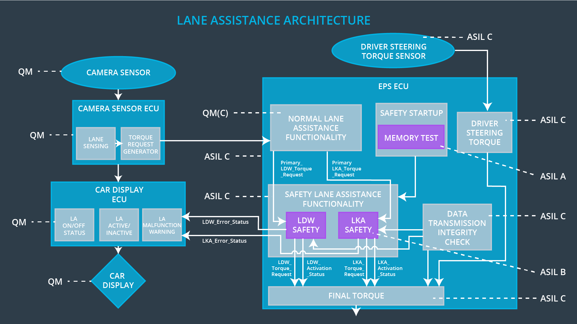

## Allocation of Technical Safety Requirements to Architecture Elements

For this particular item, all technical safety requirements are allocated to the Electronic Power Steering ECU.

## Warning and Degradation Concept

|  |  |  |  |  |
| --- | --- | --- | --- | --- |
| **ID** | **Degradation Mode** | **Trigger for Degradation Mode** | **Safe State invoked?** | **Driver Warning** |
| WDC-01 | Lane keeping assistance mode is disabled | Lane keeping assistance torque has been applied for some time greater than Max_Duration | Yes | Lane keeping mode has been disabled because the functionality is not meant for autonomous driving, and the driver maintains responsibility for the safe operation of the vehicle. |
| WDC-02 | Lane departure warning mode is disabled | The departure warning vibrations have exceeded either Max_Torque_Amplitude or Max_Torque_Frequency | Yes | Lane departure warning mode is disabled to ensure that the driver can maintain control of the vehicle |