
SOFTWARE REQUIREMENTS SPECIFICATION
Sidekick PA
Your Personal, Proactive AI Companion
A private, offline-first desktop assistant for Windows that helps you manage reminders, routines and responsibilities, and speaks up when something needs your attention.
Document | Software Requirements Specification (ISO/IEC/IEEE 29148 structure)
Version | 1.0
Date | 12/11/2026
Author | Nick Ndeda
Status | Baseline for buyer review
Coverage | Release 0.1 Core Desktop Foundation (full detail); Phases 2 to 7 (summary)
Classification | Confidential

Document Control
Version | Date | Author | Description
1.0 | 12/11/2026 | Nick Ndeda | First baseline for buyer review

Contents
1. Introduction 4
1.1 Purpose 4
1.2 Product scope and value 4
1.3 Definitions and abbreviations 4
1.4 References 4
1.5 Conventions 4
1.6 Document overview 5
2. Product Overview 5
2.1 Product perspective 5
2.2 Product functions 5
2.3 Users and stakeholders 5
2.4 Operating environment 6
2.5 Design and implementation constraints 6
2.6 Assumptions and dependencies 6
2.7 Release plan 6
3. System Models 7
3.1 System context 7
3.2 Use cases 7
3.3 Data flow 9
3.4 Architecture layers 10
3.5 Data model 11
4. Release 0.1 Requirements 13
4.1 Lifecycle and desktop presence 13
4.2 Reminders and scheduling 13
4.3 Notification engine 14
4.4 Productivity and activity monitoring 15
4.5 Wellness reminders 15
4.6 Conversational assistant 16
4.7 Settings, data and privacy controls 16
5. Later-Release Requirements 17
5.1 Productivity and wellness completion (Phase 2) 17
5.2 Planner and finance (Phase 3) 17
5.3 Learning intelligence (Phase 4) 18
5.4 Conversational AI and voice (Phase 5) 18
5.5 Machine learning (Phase 6) 18
5.6 Multi-device and institutional expansion (Phase 7) 19
6. External Interface Requirements 19
6.1 User interface 19
6.2 Software interfaces 19
6.3 Communications interfaces 20
6.4 Internal interface between interface and main process 20
7. Data Requirements 20
7.1 Release 0.1 data 20
7.2 Data rules 20
8. Non-Functional Requirements 20
8.1 Performance and resource use 21
8.2 Reliability 21
8.3 Security 21
8.4 Privacy 21
8.5 Usability and accessibility 22
8.6 Compatibility 22
8.7 Maintainability 23
8.8 Localisation 23
9. Verification and Acceptance 23
9.1 Verification methods 23
9.2 Acceptance criteria for Release 0.1 23
9.3 User acceptance 24
10. Traceability to the Project Specification 24
11. Risks 25
12. Open Issues 25
Appendix A. Glossary 26
Appendix B. Notification Behaviour 26
Appendix C. Supported Chat Commands (Release 0.1) 26
Appendix D. Screen Inventory 27

1. Introduction

1.1 Purpose
This Software Requirements Specification (SRS) defines what Sidekick PA shall do, how well it shall do it, and how a buyer can check that it does. It describes Release 0.1, the Core Desktop Foundation, in full detail and summarises the later releases so that the product direction is clear. It is written to the structure of IEEE/ISO/IEC 29148 so that a buyer, a developer and a tester can all work from the same document.

1.2 Product scope and value
Sidekick PA is a personal, proactive assistant for Windows. It lives on the user's computer as a small floating assistant and a full dashboard, keeps track of reminders, routines and responsibilities, and speaks up when something needs attention. Most productivity tools wait to be opened. Sidekick does not.
What a buyer gets.
- Proactive help: break prompts, reminders and renewal heads-ups arrive on their own, with the right priority and at a sensible moment.
- Private and offline: all data stays on the computer. Every Release 0.1 function works with no internet connection.
- One assistant, not six apps: the widget, chat and dashboard are three views of the same assistant, sharing one state.
- Calm by design: Focus mode and quiet hours keep the assistant quiet when the user needs it to be.
- A clear growth path: planner, finance, learning intelligence, voice, local AI and multi-device support build on the same foundation.
Out of scope for Release 0.1: voice input, finance, learning intelligence, machine learning, generative AI, cloud synchronisation, Android and institutional (school) deployment. They are specified in section 5 so they can be planned, not built now.

1.3 Definitions and abbreviations
Terms used in this document are defined in Appendix A. Requirement priorities follow section 1.5.

1.4 References
- Sidekick PA Project Charter, Product Requirements and Technical Development Specification (the "Project Specification").
- Sidekick PA Product Vision and Visual Product Direction documents.
- Sidekick PA clickable prototype and visual design (identity, hybrid desktop presence and nine dashboard screens).
- ISO/IEC/IEEE 29148:2018, Systems and software engineering, Life cycle processes, Requirements engineering.
- The Data Protection Act, 2019 (Kenya).

1.5 Conventions
Each requirement has a unique ID and uses "shall" for obligation and "should" for a strong recommendation. Priorities are: Must, required for Release 0.1 to be accepted; Should, important and included unless risk or time forces a deferral that the buyer agrees to; Could, desirable. IDs are grouped by area (for example LC for lifecycle, RM for reminders, NT for notifications). Later-release requirements carry the prefix P followed by the phase number.

1.6 Document overview
Section 2 describes the product and its context. Section 3 gives five models: context, use cases, data flow, architecture and data. Section 4 lists the Release 0.1 requirements. Section 5 summarises later releases. Sections 6 to 8 cover interfaces, data and quality attributes. Sections 9 and 10 explain how the product is verified and how requirements trace back to the Project Specification. Sections 11 and 12 list risks and open issues.

2. Product Overview

2.1 Product perspective
Sidekick PA is a self-contained desktop product. It needs no server. It relies on Windows for notifications, the tray, start-up and an idle-time signal, and it stores everything in a local database. Figure 1 shows the system and its surroundings.

2.2 Product functions
Area | What it does | Release
Desktop presence | Floating assistant, tray, dashboard, light and dark themes | 0.1
Reminders and scheduling | Create, complete and recur reminders; survive restarts and sleep | 0.1
Notification engine | Priority, snooze, de-duplication, quiet hours, Focus mode, history | 0.1
Productivity | Estimated active time, break prompts, focus sessions, summaries | 0.1
Wellness reminders | Hydration, movement and eye-rest reminders | 0.1
Conversational assistant | Offline text chat with confirmation before any change | 0.1
Settings and data | Preferences, local storage, backup, integrity check | 0.1
Planner and finance | Tasks, calendar, subscriptions, bills, savings goals (KES) | Phase 3
Learning intelligence | Subjects, quizzes, weak-topic detection, revision plans | Phase 4
Voice and local AI | Speech, natural language, local language model | Phase 5
Machine learning | Predictions from the user's own history | Phase 6
Multi-device and schools | Android, sync, profiles, institutional deployment | Phase 7

2.3 Users and stakeholders
Stakeholder | Interest
Primary user | One person using their own Windows laptop for study, development, personal projects and everyday routines. Release 0.1 is built for this user.
Buyer / product owner | Wants a dependable, private assistant with a clear roadmap and verifiable acceptance criteria.
Future users | University and secondary-school students, tutors, remote workers and freelancers.
Future institutions | Schools with unreliable internet. They need a separate institutional design (Phase 7) and are not served by Release 0.1.

2.4 Operating environment
Windows 11 (primary) and Windows 10 where supported by the chosen Electron version, on ordinary laptops including machines with 8 GB of RAM. The computer must be switched on for live notifications to be delivered. No internet connection is needed.

2.5 Design and implementation constraints
- Technology: Electron, React, TypeScript, Node.js and SQLite (through better-sqlite3), as set out in the Project Specification.
- Offline-first: essential functions shall not depend on an internet connection or an external AI service.
- Local data: one local user profile and local storage; no automatic cloud upload in Release 0.1.
- Security: context isolation on, Node integration off in the renderer, explicit and validated IPC.
- Resource use: suitable for computers with limited memory and processing power.
- Scope discipline: development proceeds in phases, and each module is stable and tested before the next begins.

2.6 Assumptions and dependencies
- The first deployment is one Windows computer with one local user.
- Windows start-up integration works only if the user turns it on.
- Idle detection estimates activity. It does not prove that the user is studying or working productively.
- Subscription and bill details are entered by the user (Phase 3).
- Machine-learning features need enough reliable user data (Phase 6).
- Voice recognition is not offline until a local speech engine is added (Phase 5).

2.7 Release plan
Release / phase | Focus | Detail in this SRS
0.1 Core Desktop Foundation | Background operation, widget, tray, database, reminders, notifications, activity monitoring, basic chat | Section 4 (full)
Phase 2 | Productivity and wellness completion: habits, reports | Section 5.1
Phase 3 | Planner and finance | Section 5.2
Phase 4 | Learning intelligence | Section 5.3
Phase 5 | Conversational AI and voice | Section 5.4
Phase 6 | Machine learning | Section 5.5
Phase 7 | Multi-device and institutional expansion | Section 5.6

3. System Models

3.1 System context
The user talks to Sidekick and Sidekick talks back. Windows provides notifications, the tray, start-up and idle time. Everything is stored in a local database. Dashed lines are later releases.
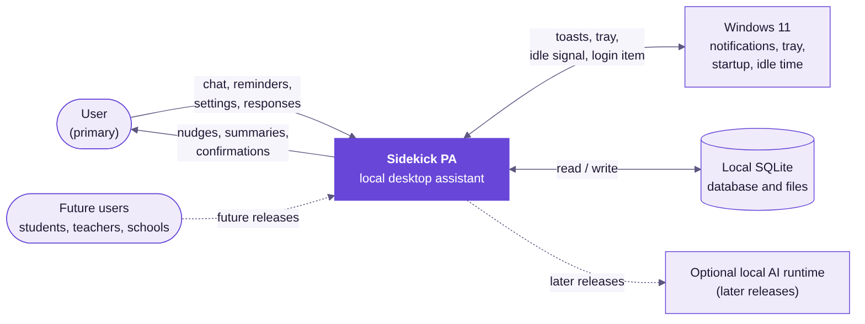
Figure 1. System context

3.2 Use cases
Release 0.1 has twelve use cases. The user starts nine of them. The scheduler and Windows take part in the other three, which Sidekick starts itself.
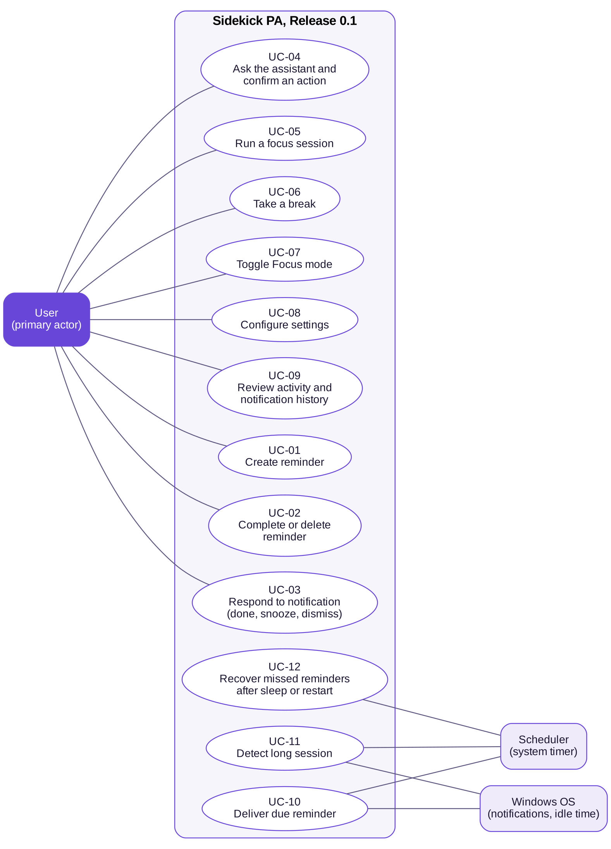
Figure 2. Use cases for Release 0.1
ID | Use case | Trigger and outcome | Requirements
UC-01 | Create reminder | User adds a reminder in Planner, the widget or chat. It is saved and will fire at its due time. | RM-01, RM-06, RM-10
UC-02 | Complete or delete reminder | User marks a reminder done or removes it. Recurring reminders roll forward. | RM-03, RM-04
UC-03 | Respond to notification | User chooses Done, Snooze 10 min or Dismiss. The choice is recorded. | NT-03, NT-05, NT-06
UC-04 | Ask the assistant | User types a request. Sidekick answers or asks for confirmation, then acts. | CH-01 to CH-05
UC-05 | Run a focus session | User starts a 25, 50 or 90 minute session. Focus mode is on until it ends. | PR-07, NT-09
UC-06 | Take a break | User answers a break prompt. The break is timed or the prompt is rescheduled. | PR-05, PR-06
UC-07 | Toggle Focus mode | User switches Focus mode from the widget, tray, dashboard or chat. | NT-09, LC-11
UC-08 | Configure settings | User changes preferences. They apply at once. | ST-01, ST-02
UC-09 | Review history | User views activity summaries and notification history. | PR-09, NT-11
UC-10 | Deliver due reminder | A reminder reaches its due time. The notification engine applies policy and delivers it. | RM-08, NT-01 to NT-09
UC-11 | Detect long session | Continuous activity reaches the threshold. A break prompt is raised. | PR-01, PR-04
UC-12 | Recover missed reminders | After restart or sleep, overdue reminders are found and delivered once, as missed. | RM-09

3.3 Data flow
Figure 3 shows the main flows. All alerts pass through process 4.0, which reads the user's Focus mode and quiet-hours settings before anything is shown.
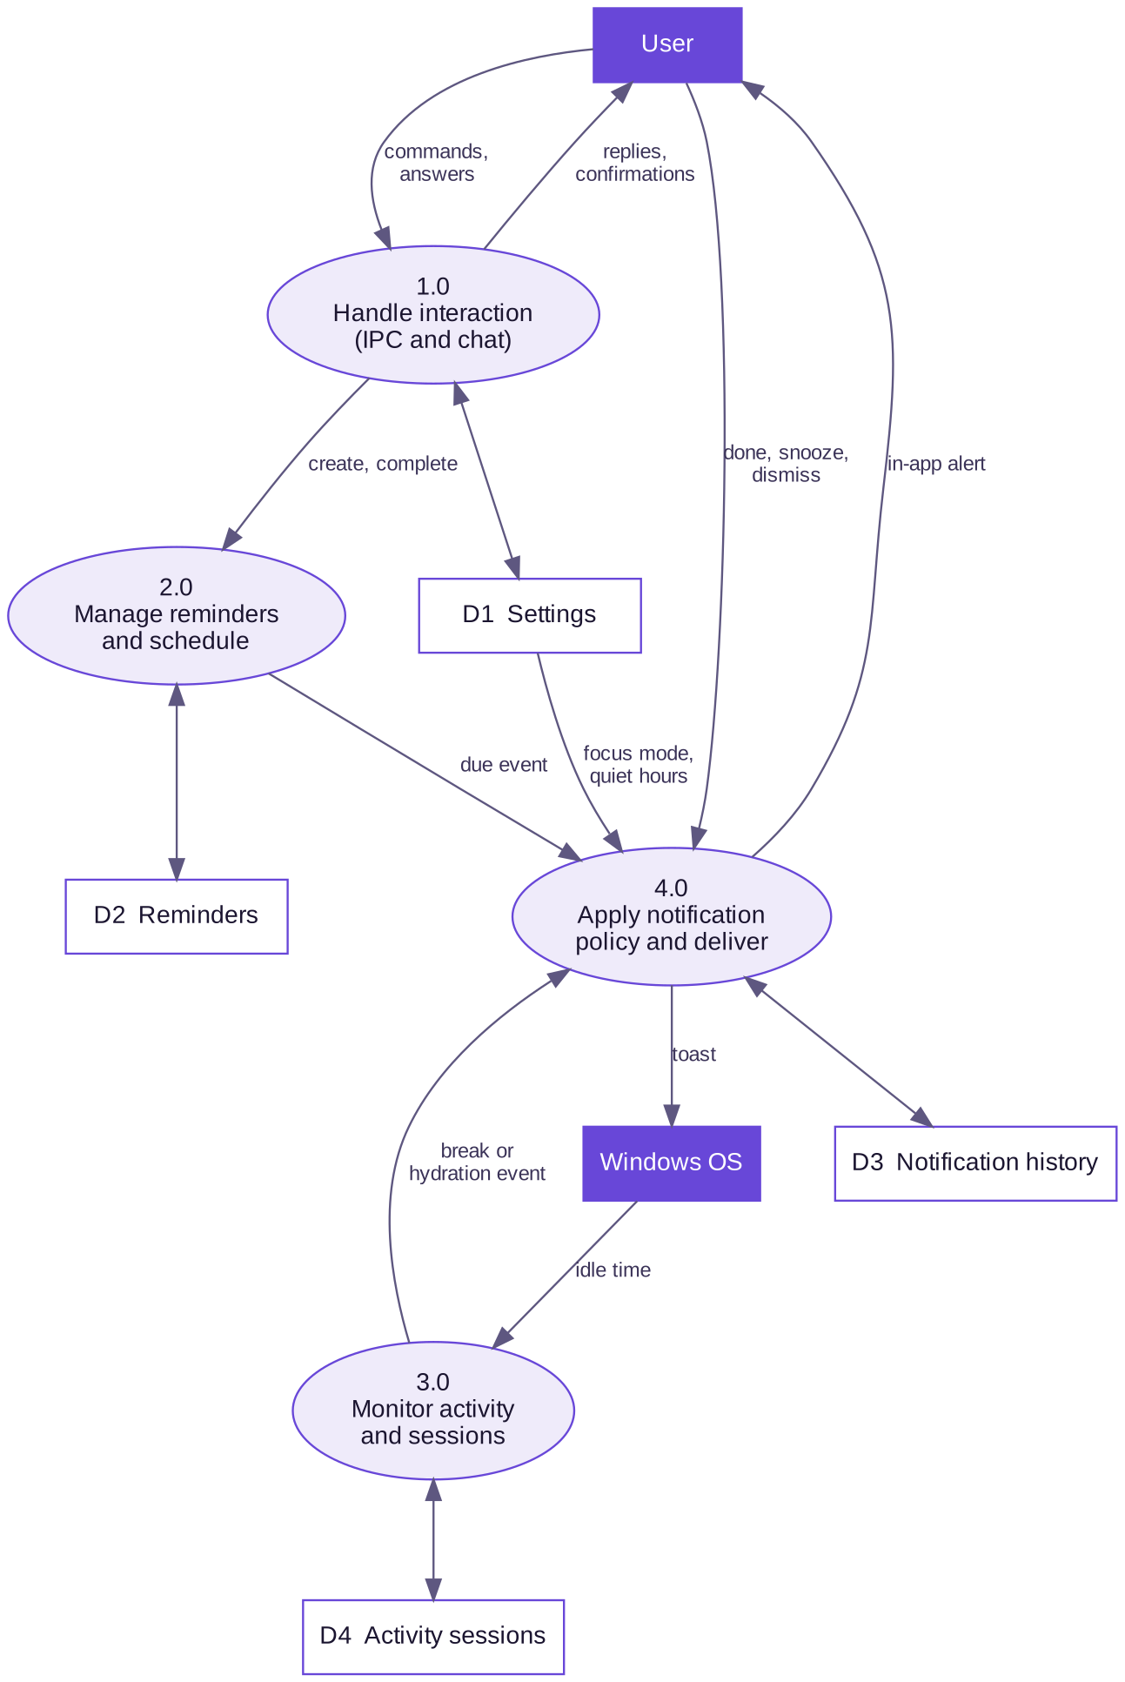
Figure 3. Level 1 data-flow diagram

3.4 Architecture layers
Sidekick uses a modular desktop architecture. The interface never touches the database or the operating system directly: it talks to the main process through a small, explicit and validated bridge. Modules do not call each other. They communicate through the assistant core, and every alert goes through the notification service.
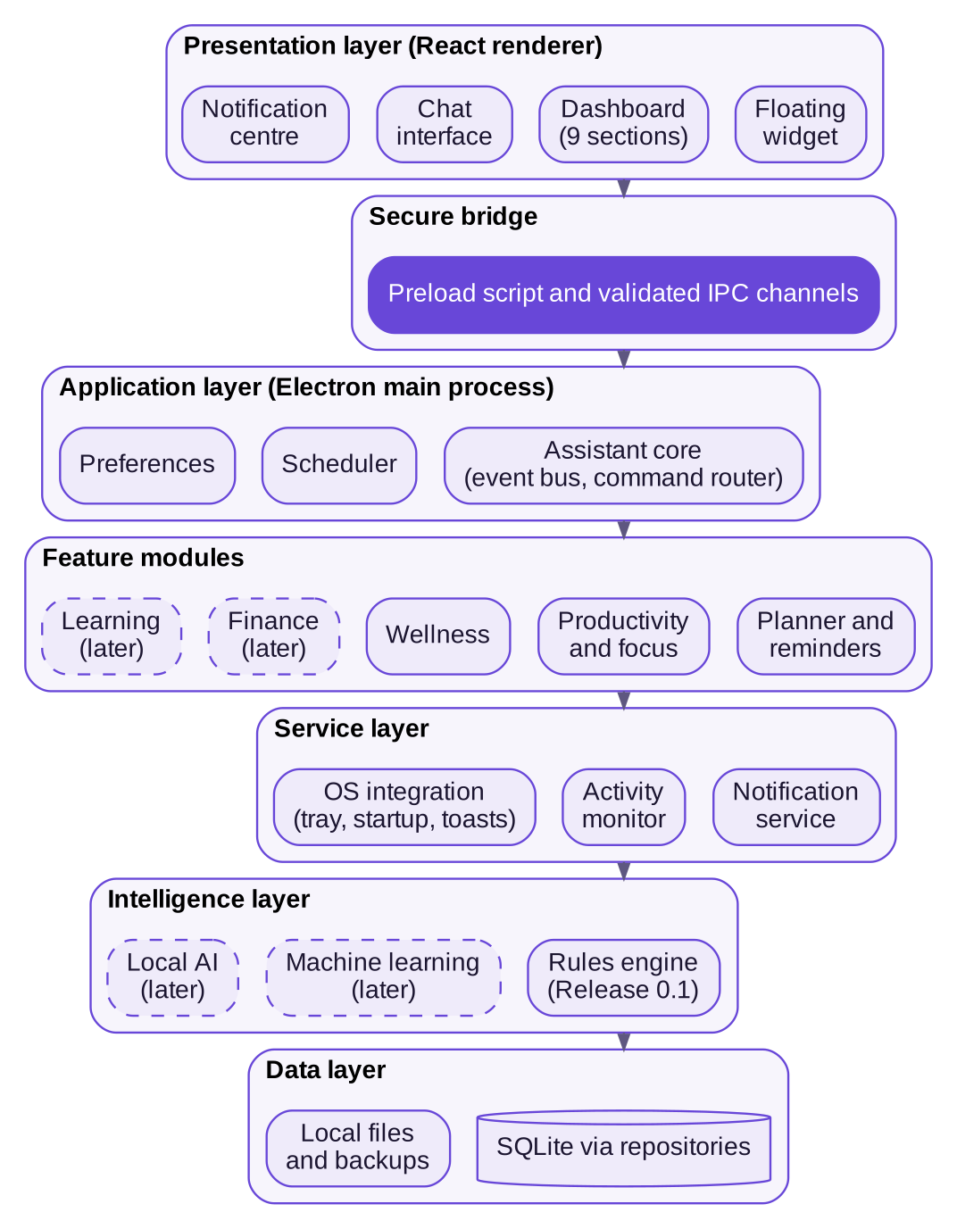
Figure 4. Architecture layers

3.5 Data model
Figure 5 shows the logical data model. Release 0.1 uses the five tables at the top. Later tables are shown so that early decisions leave room for them. Section 7 gives the data rules.
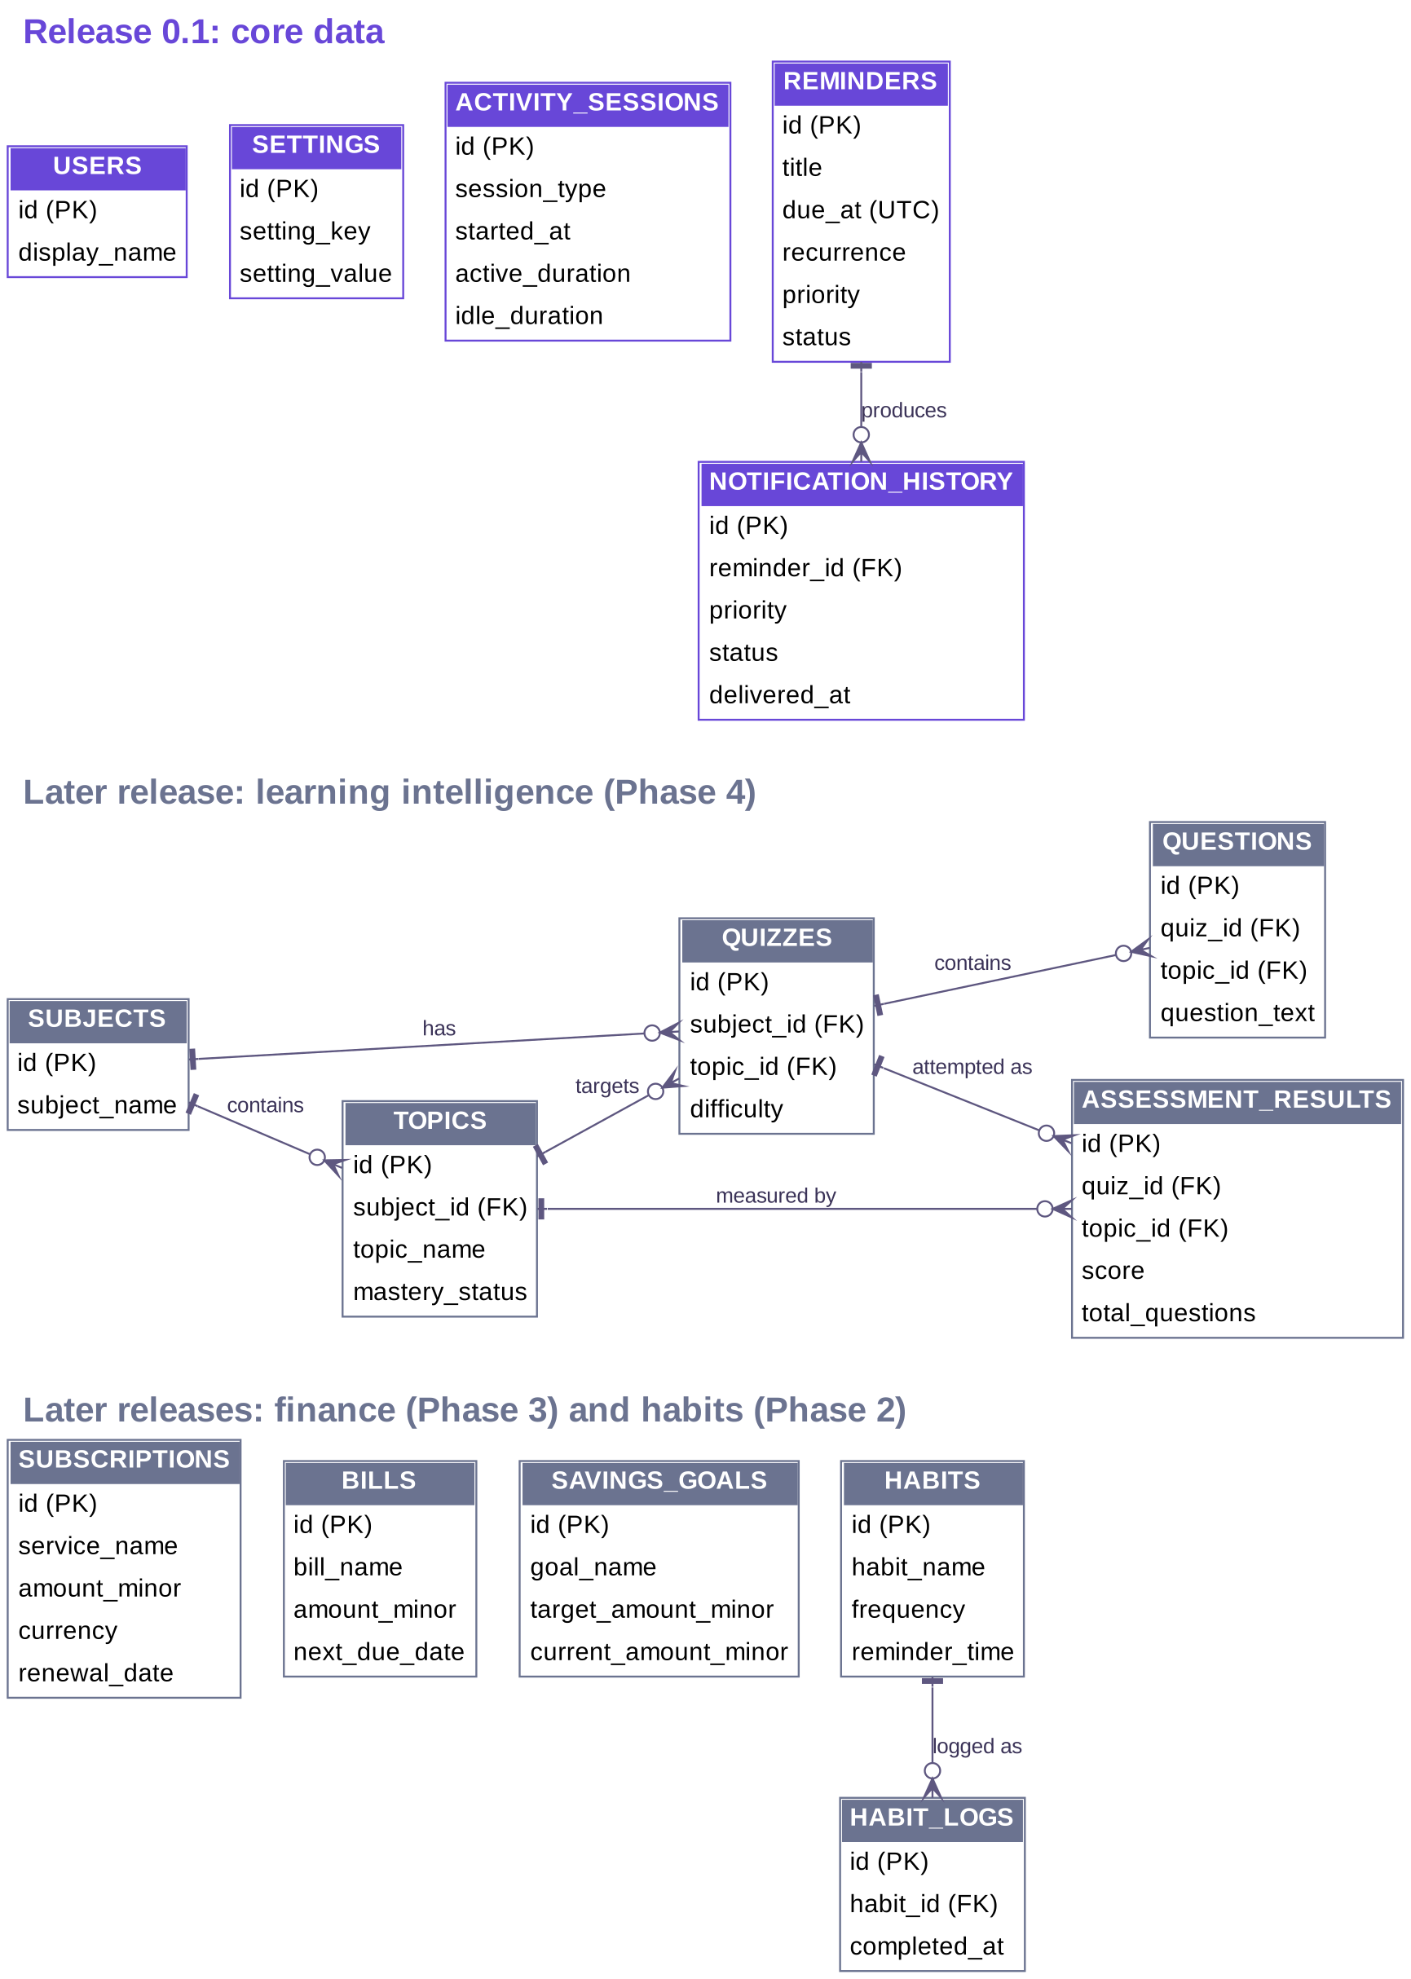
Figure 5. Logical data model (entity-relationship diagram)

4. Release 0.1 Requirements
These requirements define Release 0.1, the Core Desktop Foundation. All of them must be met for the release to be accepted, except where marked Should or Could.

4.1 Lifecycle and desktop presence
ID | Requirement | Priority
LC-01 | Sidekick shall run as a desktop application on Windows 11 and be installed and launched like an ordinary Windows program. | Must
LC-02 | Only one instance of Sidekick shall run at a time. Starting a second instance shall bring the existing one to the front. | Must
LC-03 | Closing the dashboard window shall hide it and not exit the application. Background services (scheduler, activity monitor, notifications) shall continue to run. The application shall exit only when the user chooses Quit from the tray menu. | Must
LC-04 | Sidekick shall show a system tray icon. Clicking it shall reopen the dashboard. The tray menu shall offer Open dashboard, Focus mode on/off, Pause reminders and Quit. | Must
LC-05 | Sidekick shall provide a small floating widget that stays above ordinary windows and shows a time-of-day greeting, the next task, the number of items needing attention, a Focus mode toggle, an Ask Sidekick button and an Open dashboard link. | Must
LC-06 | The floating assistant shall have three states the user can move between: a collapsed orb, the compact widget, and an expanded chat panel. The user shall be able to minimise, hide and restore it. | Must
LC-07 | The widget shall not obstruct normal work: it shall be draggable, remain within the visible screen area, and remember its position between sessions. | Should
LC-08 | The dashboard shall provide navigation to nine sections: Overview, Productivity, Learning, Finance, Wellness, Planner, Notifications, Chat and Settings. A section whose module is not part of the installed release shall show a clear explanatory state, and shall never present sample content as the user's own data. | Must
LC-09 | Sidekick shall offer an opt-in setting to start automatically when the user signs in to Windows. The default shall be off. | Should
LC-10 | Sidekick shall support a Dark theme and a Light theme, applied consistently to the widget, chat, dashboard and notifications. It should also offer Follow Windows appearance. | Must
LC-11 | All windows shall present the same state. Focus mode, notification counts, reminders and settings shall have one source of truth in the main process, so a change in one window is reflected in the others without a restart. | Must

4.2 Reminders and scheduling
ID | Requirement | Priority
RM-01 | The user shall be able to create a reminder with a title (required), description, category, due date and time, priority and recurrence. | Must
RM-02 | The user shall be able to edit an existing reminder. | Should
RM-03 | The user shall be able to mark a reminder complete. Completing a recurring reminder shall schedule its next occurrence. | Must
RM-04 | The user shall be able to delete a reminder, after confirmation. | Must
RM-05 | Sidekick shall list reminders by status and due date, including a Today view and an Overdue view. | Must
RM-06 | Recurrence shall support none, daily, weekly and monthly. A monthly reminder set for a day that does not exist in a given month (for example the 31st) shall fall on the last day of that month. | Must
RM-07 | Reminders shall be stored in the local database and shall survive application restarts and Windows restarts. | Must
RM-08 | A due reminder shall fire while the application is running in the background, whether or not the dashboard is open. | Must
RM-09 | After an application restart, Windows sleep and resume, or a system clock change, Sidekick shall detect reminders that came due in the meantime and deliver each at most once, marked as missed while the user was away. Several missed reminders shall be summarised and not delivered as a flood. | Must
RM-10 | Each reminder shall carry one of four priorities: Critical, High, Normal or Low. | Must

4.3 Notification engine
ID | Requirement | Priority
NT-01 | Every module shall raise alerts through one notification engine. No module shall show an alert on its own. | Must
NT-02 | The engine shall assign each notification one of four priorities: Critical (important deadlines, user-defined urgent events), High (upcoming payments, important academic events), Normal (scheduled tasks, study reminders) and Low (hydration, movement and general wellness suggestions). | Must
NT-03 | Notifications shall be delivered through the Windows notification system. Where Windows supports it, each shall offer Snooze 10 min, Done and Dismiss actions. | Must
NT-04 | The dashboard shall include a notification centre that lists notifications, filters them by priority, and updates its counts live. | Must
NT-05 | Snoozing a notification shall re-deliver it after 10 minutes. | Must
NT-06 | Done, Snooze and Dismiss shall each be recorded with a timestamp. | Must
NT-07 | The engine shall not deliver a duplicate of a notification (same source and subject) while an earlier one is still unresolved within a suppression window. | Must
NT-08 | The user shall be able to define quiet hours (default 10:30 PM to 7:30 AM). During quiet hours, only Critical notifications shall be delivered, and only if the setting Allow critical alerts is on (default on). | Must
NT-09 | While Focus mode is on, only Critical notifications shall be delivered, subject to the same Allow critical alerts setting. All others shall be held. | Must
NT-10 | Held notifications shall stay visible in the notification centre and be summarised when quiet hours or Focus mode end. Held Low-priority notifications that are no longer relevant may be dropped and recorded as suppressed. | Should
NT-11 | Notification history shall be kept and viewable, including counts of completed, postponed and dismissed items. | Must
NT-12 | The engine shall limit overload by capping simultaneous toasts and batching Low-priority notifications. Exact limits are an open issue (OI-2). | Should
NT-13 | A failed delivery shall be logged and the notification shall remain in the notification centre. | Should
NT-14 | Notification wording shall be friendly and supportive, offer a choice of action, and never shame or pressure the user. | Should

Appendix B summarises how each priority behaves in normal use, quiet hours and Focus mode.

4.4 Productivity and activity monitoring
ID | Requirement | Priority
PR-01 | Sidekick shall estimate active and idle computer time using the operating system's idle-time signal only. It shall not capture keystrokes, screenshots, window contents or application names. | Must
PR-02 | The idle threshold, after which the user is considered idle, shall be configurable. | Must
PR-03 | Sidekick shall record activity sessions and maintain estimated active time for the current day and week. | Must
PR-04 | When continuous active time reaches the break threshold (default 90 minutes, configurable), Sidekick shall raise a break prompt such as "You've been at it for a while. Fancy a break?". | Must
PR-05 | The break prompt shall offer Take a break, Remind me in 10 minutes and Dismiss. Each choice shall be recorded and shall take effect. | Must
PR-06 | When the user takes a break, Sidekick shall let them know when the break length (default 10 minutes) is over. | Should
PR-07 | The user shall be able to start and end a focus session of 25, 50 or 90 minutes, and be notified when it ends. Focus sessions shall switch Focus mode on for their duration. | Must
PR-08 | The user shall be able to set working hours. Break prompts and activity estimates shall apply within them. | Should
PR-09 | Sidekick shall show daily and weekly summaries of estimated active time, idle time, sessions and breaks. | Should
PR-10 | Wherever activity is shown, Sidekick shall state that it is estimated from computer idle time and does not measure productivity. | Must
PR-11 | The user shall be able to pause activity monitoring at any time. | Should

4.5 Wellness reminders
ID | Requirement | Priority
WL-01 | The user shall be able to turn hydration reminders on or off and set their interval. | Must
WL-02 | Sidekick shall offer movement reminders, triggered by a configured interval or by long continuous activity. | Should
WL-03 | Sidekick shall offer eye-rest reminders at a configurable interval. | Should
WL-04 | Wellness reminders shall have Low priority and shall be worded as suggestions. Sidekick shall never claim to detect hydration, fatigue or any medical condition. | Must
WL-05 | Each wellness reminder type shall be individually adjustable and can be switched off. | Must

4.6 Conversational assistant
ID | Requirement | Priority
CH-01 | Sidekick shall provide text chat in the expanded floating assistant and in the dashboard Chat section, sharing one conversation. | Must
CH-02 | Chat shall work fully offline using rule-based understanding. No network connection shall be needed. | Must
CH-03 | Chat shall support the command intents listed in Appendix C. | Must
CH-04 | Before changing anything (creating, completing or deleting a reminder, changing a setting, starting a session), Sidekick shall show a confirmation with Confirm, Change and Cancel, and shall act only after Confirm. | Must
CH-05 | When it does not understand a message, Sidekick shall say so kindly, suggest what it can do, and take no action. | Must
CH-06 | The chat shall offer suggestion chips for common requests. | Should
CH-07 | Sidekick shall be able to start a conversation, for example to offer a break, in the floating assistant. The user shall be able to answer by tapping a reply. | Must
CH-08 | Conversations shall be stored locally and the user shall be able to view and delete them. | Should
CH-09 | Voice input is not part of Release 0.1. The microphone control shall be absent, or shown disabled with the label "Voice is coming later". No microphone access shall be requested. | Should

4.7 Settings, data and privacy controls
ID | Requirement | Priority
ST-01 | The Settings section shall let the user change: theme, start with Windows, quiet hours, Allow critical alerts, break and hydration intervals, idle threshold and working hours. | Must
ST-02 | Settings shall be saved and applied immediately, without restarting the application. | Must
ST-03 | All user data shall be stored locally. Release 0.1 shall make no automatic cloud upload and shall need no internet connection for any function. | Must
ST-04 | The user shall be able to make a manual backup of their data to a location they choose. | Should
ST-05 | The user shall be able to run a database integrity check. If a problem is found, Sidekick shall tell the user plainly that their data is safe and offer to restore from a backup. | Should
ST-06 | The user shall be able to export their reminders, notification history and activity records in an open format (CSV or JSON). | Could
ST-07 | Settings shall include a panel stating what Sidekick never does: capture keystrokes, take screenshots, read private messages, record the microphone continuously, collect passwords or read unrelated personal files. | Should
ST-08 | On first run Sidekick shall ask for a display name and create the local user profile. | Should

5. Later-Release Requirements
These are planned capabilities, written at a lighter level than Release 0.1. They will be detailed before each phase begins. Priorities are provisional.

5.1 Productivity and wellness completion (Phase 2)
ID | Planned requirement | Priority | Phase
P2-01 | Custom focus and study-session lengths, with sessions tagged as work or study. | Should | P2
P2-02 | Custom recurring habits with completion tracking and a habit log. | Must | P2
P2-03 | Sleep-routine reminders. | Should | P2
P2-04 | Daily habit summaries. | Should | P2
P2-05 | Downloadable daily and weekly activity reports. | Could | P2
P2-06 | Reminder timing that adapts to the user's own history, using transparent rules. | Could | P2

5.2 Planner and finance (Phase 3)
ID | Planned requirement | Priority | Phase
P3-01 | Tasks with deadlines, priorities and completion tracking; academic deadlines and project milestones. | Must | P3
P3-02 | Appointments and a personal calendar with a month view. | Must | P3
P3-03 | Scheduled backup reminders, for example "back up project files at the end of the month". | Should | P3
P3-04 | Register subscriptions and recurring bills with name, amount, currency (KES by default), billing frequency, renewal date and days-before-renewal to be reminded. | Must | P3
P3-05 | Money shall be stored as whole minor units (cents), never as floating-point numbers. | Must | P3
P3-06 | High-priority advance renewal notifications. | Must | P3
P3-07 | Upcoming-payments view and expected monthly expense totals. | Must | P3
P3-08 | Savings goals with monthly reminders. | Should | P3
P3-09 | Manual payment confirmation, and a history of payments and reminders. | Must | P3
P3-10 | Sidekick shall not connect to bank accounts or hold payment credentials. Users enter billing details themselves. | Must | P3

5.3 Learning intelligence (Phase 4)
ID | Planned requirement | Priority | Phase
P4-01 | Register subjects and academic units, with topics beneath each. | Must | P4
P4-02 | Record completed topics. | Should | P4
P4-03 | Create and administer quizzes and store their questions. | Must | P4
P4-04 | Store every assessment attempt. Historical results shall never be overwritten. | Must | P4
P4-05 | Classify each topic as Not studied, Struggling, Improving or Mastered, using documented, transparent rules. | Must | P4
P4-06 | Identify repeatedly weak topics and explain the finding in plain language. | Must | P4
P4-07 | Recommend revision sessions and schedule spaced revision. | Must | P4
P4-08 | Adjust question difficulty to the user's performance. | Should | P4
P4-09 | Produce learning progress reports. | Should | P4

5.4 Conversational AI and voice (Phase 5)
ID | Planned requirement | Priority | Phase
P5-01 | Understand natural-language requests beyond the fixed command set. | Must | P5
P5-02 | Voice input that the user switches on deliberately, with a clearly visible microphone indicator. | Must | P5
P5-03 | A path to offline speech recognition and speech synthesis. | Should | P5
P5-04 | Integration with a local language model for answers, study plans and summaries. | Should | P5
P5-05 | Optional external AI services, off by default, never required, and never sent personal data without the user's permission. | Should | P5
P5-06 | Every action proposed by the assistant shall need user approval. | Must | P5

5.5 Machine learning (Phase 6)
ID | Planned requirement | Priority | Phase
P6-01 | Collect and validate historical data, and train only when there is enough of it. | Must | P6
P6-02 | Predict topics likely to cause difficulty, helpful reminder timing and personal productivity patterns. | Should | P6
P6-03 | Evaluate model accuracy, version models, and fall back to rule-based behaviour if a model is disabled or performs poorly. | Must | P6
P6-04 | Explain each recommendation to the user. | Should | P6

5.6 Multi-device and institutional expansion (Phase 7)
ID | Planned requirement | Priority | Phase
P7-01 | An Android companion application. | Could | P7
P7-02 | Optional, secure synchronisation between a user's devices. | Could | P7
P7-03 | Multiple user profiles on one computer. | Could | P7
P7-04 | Institutional deployment as a separate architecture with teacher and administrator roles, student privacy protections, local-network synchronisation and periodic internet synchronisation. | Could | P7
P7-05 | Offline educational content and timetables for schools with limited connectivity. | Could | P7

A school deployment shall not simply copy the personal version and add student accounts. It needs its own architecture, permissions and privacy design (P7-04).

6. External Interface Requirements

6.1 User interface
The interface follows the approved visual direction: friendly, premium and calm. It has a dark and a light theme designed separately (not inverted), a soft violet accent used sparingly for primary actions and active navigation, and a glowing orb as the assistant's identity. The orb is abstract, never a character.
- Layout: a left sidebar with the nine sections, a top bar with greeting, Focus toggle, notification bell and theme switcher, and a card-based content area with generous spacing.
- Voice of the assistant: friendly, observant and respectful. It speaks naturally ("You've been at it for a while. Fancy a break?"), offers a choice, and never shames. It does not act as though it controls the user's time.
- Honesty: wherever activity is shown, the interface says it is an estimate. Sample data is never shown as the user's own.
- Accessibility: keyboard operation, visible focus, 4.5:1 text contrast, text no smaller than 12 px, and meaning never carried by colour alone (USA-04 to USA-06).
- Screens: Appendix D lists each screen and its release.

6.2 Software interfaces
Interface | Use
Windows notifications | Deliver toasts with Snooze, Done and Dismiss actions (NT-03).
Windows system tray | Persistent icon and menu (LC-04).
Windows start-up | Optional start when the user signs in (LC-09).
Operating-system idle time | The only activity signal Release 0.1 uses (PR-01).
Local SQLite database | All persistent data, with transactional writes and enforced foreign keys.
File system | User-chosen locations for backups and exports (ST-04, ST-06).

6.3 Communications interfaces
None are required. Release 0.1 makes no network calls. Any future network feature (optional external AI, synchronisation) shall be off by default and opt-in.

6.4 Internal interface between interface and main process
The renderer reaches the main process only through a preload bridge that exposes a fixed list of operations: reminders (list, create, complete, remove), notifications (list, act), settings (get, update), activity summary, chat (send, confirm), window control, and a subscription to push events. Every request is validated in the main process (SEC-03).

7. Data Requirements

7.1 Release 0.1 data
Table | Holds | Notes
users | Local user profile (display name) | One row in Release 0.1
settings | Preferences as key and value | Applied immediately (ST-02)
reminders | Title, description, category, due time, recurrence, priority, status | Survive restarts (RM-07)
notification_history | Every notification and what happened to it | Linked to its source reminder where there is one
activity_sessions | Session type, start, end, active and idle duration | Idle-time estimates only (PR-01)

7.2 Data rules
ID | Requirement
DAT-01 | Every important record shall have a unique identifier.
DAT-02 | Dates and times shall be stored in UTC and displayed in the user's local time zone (Africa/Nairobi by default).
DAT-03 | Monetary values shall be stored as integer minor units, never floating point.
DAT-04 | Foreign keys shall be enforced.
DAT-05 | Historical records, such as assessment results and notification history, shall not be overwritten by later events.
DAT-06 | Schema changes shall be applied by version-controlled migrations, each applied once and atomically.
DAT-07 | Sensitive information shall not be stored unless a feature needs it.

8. Non-Functional Requirements
Numeric targets for performance and resource use have not been set (open issue OI-1). Until they are, those requirements are verified against a baseline measured during acceptance.

8.1 Performance and resource use
ID | Requirement | Verification
PERF-01 | The background process shall use little CPU while the user is idle. | Profiling against a baseline recorded during acceptance
PERF-02 | Memory use shall suit ordinary laptops, including machines with 8 GB of RAM. | Profiling during acceptance
PERF-03 | The dashboard and widget shall open without a perceptible delay, and database queries shall stay responsive as data grows. | Demonstration and profiling

8.2 Reliability
ID | Requirement | Verification
REL-01 | Reminders, settings and history shall persist across restarts and Windows restarts. | Test
REL-02 | Database writes shall be transactional so that a crash cannot leave partial records. | Test
REL-03 | Critical operations (scheduling, notification) shall not depend on any window being open. | Test
REL-04 | Scheduled work shall be recoverable after restart and after sleep or resume (see RM-09). | Test
REL-05 | A failure in one module shall not stop the others, and failures shall be logged. | Test and inspection

8.3 Security
ID | Requirement | Verification
SEC-01 | Electron context isolation shall be enabled for every window. | Inspection
SEC-02 | Node integration shall be disabled in every renderer. | Inspection
SEC-03 | The renderer may use only an explicit list of IPC channels, and every request shall be validated in the main process. | Inspection and test
SEC-04 | The application shall load no remote code or content in its windows. | Inspection
SEC-05 | Backups shall be written only to a location the user chooses. Optional encrypted backup is planned for a later release. | Test
SEC-06 | No personal information shall be passed to any AI service without the user's explicit permission. | Inspection

8.4 Privacy
ID | Requirement | Verification
PRV-01 | Personal data shall be stored locally by default. | Inspection
PRV-02 | Sidekick shall not capture keystrokes or screenshots, monitor private messages, record the microphone continuously, collect passwords or read unrelated personal files. | Inspection and test
PRV-03 | The design shall be consistent with the principles of the Data Protection Act, 2019 (Kenya): data minimisation, purpose limitation, security safeguards, and the user's rights of access, correction and erasure. | Inspection
PRV-04 | The user shall be able to export their data and delete all of their local data. | Demonstration
PRV-05 | Microphone access, when introduced, shall be user-activated and clearly indicated whenever active. | Inspection

8.5 Usability and accessibility
ID | Requirement | Verification
USA-01 | Wording shall be friendly and supportive in the voice defined in section 6.1. | Inspection
USA-02 | Frequent actions (answering a notification, toggling Focus mode, opening chat) shall be reachable in no more than two interactions. | Demonstration
USA-03 | The assistant shall not overwhelm the user: no unprompted interruption in Focus mode or quiet hours beyond what NT-08 and NT-09 allow. | Test
USA-04 | All controls shall be operable by keyboard and show a visible focus indicator. | Inspection
USA-05 | Text shall meet at least a 4.5:1 contrast ratio in both themes, and no text shall be smaller than 12 px. | Inspection
USA-06 | Priority and status shall never be conveyed by colour alone; an icon and a label shall accompany it. | Inspection

8.6 Compatibility
ID | Requirement | Verification
COM-01 | Windows 11 shall be fully supported. Windows 10 shall be supported where the chosen Electron version supports it. | Test
COM-02 | The interface shall work at common display scaling levels and screen sizes down to 1100 px wide for the dashboard. | Test
COM-03 | Installing and running Sidekick should not need administrator rights. | Test

8.7 Maintainability
ID | Requirement | Verification
MNT-01 | Each module shall be independently developed and testable, and modules shall communicate through defined interfaces or events, never through each other's internals. | Inspection
MNT-02 | Business logic shall be separate from presentation. Database changes shall be made by version-controlled migrations. | Inspection
MNT-03 | Reminder dates and recurrence, notification prioritisation, activity durations and settings validation shall have automated unit tests. | Test

8.8 Localisation
ID | Requirement | Verification
LOC-01 | The interface shall be in English. Currency shall default to Kenya shillings (KES), dates shall be shown as day/month/year, and the time zone shall be Africa/Nairobi (UTC+3). | Inspection
LOC-02 | Dates and times shall be stored in UTC and shown in the user's local time zone. | Test

9. Verification and Acceptance

9.1 Verification methods
Each requirement is verified by inspection (reading code, configuration or design), demonstration (operating the product), test (automated or scripted) or analysis (measurement, such as profiling). Every module is tested on its own before it is integrated.

9.2 Acceptance criteria for Release 0.1
AC-01 to AC-10 come from the Project Specification. AC-11 and AC-12 are added here because they protect the product's main promises.
ID | Release 0.1 is accepted when | Requirements
AC-01 | The application launches successfully. | LC-01, LC-02
AC-02 | The assistant keeps running after the dashboard is hidden. | LC-03
AC-03 | The system tray can reopen the application. | LC-04
AC-04 | User data persists after a restart. | RM-07, ST-03, REL-01
AC-05 | Reminders can be created and completed. | RM-01, RM-03
AC-06 | Due reminders produce desktop notifications. | RM-08, NT-03
AC-07 | Break reminders operate at the configured threshold. | PR-04, PR-05
AC-08 | Hydration reminders can be configured. | WL-01, WL-05
AC-09 | The basic chat responds to the supported commands. | CH-02, CH-03, CH-04
AC-10 | No internet connection is needed for reminders and scheduling. | ST-03, RM-08
AC-11 | Reminders that came due during sleep or while the app was closed are delivered once, as missed. | RM-09
AC-12 | Quiet hours and Focus mode hold non-critical notifications and release them afterwards. | NT-08, NT-09, NT-10

9.3 User acceptance
The product owner uses Release 0.1 in ordinary daily work and judges whether reminders arrive at the right time, whether notifications are useful, whether the assistant gets in the way, whether activity estimates are reasonable, whether the product stays responsive, and whether data is still there after a restart.

10. Traceability to the Project Specification
Each functional requirement of the Project Specification (FR-01 to FR-20) maps to requirements in this SRS.
Spec ID | Specification requirement | SRS requirements | Release
FR-01 | Launch as a desktop application | LC-01, LC-02 | 0.1
FR-02 | Run in the background | LC-03, RM-08 | 0.1
FR-03 | Display a floating assistant | LC-05, LC-06, LC-07 | 0.1
FR-04 | Provide a system tray menu | LC-04 | 0.1
FR-05 | Store data locally | RM-07, ST-03, DAT-01 to DAT-07 | 0.1
FR-06 | Create and manage reminders | RM-01 to RM-10 | 0.1
FR-07 | Send desktop notifications | NT-01 to NT-14 | 0.1
FR-08 | Monitor idle and active time | PR-01 to PR-03 | 0.1
FR-09 | Configure break reminders | PR-04 to PR-06 | 0.1
FR-10 | Configure hydration reminders | WL-01 to WL-05 | 0.1
FR-11 | Support conversational commands | CH-01 to CH-08 | 0.1
FR-12 | Support voice interaction | CH-09 (excluded), P5-02, P5-03 | Phase 5
FR-13 | Manage subscriptions | P3-04 to P3-07, P3-10 | Phase 3
FR-14 | Manage recurring bills | P3-04 to P3-09 | Phase 3
FR-15 | Track learning progress | P4-01 to P4-04, P4-09 | Phase 4
FR-16 | Identify weak learning topics | P4-05 to P4-07 | Phase 4
FR-17 | Maintain habit history | P2-02, P2-04 | Phase 2
FR-18 | Predictive ML insights | P6-01 to P6-04 | Phase 6
FR-19 | Local generative AI | P5-04 to P5-06 | Phase 5
FR-20 | Synchronise across devices | P7-02 | Phase 7

11. Risks
Risk | Mitigation in this SRS
Excessive RAM use | PERF-01, PERF-02: profile against a baseline; keep the background process lean.
Notification overload | NT-07 to NT-12, USA-03: priorities, de-duplication, quiet hours, Focus mode.
Missed reminders | RM-07 to RM-09, REL-04: persistent scheduling and recovery.
Inaccurate activity estimates | PR-01, PR-10: use idle time only and say so.
Internet-dependent voice | CH-09, P5-03: voice excluded from 0.1; local speech planned.
Poor ML predictions | P6-01, P6-03: train only on enough data, evaluate, fall back to rules.
Database corruption | REL-02, ST-04, ST-05: transactions, backup, integrity check.
Scope growth | Section 2.7 and section 5: strict phases; later work is specified but not built.
Privacy concerns | PRV-01 to PRV-05, SEC-06: local-first, explicit prohibitions.
Sleep or clock change breaks timers | RM-09: reconcile overdue events after resume.

12. Open Issues
These items are not yet decided. Nothing in this SRS assumes an answer to them.
ID | Issue | Proposed handling
OI-1 | Numeric targets for CPU, memory, start-up time and reminder accuracy. | Measure a baseline during acceptance, then agree targets with the buyer.
OI-2 | Default idle threshold, notification suppression window, and toast cap. | Propose defaults during Phase 2 design and confirm in user testing.
OI-3 | Commercial model: licensing, price, support, maintenance and warranty. | Outside this SRS. Agree separately with the buyer.
OI-4 | Installer, code signing and update mechanism. | Decide before the first external release.
OI-5 | Minimum Windows 10 build supported by the chosen Electron version. | Confirm when the Electron version is fixed.
OI-6 | Backup file format and encryption. | Plain backup in 0.1; encryption later.
OI-7 | Default quiet hours (10:30 PM to 7:30 AM taken from the prototype). | Confirm with the primary user.
OI-8 | How Learning and Finance sections appear in 0.1 (explanatory state or hidden). | Explanatory state per LC-08; confirm.
OI-9 | How long to keep conversation history. | Keep until the user deletes it (CH-08); revisit.
OI-10 | Interface languages beyond English, for example Kiswahili. | Not planned; revisit for school deployments.
OI-11 | Whether selling or distributing Sidekick creates obligations under the Data Protection Act, 2019 (for example registration). | Take legal advice before commercial distribution. This SRS is not legal advice.

Appendix A. Glossary
Term | Meaning
Assistant core | The part of the main process that routes events and commands between modules.
Critical, High, Normal, Low | The four notification priorities (NT-02).
Electron | The framework that packages a web interface as a Windows desktop application.
Focus mode | A state in which only Critical notifications are delivered.
Idle time | Time since the user last used the keyboard or mouse, as reported by Windows. Sidekick never sees what was typed.
IPC | Inter-process communication between the interface and the main process.
KES | Kenya shilling.
Migration | A versioned change to the database structure.
Orb | The assistant's abstract visual identity.
Quiet hours | A daily period in which non-critical notifications are held.
Release 0.1 | The Core Desktop Foundation milestone.
Snooze | Postpone a notification, by default 10 minutes.
SQLite | An embedded database stored in a single local file.
Toast | A Windows pop-up notification.
Widget | The compact floating assistant on the desktop.

Appendix B. Notification Behaviour
Priority | Typical sources | Normal use | Quiet hours | Focus mode
Critical | Important deadlines, user-defined urgent events | Toast and centre; stays until acted on | Delivered if Allow critical alerts is on | Delivered if Allow critical alerts is on
High | Upcoming payments, important academic events | Toast and centre | Held | Held
Normal | Scheduled tasks, study reminders | Toast and centre | Held | Held
Low | Hydration, movement, eye rest, general suggestions | Centre; toasts batched | Held or dropped if stale | Held or dropped if stale

Appendix C. Supported Chat Commands (Release 0.1)
Sidekick understands these intents by rules, offline. Anything else gets a friendly clarification (CH-05). Questions that need application-level data, such as "How much time did I spend coding?", are not supported, because Sidekick measures only computer idle time.
Intent | Example | Confirms first? | Result
Create reminder | Remind me to back up my project on Friday at 5 pm | Yes | Reminder saved
Today's focus | What should I concentrate on today? | No | Today's and overdue reminders, by priority
Upcoming | What's coming up this week? | No | List of upcoming reminders
Complete reminder | Mark "Review notes" as done | Yes | Reminder completed
Focus mode | Turn on Focus mode | Yes | Focus mode switched
Start a break | Start a 10 minute break | Yes | Break timed
Start focus session | Start a 50 minute focus session | Yes | Session started
Activity today | How long have I been active today? | No | Estimated active time
Help | What can you do? | No | List of what Sidekick can do

Appendix D. Screen Inventory
Screen | Purpose | Release 0.1 content
Floating assistant | Quick access while working | Orb, widget, expanded chat (all)
Overview | The day at a glance | Schedule, tasks, activity, attention items
Productivity | Activity and focus | Active time, focus sessions, break prompt, summaries
Learning | Learning intelligence | Explanatory state (Phase 4)
Finance | Payments and savings | Explanatory state (Phase 3)
Wellness | Routine reminders | Hydration, movement, eye rest
Planner | Reminders and tasks | Reminders; tasks and calendar in Phase 3
Notifications | Everything Sidekick has told you | Centre, filters, actions, history
Chat | Talk to Sidekick | Text chat, confirmations
Settings | Preferences and privacy | All of ST-01 to ST-08

