OUTPUTS:

**BRUTE FORCE VS HASH MAP (1,000,000)**

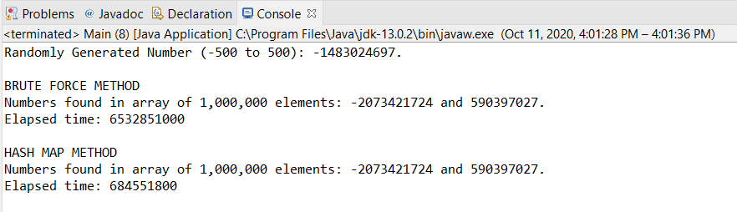

**BRUTE FORCE VS HASH MAP (100)**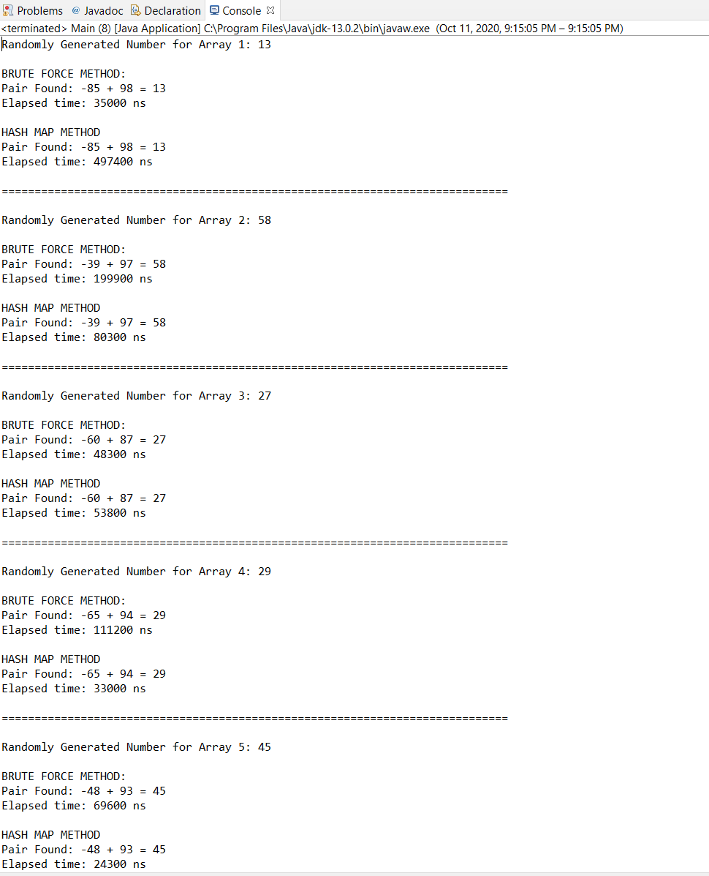

BINARY SEARCH TREE (100)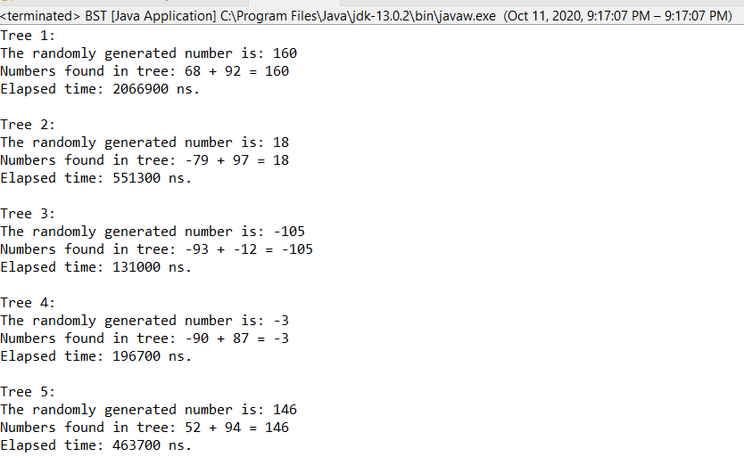s