FORTIFY – INSTRUCTION:

1) Install Fortify: Copy “Uninstall_HPESecurityFortifySCAandApps_17.10.exe” and right click as run as administrator.

Follow up the instruction “SCA 17.1 installation.docx”

2) Install Eclipse: Copy “eclipse-jee-indigo-SR2-win32-x86_64” from DDDTools([\\10.100.112.32](\\\\10.100.112.32) (Y):\Included to DDD local to install.

From Eclipse tool to add fortify tab:

Copy all jar file from C:\Program Files\HPE_Security\Fortify_SCA_and_Apps_17.10\plugins\eclipse\plugins

To C:\Program Files\eclipse\plugins

3) Load FAS RELEASE 5.3: From Eclipse tool, from File🡪New🡪Project-🡪Java Project (Local: C:\BRANCHES_SVN_5_3\src\NX-folio\src\main)

4) From Eclipse Tool: Select BRANCHES_SVN_5_3 first, from Fortify tab 🡪Analyze Project (Take a while).

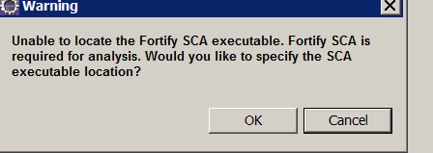

Click Ok

Go to C:\Program Files\HPE_Security\Fortify_SCA_and_Apps_17.10\bin\**sourceanalyzer.exe**

Click Open

5) When complete Scanning in Eclipse tool, go to C:\BRANCHES_SVN_5_3\src\NX-folio\src\main\bin

See the file “BRANCHES_SVN_5_3_scan.fpr”

6) Open Internet Explorer: USR <http://sdczht039d.dev.tsa.dhs.gov:8080/ssc/login.jsp#/>

User name: [binh.nguyen@tsa.dhs.gov](mailto:binh.nguyen@tsa.dhs.gov); qazQAZ12!@

From below Logout Binh on the right top side, select 4.30 UI

Select 4.30 UI-→Project FAS – 5.3 -→Artifact tab-→(loading project): C:\BRANCHES_SVN_5_3\src\NX-folio\src\main\bin\BRANCHES_SVN_5_3_scan.fpr

Click upload artifact.

See below:

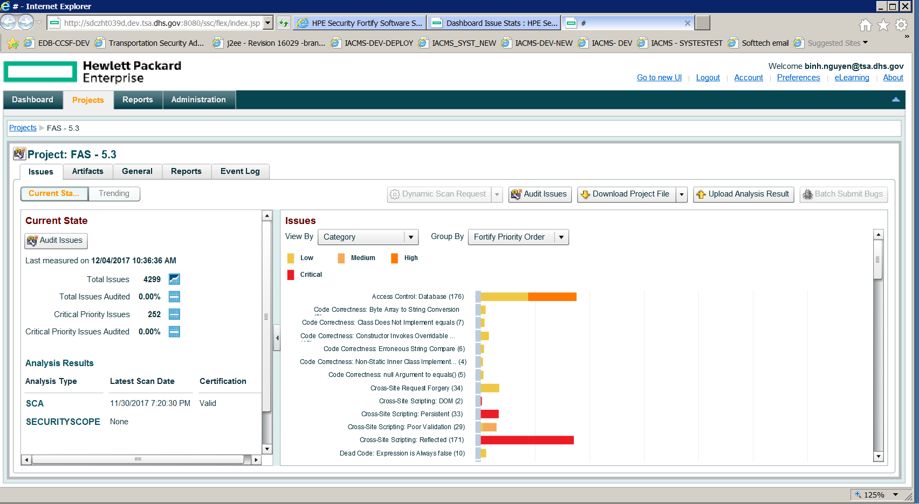

Click on Audit Issues:

