**MINISTRY OF EDUCATION AND TRAINING**

**FPT UNIVERSITY**

Capstone Project Document

**Vietnamese Sign Language Recognition**

|  |  |
| --- | --- |
| **Group 05** | |
| **Group members** | Nguyễn Hữu Kỳ Long – Team leader – SE60984  Nguyễn Đình Tân – Team member – SE61115  Nguyễn Xuân Ý – Team member – SE60869  Lê Phương Bình – Team member – SE61049 |
| **Supervisor** | Mr. Đỗ Đức Minh Quân |
| **Ext. Supervisor** | N/A |
| **Capstone Project code** | EPS |

-Ho Chi Minh City, 31/05/2015-

*This page is intentionally left blank*

# Table of Contents

Table of Contents 3

Definitions, Acronyms, and Abbreviations 4

A. Report No. 3 Software Requirement Specification 5

1. User Requirement Specification 5

2. System Requirement Specification 5

2.1 External Interface Requirement 5

2.2 System Overview Use Case 6

2.3 List of Use Case 6

3. Software System Attribute 12

3.1 Usability 12

3.2 Reliability 12

3.3 Availability 12

3.4 Security 13

3.5 Maintainability 13

3.6 Portability 13

3.7 Performance 13

**List of Figures**

Figure 1: System Overview Use Case 6

Figure 2: Translate sign use case diagram 7

# Definitions, Acronyms, and Abbreviations

|  |  |
| --- | --- |
| **Name** | **Definition** |
| VSLR | Vietnamese Sign Language Recognition |
|  |  |
|  |  |
|  |  |

# Report No. 3 Software Requirement Specification

## User Requirement Specification

*The system is not only reserved for mute person but also everyone who wants to learn sign language. Therefore, we have determined the requirement from these users:*

* Recognizing his or her hand signs to text and sound: users want devices that can recognize exactly their hand signs. Then, the device must show recognition results via text on screen and emit pronunciation of this word via speaker.
* Learning the way expressing hand signs: there still is a lots of hand signs that users do not know exactly, they want a device that can help them practice these signs. The system should have images which can describe clearly the way expressing hand sign for user can follow. In addition, the system should have practice function for user practice.
* Controlling the system by hand gesture: users want to perform the operations of the system through his or her hand gesture without electricity devices.
* The system is portable: Users can easily move the system. They expect the system can work at many places, and it still works during a power outage.
* System's power must be controlled: Users can know the remaining battery capacity to monitor the use of equipment. Moreover, they can charge the battery when the battery is low.
* System should be easy to control the hardware: Users can turn on/off the system safely without prejudice to the durability of the equipment.

## System Requirement Specification

### External Interface Requirement

External interface is concerned with designing interactive products to support the way people communicate and interact in their everyday and working lives. The products must be usability means easy to learn, effective to use and provide an enjoyable experience.

#### User Interface

* The GUI should be simple, clear, intuitive, and reminiscent.
* The interface is accessible, easy to use, and efficient.
* The interface should meet some criterias such as direct manipulation, device actions, information processing approach, visual features, …
* Each screen has fully instructions of the function implementation. Besides that, it still provides error, success, or implementation notification.

#### Hardware Interface

* The system must design hardware interface similar to the standard electricity system for anyone can use.
* Providing fully devices of a portable system.
* The system need to be designed suitable for capturing the hands with a appropriate height, and a width for people can watch the LCD.
* The provided devices should be easy to replace.
* Electricity devices should be packaged in the safety way.

#### Software Interface

* Linux GUI for Raspbian Operating System.
* The interface must be responsive for LCD 7-inch with the resolution 1024 * 600.

### System Overview Use Case

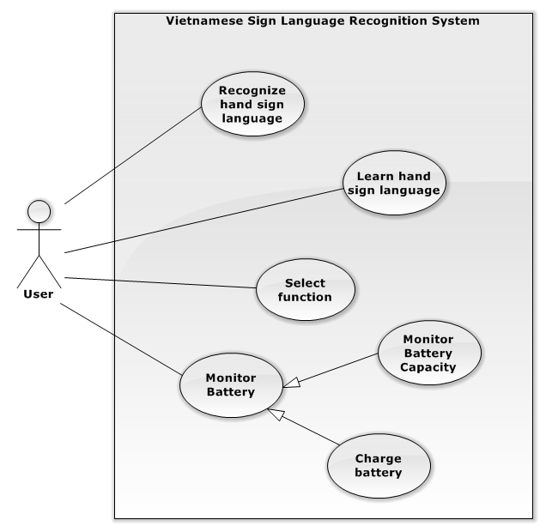

Figure 1: System Overview Use Case



### List of Use Case

#### Select Function

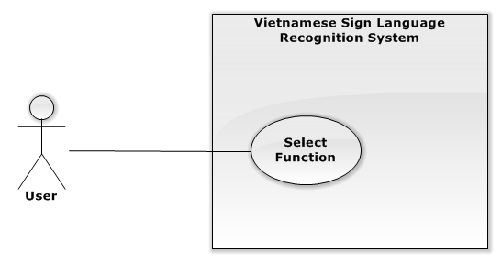

Figure 2: Select Function use case diagram

**Use Case Specification**

|  |  |  |  |  |  |
| --- | --- | --- | --- | --- | --- |
| **USE CASE -1 SPECIFICATION** | | | | | |
| **Use-case No.** | VSLR001 | **Use-case Version** | | | 1.0 |
| **Use-case Name** | Select Function | | | | |
| **Author** | Nguyễn Hữu Kỳ Long | | | | |
| **Date** | 31/05/2015 | | **Priority** | High | |
| **Actor**   * User   **Summary**   * The use case describes the way selecting the system functions.   **Goal**   * Select the desired function by the hand gesture.   **Triggers**   * User turns on the system or back from the function implementation interfaces.   **Preconditions**   * N/A   **Post Conditions**   * **On Success**: The selected function interface will be shown.   **Main Success Scenario**   |  |  |  | | --- | --- | --- | | Step | Actor Action | System Response | | 1 | User turns on the system by switch button. | - The system shows images captured by camera continuously and a notification requiring users move out of the captured camera area: “Người dùng vui lòng di chuyển ra khỏi vùng camera đang theo dõi”.  - At the same time, the system shows the processing time counted down by seconds under notifications “Người dùng vui lòng di chuyển ra khỏi vùng camera theo dõi”. The time interval is 5 seconds.  - After 5 seconds, the system shows notification requiring users show the hands into the hand shape drawn on the screen with the correct shape: “Vui lòng điều chỉnh bàn tay của bạn vào vùng bàn tay được hiển thị trên màn hình LCD”. | | 2 | User adjusts the hands into the hand shape shown on the LCD screen.  [Alternative No.1] | - The system shows images captured by camera continuously.  - The system shows the processing time counted down by second under notifications “Vui lòng điều chỉnh bàn tay của bạn vào vùng bàn tay được hiển thị trên màn hình LCD”. The time interval is 5 seconds.  - After 5 seconds, the system shows black and white images analyzed from captured images continuously and a notification requiring users show the “testing” hand gesture displayed on the screen “Vui lòng điều chỉnh bàn tay theo kí hiệu bàn tay như hình bên”. | | 3 | User shows the “testing” hand sign through camera | - The system shows hand images analyzed from captured images continuously.  - The system shows the processing time counted down by second under notifications “Vui lòng điều chỉnh bàn tay của bạn vào vùng bàn tay được hiển thị trên màn hình LCD”. The time interval is 3 seconds. | | 4 | The system recognized the “testing” hand sign from user after 3 seconds. | - After 3 seconds, the system shows the function selection interfaces containing an instruction image and black and white images analyzed from captured images continuously.  - The system shows notifications “Hãy chọn chức năng mong muốn bằng cách đưa ký hiệu hình bên vào vùng chức năng đó”.  [Alternative No.2] | | 5 | User shows the “selecting” hand into the desired function area. | - The system shows the selected function interface. |   **Alternative Scenario**   |  |  |  | | --- | --- | --- | | No | Actor Action | System Response | | 1 | User does not move the hands into the hand shape or show the hands incorrectly with the hand shape. | - The system will stop time countdown temporarily and show the warning notification “Hệ thống không tìm thấy được bàn tay của bạn trên khung hình tay!” | | 2 | The system can not recognize the hand. | - After 3 seconds, the system shows a notification “Vui lòng điều chỉnh phông nền. Hình ảnh thu được không thể nhận dạng.” in 5 seconds.  - After 5 seconds, the system backs to  Step No.1 |   **Exceptions**   |  |  |  | | --- | --- | --- | | No | Actor Action | System Response | |  |  |  |   **Relationships**   * N/A   **Business Rules**   * N/A | | | | | |

#### Recognize Hand Sign Language

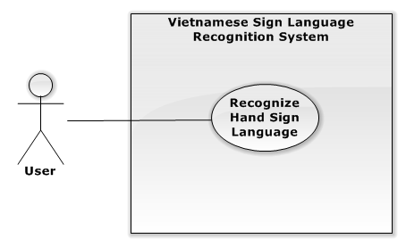

Figure 2: Recognize Hand Sign Language use case diagram

**Use Case Specification**

|  |  |  |  |  |  |
| --- | --- | --- | --- | --- | --- |
| **USE CASE -2 SPECIFICATION** | | | | | |
| **Use-case No.** | VSLR001 | **Use-case Version** | | | 1.0 |
| **Use-case Name** | Recognize Hand Sign Language | | | | |
| **Author** | Nguyễn Hữu Kỳ Long | | | | |
| **Date** | 31/05/2015 | | **Priority** | High | |
| **Actor**   * User   **Summary**   * The use case describes the way recognizing hand signs captured by camera.   **Goal**   * Recognize hand signs and translate them to the same meaning content with the kind of sound and text.   **Triggers**   * User shows the specific “select” hand sign on the “Recognize” function area to select “Recognize Hand Sign” function.   **Preconditions**   * The “Recognize Hand Sign” function is selected.   **Post Conditions**   * **On Success**: The translated content shows on the screen and speaker of LCD.   **Main Success Scenario**   |  |  |  | | --- | --- | --- | | Step | Actor Action | System Response | | 1 |  | - The system shows the “Recognize Hand Sign Language” interface containing the black and white images analyzed from captured images and a notification “Hệ thống sẽ lưu lại kết quả nhận dạng sau 3 giây”.  - The system shows the processing time counted down by second under notifications “Hệ thống sẽ lưu lại kết quả nhận dạng sau 3 giây”. The time interval is 3 seconds. | | 2 | User shows the hand sign through camera  [Alternative No.1] | - The system shows the mean of the current sign on text on the left of label “Kết quả hiện tại” and via speaker of LCD continuously.  - Every 3 seconds the main translated content will be updated and shown on the screen under the label “Nội dung”  - After 3 seconds, the system back to step No.1 |   **Alternative Scenario**   |  |  |  | | --- | --- | --- | | No | Actor Action | System Response | | 1 | User shows “end” hand sign. | - The system will show the whole content which was translated via text and speaker of LCD.  - After that, the system navigates to “Select Function” interfaces. |   **Exceptions**   |  |  |  | | --- | --- | --- | | No | Actor Action | System Response | |  |  |  |   **Relationships**   * N/A   **Business Rules**   * N/A | | | | | |

#### Learn Hand Sign

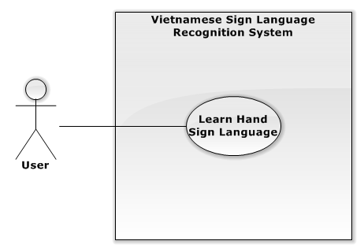

Figure 3: Learn sign use case diagram

**Use Case Specification**

|  |  |  |  |  |  |
| --- | --- | --- | --- | --- | --- |
| **USE CASE -3 SPECIFICATION** | | | | | |
| **Use-case No.** | VSLR002 | **Use-case Version** | | | 1.0 |
| **Use-case Name** | Learn Hand Sign | | | | |
| **Author** | Nguyễn Hữu Kỳ Long | | | | |
| **Date** | 31/05/2015 | | **Priority** | Medium | |
| **Actor**   * User   **Summary**   * The use case describes the way practising a hand sign.   **Goal**   * It is to help user training his or her hand gesture more accurately.   **Triggers**   * User the specific “select” hand sign on the “Learn Hand Sign” function area to select “Learn Hand Sign” function.   **Preconditions**   * The “Learn Hand Sign” function is selected.   **Post Conditions**   * **On Success**: The system shows the mean of the hand sign which is captured.   **Main Success Scenario:**   |  |  |  | | --- | --- | --- | | Step | Actor Action | System Response | | 1 | The “Learn Hand Sign” function is selected. | - The system shows the list of words supported in the system.  - The system shows the black and white binary images analyzed from captured images continuously on the interface. | | 2 | User shows the specific “select” hand sign through camera on the “up” function area.  [Alternative No.1] | - The system moves the selection to upper word in the list of words.  - The system shows the images describing the hand gesture of the selected word.  - The system shows a notification “Hãy giơ kí hiệu bàn tay của bạn để kiểm tra” | | 3 | User shows the hand gesture through camera.  [Alternative No.2] | - The system return the recognized result text on the screen and sound via speaker of LCD continuously. |   **Alternative Scenario**   |  |  |  | | --- | --- | --- | | No | Actor Action | System Response | | 1 | User shows the specific “select” hand sign through camera on the “down” function area. | - The system moves the selection to lower word in the list of words.  - The system shows the images describing the hand gesture of the selected word.  - The system shows a notification “Hãy giơ kí hiệu bàn tay của bạn để kiểm tra” | | 2 | User shows the specific “end” hand sign through camera. | - The system nevigates to “Select Function” interfaces. |   **Exceptions:**   |  |  |  | | --- | --- | --- | | No | Actor Action | System Response | |  |  |  |   **Relationships**   * N/A   **Business Rules**   * N/A | | | | | |

#### Charge Battery

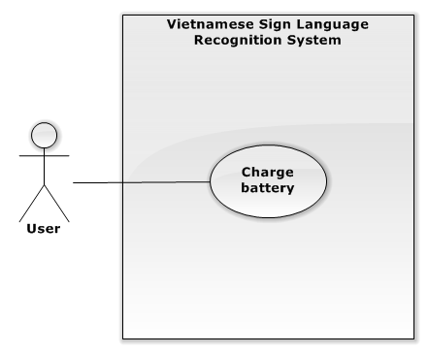

Figure 3: Learn sign use case diagram

**Use Case Specification**

|  |  |  |  |  |  |
| --- | --- | --- | --- | --- | --- |
| **USE CASE -4 SPECIFICATION** | | | | | |
| **Use-case No.** | VSLR003 | **Use-case Version** | | | 1.0 |
| **Use-case Name** | Charge Battery | | | | |
| **Author** | Lê Phương Bình | | | | |
| **Date** | 31/05/2015 | | **Priority** | High | |
| **Actor**   * User   **Summary**   * The use case describes users how to know to charge battery.   **Goal**   * It is to help the system has enough power to operate.   **Triggers**   * User is connected battery charger with AC power source 220v.   **Preconditions**   * Has 220v electric source.   **Post Conditions**   * **On Success**: The charge battery will be shown led on the charge battery.   **Main Success Scenario:**   |  |  |  | | --- | --- | --- | | Step | Actor Action | System Response | | 1 | The system detects the battery is low. | - The system shows message “Pin yếu vui lòng tắt máy và cắm sạc cho hệ thống!”. | | 2 | - Users are connected the system with battery charger. | - The charge battery will shows led on the charge battery. |   **Alternative Scenario**   |  |  |  | | --- | --- | --- | | No | Actor Action | System Response | |  |  |  |   **Exceptions:**   |  |  |  | | --- | --- | --- | | No | Actor Action | System Response | |  |  |  |   **Relationships**   * N/A   **Business Rules**   * N/A | | | | | |

#### Monitor Battery Capacity

**Use Case Specification**

|  |  |  |  |  |  |
| --- | --- | --- | --- | --- | --- |
| **USE CASE - 5 SPECIFICATION** | | | | | |
| **Use-case No.** | VSLR004 | **Use-case Version** | | | 1.0 |
| **Use-case Name** | Monitor Battery Capacity | | | | |
| **Author** | Lê Phương Bình | | | | |
| **Date** | 31/05/2015 | | **Priority** | Medium | |
| **Actor**   * User   **Summary**   * The use case describes users how to know the remaining battery capacity to supply the system.   **Goal**   * It is to help user uses reasonable system.   **Triggers**   * User uses his or her look at the battery capacity LEDs.   **Preconditions**   * The system is on. * The battery capacity display circuit is activated.   **Post Conditions**   * **On Success**: Battery capacity display is shown at the battery capacity LEDs.   **Main Success Scenario:**   |  |  |  | | --- | --- | --- | | Step | Actor Action | System Response | | 1 |  | Battery capacity display is shown by led:   * 4 Led: Full * 3 Led: 75% * 2 Led: 50% * 1 Led: 25% * No Led: empty |   **Alternative Scenario**   |  |  |  | | --- | --- | --- | | No | Actor Action | System Response | | 1 |  |  |   **Exceptions:**   |  |  |  | | --- | --- | --- | | No | Actor Action | System Response | |  |  |  |   **Relationships**   * N/A   **Business Rules**   * N/A | | | | | |

## Software System Attribute

### Usability

The system should be designed for everyone can use easily in controlling and GUI operations.

#### Graphic User Interface

* The system musts show all instructions, notifications and operations in Vietnamese.

#### Usability

* User just needs to read the user manual which is enclosed with the system for using in the first time. The attached manual guide must be clear. User can read and do by themselves.

#### Hardware controlling

* User can control the device very easily as well as using any electronic device in the daily live.

### Reliability

* The database should be constructed on Vietnamese sign language.
* The system uses “Support Vector Machine” library to recognize hand sign language and OpenCV library to process image.
* The system is using Raspberry PI 2 to process which is popular board in the world.

### Availability

The system runs continuously about 3 hours with 2700mAh battery and 3.5V to 5V battery. That means it is safe to user.

### Security

N/A

### Maintainability

* Electronic devices in the system are common so when any electronic equipment, which is attached with the system, is out of ordered, it is so easy to change or to fix at any electronic store.
* The system can be extended in the future.

### Portability

* The system supplies the power source in which user can use for 7 hours without charging. In addition, the system also provides battery charger for users.
* The device should be designed as quite small and convenient.

### Performance

* The system uses Raspberry PI 2 with RAM 1GB as central unit processing, so that the system can recognize one hand sign in 1 to 3 seconds.