**MINISTRY OF EDUCATION AND TRAINING**

**FPT UNIVERSITY**

Capstone Project Document

**Vietnamese Sign Language Recognition**

|  |  |
| --- | --- |
| **Group 05** | |
| **Group members** | Nguyễn Hữu Kỳ Long – Team leader – SE60984  Nguyễn Đình Tân – Team member – SE61115  Nguyễn Xuân Ý – Team member – SE60869  Lê Phương Bình – Team member – SE61049 |
| **Supervisor** | Mr. Đỗ Đức Minh Quân |
| **Ext. Supervisor** | N/A |
| **Capstone Project code** | VSLR |

-Ho Chi Minh City, 06/01/2015-

*This page is intentionally left blank*

# Table of Contents

Table of Contents 3

List of Tables 3

List of Figures 3

Definitions, Acronyms, and Abbreviations 5

A. Report No. 5 System Implementation & Test 7

1. Introduction 7

1.1 Overview 7

1.2 Test Approach 7

2. Database Relationship Diagram 7

2.1 Physical Diagram 7

2.2 Data Dictionary 7

3. Performance Measurement 10

4. Test Plan 10

4.1 Features to be tested: 10

4.2 Features not to be tested: 10

5. System Testing Test Case 10

5.1 Storeowner Core Flow 12

5.2 Employee Core Flow 23

# List of Tables

Table 1: Definitions 5

# List of Figures

Figure 52: Physical Database Diagram 5

# Definitions, Acronyms, and Abbreviations

|  |  |
| --- | --- |
| **Name** | **Definition** |
| EPS | E-Printer Services |
| App | Application |
| OS | Operating System |
| Playstore | A Market where you can install an app for Android device. |

Table 1: Definitions

# Report No. 5 System Implementation & Test

## Introduction

### Overview

This section contains in detail of all necessary information about system implementation and testing of EPS System includes all test plans, test cases, test results and test environment.

### Test Approach

- Goal: To test the whole system based on the core flow.

- Method: System testing, Black box testing.

## Database Relationship Diagram

### Physical Diagram

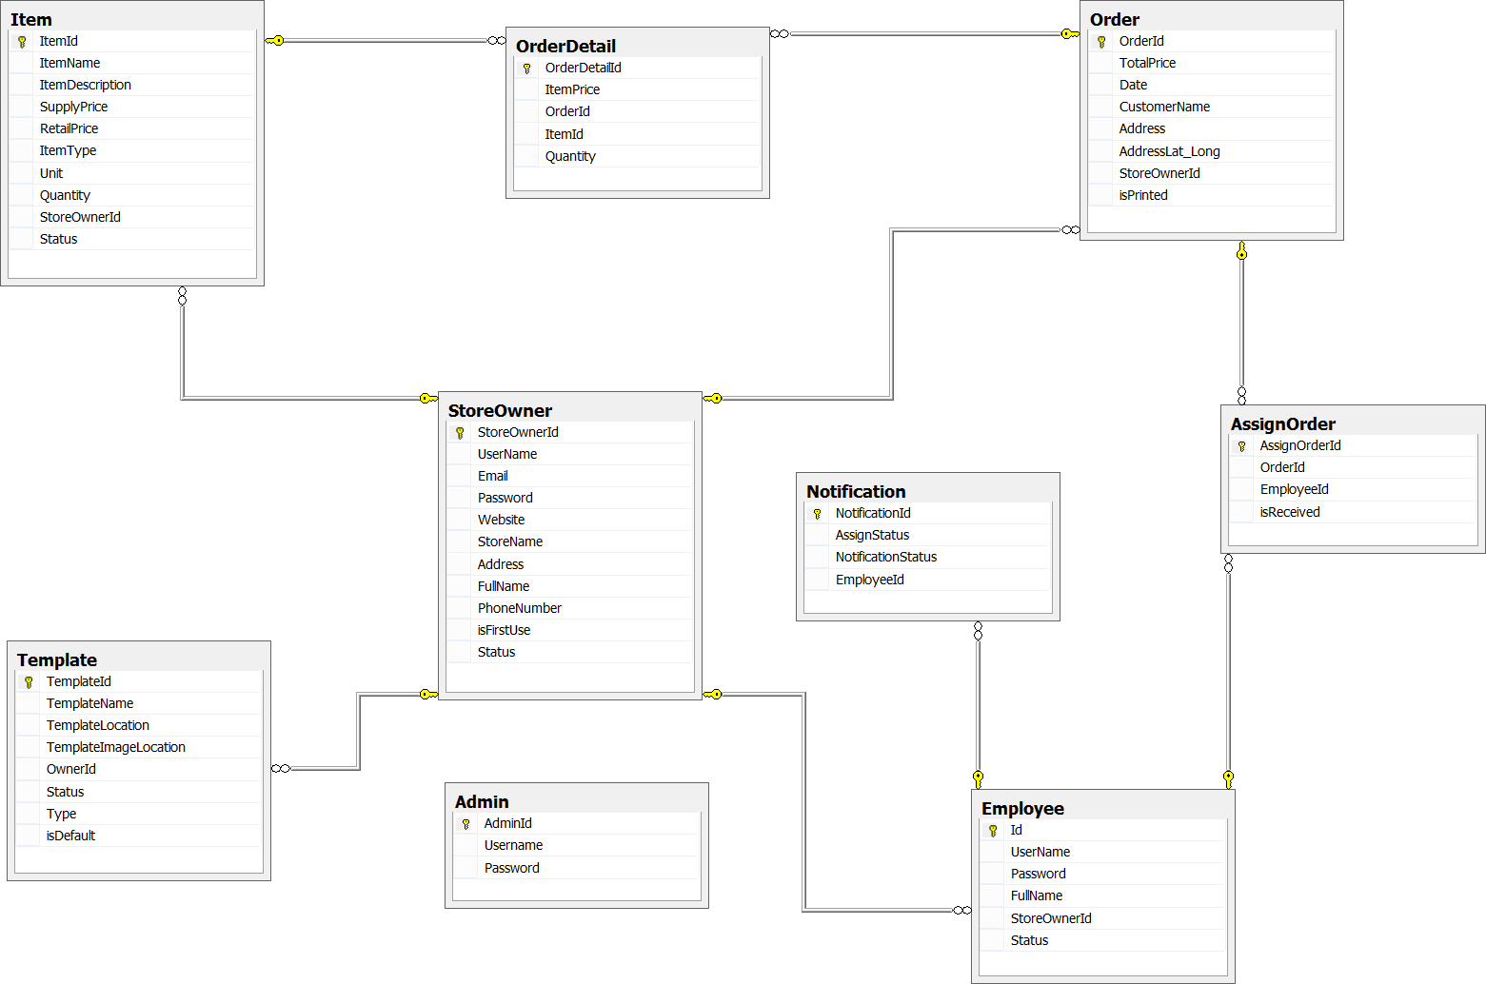Figure 52: Physical Database Diagram

### Data Dictionary

|  |  |
| --- | --- |
| **Entity Data dictionary: describe content of all entities** | |
| Entity Name | Description |
| Store Owner | Describe all storeowner profiles in the system. |
| Employee | Describe all employee profiles in the system. |
| Item | Describe all items stored in the system. |
| Template | Describe all templates available in the system. |
| Order | Describe all order of store in the system. |
| Order Detail | Describe all order detail in the system |
| Notification | Describe all notification of storeowner and employee in the system. |
| AssignOrder | Describe all assignments of orders to employee |

|  |  |  |  |  |
| --- | --- | --- | --- | --- |
| **Entity name** | **Attributes** | **Description** | **Domain** | **Null** |
| Store Owner | StoreOwnerId | Unique identifier of storeowner, auto increment. | int | No |
| UserName | Storeowner’s username. | nvarchar(50) | No |
| Email | Storeowner’s email address. | nvarchar(50) | No |
| Password | Storeowner’s password. | nvarchar(50) | No |
| Website | Storeowner’s website address. | nvarchar(50) | Yes |
| StoreName | Name of the store. | nvarchar(50) | No |
| Address | The address of storeowner. | nvarchar(100) | No |
| FullName | Full name of storeowner. | nvarchar(100) | No |
| PhoneNumber | Phone number of storeowner. | int | No |
| isFirstUse | Value to check whether storeowner log in for the first time or not. | bit | No |
| Status | Status of storeowner. | nchar(10) | No |
| Employee | Id | Unique identifier of employee, auto increment. | int | No |
| UserName | Employee’s username. | nchar(20) | No |
| Password | Employee’s password. | nchar(10) | No |
| FullName | Employee’s full name. | nvarchar(50) | Yes |
| StoreOwnerId | Id of storeowner | int | No |
| Status | Status of employee. | nchar(20) | No |
| Item | ItemId | Unique identifier of item, auto increment. | int | No |
| ItemName | Name of an item. | nvarchar(100) | No |
| ItemDescription | Description about an item. | nvarchar(500) | Yes |
| SupplyPrice | Supply price of item. | float | No |
| RetailPrice | Retail price of item. | float | No |
| ItemType | Type of item. | nvarchar(50) | No |
| Unit | Unit of an item. | nvarchar(50) | No |
| Quantity | Quantity of item in store. | int | No |
| StoreOwnerId | Id of storeowner | int | No |
| Status | Status of an item. | nchar(10) | No |
| Template | TemplateId | Unique identifier of template, auto increment. | int | No |
| TemplateName | Name of template. | nvarchar(50) | No |
| TemplateLocation | Location of template on server. | nvarchar(260) | No |
| TemplateImageLocation | Location of image template on server. | nvarchar(260) | No |
| OwnerId | Id of template’s owner | int | No |
| Status | Status of template. | nvarchar(20) | No |
| Type | Type of template. | nchar(10) | No |
| isDefault | Value to check whether template is a default template | bit | No |
| Order | OrderId | Unique identifier of order, auto increment. | int | No |
| TotalPrice | Total price of order. | float | No |
| Date | Date order made. | datetime | No |
| CustomerName | Name of the customer. | nvarchar(30) | No |
| Address | Address of customer. | nvarchar(100) | No |
| AddressLat_Long | Latitude and longitude of address. | varchar(100) | No |
| StoreOwnerId | Id of storeowner | int | No |
| isPrinted | Value to check whether the order is printed or not. | bit | No |
| OrderDetail | OrderDetailId | Unique identifier of orderdetail, auto increment. | int | No |
| ItemPrice | Price of an item in orderdetail. | float | No |
| OrderId | Id of order | int | No |
| ItemId | Id of item | int | No |
| Quantity | Quantity of items in order. | int | No |
| Notification | NotificationId | Unique identifier of notification, auto increment. | int | No |
| AssignStatus | Status of job assigned to employee | bit | No |
| NotificationStatus | Status of notification | bit | No |
| EmployeeId | Id of employee | int | No |
| AssignOrder | AssignOrderId | Unique identifier of assign order, auto increment. | int | No |
| OrderId | Id of Order | int | No |
| EmployeeId | Id of Employee | int | No |
| isReceived | Value to check whether the order is received or not. | bit | No |
| Admin | AdminId | Unique identifier of admin, auto increment. | int | No |
| Username | Username of admin | nvarchar(20) | No |
| Password | Password of admin | nvarchar(10) | No |

## Performance Measurement

**3.1 Clustering Performance**

Clustering is performed by running K Mean Algorithm which has complexity of : O(n * k * I * d)

* n : number of points
* k : number of cluster
* I : number of iteration
* d : number of attributes (3)

Clustering take almost the time of process that we can ignore the time needed to load data from database, digitalize data.

The speed of clustering will vary and increase dramatically when n increase. The purpose of this project is not about optimizing K-Mean Algorithm so it is accepted to let the process run till it completes. Moreover, the clustering is designed to run by staff, wait time is acceptable.

## Test Plan

We have two main test phases: Function test (Integration test) and System test.

For Integration test, we use the functional test. This kind of test shows us the working of each function right or wrong. We focus on the result of the function in different cases.

The System test check all the activities after setup such as: what the system do when it is turned on and if user do somethings, what will response. We create test case to check each function’s activity. Then, we observe and record the result.

### Features to be tested:

* Functional Testing:

+ Integration testing: Test all function on Raspberry Application and each external module

+ System testing: Test all function for Raspberry Application – external modules

- UI Testing: Test UI on Raspberry Application

### Features not to be tested:

* Hardware module: Raspberry Pi B2.

### Testing tools and environment

- Testing tools:

+ A raspberry board with connect to PC/Laptop running Linux OS

+ QT Creattor

+ Minicom on Raspberry

- Environment:

+ Some where with good light condition

## System Testing Test Case

5.1. Test on real device

5.1.1. Component testing

|  |  |  |  |  |  |  |
| --- | --- | --- | --- | --- | --- | --- |
| **ID** | **TEST CASE DESCRIPTION** | **PRE-CONDITION** | **TEST CASE PROCEDURE** | **EXPECTED OUTPUT** | **Result** | **Note** |
| CPN04 | Receive picture from camera | _Camera connect to Raspberry using Camera port. - Raspberry is alrealy installed camera driver - Connect to LCD | _ Open terminal on raspberry _ Type command "raspistill -o image.jpg" then press enter | _ LCD show a camera windows and image which is recorded by camera |  |  |
| CPN05 | Receive signal from LED | _LED 1W connect to Raspberry using GPIO port | _Turn on terminal on Raspberry _ Type in "sudo ./testled.c" then ENTER - Press any button on keypad | Raspberry receive signal and show pressed key on terminal |  |  |
| CPN06 | Show screen on LCD | _LCD connect to Raspberry using HDMI port | _Turn on LCD  _ Do something on Raspberry | See your activities on LCD screen. |  |  |

5.1.2. Integration test

|  |  |  |  |  |  |  |
| --- | --- | --- | --- | --- | --- | --- |
| **ID** | **TEST CASE DESCRIPTION** | **PRE-CONDITION** | **TEST CASE PROCEDURE** | **EXPECTED OUTPUT** | **Result** | **Note** |
| SLFROR01 | Controlling System | Raspberry is connected to: - LED 1W using GPIO PORT - CAMERA using GPIO PORT _ LCD using HDMI port | _ Press power button on | _ Interface getting avarage background color appeared on LCD |  |  |
| _ Guest give the background and wait 5 seconds | _ Interface getting avarage hand color appeared on LCD |  |  |
| _ Guest give hand and wait 5 seconds | _ Menu of funtion appeared on LCD |  |  |
| _ Guest give hand signs | _ Interface of funtion guest chosen appeared on LCD |  |  |
|  |
| SLFROR02 | Translate Signs | Raspberry is connected to: - LED 1W using GPIO PORT - CAMERA using GPIO PORT _ LCD using HDMI port | _ Guest give hand signs | _ Show the current content |  |  |
|  |  |  |  |
|  |  |  |  |
|  |  |  |  |
|  |  |  |  |
|  |  |  |  |
|  |  |  |  |
|  |  |  |  |
| SLFROR03 | Learn Signs | Raspberry is connected to: - LED 1W using GPIO PORT - CAMERA using GPIO PORT _ LCD using HDMI port | _ Guest chose the sign want to learn | _ Show the image explaining the way to take hand gesture |  |  |
| _ Guest give the hand sign | _ Show the meaning of the current hand gesture |  |  |
| _ Guest give the hand sign | _ Navigate to the screen for seraching others |  |  |
|  |  |  |  |
|  |  |  |  |
|  |  |  |  |
|  |  |  |  |
|  |  |  |  |
|  |  |  |  |