**MINISTRY OF EDUCATION AND TRAINING**

**FPT UNIVERSITY**

Capstone Project Document

**Vietnamese Sign Language Recognition**

|  |  |
| --- | --- |
| **Group 05** | |
| **Group members** | Nguyễn Hữu Kỳ Long – Team leader – SE60984  Nguyễn Đình Tân – Team member – SE61115  Nguyễn Xuân Ý – Team member – SE60869  Lê Phương Bình – Team member – SE61049 |
| **Supervisor** | Mr. Đỗ Đức Minh Quân |
| **Ext. Supervisor** | N/A |
| **Capstone Project code** | VSLR |

-Ho Chi Minh City, 24/05/2015-

*This page is intentionally left blank*

# Table of Contents

Table of Contents 3

List of Tables 3

Definitions, Acronyms, and Abbreviations 4

F. Report No. 6 Software User’s ManualProblem Definition 5

1. Installation Guide 5

1.1 Setting up environment 5

1.2 Deployment at Raspberry PI 2 18

2. User Guide 18

2.1 Instructions for use in hardware 18

2.2 Instructions for use in software 22

# List of Tables

**No table of figures entries found.**

# Definitions, Acronyms, and Abbreviations

|  |  |
| --- | --- |
| **Name** | **Definition** |
| VSLR | Vietnamese Sign Language Recognition |
|  |  |
|  |  |
|  |  |

# F. Report No. 6 Software User’s ManualProblem Definition



## Installation Guide

### Setting up environment

The following requirements in hardware and software must be set up to system can works.

#### Hardware requirements

- Raspberry Pi 2 Kit is used to process as central processing unit

- Micro SD card 16GB is used to setup Raspbian operating system.

- Logitech C270 webcam is used to capture images.

- 7 INCH TFT COLOR MONITOR LCD is used to show the interface of application.

- LIPO 3 cells battery (12V - 2.2 A) is power source of the system.

- UNI regulator board: LM2576ADJ - Board

- B3AC compact charger is charger of LIP0 3 cells battery.

- Monitor Battery Capacity circuit which is constructed by the system.

- HDMI to HDMI cable is connection between Raspberry PI 2 Kit and LCD.

- 1 LED (1 W) is used to balance light.

#### Hardware connection

##### For LCD

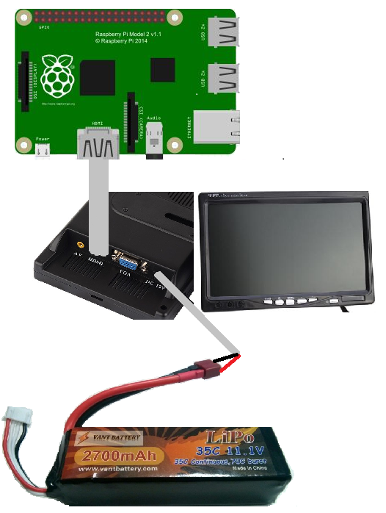

Figure 1: Connection LCD to raspberry and Lipo Battery

Connect Lipo battery: plug to DC 12V port on LCD

Connect to Raspberry: plug HDMI cable from HDMI port on LCD to HDMI port on Raspberry

##### For Monitor Battery Capacity Circuit

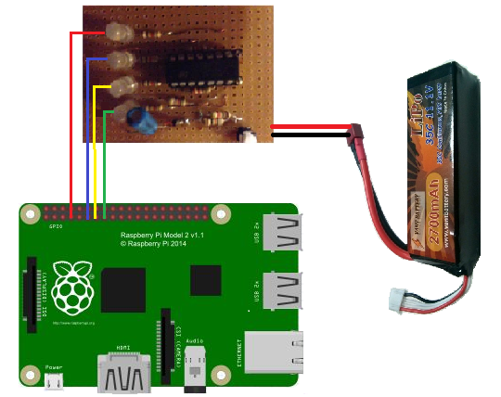

**Figure 2: Connection Monitor Battery Capacity Circuit to raspberry and Lipo Battery**

Connect to Lipo Battery : Red wire to anode (+) of battery (red wire ). Black wire to cathode (-) of battery (black wire).

Connect to Raspberry: 4 wires connect to PIN No.7, PIN No.11, PIN No.13, PIN No.15

##### For Webcam

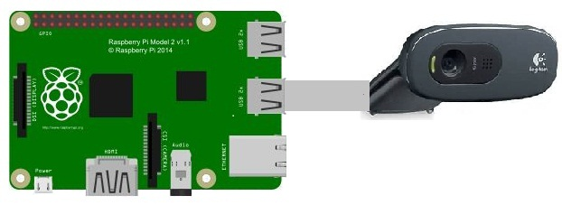

**Figure 3: Connection Webcam to raspberry**

Connect to Raspberry: plug wire of Webcam to USB port on Raspberry

##### Power for Raspberry

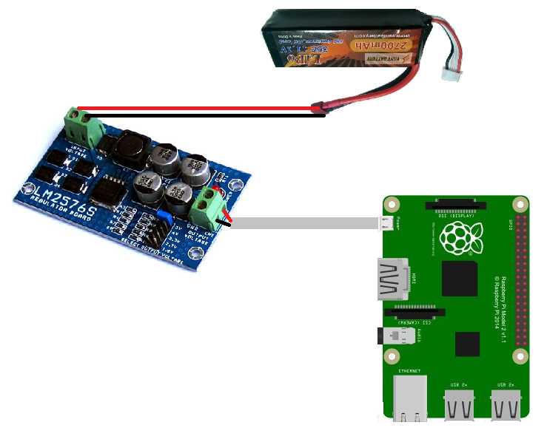

**Figure 4: Connection LM2596ADJ-Board to raspberry and battery**

Connect LM2596ADJ-Board to Lipo Battery: connect anode (+) of battery (red wire) to Vccin (+) Pin of LM2596ADJ-Board, connect cathode (-) of battery (black wire) to Vccin (-) Pin of LM2596ADJ-Board

Connect LM2596ADJ-Board to Raspberry: connect to Micro USB port of Raspberry.

##### For switch “Shutdown application”

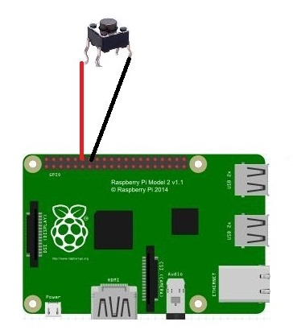

**Figure 5: Connection switch “Shutdown Application” to raspberry**

Connect to Raspberry : connect to Pin No 14, Pin No 16 on Raspberry.

##### For Led 1W

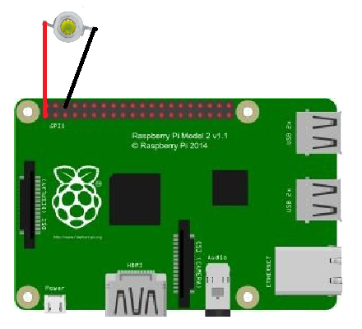

**Figure 6: Connection Led 1W to raspberry**

Connect anode (+) of Led to Pin No. 1 of raspberry, cathode (-) of led to Pin No. 6 of raspberry

#### Configure Raspberry PI 2

##### Install operating system

* Download RASPBIAN operating system from this webpage <https://www.raspberrypi.org/downloads/>
* Install operating system images by following instructions in this webpage <https://www.raspberrypi.org/documentation/installation/installing-images/README.md>

##### Make Raspberry PI 2 use full solution of the monitor

* Follow the instructions in this webpage <http://www.webtechgadgetry.com/2013/12/make-raspberry-pi-use-full-resolution-monitor/>

##### Configure LCD settings

Prevent the monitor screen from going to blank

* Firstly, install xset, a lightweight application that controls power-saving settings.

Execute below command in terminal

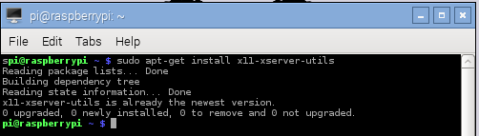

* Enable to configure power-saving setting at the time Raspberry PI 2 starts up.

Execute below command to edit “autostart” file containing commands which will be executed at startup.

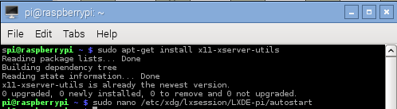

Comment line @xscreensaver -no-splash by adding # in the start line.

Add settings to this file by adding below lines at the end of file

@/usr/bin/xset s off

@/usr/bin/xset s noblank

@/usr/bin/xseet -dpms

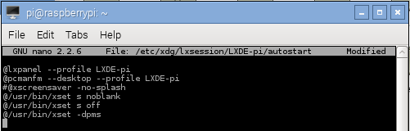

* Ctrl + X and then type Y to save this file.

##### Configure webcam settings

Disable auto balancing exposure and light

* Firstly, we need to install uvcdynctrl, a application controls webcam settings.

Execute below command to install uvcdynctrl

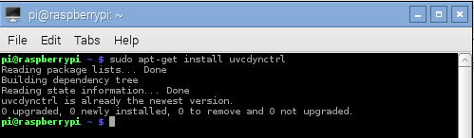

* Change setting exposure and auto_white_balance to manual.

Execute below command to edit “autostart” file containing commands which will be executed at startup.

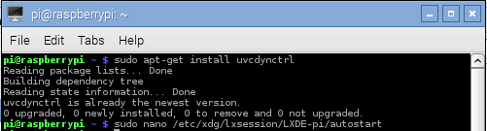

Add settings to this file by adding below lines at the end of file

@/usr/bin/uvcdynctrl -s “Exposure, Auto” 1

@/usr/bin/uvcdynctrl -s “White Balance Temperature, Auto” 0

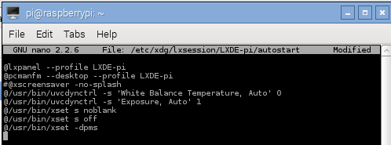

Press Ctrl + X and type Y to save this file

##### Enable Raspberry PI to run application automatically at startup

* Enable Raspberry PI to auto start the desktop

**Step 1**: Open a terminal and run below command to open Raspberry PI configuration

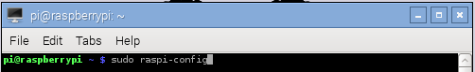

**Step 2**: Select Enable Boot to Desktop/Scratch from the menu and press Enter

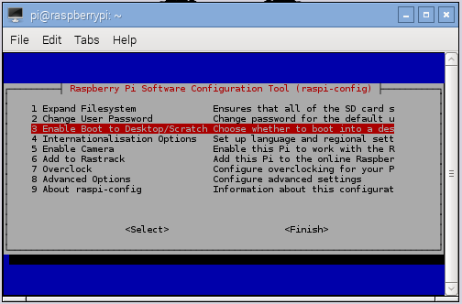

**Step 3**: Select Desktop Login as user pi at the Graphical Desktop.

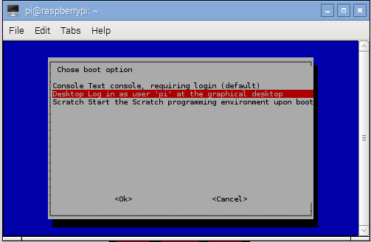

**Step 4**: Select <Finish> and Enter, then select <Yes> to reboot.

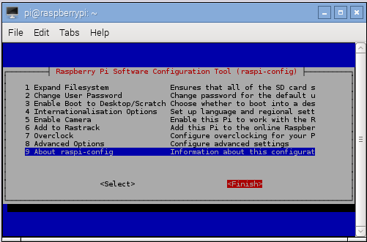

* Enable the root user can run application at startup

**Step 1**: Open terminal and execute command “sudo nano /etc/xdg/lxsession/LXDE-pi/autostart” to edit “autostart” file containing commands which will be executed at startup  
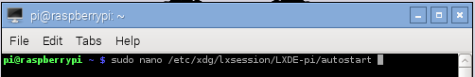

**Step 2**: Add above lines to this file

@/usr/bin/xhost +

@/usr/bin/xhost + localhost

@/usr/bin/sudo /home/pi/SRC/MainCapstoneProject-build/MainCapstoneProject &  
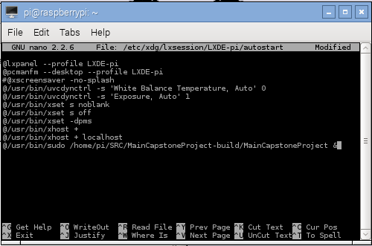

**Step 3**: Press Ctrl + X and type Y to save this file.

#### Software requirements

* Install Opencv library version 2.4.9 on Raspberry PI 2 by following the instructions in this webpage <http://daveaubin.com/index.php/how-to-build-and-install-opencv-2-4-9-on-raspberry-pi/>
* Install bcm2835 library version 1..45 on Raspberry PI 2

**Step 1**: Download bcm2835 from <http://www.airspayce.com/mikem/bcm2835/bcm2835-1.45.tar.gz>

**Step 2**: Install bcm2835 library by following the steps at “Installation” section in this webpage <http://www.airspayce.com/mikem/bcm2835/>

**Step 3**: Enable Raspberry PI 2 can work with bcm2835 library by  following the steps at “Raspberry Pi 2 (RPI2)” section in this webpage <http://www.airspayce.com/mikem/bcm2835/>

* Install espeak library version 1.48.04 on Raspberry PI 2

**Step 1**: Install development library for portable audio I/O from this link

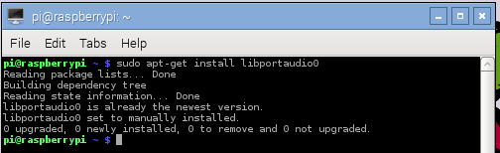

**Step 2**: Download espeak library version 1.48.04 from this link <http://sourceforge.net/projects/espeak/files/espeak/espeak-1.48/espeak-1.48.04-source.zip> and uncompress it.

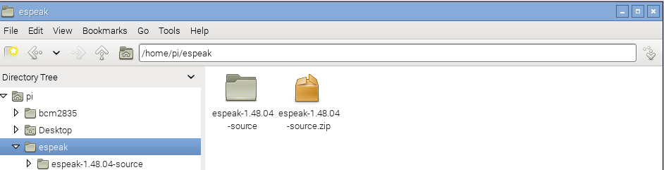

**Step 3**: Execute the following commands to install espeak library

cd espeak-1.48.04-source/src

make

sudo cp espeak speak /usr/bin

cd ../

sudo cp -r espeak-data /usr/share

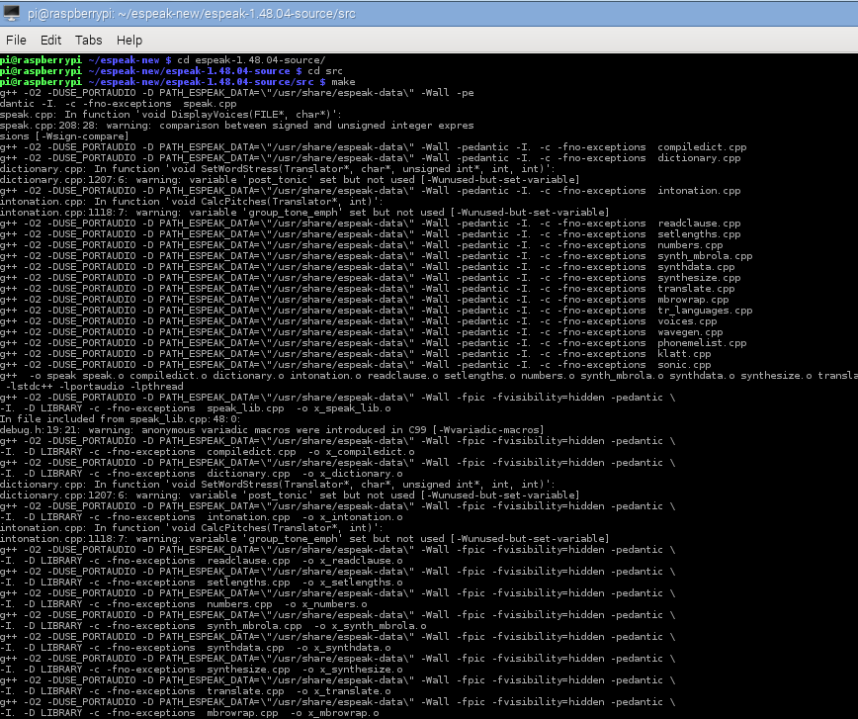

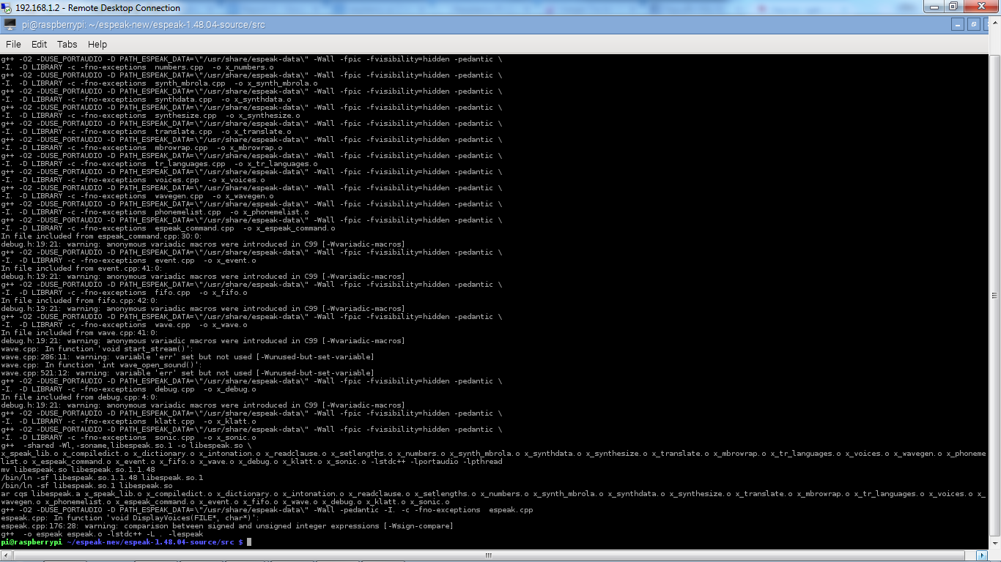

- Install QT 4 on Raspbbery PI 2 by following the instructions at “Description” section in this webpage http://www.engineersgarage.com/embedded/raspberry-pi/how-to-install-qt-in-raspberry-pi#

### Deployment at Raspberry PI 2

**Step 1**: Prepare a deploy.zip file which contains one “Database” folder and one “MainCapstoneProject” folder on the laptop.

2.png

**Step 2**: Copy this .zip file to Raspberry PI 2 at location /home/pi/SRC via scp

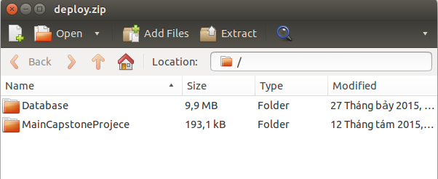

**Step 3**: Uncompress this file by the following command on Raspbbery PI 2

cd /home/pi/SRC

unzip project.zip

**Step 4**: Reboot Raspberry PI

## User Guide

### Instructions for use in hardware

#### Turn On System

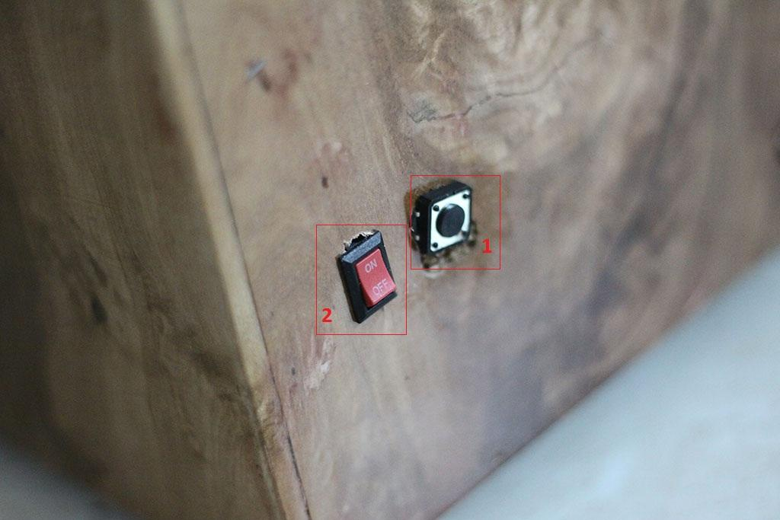

Figure 7: Right side of the box

|  |  |
| --- | --- |
| **Step** | **Description** |
| 1 | Press switch “2” |

#### Shutdown Application



Figure 8: Right side of the box

|  |  |
| --- | --- |
| **Step** | **Description** |
| 1 | Press switch “1” |

#### Monitor Battery Capacity by Led Indicator

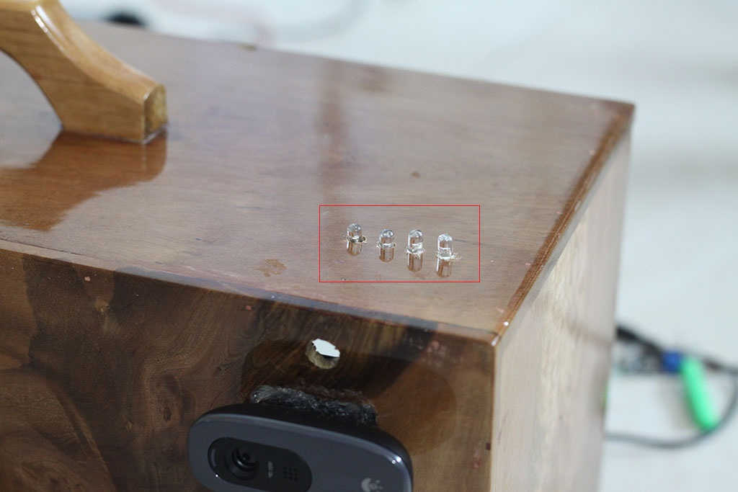

Figure 9: Above side of the box

|  |  |
| --- | --- |
| **Step** | **Description** |
| 1 | Watch number of led bright to know battery capacity |

#### Show hand sign, view application interface

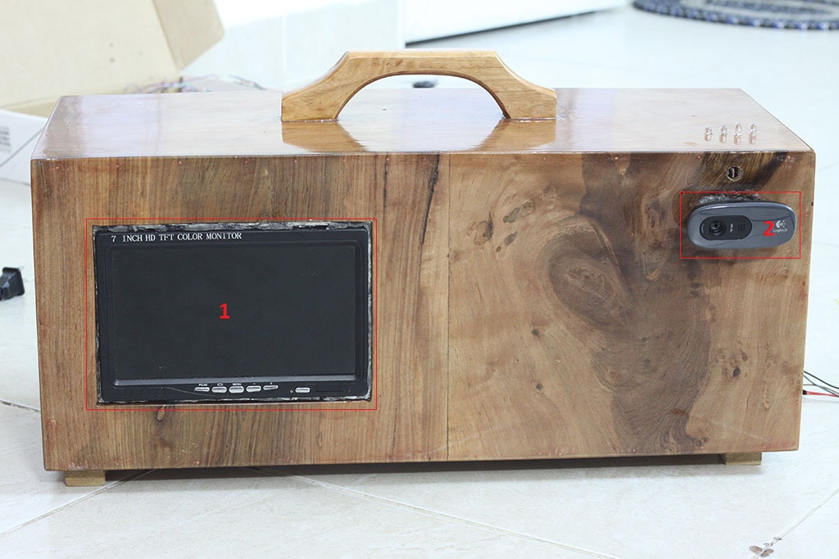

Figure 10: Front side of the box

|  |  |
| --- | --- |
| **Step** | **Description** |
| 1 | User show hand sign front of webcam (1) |
| 2 | User view application’s interface on LCD (2) |

### Instructions for use in software