**Pinkham Notch Plots**

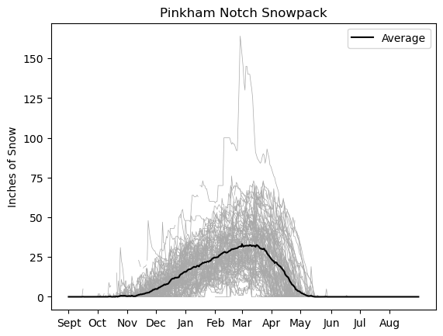

Number of days with the snow depth above a certain threshold. When the threshold is 10 in. there isn’t any substantial trend in the last 40 years or so. However, when the threshold is increased, the decline becomes much more apparent. Note the changing y axis scales.

|  |  |
| --- | --- |
|  |  |
|  |  |
|  |  |

We can look at changes in how variable the snowpack is over the course of the season using a metric called total harmonic distortion (THD). This is defined as

$$\text{THD}=\frac{\sqrt{\sum_{i=2}^{N}{V_{i}^{2}}}}{V_{1}}$$

where $V_{i}$ is the amplitude of the ith component of the Fourier decomposition of the snow depth time series. $V_{0}$ would be the annual mean snow depth, and is not included here. THD tells us how much variability there is in the snowpack over the course of the season. A snowpack that smoothly builds up until early April and then declines (line the climatology does) will have a lower THD than a snowpack subject to many melt events throughout the winter.

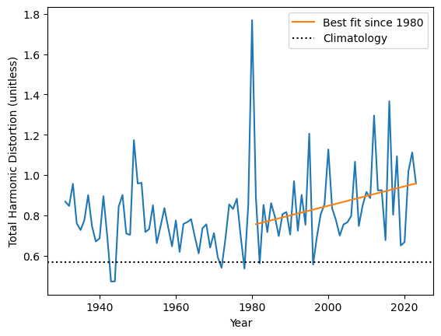

Since 1980, there has been a significant (p value of 0.028) increase in THD for the Pinkham Notch Snowpack. This suggests that the snow depth has more ups and downs throughout the winter season with passing years.

**Mount Mansfield Plots**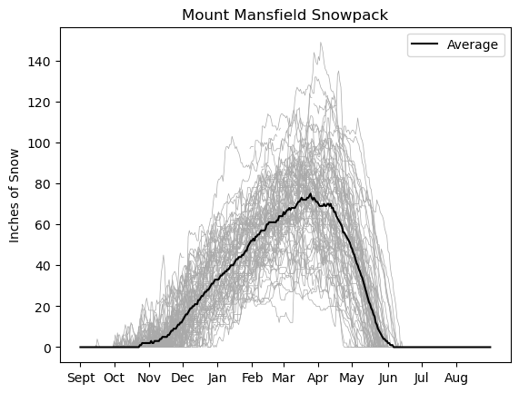

|  |  |
| --- | --- |
|  |  |
|  |  |
|  |  |

These are the same plots as above, but for Mount Mansfield. Note that in the last 20 years or so there has been a decline in the number of days above all thresholds. However, this is on the heels of a dip and then increase of days above the threshold that occured between 1990 and 2000.

We also look at THD for Mount Mansfield: 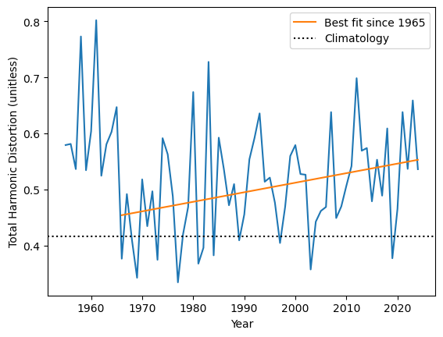

There is a significant (p value 0.014) upward trend since the mid 60s, again suggesting that the snowdepth has become more variable over the winter.