Submitted By: Nishant Kumar 2022EPB1240

EE301 Analog Circuits: Course Project

Course Instructor: Mahendra Sakare

Aim:

Design of cascode amplifier and cascode current mirror in schematic and layout using LTspiceand Magic in 180 nm (supply 1.8 V) technology and only schematic of cascode amplifier, beta multiplier and cascode current mirror in 22 nm (supply 0.8 V) technology node to see the effect of lowering the technology node.

**LT Spice**

**For 180nm**

**BETA MULTIPLIER CIRCUIT**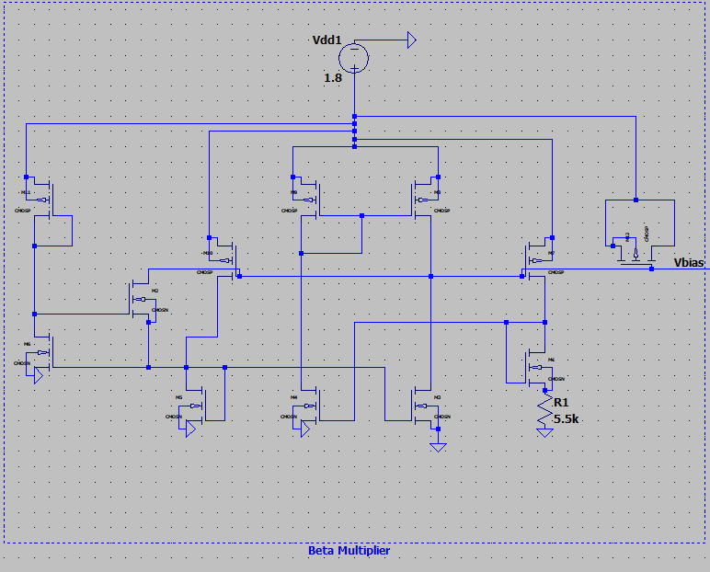

**Vbias**

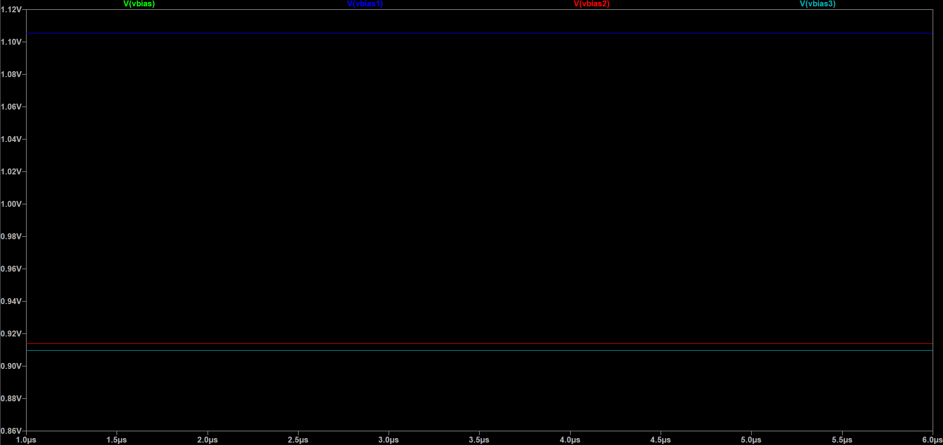Vbias=1.2239V

Vbias1=1.1053V

Vbias2=0.9135V

Vbias3=0.9094V

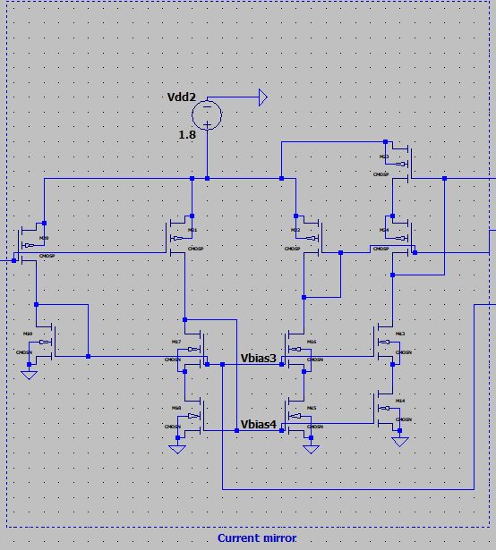**Cascode Current Mirror:**

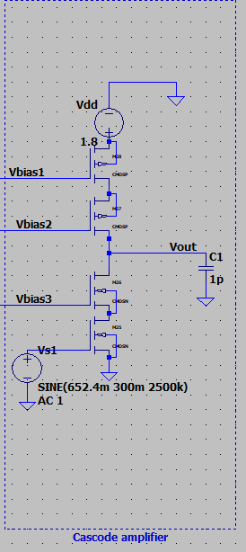**Cascode Amplifier**

**Whole Circuit**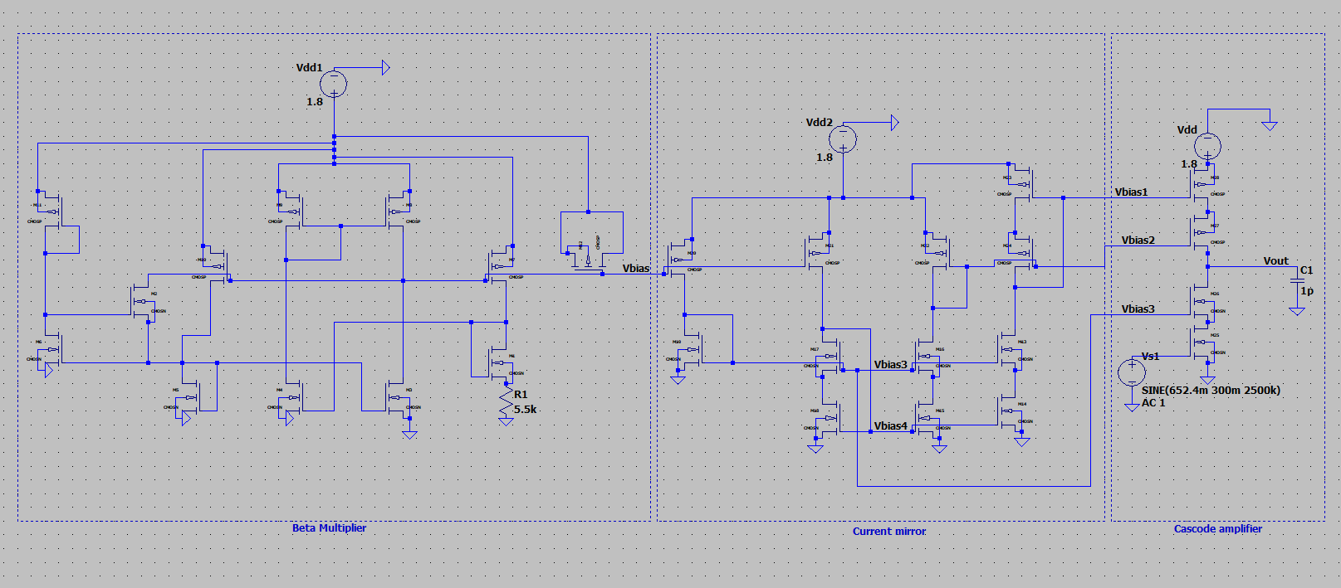

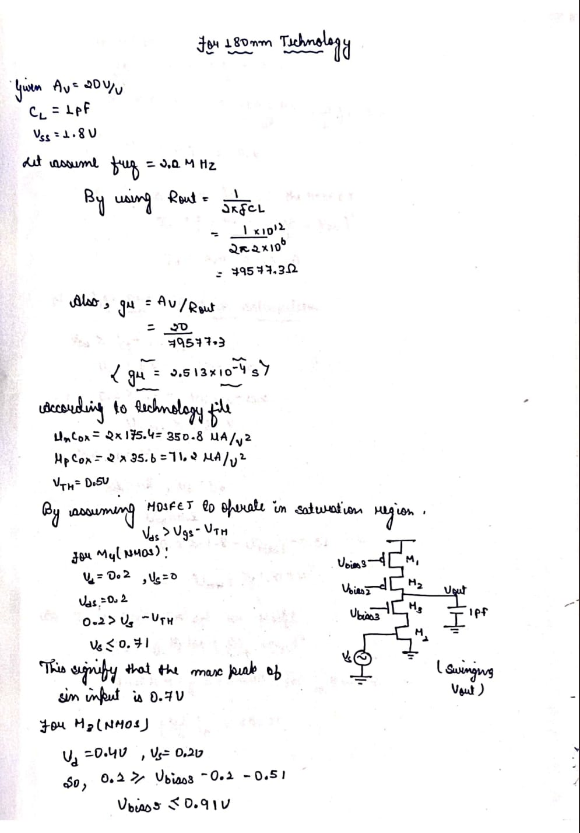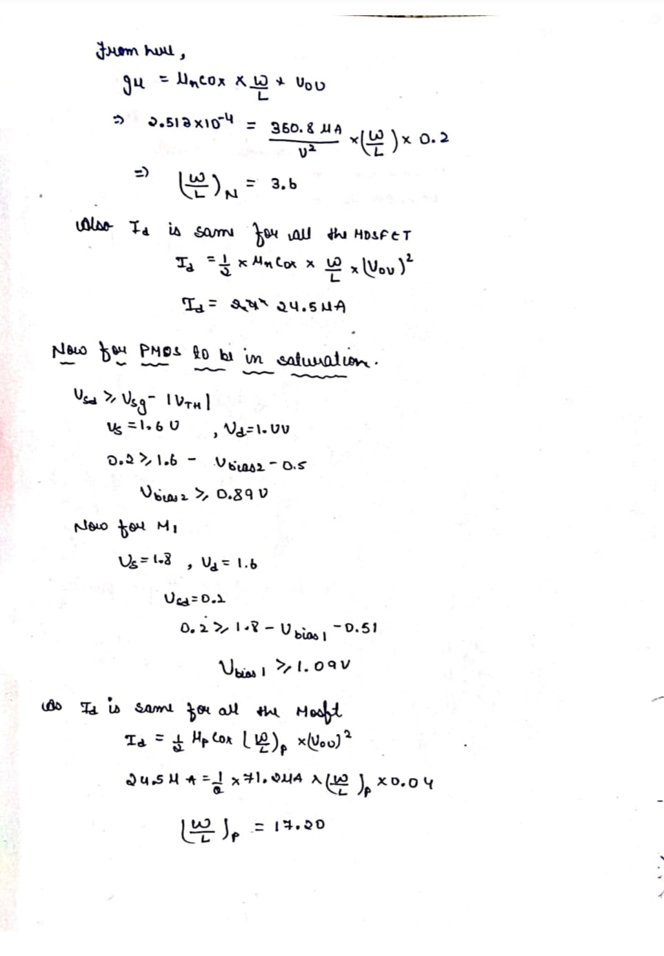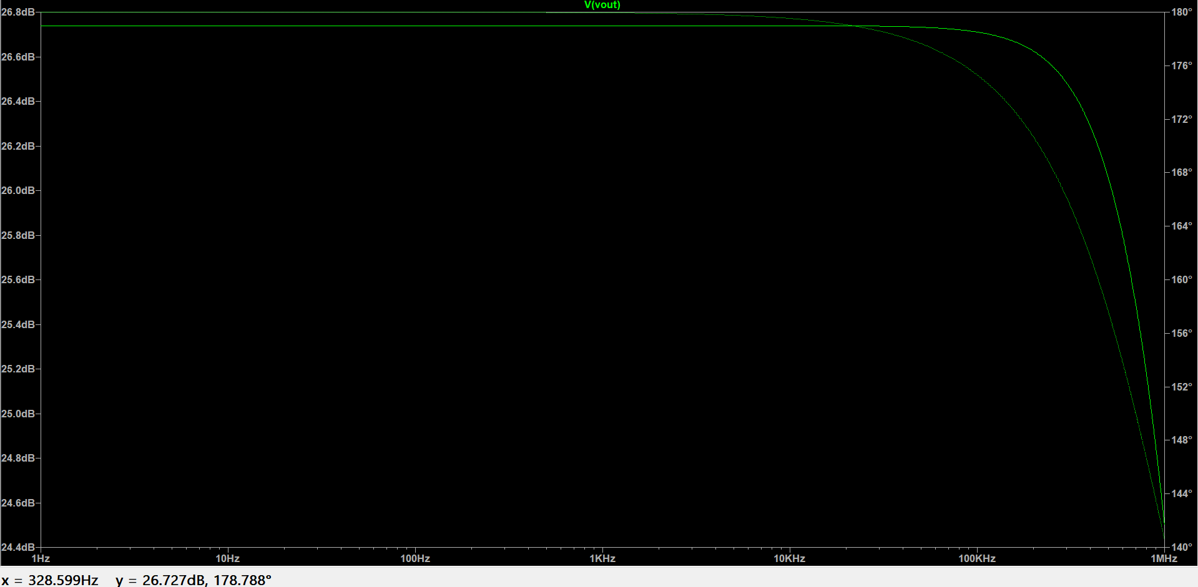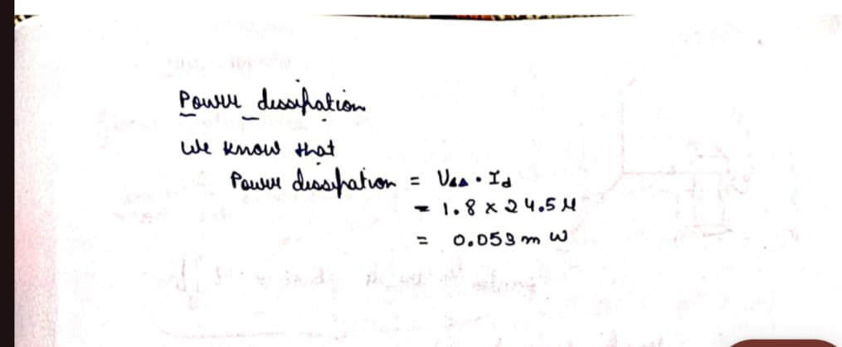

The Calculation for 180nm

**FIG: Bode Plot**

**Gain:26.7**

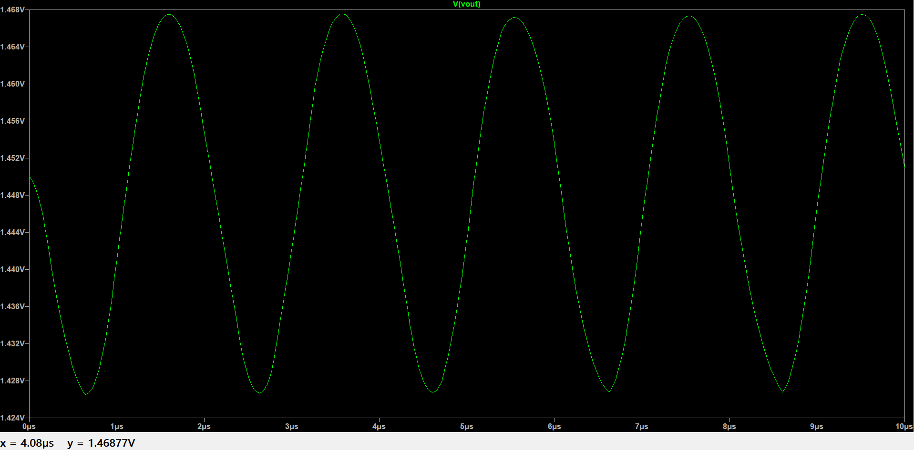

**FIG: Vout**

FOR 22nm

**WHOLE CIRCUIT**

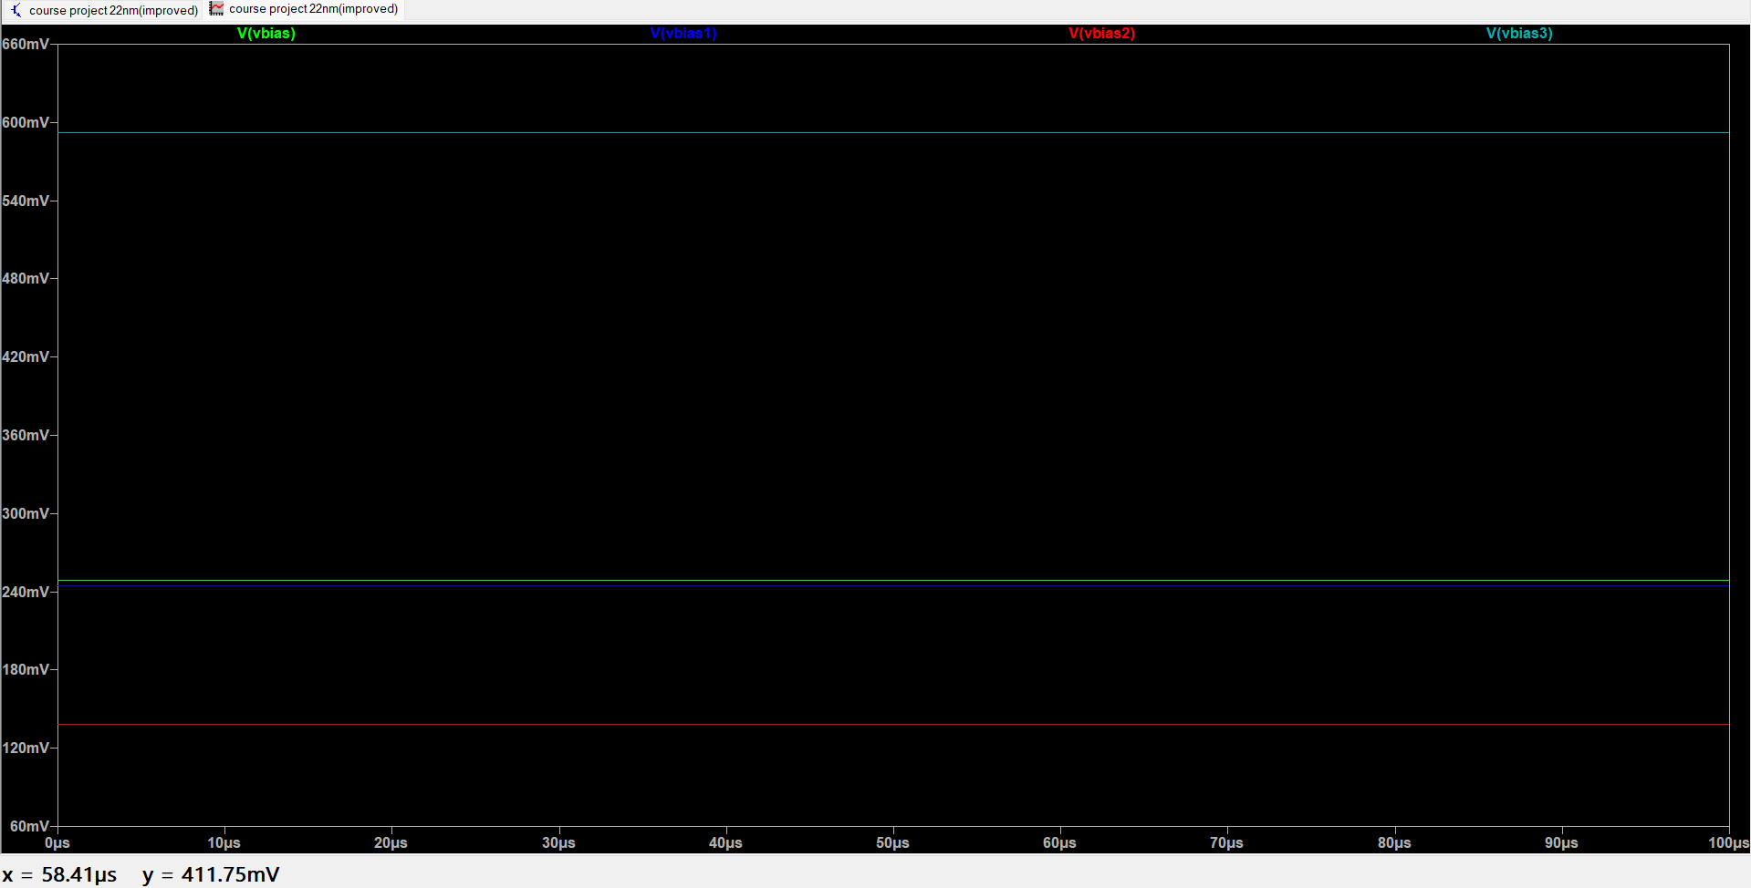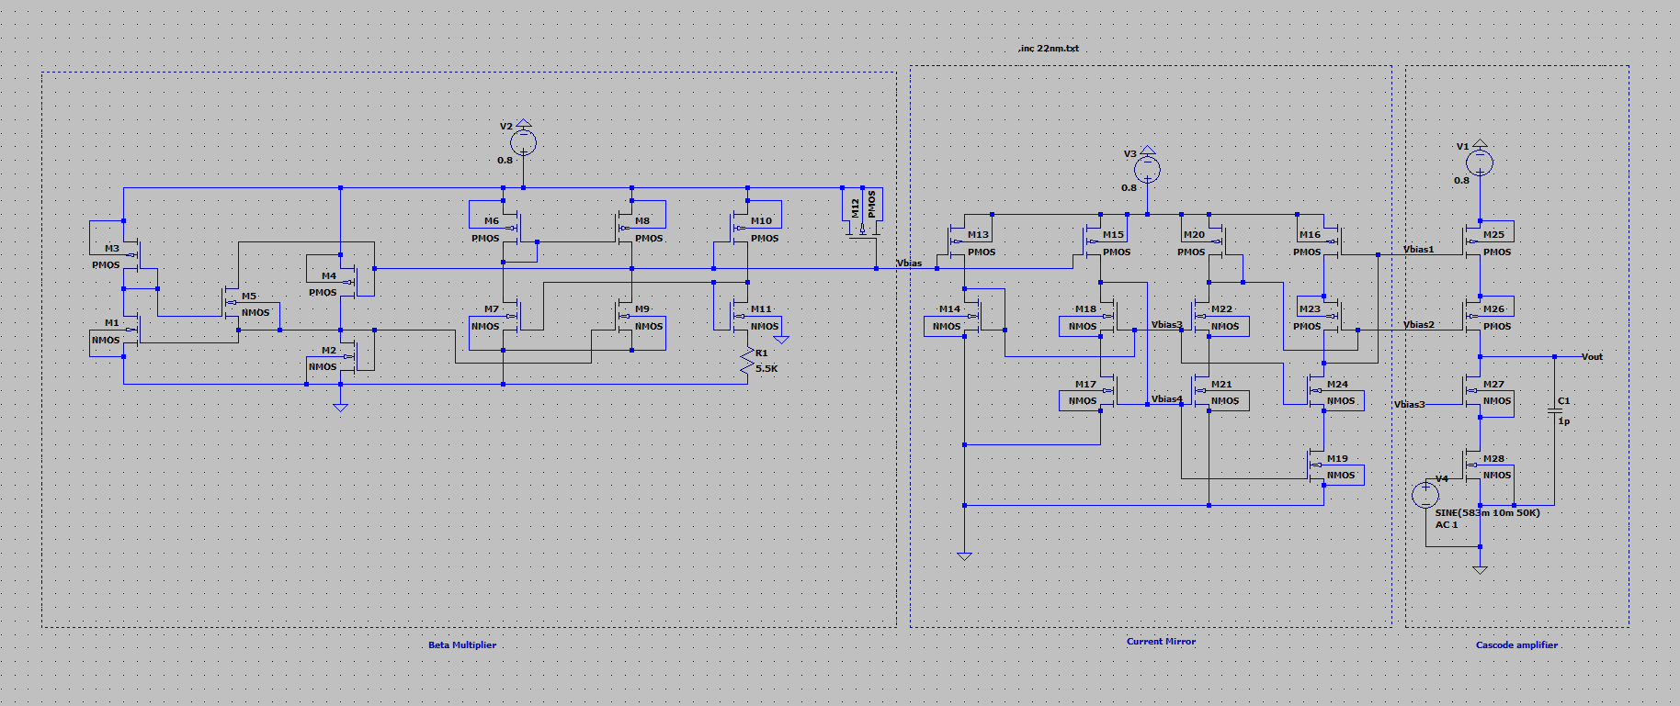

Vbias=251.6mV

Vbais1=245.6mV

Vbias2=138.8mV

Vbias3=591.4mV

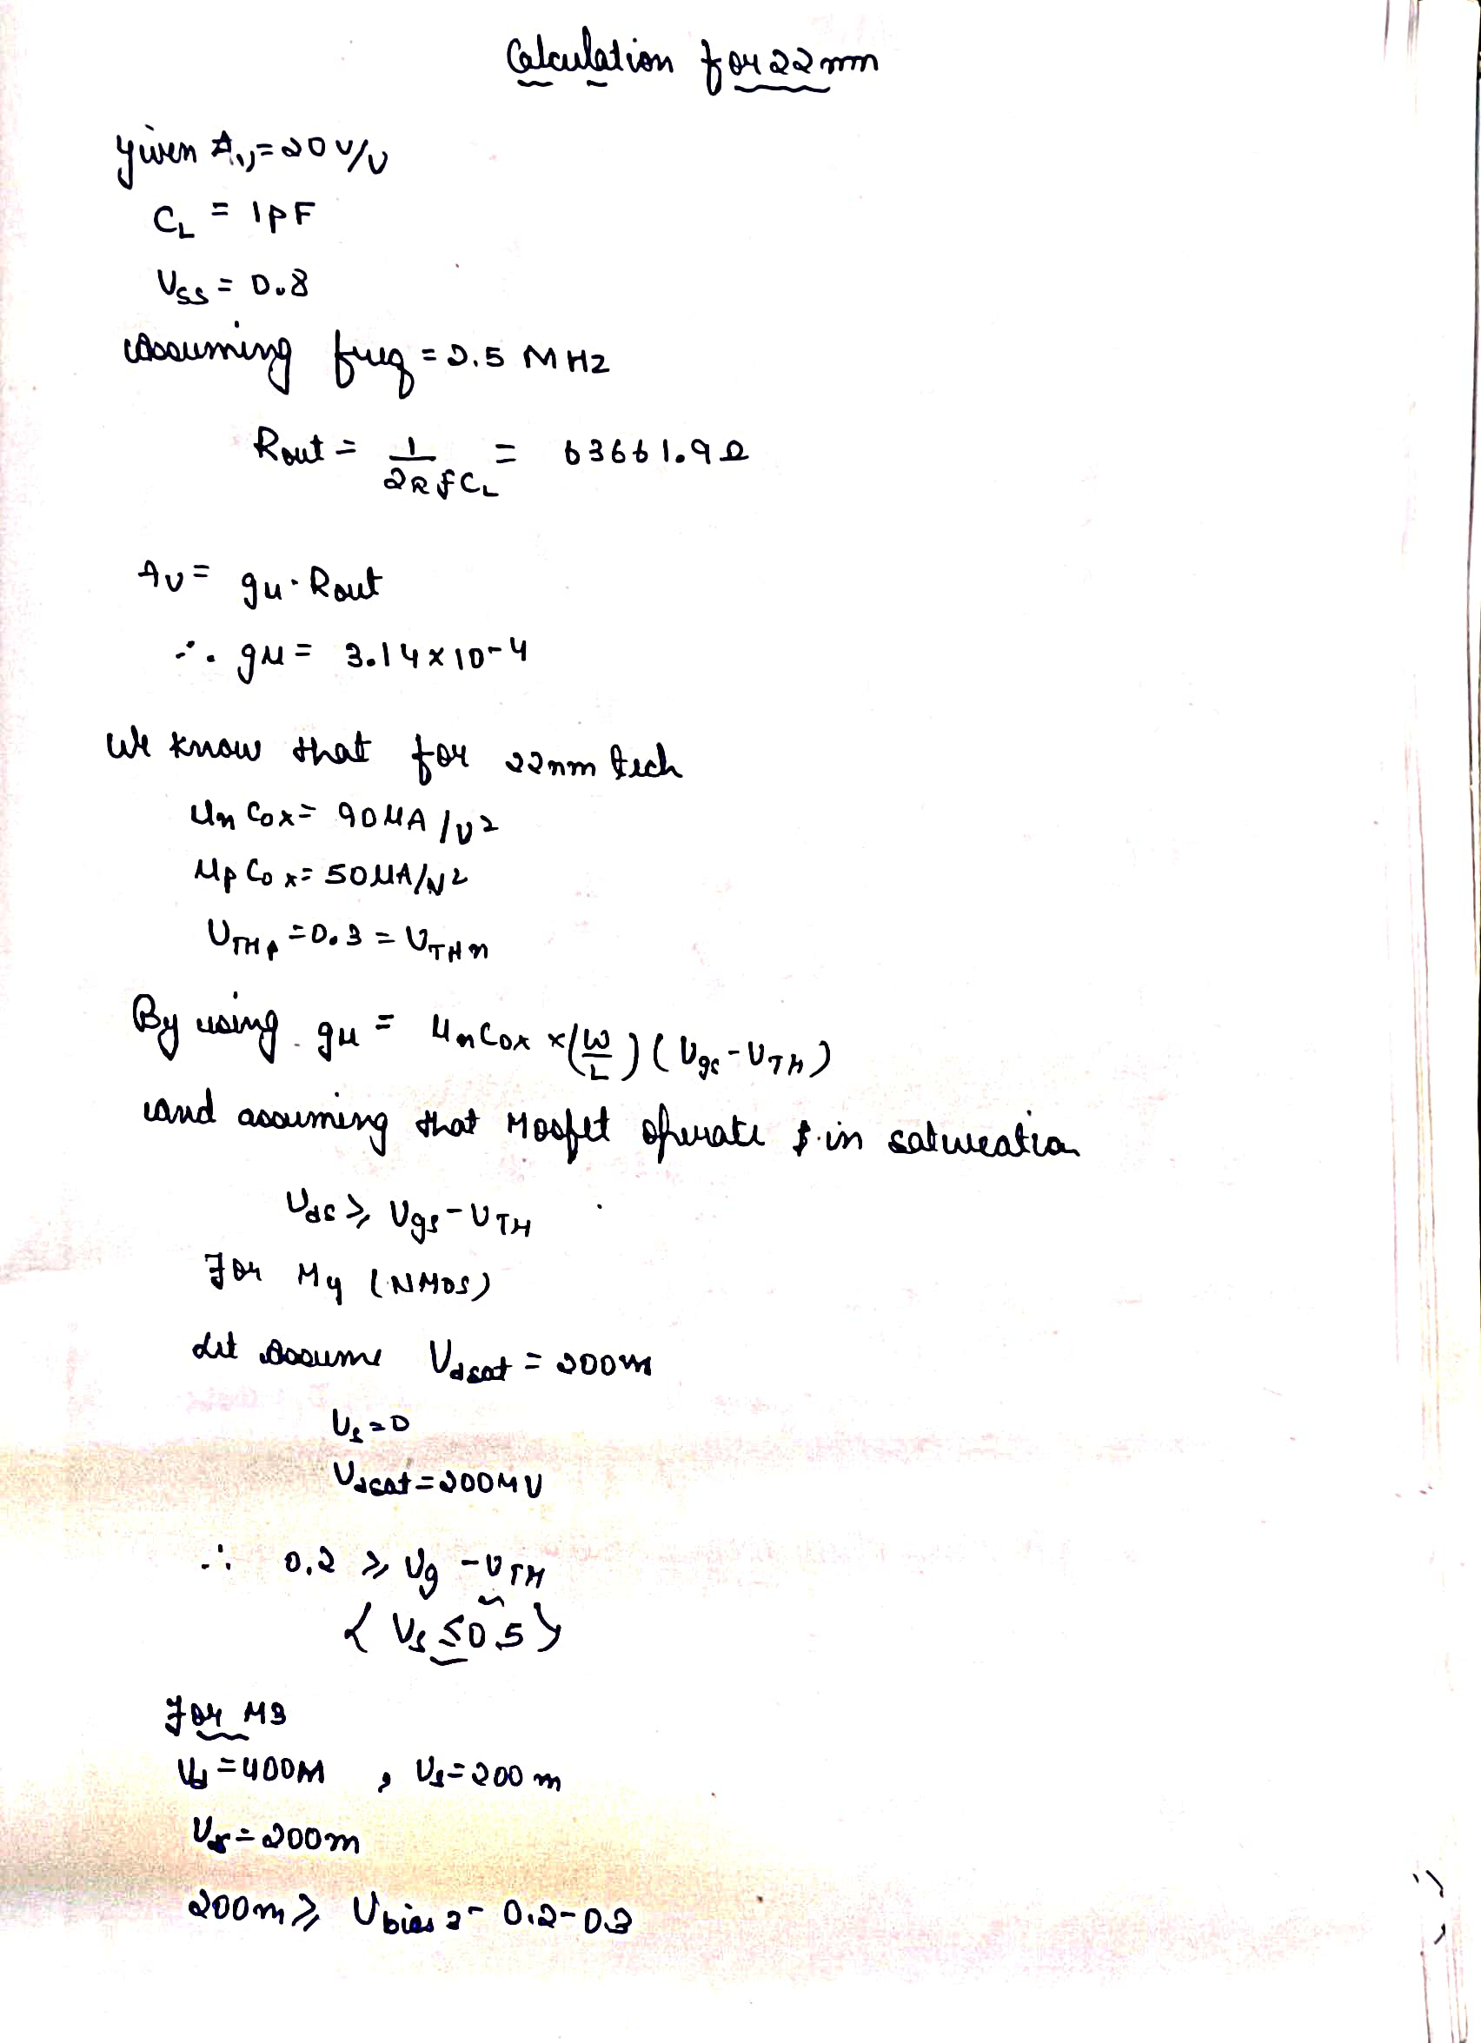

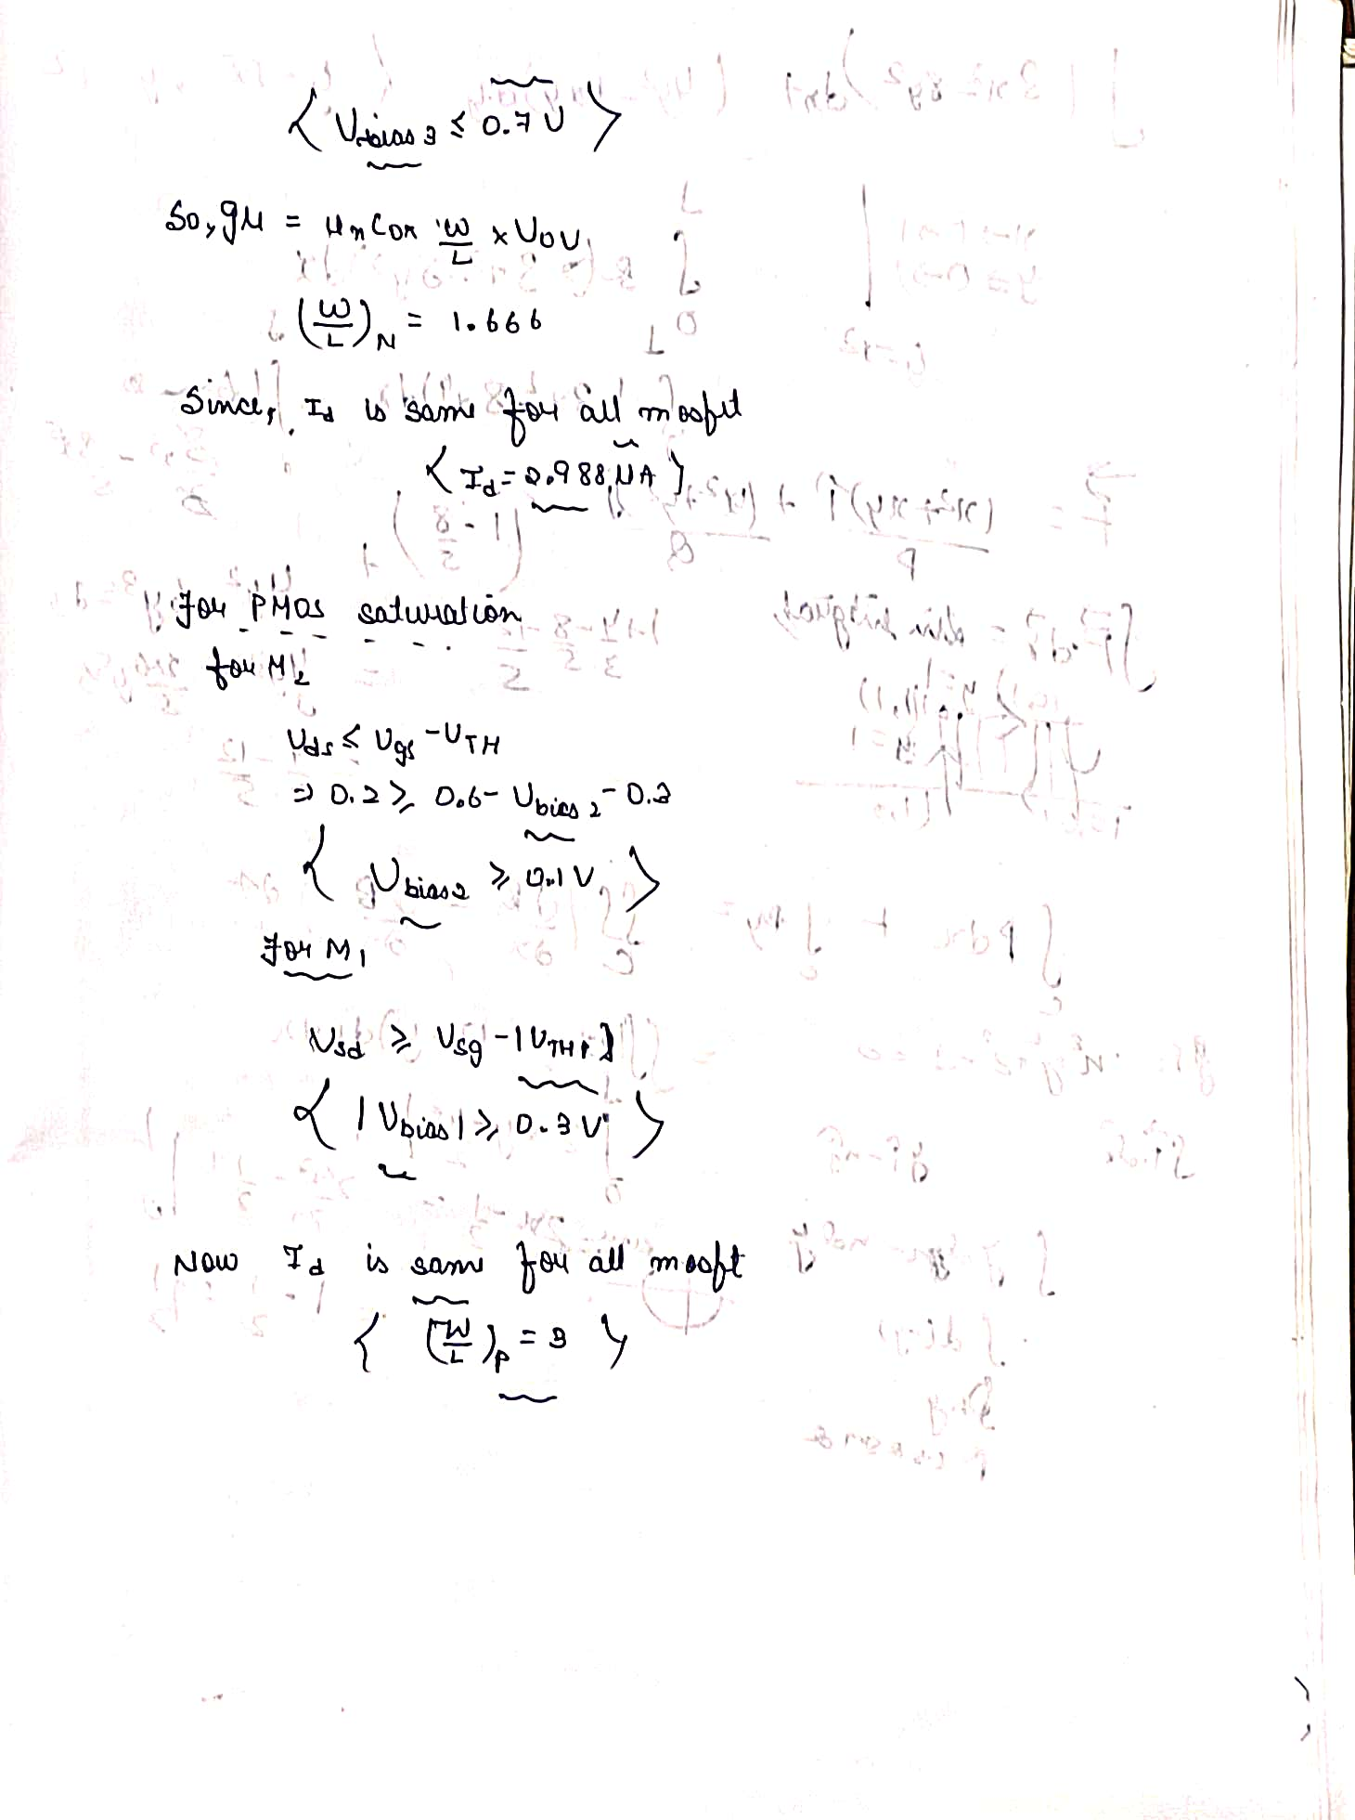

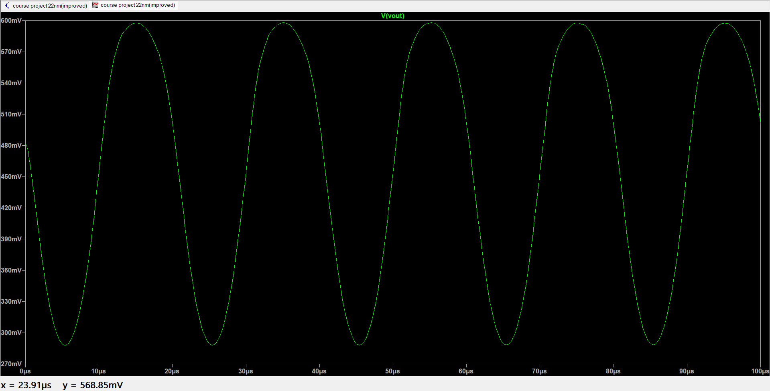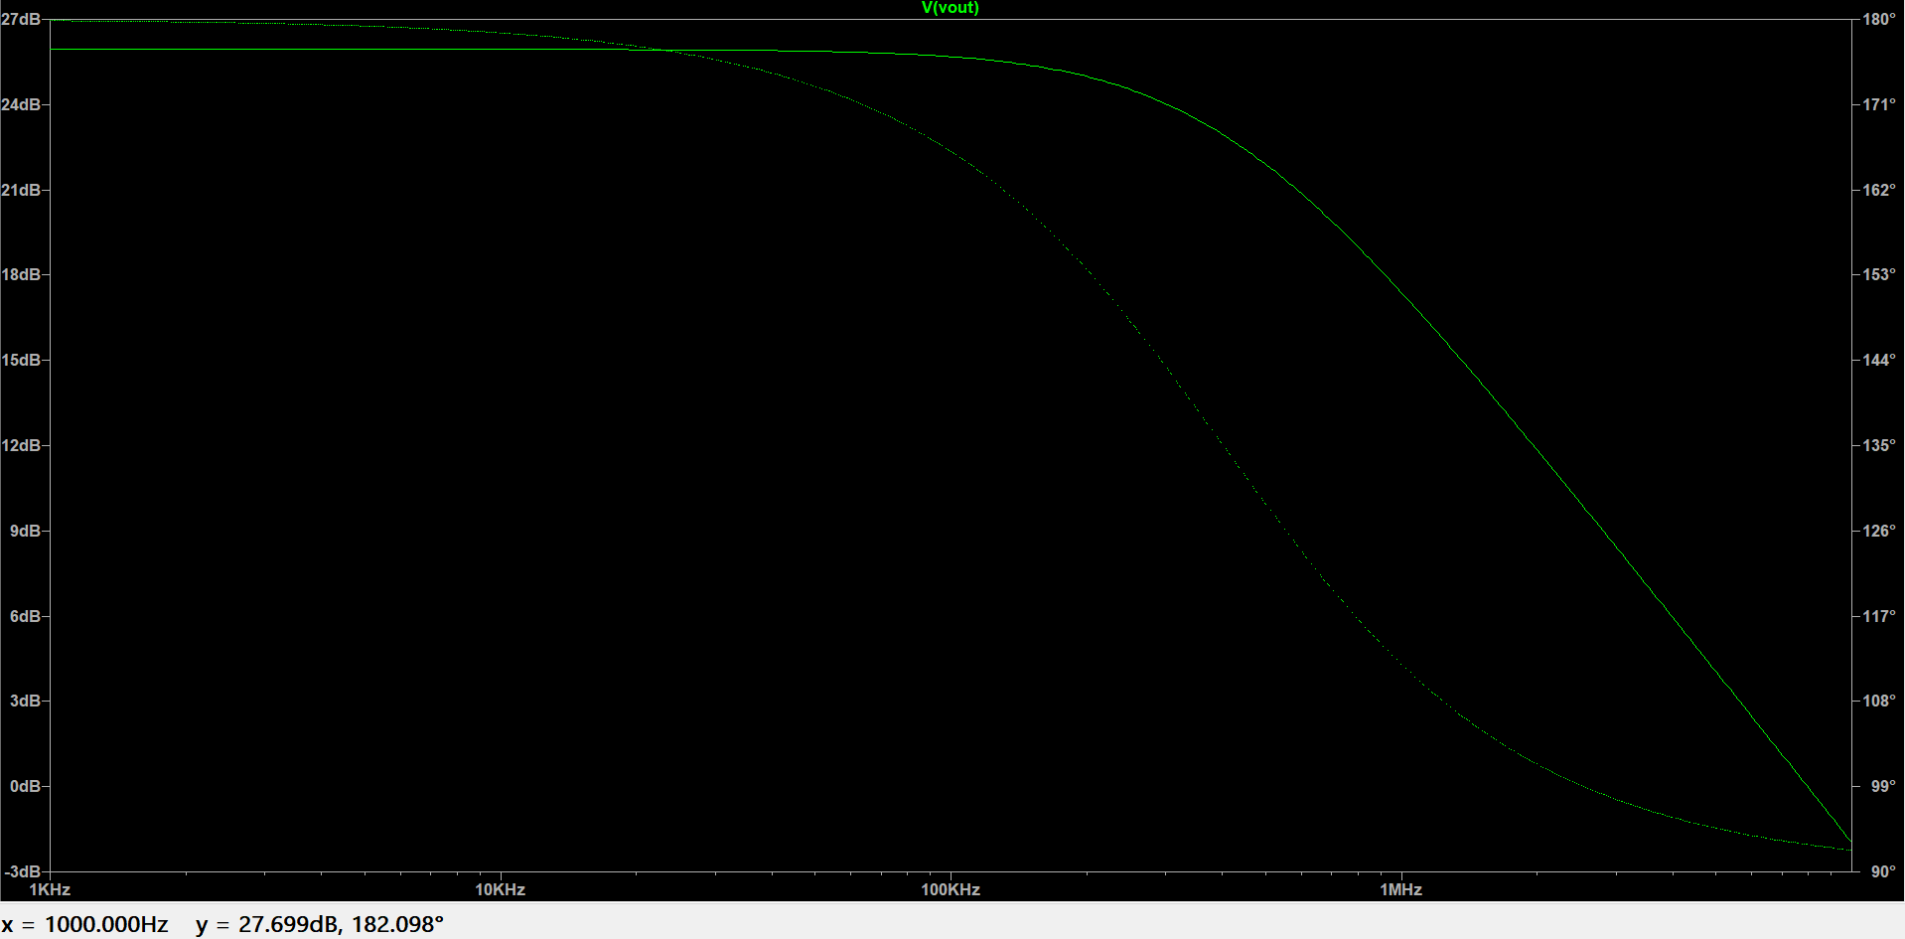

**FIG: Vout**

**FIG: BODE PLOT**

**GAIN=25.987db**

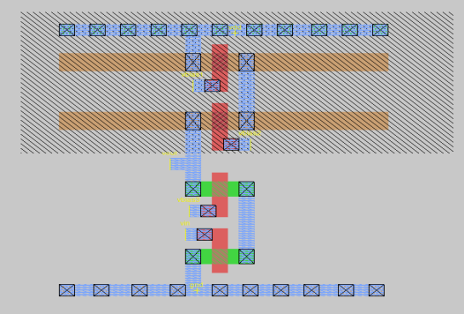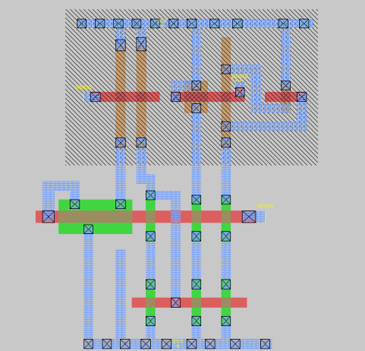Magic layout

Cascode Amplifier

Cascode Current Mirror

**Conclusion**

For 180nm

We get (W/L)n =3.6

(W/L)p=17.20

And we get gain=26.7

For 22nm

We get (W/L)n =1.666

(W/L)p=3.12

And we get gain =25.987