Raspberry Pi

and

Basic Linux

Author: Nick Lee
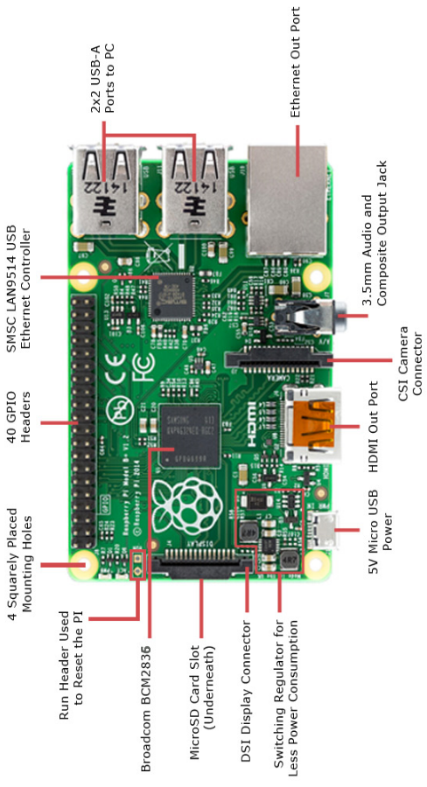
Raspberry Pi 3 Model B+ vs Arduino

 | 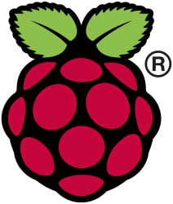 | 
 | Micro-computer | Micro-controller
 | Has OS  Run your program  along with many others | No OS  Run your program  ONLY
 | Python, NodeJS, Ruby,  Java, C, C++, etc. | C++
 | Knowledge of Linux required | Program and debug on Windows
GPIO pins | Digital only | Analog and digital
Processor | BCM2837  (Broadcom) | ATmega  (Atmel)
Speed | 1.4 GHz, quad-core | 8-16 MHz
RAM | 1 GB | 32-256 KB

From official documentations:
[Pi 3] can still be run from a 5V micro-USB power adapter ... we’re recommending a 2.5A adapter if you want to connect power-hungry USB devices to the Raspberry Pi.
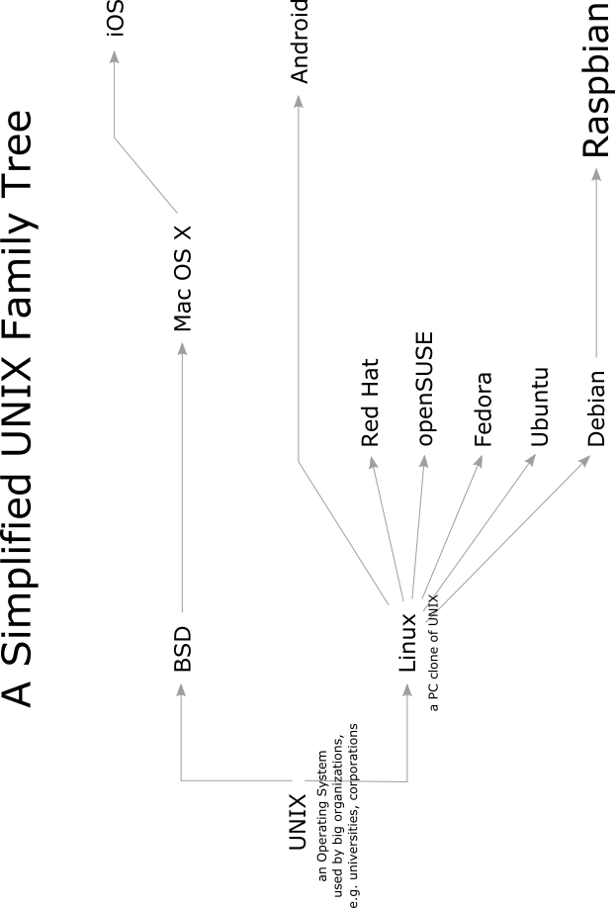
Prepare an SD card

- Download Raspbian, a Linux flavor commonly used for Raspberry Pi.
- Go to the Downloads section on raspberrypi.org
- Find Raspbian. Download its zip file.
- Unzip it. The resulting file is called a disk image.
- Download and install an image burner program.
- On Windows, search for Win32DiskImager
- On Mac, search for Pi Filler
- Cross-platform: Etcher
- With the program you have just installed, burn the Raspbian image onto an SD card.
To enable SSH on first startup, manually insert a file named "ssh" (without the quotes, contents don't matter) into the boot partition. For more details, refer to:
https://www.raspberrypi.org/blog/a-security-update-for-raspbian-pixel/
- Insert the SD card to a Raspberry Pi.

Initial Configuration

$ sudo raspi-config

- Change User Password: Doesn’t really matter, but good practice.
Notice that, as you type the password, the cursor NEVER moves. This is normal. Linux does not reveal the length of password as you type. If you type wrong, [backspace] all the way to start anew, or just [enter] to give yourself another chance.
If you do not change password, the default is:
User: pi
Password: raspberry
- Network Options → Hostname: Change the computer's name, so it is more easily recognized on the network.
- Interfacing Options → SSH → Yes: Enable SSH server, so you can login remotely.
- Interfacing Options → VNC → Yes: Enable VNC server, so you can use the graphical desktop remotely.
- Finish and Reboot.

After reboot, update the system:
$ sudo apt-get update
$ sudo apt-get upgrade

Install LCD driver

$ wget https://github.com/waveshare/LCD-show/archive/master.zip
$ unzip master.zip
$ cd LCD-show-master
$ sudo ./LCD5-show

It should reboot, and you should see system messages printing on LCD as it is starting up.

Calibrate touchscreen

The mouse pointer is not entirely accurate. The touchscreen needs calibration.

$ sudo dpkg -i -B xinput-calibrator_0.7.5-1_armhf.deb
$ DISPLAY=:0.0 xinput_calibrator

DISPLAY=:0.0 to force graphical display to LCD screen.

There will be a prompt for four-point calibration on the LCD screen. Click the points one by one to finish the process.

The new calibration data should be displayed in the terminal, like this:

Section "InputClass"
Identifier "calibration"
MatchProduct "ADS7846 Touchscreen"
Option "Calibration" "162 3988 195 3862"
EndSection

Put them in the file /etc/X11/xorg.conf.d/99-calibration.conf to make the calibration permanent.

Reboot and check the touchscreen again.

The LCD may turn dark after a period of inactivity. Don't panic. Touch it to turn it back on.
VNC

On a PC within the same network:

- Download RealVNC viewer
- Connect to Pi's IP address

You may find the desktop resolution very small. To make it bigger, you may create a new desktop:

$ vncserver -geometry 1000x800

Take note of the IP address:display number printed out, e.g. 192.168.0.103:1

Connect to that <IP address:display number>.

For more tips on using Raspberry Pi:

https://www.raspberrypi.org/documentation

如何找出IP地址？

- LCD螢光幕：將滑鼠箭咀移至右上角網路icon上

- Router：登入路由器管理介面（通常是192.168.?.1），查看DHCP使用者列表之類。

- hostname.local：電腦需要支援multicast DNS

- Network scan：下載一個網絡掃描軟件，掃吓內聯網有什麼電腦、什麼IP。
掃描軟件可試吓Advanced Port Scanner或Angry IP Scanner，或Fing手機應用程式。

- Plug n Pi：下載Plug n Pi手機應用程式，以USB線連接手機及樹莓批，手機就可查看樹莓批的IP地址。
手機必須是Android。樹莓批必須裝有Plug n Pi Server軟件。

熟習Linux，
事半功倍。
ls
list

ls | What things are there?

ls -l | Give me more details.

ls -a | Show me the hidden stuff (those starting with a dot).

ls –l -a | Chain two options together to double the benefits.

ls –la | You may also chain them like this.

ls –tl | Sort by date.

ls directory | What is in that directory?

man ls | Explain this command.

ls --help | Another way to explain this command.  But the output overflows the page, what can I do?

cd
change directory

cd directory | Go to a directory.

cd .. | Go up a level.  Double-dot means the parent directory.

cd . | Stay in the same directory.  Single-dot means the current directory.  In practice, you never do this. It is here for educational purposes only.

cd ~ | Go back to home directory.  The tilde (~) means home directory.

cd | Go back to home directory. Equivalent to cd ~.

pwd
print working directory

pwd | Where am I?

cp
copy

cp oldfile newfile | Make a copy of oldfile, and name it newfile.

cp -r olddir newdir | Copy an entire directory.  “-r” means “recursive”. That is, copy sub-directories, and their sub-directories, and their sub-directories, and so on.  Type cp --help or man cp to review the options.

mv
move or rename

mv oldfile newfile | oldfile now becomes newfile.

mv file dir | Move file to directory.

rm
remove

rm filename | Delete a file.

rm -r directory | Delete a directory.  “-r” means “recursive”. That is, delete sub-directories, and their sub-directories, and their sub-directories, and so on.

mkdir
make directory

mkdir directory | Create a new directory.

rmdir
remove directory

rmdir directory | You can only remove an empty directory.  Delete everything inside first, or use rm -r.

nano
a text editor

nano | When you want to write something, bring up a text editor.

nano filename | Edit an existing file.  Two shortcuts you need to know, for now:  Ctrl-O to save  Ctrl-X to exit

more or less
show text content, or show output page-by-page

less filename | Display file content.  If content is longer than one page:  - Use ← ↑ ↓ → [Page Up/Down] to navigate  - Type q to quit.

ls --help | less | Display the preceding command’s output in a page-by-page manner.  “|” is called a “pipe”. We will see more of it later.  If you have trouble typing the “|”:  - Enter sudo raspi-config  - Select Internationalisation options  - Select Change Keyboard Layout, this may take a while.  - Linux should have detected the keyboard for you. Press [enter].  - Then, it asks for Keyboard Layout. Default is English (UK). DO NOT trust that. You should select Other, then English (US), then English (US) again.  - Finally, it asks a few more questions. Press [enter] to skip all of them.  - Finish and reboot.

sudo reboot, sudo halt -h
Reboot and shutdown

sudo reboot | “sudo” means “superuser do”.  You cannot reboot the machine as an ordinary user. You must turn yourself into a superuser first.

sudo halt -h | To shutdown the machine, you also have to be a superuser.  Type halt --help or man halt to review the options.  DO NOT unplug the power until Raspberry Pi is completely shut down. The SD card may be corrupted if power is pulled prematurely.  Pay attention to the blinking lights on Raspberry Pi. Wait until only one steady red light is left and all other lights are dead. That’s when you can unplug the power safely.  How do you turn it on again? Just re-plug the power.

find
look for files with certain properties

find . -name *.wav | Any .wav files in current directory?

find python_games -name *.py | Any .py files in python_games directory?

find . -type d | Any directories in current directory?  “-type d” tells it to show directories only.

find directory -type f | Any files in that directory?  “-type f” tells it to show files only.  Type man find or find --help to learn more.

grep
look for lines with certain words

grep -lr import python_games | Which files in python_games contain the word “import”?

grep -Hr word directory_or_file | Try the command with the -H option. What are the differences?  You may look for any word in any directory or file with this command.

ps aux | It tells you what processes are running on the Raspberry Pi. The output is usually very long. What can you do?

ps aux | less | You may “pipe” it to a less command to read the information page-by-page.

ps aux | grep ssh | Sometimes, you want to look for a process to see if it is running, or how many of it are running.  For example, if you want to list all ssh-related processes, you may “pipe” the output to a grep command that looks for “ssh” and only shows those lines.

Other useful commands

ps - report a snapshot of current processes

top - report current processes in an interactive manner

kill - send a signal to a process. As the name implies, it is often used to kill a process.

dd - convert and copy a file, often used to create backups.

df - report disk space usage

ifconfig - network interface information

wget - download files from the internet

tar - archive and (de)compress files

unzip - decompress zip files

How to find something to kill

Use ps or pgrep to find the PID (Process ID).

$ ps
$ ps aux
$ ps aux | grep ssh
$ ps aux | grep python
$ pgrep ssh

Use kill (with -9 option if necessary) to kill.

$ kill 1234
$ kill -9 1234

Always remember that you are logged in as the user pi. To kill a process belonging to the user root, you have to sudo.

Think twice before you sudo kill something.

