Telegram Bot

Author: Nick Lee
Obtain a token

Open Telegram on the phone, search for a user called BotFather. As the name implies, he is the Father of All Bots.

Text him /newbot. He will then ask a couple of questions. Follow his guidance and you will get a token eventually, which looks something like this:

123456789:ABCdefGhIJKlmNoPQRsTUVwxyZ

That token identifies the bot account you are going to put on the Pi.

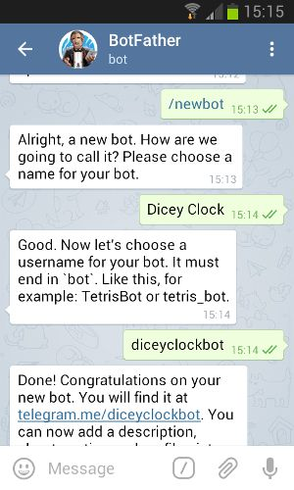

Telegram Web Version

We have a problem. How are we going to copy the looooonnnng token from the phone to the Pi? By hand?

Fortunately, you can access Telegram on the web, from a PC.

On your PC, open a browser, go to:

https://web.telegram.org/

It will ask for your phone number, then send you an SMS message containing a code. Enter the code, and you will be led to an interface very similar to your Telegram app.

Find the conversation with BotFather. You should see the token right there. Now, you can easily copy-and-paste the token from the browser window to the Pi, whenever you want, as often as you want.

Test the token

Enter the Pi. Install a Python package that helps you talk to Telegram.

$ sudo pip3 install telepot

$ python3

>>> import telepot
>>> bot = telepot.Bot('COPY TOKEN FROM BROWSER')
>>> bot.getMe()

You should see the bot's info.

Receive messages

import sys
import time
import telepot
from telepot.loop import MessageLoop
from pprint import pprint

def handle(msg):
pprint(msg)

token = sys.argv[1] ❶

bot = telepot.Bot(token)
MessageLoop(bot, handle).run_as_thread() ❷
print('Listening ...')

while 1: ❸
time.sleep(1)

❶ Get token as a command-line argument. It is not a good habit to embed token in source code, because token is supposed to be kept secret.

❷ Monitor Telegram servers for new messages. For every message received, handle() is called.

❸ Keep the program running. Otherwise, we would lose the bot and its message notification.

Note your phone's ID

{'chat': {'first_name': 'Nick',
'id': 00000000,
'type': 'private'},
'date': 1504581971,
'from': {'first_name': 'Nick',
'id': 00000000,
'is_bot': False,
'language_code': 'en-US'},
'message_id': 25252,
'text': 'Hello'},

When a message arrives, you should see something similar to the above. Note the chat field and from field. That is YOU.

Send messages

>>> bot.sendMessage(999999999, 'Good evening!')

Use your own ID instead of 999999999. Do not copy me blindly.

Do you receive the message on the phone?

echobot.py

import sys
import time
import telepot
from telepot.loop import MessageLoop

def handle(msg):
chat_id = msg['chat']['id'] ❶
text = msg['text']

print('%s %s' % (chat_id, text))
bot.sendMessage(chat_id, text) ❷

token = sys.argv[1]

bot = telepot.Bot(token)
MessageLoop(bot, handle).run_as_thread()
print('Listening ...')

while 1:
time.sleep(1)

❶ Extract message info

❷ Reply sender with the original text

Dicey Clock

Let's make a more capable bot. Imagine a bot that responds to two commands:

- /roll - reply with a random integer between 1 and 6, like rolling a dice.
- /time - reply with the current time, like a clock.

I call this a Dicey Clock.

The commands start with a slash (/). We will see why in a moment.

How would you program?

diceyclock.py

import sys
import time
import random
import datetime
import telepot
from telepot.loop import MessageLoop

def handle(msg):
chat_id = msg['chat']['id']
command = msg['text']

if command == '/roll':
n = random.randint(1,6) ❶
bot.sendMessage(chat_id, n)
elif command == '/time':
d = str(datetime.datetime.now()) ❷
bot.sendMessage(chat_id, d)

token = sys.argv[1]

bot = telepot.Bot(token)
MessageLoop(bot, handle).run_as_thread()
print('Listening ...')

while 1:
time.sleep(1)

❶ Get a random integer between 1 and 6

❷ Get the current time and turn it into a textual representation
/setcommands

According to Telegram's convention, commands for bots start with a slash (/). You may configure the bot to present a list of commands, so you don't have to type them every time.

Go back to the conversation with BotFather.

Text him /setcommands. Follow his instructions, and somewhere along the way, he should ask you for a list of command descriptions. In response, send:

roll - Roll a dice
time - Report current time

Start each line with lowercase, and no slash.

After /setcommands is complete, go back to your Dicey Clock bot. Type a slash, do you see the command list as shown on the opposite page?

It probably takes a few minutes for Telegram to update. If you don't want to wait, just exit, kill (force stop), and re-launch the Telegram app. You should see the command list right away.

