Python and GPIO

for

Raspberry Pi

Author: Nick Lee

$ python

>>> 1 + 3  >>> 9 - 7  >>> 6 * 3  >>> 3 / 2  >>> 3 / 2.0  >>> 3.0 / 2  >>> 4 + 2 * 3  >>> (4 + 2) * 3  >>> 2 ** 3  >>> type(3)  >>> type(3.0)  >>> float(3)  >>> int(3.0)  >>> int(3.9)  >>> type('3')  >>> '3' == 3  >>> 'abd' + 'xyz'  >>> 'abc' * 3  >>> x = 1  >>> y = 2  >>> x + y  >>> x * y  >>> z = 'How are you?'  >>> zz = 'I don\'t know'  >>> len(z)  >>> z[0]  >>> z[-1]  >>> z[1:4]  >>> exit() | 加減乘除  先乘除 後加減  括號  數字分種類，int或float  還有string字串，單雙引號均可  '3' 等於3嗎？  代數  用 \ 去escape單引號，或整個用雙引號

Let's write a very simple Python program.

$ nano first.py

a = 1
b = 2

print a
print b
print a + b

$ python first.py

What do you see?
list, dictionary

$ python

>>> a = [1,2,3,'abc',34.2]
>>> type(a)
>>> len(a)
>>> a[0]
>>> a[-1]
>>> a[1:4]

>>> b = [7,8,9]
>>> a + b
>>> a * 3

>>> a.append(4)
>>> a.pop(0)
>>> a.remove(3)

>>> d = {'x': 2, 7: 'Eleven', 5.6: [1,2,3]}
>>> type(d)
>>> d['x']

>>> d['z'] = 99
>>> d
>>> del d['x']
>>> d

import

>>> import math
>>> math.sqrt(25)
>>> math.pi
>>> math.log10(100)

>>> import random
>>> random.randint(1,3)
>>> random.choice('abc')
>>> random.choice([5,6,7])

Roll a dice

$ nano dice.py

import random

print random.randint(1,6)

$ python dice.py

What if we want to roll a 12-sided dice, like this?

$ python dice.py 12

How do we capture command-line arguments?

Command-line arguments

$ nano printargs.py

import sys

print sys.argv

$ python printargs.py
$ python printargs.py 1 2
$ python printargs.py 88 nick 3.1416

As you can see, command-line arguments are captured in the variable, sys.argv, as a list, the first element of which is always the filename.

A dice with variable sided-ness

$ nano dice.py

import sys
import random

sides = int(sys.argv[1])
print random.randint(1, sides)

$ python dice.py 12

What if we want to roll it repeatedly, like this?

$ python dice.py 12 3
6
3
10
Roll it repeatedly: loop

$ nano dice.py

import sys
import random

sides = int(sys.argv[1])
n = int(sys.argv[2])

for i in range(0,n):
r = random.randint(1, sides)
print r

$ python dice.py 12 3

What if we want the sum, like this?

$ python dice.py 6 3
4
5
1
= 10

Accumulate the sum

$ nano dice.py

import sys
import random

sides = int(sys.argv[1])
n = int(sys.argv[2])

sum = 0
for i in range(0,n):
r = random.randint(1, sides)
print r
sum = sum + r

print '=', sum

$ python dice.py 6 3

What if we give it zero or negative numbers?

$ python dice.py 0 -2
?????
Check user inputs: if

import sys
import random

sides = int(sys.argv[1])
n = int(sys.argv[2])

if sides <= 0 or n <= 0:
print '?????'
exit(1)

sum = 0
for i in range(0,n):
r = random.randint(1, sides)
print r
sum = sum + r

print '=', sum

Next, we will make a 六合彩 program.

$ python mark6.py
48
12
10
49
31
3
--
43

Hint: Use range() to create balls numbered 1-49, then use random.choice() to draw.
Mark Six

import random

balls = range(1,50)

for i in range(0,6):
r = random.choice(balls)
balls.remove(r)
print r

print '--'

r = random.choice(balls)
balls.remove(r)
print r

What if we want to put the drawn numbers in order, from the smallest to the largest?

$ python mark6.py
[4, 7, 12, 15, 27, 44] 22

Hint: Put drawn numbers into a list, then use Python's sorted() function.
Mark Six, sorted

import random

balls = range(1,50)
drawn = []

for i in range(0,6):
r = random.choice(balls)
balls.remove(r)
drawn.append(r)

special = random.choice(balls)
balls.remove(special)

print sorted(drawn), special

The action of drawing a ball always consists of random.choice() followed by balls.remove(). We may group them into a function to make the code more succinct.

Draw using a function

import random

def draw(list_of_numbers):
n = random.choice(list_of_numbers)
list_of_numbers.remove(n)
return n

balls = range(1,50)
drawn = []

for i in range(0,6):
r = draw(balls)
drawn.append(r)

special = draw(balls)

print sorted(drawn), special

Write to a file

Let's try this in the Python interpreter.

$ python

>>> f = open('filename.txt', 'w')
>>> f.write('Line 1\n')
>>> f.write('Line 2\n')
>>> f.close()
>>> exit()

When you are done with a file, call f.close() to close it and free up any system resources taken up by the open file.

It is a good practice to use the with keyword when dealing with file objects. This ensures that the file is always properly closed.

$ python

>>> with open('filename.txt', 'w') as f:
... f.write('Line 1\n')
... f.write('Line 2\n')
...
>>> exit()

LED

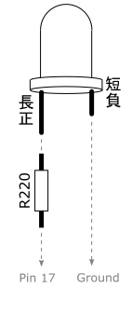

Raspberry Pi interacts with the outside world via General-purpose Input Output (GPIO) pins. We are going to control the pins using Python.

$ python

>>> from RPi import GPIO
>>> GPIO.setmode(GPIO.BCM) # use Broadcom numbering
>>> GPIO.setup(17, GPIO.OUT) # setup pin 17 as output
>>> GPIO.output(17, 1) # turn it on
>>> GPIO.output(17, 0) # turn it off
>>> GPIO.cleanup()

Can you write a program that blinks the LED?
blink.py
example

import time
from RPi import GPIO

led = 17 ❶

GPIO.setmode(GPIO.BCM)
GPIO.setup(led, GPIO.OUT)

while 1:
GPIO.output(led, 1)
time.sleep(0.5) ❷
GPIO.output(led, 0)
time.sleep(0.5) ❸

❶ Define the LED pin number. If you change pin, this is the only place you need to change.

❷ Keep the light on for 0.5 second.

❸ Keep the light off for 0.5 second.
Button

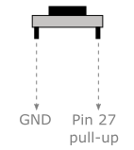

Because it is pulled up, pin 27 is normally HIGH (1). On pressed, it becomes LOW (0).

There are several methods to detect press of button.

You may keep checking the button state manually. This is called polling - you constantly poll the input signal. This method should look familiar to you if you have programmed Arduino.

poll.py

from RPi import GPIO

button = 27

GPIO.setmode(GPIO.BCM)
GPIO.setup(button, GPIO.IN, pull_up_down=GPIO.PUD_UP) ❶

while True:
if GPIO.input(button) == 0:
print 'Pressed' ❷

❶ Set up pin 27 as input and activate pull-up

❷ Print out "pressed" as long as button is pressed

Most of the time, we are more interested in the change of state rather than the state itself. A button press is a change of voltage from HIGH to LOW.

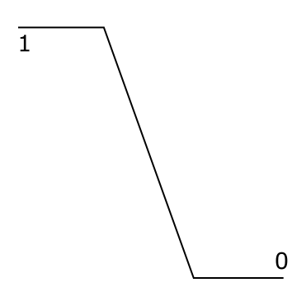

We call that a falling edge.

waitforedge.py

from RPi import GPIO

button = 27

GPIO.setmode(GPIO.BCM)
GPIO.setup(button, GPIO.IN, pull_up_down=GPIO.PUD_UP)

while True:
GPIO.wait_for_edge(button,
GPIO.FALLING, ❶
bouncetime=300) ❷
print 'Edge falling'

❶ Blocks until a falling edge occurs

❷ Keep reading for an explanation of bouncetime

While wait_for_edge() is waiting, we can't do anything else. Another method is to set up a callback, and let the GPIO library invoke the callback when it detects a falling edge.

detect.py

import time
from RPi import GPIO

button = 27

GPIO.setmode(GPIO.BCM)
GPIO.setup(button, GPIO.IN, pull_up_down=GPIO.PUD_UP)

def button_pressed(channel): ❶
print 'Pressed on channel %d' % channel

GPIO.add_event_detect(button,
GPIO.FALLING,
callback=button_pressed, ❷
bouncetime=300) ❸

while True: ❹
time.sleep(1)

❶ Define a callback function

❷ Tell GPIO to invoke the callback function on a falling edge

❸ See the following page for an explanation of bouncetime

❹ Keep the program running. Otherwise, we would lose the edge detection.

What is bouncetime?

A push button is imperfect. The voltage change from HIGH to LOW is not a smooth edge as depicted before. In reality, it looks more like this:

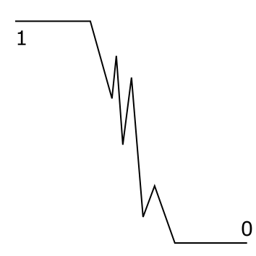

The button bounces.

bouncetime=300 tells GPIO to ignore the bounces for 300 milliseconds.

If we don't tell it to ignore bounces, it would report multiple falling edges for a single button press.

Try removing bouncetime=300 from the above code. What do you expect?

Experiment with various bouncetime. Which values do you prefer?

Quick reaction game

Now that you know how to handle LED and push button, let's check how quick your reaction is. Make a reaction timer as follows:

- Turn on LED

- User presses button to "start the clock". LED is turned off.

- After a random number of seconds (say, 2-10 seconds), LED is turned back on!

- User has to press button as soon as he can. Print out his reaction time.

- Back to step 2

Which strategy would you use to detect button press?
reaction.py

import random, time
from RPi import GPIO

GPIO.setmode(GPIO.BCM)

led = 17
button = 27

GPIO.setup(led, GPIO.OUT)
GPIO.setup(button, GPIO.IN, pull_up_down=GPIO.PUD_UP)

GPIO.output(led, 1)

while 1:
GPIO.wait_for_edge(button, ❶
GPIO.FALLING,
bouncetime=300)
GPIO.output(led, 0)

delay = random.uniform(2, 10)
time.sleep(delay) ❷

light_on = time.time() ❸
GPIO.output(led, 1)

GPIO.wait_for_edge(button, ❹
GPIO.FALLING,
bouncetime=300)
pressed = time.time() ❺

reaction = pressed - light_on
print 'Reaction time: %.3f sec' % reaction

❶ Wait for user to "start the clock"

❷ Delay for a random number of seconds (2-10)

❸ Remember the time when LED is turned on

❹ Wait for user to press

❺ Remember the time when user presses the button
HC-SR501
PIR (Passive Infra-red) motion sensor

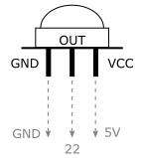

This motion sensor outputs HIGH when motion is detected, LOW otherwise.

Sensitivity and delay may be adjusted by turning a screw on the back of the sensor - clockwise to increase sensitivity and lengthen delay.

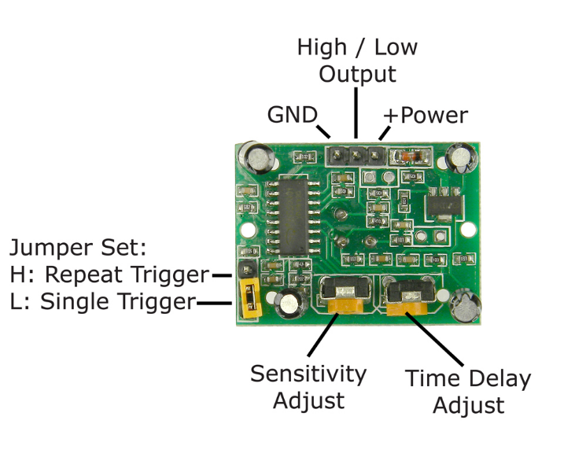
motion.py

import time
from RPi import GPIO

GPIO.setmode(GPIO.BCM)

motion = 22

GPIO.setup(motion, GPIO.IN)

def motion_changed(channel):
if GPIO.input(channel): ❶
print 'Somebody'
else:
print 'Nobody'

GPIO.add_event_detect(motion,
GPIO.BOTH, ❷
callback=motion_changed) ❸

while True:
time.sleep(1)

❶ Have to check whether it is currently HIGH or LOW because ...

❷ We are catching both rising and falling edges.

❸ No bouncetime needed because motion sensor's output has been smoothed by its internal circuit.

Stepper Motor

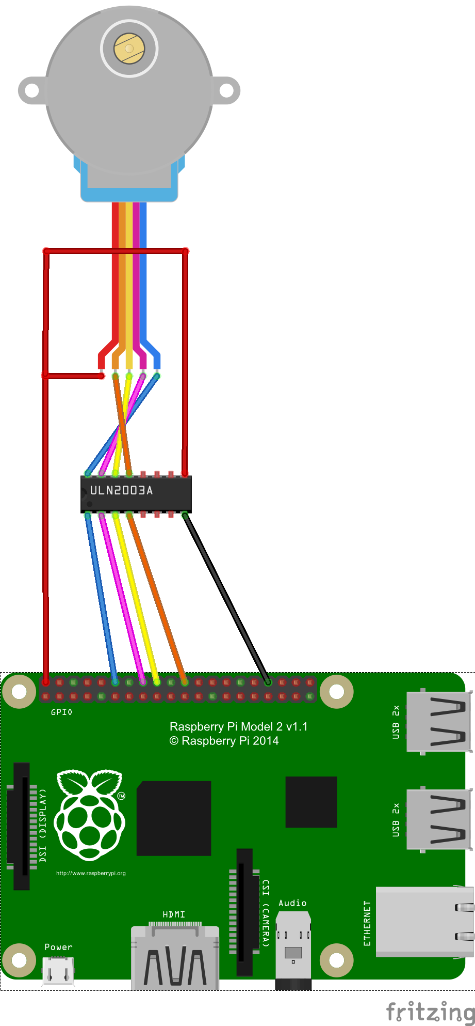

Motor type | Unipolar stepper motor
Voltage | 5 - 12V DC
Step angle | Half-step mode: 8 step control signal sequence  5.625 degrees per step, or 64 steps per revolution  Full-step mode: 4 step control signal sequence  11.25 degrees per step, or 32 steps per revolution
Gear ratio | 64:1  That means, in full-step mode, we will have 32 steps per revolution × 64 gear ratio = 2048 total steps per revolution.

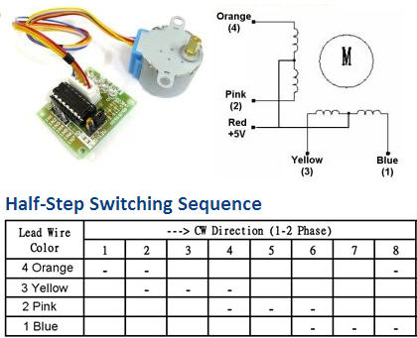

The motor has 4 coils of wire that are powered in a sequence to make the magnetic motor shaft spin. When using the full-step method, 2 of the 4 coils are powered at each step.
stepper.py
from RPi import GPIO
import time
import sys

GPIO.setmode(GPIO.BCM)

pins = [18, 23, 24, 25] ❶

for p in pins:
GPIO.setup(p, GPIO.OUT)

def set_step(*outputs):
for p,out in zip(pins, outputs):
GPIO.output(p, out)

def rotate_forward(steps, delay):
for i in range(0, steps): ❷
set_step(1,1,0,0)
time.sleep(delay)
set_step(1,0,0,1)
time.sleep(delay)
set_step(0,0,1,1)
time.sleep(delay)
set_step(0,1,1,0)
time.sleep(delay)

def rotate_backward(steps, delay):
for i in range(0, steps): ❸
set_step(0,1,1,0)
time.sleep(delay) ❹
set_step(0,0,1,1)
time.sleep(delay)
set_step(1,0,0,1)
time.sleep(delay)
set_step(1,1,0,0)
time.sleep(delay)

forward = (sys.argv[1]=='f') ❺
steps = int(sys.argv[2])
delay = float(sys.argv[3]) ❻

if forward:
rotate_forward(steps, delay)
else:
rotate_backward(steps, delay)

GPIO.cleanup()

❶ Those are the 4 GPIO pins controlling the coils.

❷ Go through the control signal sequence.

❸ The same sequence, but backward.

❹ Delay between signals controls speed of rotation.

❺ Use the first argument on command-line to control spin direction. 'f' means forward, otherwise backward.

❻ Also specify the number of steps and delay between signals on command-line.

Nano shortcuts

Ctrl-O to save
Ctrl-X to exit

Ctrl-^ to set mark, then move cursor to select
Alt-^ to copy
Ctrl-K to cut
Ctrl-U to paste (uncut)

Ctrl-_ to go to a line number
Ctrl-W to find
Alt-W to find next
Ctrl-\ to find and replace

Alt-} to block indent
Alt-{ to block unindent

Edit /etc/nanorc to change settings.

Recommended settings:

set tabsize 4
set tabstospaces

