Sensors

for

Raspberry Pi

Author: Nick Lee

We are going to hook up a number of sensors to enable Raspberry Pi to detect its environment.

Raspberry Pi is a digital computer, and a digital computer only knows two numbers: 1 and 0.

A lot of physical quantities, e.g. temperature, humidity, wind speed, etc., are smooth-varying numbers. They can take on values such as 25.6, 98.76, or 33.3333333333. These are called analog quantities.

For Raspberry Pi to understand analog quantities, a sensor has to convert those analog quantities to digital signals.

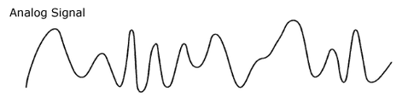

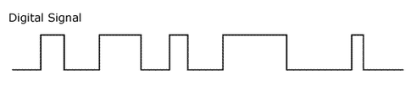

However, there are many digital "languages". Widely used are 1-wire, I2C, and SPI. A sensor may speak any of these, and you have to configure Raspberry Pi to speak the sensor's "language" before they can communicate.
DS18B20
temperature sensor

First, we try a temperature sensor. Wire it up according to the diagram below. You will need a 10K pull-up resistor.

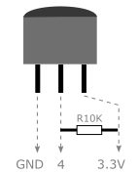

It speaks the 1-wire protocol. We have to enable 1-wire on Raspberry Pi.
Enable 1-wire

$ sudo nano /boot/config.txt  dtoverlay=w1-gpio  $ sudo reboot | Add this line

$ cd /sys/bus/w1/devices  $ cd 28-ZZZZZZZZ  $ cat w1_slave  c6 01 4b 46 7f ff 0a 10 17 : crc=17 YES  c6 01 4b 46 7f ff 0a 10 17 t=28375 | What do you see?  Temperature = 28.375 °C

The first line checks if the response is valid. Make sure it says "YES" at the end.

Now, you know how to read the sensor from the command-line. How do you read it using Python?
Use the sensor package

$ sudo apt-get update
$ sudo apt-get upgrade

Install software for I2C:

$ sudo apt-get install i2c-tools python-smbus

Install software for SPI:

$ sudo apt-get install python-dev
$ sudo pip install spidev

Finally, install the sensor package:

$ sudo pip install sensor

$ python

>>> from sensor.DS18B20 import DS18B20
>>> ds = DS18B20('28-ZZZZZZZZZ')
>>> ds.temperature()

What do you see? How do you access different units of the temperature?

>>> t = ds.temperature()
>>> t.C
28.937
>>> t.F
84.0866

The sensor package supports all sensors we are going to use in this course.

Next, we try to display the temperature on an LCD, which speaks the I2C protocol. We have to enable I2C on Raspberry Pi.
Enable I2C

$ sudo nano /etc/modules  i2c-dev  $ sudo nano /boot/config.txt  dtparam=i2c1=on  $ sudo reboot | Add this line  Add this line

$ i2cdetect -y 1

0 1 2 3 4 5 6 7 8 9 a b c d e f
00: -- -- -- -- -- -- -- -- -- -- -- -- --
10: -- -- -- -- -- -- -- -- -- -- -- -- -- -- -- --
20: -- -- -- -- -- -- -- -- -- -- -- -- -- -- -- --
30: -- -- -- -- -- -- -- -- -- -- -- -- -- -- -- --
40: -- -- -- -- -- -- -- -- -- -- -- -- -- -- -- --
50: -- -- -- -- -- -- -- -- -- -- -- -- -- -- -- --
60: -- -- -- -- -- -- -- -- -- -- -- -- -- -- -- --
70: -- -- -- -- -- -- -- --

Nothing is on the I2C bus, because nothing has been attached yet.
LCD1602

Wire it up:

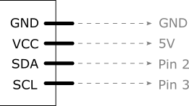

All I2C devices share 2 wires: SDA (data) and SCL (clock). Their wiring diagrams are nearly identical, except that most sensors use 3.3V power supply instead of 5V. Read their datasheets.

$ i2cdetect -y 1

Do you see the address of the LCD?

Display on the LCD

$ python

>>> from sensor.LCD1602 import LCD1602

>>> lcd = LCD1602(1, ??address??)

>>> lcd.display('Nick Lee', 1)
>>> lcd.display('Hong Kong', 2)

>>> lcd.clear()

Can you write a program that displays the temperature on the LCD?

display.py

import time
from sensor import DS18B20, LCD1602

ds = DS18B20.DS18B20('??address??')
lcd = LCD1602.LCD1602(1, ??address??)

try:
while 1:
t = ds.temperature()
lcd.display('%.1f C' % t.C, 1) ❶

time.sleep(1)
finally: ❷
lcd.clear()

❶ Display Celsius to 1 decimal place

❷ When you Ctrl-C to kill the infinite loop, an exception is raised and the finally clause is executed, clearing the display.

HTU21D
humidity and temperature sensor

Wiring: nearly identical to LCD1602, except that supply voltage is 3.3V.

$ i2cdetect -y 1

What is the sensor's address?

$ python

>>> from sensor.HTU21D import HTU21D

>>> htu = HTU21D(1, ??address??)

>>> h = htu.humidity()
>>> h.RH

>>> t = htu.temperature()
>>> t.C

BMP180
pressure and temperature sensor

Wiring: nearly identical to LCD1602, except that supply voltage is 3.3V.

$ i2cdetect -y 1

What is the sensor's address?

$ python

>>> from sensor.BMP180 import BMP180

>>> bmp = BMP180(1, ??address??)

>>> p = bmp.pressure()
>>> p.hPa

>>> t = bmp.temperature()
>>> t.C

# Look up mean sea level pressure from local observatory.
# 1009.1 hPa is only for example.
>>> a = p.altitude(1009.1)
>>> a.m

Can you write a program that displays the temperature, humidity, and pressure on the LCD?

display.py

import time
from sensor import DS18B20, HTU21D, BMP180, LCD1602

ds = DS18B20.DS18B20('??address??')
htu = HTU21D.HTU21D(1, ??address??)
bmp = BMP180.BMP180(1, ??address??)
lcd = LCD1602.LCD1602(1, ??address??)

try:
while 1:
t = ds.temperature()
h = htu.humidity()
p = bmp.pressure()

ln1 = '%.1f C %.1f%%' % (t.C, h.RH) ❶
ln2 = ' %.1f hPa' % p.hPa ❷

lcd.display(ln1, 1)
lcd.display(ln2, 2)

time.sleep(1)
finally:
lcd.clear()

❶ On first line, display Celsius and Relative Humidity.

❷ On second line, display Hectopascal.

Deal with Analog Signals

All sensors we have used so far convert analog quantities to a digital format, so Raspberry Pi can read the numbers readily. What if we got a sensor that speaks analog signals?

For example, a TMP36 temperature sensor outputs a varying voltage proportional to the temperature measured.

Another example is a photoresistor, whose resistance changes with light intensity.

How could Raspberry Pi read these non-digital values?

The solution is to insert an analog-to-digital converter (ADC) between the sensor and the Pi.



For this course, we are going to detect light intensity using a photoresistor coupled with an ADC chip, either MCP3004 or MCP3008.

Enable SPI

MCP3004/MCP3008 speaks SPI with Raspberry Pi.

$ sudo nano /boot/config.txt  dtparam=spi=on  $ sudo reboot | Add this line

Photoresistor and MCP3008

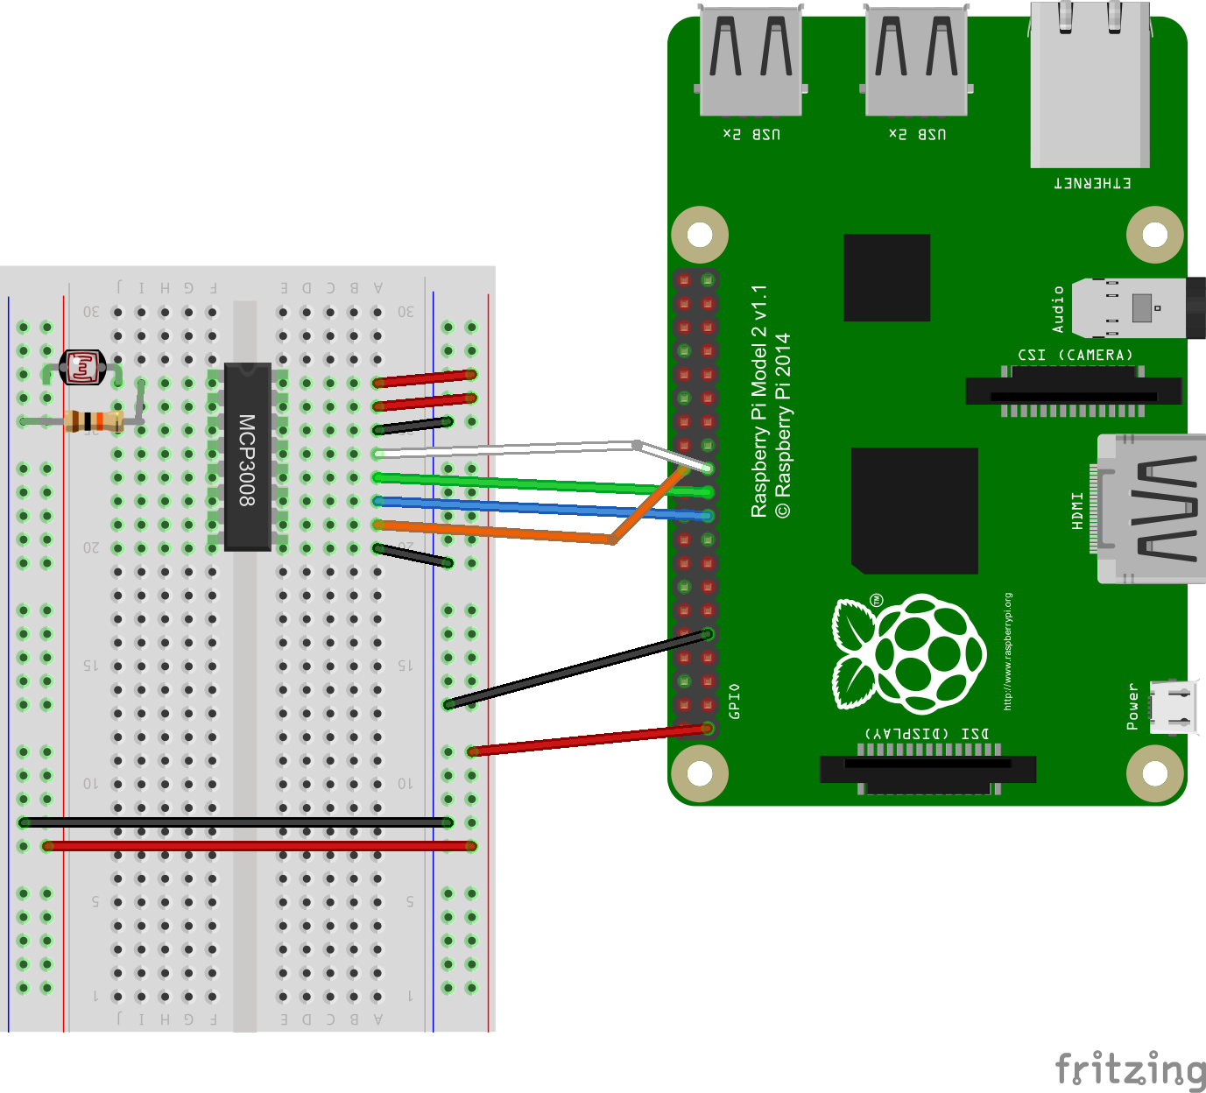

- the ADC uses a chip select of 0
- the reference voltage is 3.3V
- the photoresistor and 10K resistor form a voltage divider, and the result is tapped by channel 0
- as the photoresistor's resistance changes, channel 0's voltage also changes.
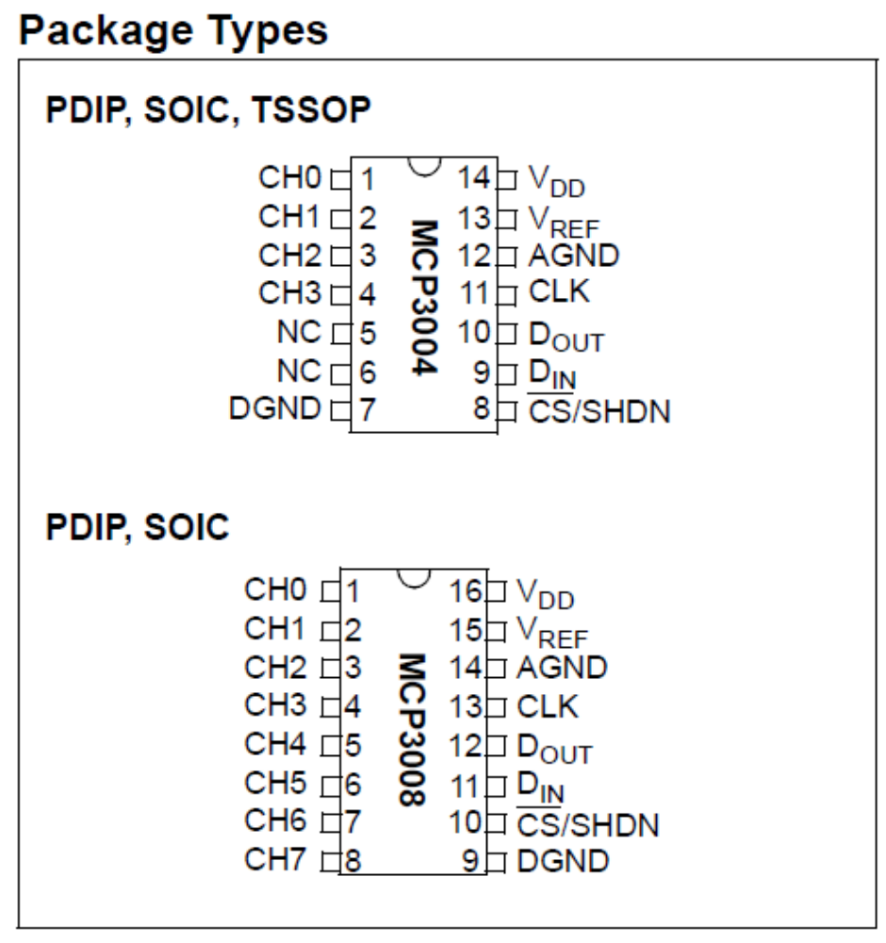

The pinouts of MCP3004 and MCP3008 are very similar. The sensor package, while explicitly supporting MCP3004, can be used to read MCP3008 as well.

$ python

>>> from sensor.MCP3004 import MCP3004
>>> # SPI bus=0, CS=0, V_ref=3.3V
>>> mcp = MCP3004(bus=0, addr=0, vref=3.3)
>>> mcp.voltage(0) # read channel 0

Varying the light intensity, you should notice the voltage changes too.

