Touchscreen
for
Raspberry Pi

How to turn Pi into a Tablet

Author: Nick Lee

This booklet will teach you how to set up these touchscreens.

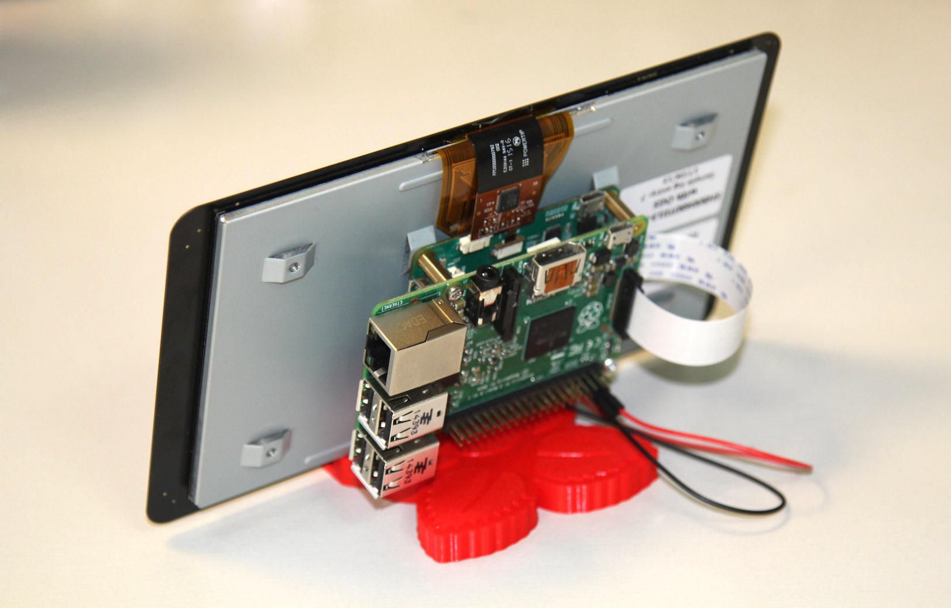 | 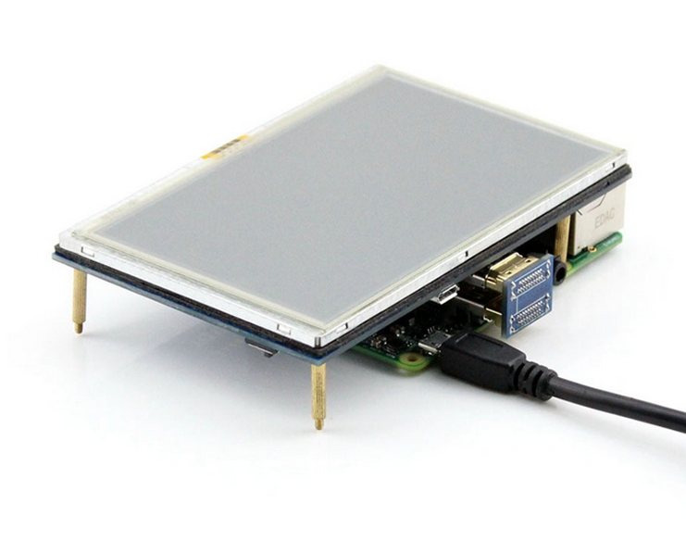
Official 7-inch | Waveshare 5-inch
DSI slot | HDMI
No calibration required. Easy setup. | Touch calibration required. Longer setup.

Official 7-inch

For assembly instructions, follow this webpage:

https://www.raspberrypi.org/blog/the-eagerly-awaited-raspberry-pi-display/

After assembly, turn on the Pi. Enter these commands:

$ sudo apt-get update
$ sudo apt-get upgrade
$ sudo reboot

That's it. Super easy!
Waveshare 5-inch

Assembly should be very obvious.

After assembly, do not turn on the Pi yet.

On a PC, go to:

http://www.waveshare.com/wiki/5inch_HDMI_LCD

Look for Drivers for Raspberry Pi, or something like that. Download a file named something like this:

LCD-show-ZZZZZZ.tar.gz

Now, this file is on the PC. We have to transfer it to the Pi.

Turn on the Pi. The display probably does not work properly. This is normal. Don't worry.

Use FTP to transfer LCD-show-ZZZZZZ.tar.gz to the Pi. Put it in the home directory.

SSH into the Pi.

$ sudo raspi-config # expand filesystem
$ tar zxf LCD-show-ZZZZZZ.tar.gz
$ cd LCD-show
$ sudo ./LCD5-show

This last command makes a lot of changes to the system, and takes a long time. Be patient. After a while, it reboots automatically.

Calibrate touchscreen

After reboot, enter the Pi again:

$ cd LCD-show
$ sudo dpkg -i xinput-calibrator_0.7.5-1_armhf.deb

This installs a calibration program on the Pi.

Plug in a mouse to the Pi. Use it to navigate to:
Menu/Preferences/Calibrate Touchscreen

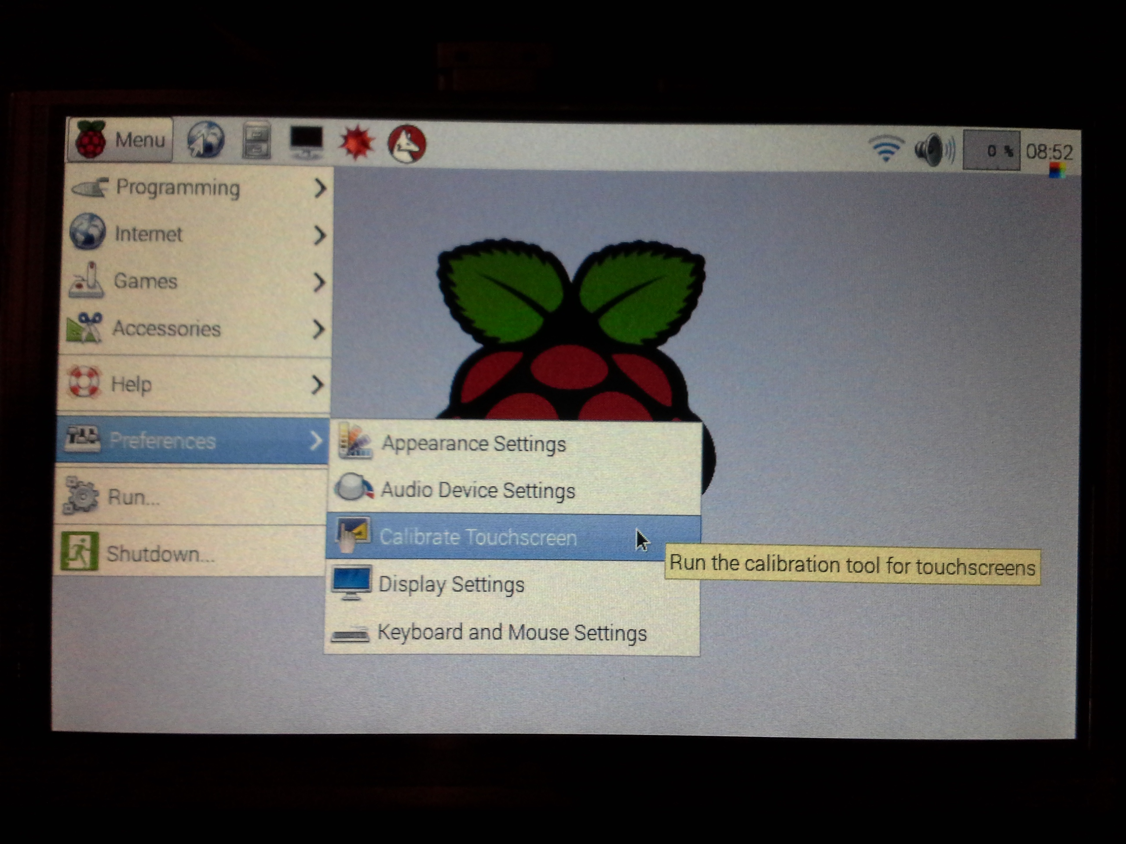

Use the stylus to dip on the indicated spots. Calibration done, you may unplug the mouse.

Virtual keyboard

$ sudo apt-get install matchbox-keyboard
$ sudo reboot

Go to Menu/Accessories/Keyboard ...

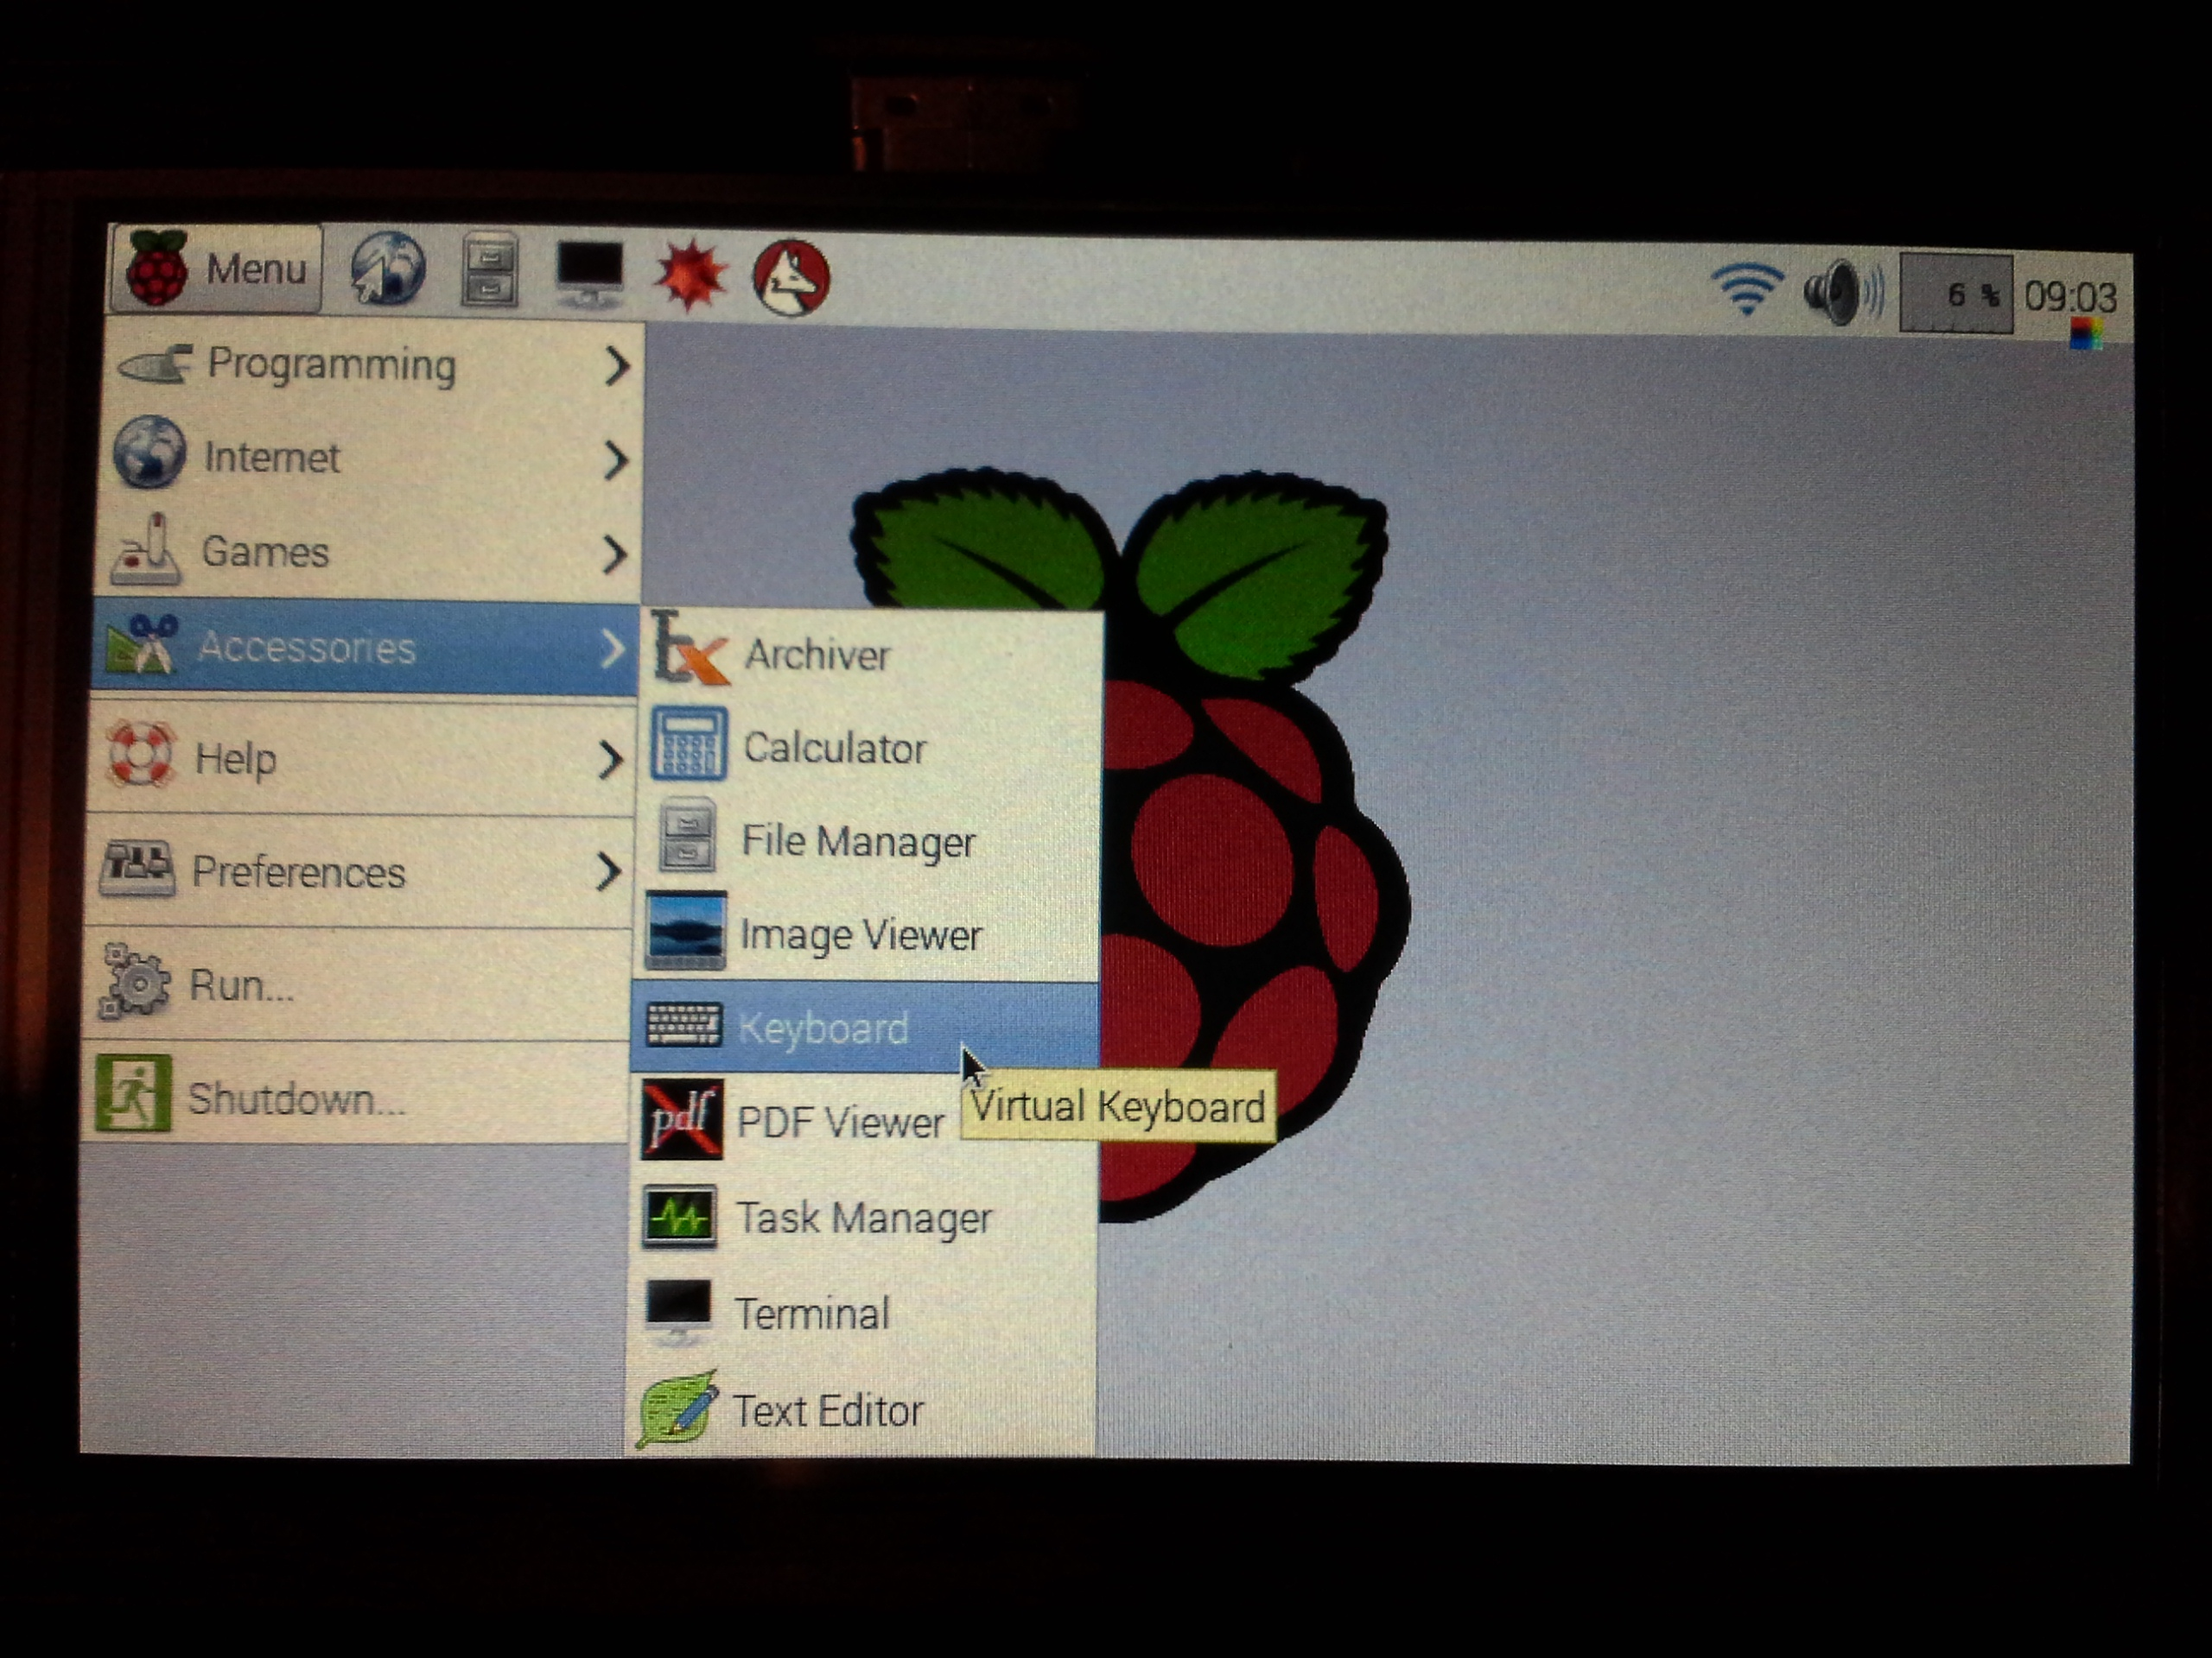

WiFi

Plug in a WiFi dongle.

Tab on the one of the icons in the top-right corner. It should be pretty easy from there ...

