How to control

Raspberry Pi

over the Internet?

Author: Nick Lee
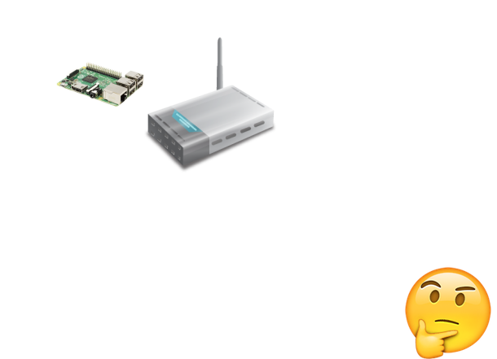

Suppose you are out on the street and want to tell your Pi at home to do something for you. How could you two get in touch?

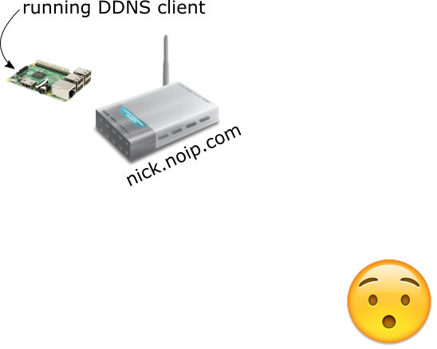

Your router should be given an IP address by the ISP. You can reach the router if you know the IP address. However, that IP address may change at any time. You have to fix the router at a certain "name".
1. Find a Dynamic DNS (DDNS) provider
2. Obtain a domain name from the DDNS provider
3. The DDNS provider should give you a DDNS client to run on a home computer. Run that DDNS client on the Raspberry Pi.
4. Your domain name will always equal your router's IP address. Use that domain name to reach the router.

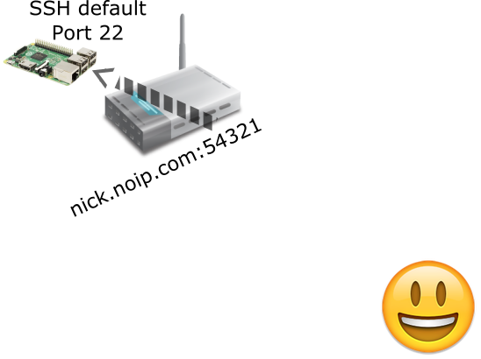

But the domain name only gets you to the router. Normally, the router would block any unsolicited traffic. To let some traffic through, you have to tell the router to open a port, and forward that port to the Raspberry Pi. This is called a port forward.
Suppose you forward router's port 54321 → Pi's port 22. You should be able to SSH the Pi with the address your-domain-name:54321, because port 22 is the SSH server's default port.

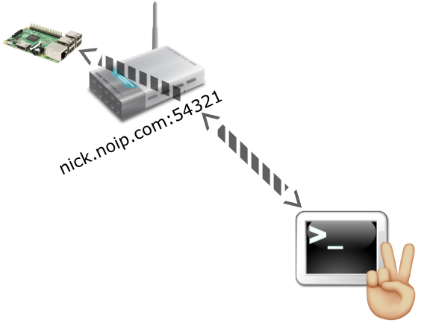

Yes!!!

If you want to access another server on the Pi, you only have to do another port forward on the router.



What if the Pi is behind a firewall? (e.g. in a school, in a company, or in a network you cannot control)
Usually, a firewall does not allow you to forward ports. There is no way to get in!

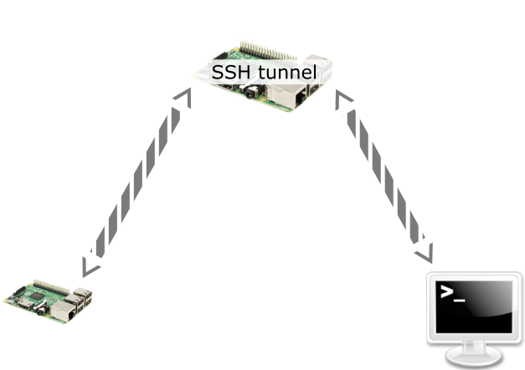

One way to bypass the firewall is to use SSH tunneling. Set up another Raspberry Pi (or any Linux computer) to be a middleman to relay traffic.

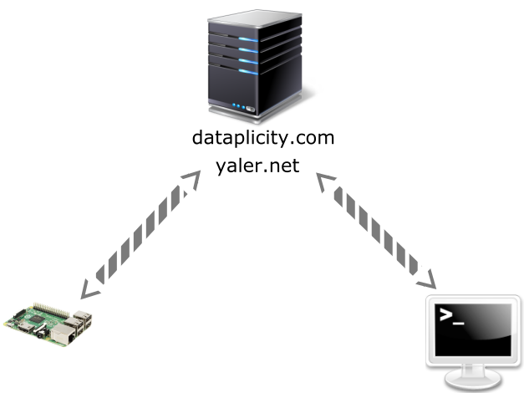

If you don't want to set up your own middleman, there are relay services available, e.g. dataplicity.com, yaler.net.

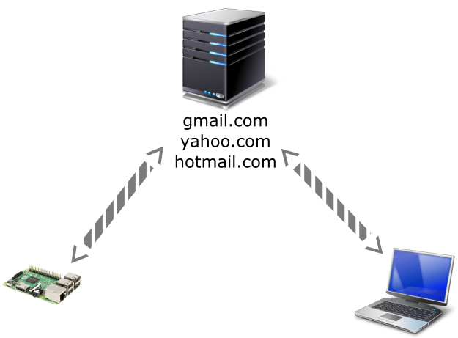

Sometimes, shell access is not what we need. For example, we may want the Pi to actively tell us something. In this case, email is a good option. We may program the Pi to send us emails.
Sending email requires SMTP, the Simple Mail Transfer Protocol. The following pages demonstrate how to send a simple text email and how to send an attachment.

Email - send simple text

!!! You may have to allow "less secure apps"（允許安全性較低的應用程式）in order to use SMTP on your Gmail account.

import smtplib
from email.mime.text import MIMEText

smtp_ssl_host = 'smtp.gmail.com' ❶
smtp_ssl_port = 465 ❷
username = 'username or email address' ❸
password = 'password' ❹
sender = 'me@gmail.com' ❺
targets = ['he@example.com', 'she@example.com'] ❻

msg = MIMEText('Hi, how are you today?') ❼
msg['Subject'] = 'Hello'
msg['From'] = sender
msg['To'] = ', '.join(targets)

server = smtplib.SMTP_SSL(smtp_ssl_host, smtp_ssl_port)
server.login(username, password)
server.sendmail(sender, targets, msg.as_string())
server.quit()

❶❷ Fill in your email service's SMTP server and port. Common ones are:

SMTP server | SSL port
smtp.gmail.com | 465
smtp.mail.yahoo.com | 465

❸❹ Fill in your username (or email address) and password. This is for login purpose.

❺ Fill in the sender's email address, which should be the same as your email address. This is for the purpose of composing the email message.

❻ Fill in the recipients' email addresses. There may be more than one. This is for the purpose of composing the email message.

❼ Compose a MIMEText email message. Remember to fill in the message body and subject.

Email - send attachment

import os
import smtplib
from email.mime.text import MIMEText
from email.mime.image import MIMEImage
from email.mime.multipart import MIMEMultipart

smtp_ssl_host = 'smtp.gmail.com'
smtp_ssl_port = 465
username = 'username or email address'
password = 'password'
sender = 'me@gmail.com'
targets = ['he@example.com', 'she@example.com']

msg = MIMEMultipart() ❶
msg['Subject'] = 'I have a picture'
msg['From'] = sender
msg['To'] = ', '.join(targets)

txt = MIMEText('I just bought a new camera.') ❷
msg.attach(txt) ❸

filepath = '/path/to/image/file'
with open(filepath, 'rb') as f:
img = MIMEImage(f.read()) ❹

img.add_header('Content-Disposition', ❺
'attachment',
filename=os.path.basename(filepath))
msg.attach(img) ❻

server = smtplib.SMTP_SSL(smtp_ssl_host, smtp_ssl_port)
server.login(username, password)
server.sendmail(sender, targets, msg.as_string())
server.quit()

❶ Compose a MIMEMultipart message.

❷❸ Create and attach a MIMEText. This should appear as the "main" text of the message.

❹ Open and read an image file into a MIMEImage.

❺ Add some descriptions of the image.

❻ Attach the image.

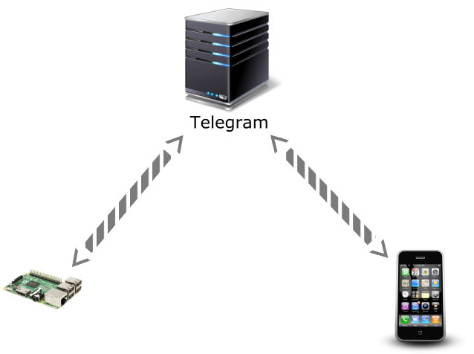

Finally, we have Telegram Bot.
Telegram is a messaging app, very much like WhatsApp. Install Telegram on your mobile phone, and then install a Telegram Bot account on Raspberry Pi. You will be able to text the Pi, and it will be able to text back. This is, no doubt, the most convenient way to communicate, and is the main subject for the rest of this booklet.

To start, install Telegram on your mobile phone.

Obtain a token

Now, you can use Telegram with your friends, but you can't use it with your Pi. You have to obtain a bot account for your Pi.

Open Telegram on the phone, search for a user called BotFather. As the name implies, he is the Father of All Bots.

Text him /newbot. He will then ask a couple of questions. Follow his guidance and you will get a token eventually, which looks something like this:

123456789:ABCdefGhIJKlmNoPQRsTUVwxyZ

That token identifies the bot account you are going to put on the Pi.

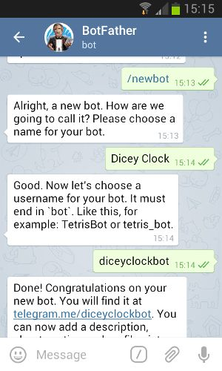

Telegram Web Version

We have a problem. How are we going to copy the lonnnnnnnng token from the phone to the Pi? By hand?

Fortunately, you can access Telegram on the web, from a PC.

On your PC, open a browser, go to:

https://web.telegram.org/

It will ask for your phone number, then send you an SMS message containing a code. Enter the code, and you will be led to an interface very similar to your Telegram app.

Find the conversation with BotFather. You should see the token right there. Now, you can easily copy-and-paste the token from the browser window to the Pi, whenever you want, as often as you want.

Test the token

Enter the Pi. Install a Python package that helps you talk to Telegram.

$ sudo pip install telepot

$ python

>>> import telepot
>>> bot = telepot.Bot('COPY TOKEN FROM BROWSER')
>>> bot.getMe()

You should see the bot's info.

>>> bot.getUpdates()
[]

It is an empty list because nobody has sent it any messages yet.

Receive messages

On the phone, search for your bot, and send it a text message.

Then, try this:

>>> from pprint import pprint
>>> response = bot.getUpdates()
>>> pprint(response)
[{u'message': {u'chat': {u'first_name': u'Nick',
u'id': 999999999,
u'last_name': u'Lee',
u'type': u'private'},
u'date': 1444723969,
u'from': {u'first_name': u'Nick',
u'id': 999999999,
u'last_name': u'Lee'},
u'message_id': 4015,
u'text': u'Hello'},
u'update_id': 100000000}]

You should see something roughly similar to the above. Note the chat field and from field. That is YOU.

Also note the update_id. It will be useful very soon.

Receive messages, again

On the phone, send the bot another message.

>>> response = bot.getUpdates()
>>> pprint(response)

Do you see two messages? How come the first message is still there?

It is because you have to acknowledge to the server that you have received a message. If you don't acknowledge, the server will keep giving the same old messages over and over, because it thinks you have not gotten them successfully.

How to acknowledge? Here is what the update_id is for. To say "I have received all update_id below 100000001", you do:

>>> bot.getUpdates(offset=100000001)

and the server will no longer bother you with update_id smaller than 100000001. Next update_id you get will be 100000001.

Your update_id will NOT be 100000000 and 100000001. Do not copy me blindly.

An easier way to receive messages

In a program, it is troublesome to keep checking messages and managing offset. Telepot can take care of that for you, and notify you whenever new messages arrive.

>>> from pprint import pprint
>>> def handle(msg):
... pprint(msg)
...
>>> bot.message_loop(handle)

Send some messages to the bot. Look at them arriving on the screen.

Send messages

>>> bot.sendMessage(999999999, 'Good evening!')

Use your own ID instead of 999999999. Do not copy me blindly.

Do you receive the message on the phone?

Can you make a bot that echo what you say? That is, it sends you back anything you send it?

echobot.py

import sys
import time
import telepot

def handle(msg):
chat_id = msg['chat']['id'] ❶
text = msg['text']

bot.sendMessage(chat_id, text) ❷

TOKEN = sys.argv[1] ❸

bot = telepot.Bot(TOKEN)
bot.message_loop(handle)
print 'Listening ...'

while 1: ❹
time.sleep(1)

❶ Extract message info

❷ Reply sender with the original text

❸ Get token as a command-line argument. It is not a good habit to embed token in source code, because token is supposed to be kept secret.

❹ Keep the program running. Otherwise, we would lose the bot and its message notification.
Dicey Clock

Let's make a more capable bot. Imagine a bot that responds to two commands:

- /roll - reply with a random integer between 1 and 6, like rolling a dice.
- /time - reply with the current time, like a clock.

I call this a Dicey Clock.

The commands start with a slash (/). We will see why in a moment.

How would you program?

diceyclock.py

import sys
import time
import random
import datetime
import telepot

def handle(msg):
chat_id = msg['chat']['id']
command = msg['text']

if command == '/roll':
n = random.randint(1,6) ❶
bot.sendMessage(chat_id, n)
elif command == '/time':
d = str(datetime.datetime.now()) ❷
bot.sendMessage(chat_id, d)

TOKEN = sys.argv[1]

bot = telepot.Bot(TOKEN)
bot. message_loop(handle)
print 'Listening ...'

while 1:
time.sleep(1)

❶ Get a random integer between 1 and 6

❷ Get the current time and turn it into a textual representation
/setcommands

According to Telegram's convention, commands for bots start with a slash (/). You may configure the bot to present a list of commands, so you don't have to type them every time.

Go back to the conversation with BotFather.

Text him /setcommands. Follow his instructions, and somewhere along the way, he should ask you for a list of command descriptions. In response, send:

roll - Roll a dice
time - Report current time

Start each line with lowercase, and no slash.

After /setcommands is complete, go back to your Dicey Clock bot. Type a slash, do you see the command list as shown on the opposite page?

It probably takes a few minutes for Telegram to update. If you don't want to wait, just exit, kill (force stop), and re-launch the Telegram app. You should see the command list right away.

