Raspberry Pi

Sensors

and

Infrared Remote Control

Author: Nick Lee
We are going to hook up a number of sensors to enable Raspberry Pi to detect its environment.

Raspberry Pi is a digital computer, and a digital computer only knows two numbers: 1 and 0.

A lot of physical quantities, e.g. temperature, humidity, wind speed, etc., are smooth-varying numbers. They can take on values such as 25.6, 98.76, or 33.3333333333. These are called analog quantities.

For Raspberry Pi to understand analog quantities, a sensor has to convert those analog quantities to digital signals.

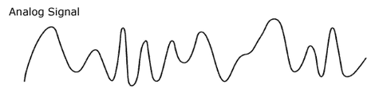

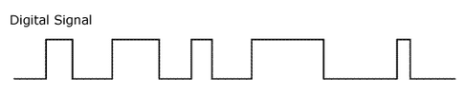

However, there are many digital "languages". Widely used are 1-wire, I2C, and SPI. A sensor may speak any of these, and you have to configure Raspberry Pi to speak the sensor's "language" before they can communicate.
DS18B20
temperature sensor

First, we try a temperature sensor. Wire it up according to the diagram below. You will need a 10K pull-up resistor.

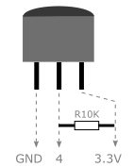

It speaks the 1-wire protocol. We have to enable 1-wire on Raspberry Pi.
Enable 1-wire

$ sudo nano /boot/config.txt  dtoverlay=w1-gpio  $ sudo reboot | Add this line. It causes Linux to load the 1-wire modules.

$ lsmod | grep w1 | Check whether the 1-wire modules are loaded. If not, check previous steps.

$ cd /sys/bus/w1/devices  $ cd 28-ZZZZZZZZ  $ cat w1_slave  c6 01 4b 46 7f ff 0a 10 17 : crc=17 YES  c6 01 4b 46 7f ff 0a 10 17 t=28375 | What do you see?  Temperature = 28.375 °C

The first line checks if the response is valid. Make sure it says "YES" at the end.

Now, you know how to read the sensor from the command-line. How do you read it using Python?
Use the sensor package

$ sudo apt-get update
$ sudo apt-get upgrade

Install software for I2C:

$ sudo apt-get install i2c-tools python-smbus

Install software for SPI:

$ sudo apt-get install python-dev
$ sudo pip install spidev

Finally, install the sensor package:

$ sudo pip install sensor

$ python

>>> from sensor.DS18B20 import DS18B20
>>> ds = DS18B20('28-ZZZZZZZZZ')
>>> ds.temperature()

What do you see? How do you access different units of the temperature?

>>> t = ds.temperature()
>>> t.C
28.937
>>> t.F
84.0866

The sensor package supports all sensors we are going to use in this course.

Next, we try to display the temperature on an LCD, which speaks the I2C protocol. We have to enable I2C on Raspberry Pi.
Enable I2C

$ sudo nano /etc/modules  i2c-dev  $ sudo nano /boot/config.txt  dtparam=i2c_arm=on  $ sudo reboot | Add this line  Add this line. It causes Linux to load the I2C modules.

$ lsmod | grep i2c | Check whether the I2C modules are loaded. If not, check previous steps.

$ i2cdetect -y 1

0 1 2 3 4 5 6 7 8 9 a b c d e f
00: -- -- -- -- -- -- -- -- -- -- -- -- --
10: -- -- -- -- -- -- -- -- -- -- -- -- -- -- -- --
20: -- -- -- -- -- -- -- -- -- -- -- -- -- -- -- --
30: -- -- -- -- -- -- -- -- -- -- -- -- -- -- -- --
40: -- -- -- -- -- -- -- -- -- -- -- -- -- -- -- --
50: -- -- -- -- -- -- -- -- -- -- -- -- -- -- -- --
60: -- -- -- -- -- -- -- -- -- -- -- -- -- -- -- --
70: -- -- -- -- -- -- -- --

Nothing is on the I2C bus, because nothing has been attached yet.
LCD1602

Wire it up:

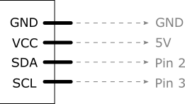

All I2C devices share 2 wires: SDA (data) and SCL (clock). Their wiring diagrams are nearly identical, except that most sensors use 3.3V power supply instead of 5V. Read their datasheets.

$ i2cdetect -y 1

Do you see the address of the LCD?

Display on the LCD

$ python

>>> from sensor.LCD1602 import LCD1602

>>> lcd = LCD1602(1, ??address??)

>>> lcd.display('Nick Lee', 1)
>>> lcd.display('Hong Kong', 2)

>>> lcd.clear()

Can you write a program that displays the temperature on the LCD?

display.py

import time
from sensor import DS18B20, LCD1602

ds = DS18B20.DS18B20('??address??')
lcd = LCD1602.LCD1602(1, ??address??)

try:
while 1:
t = ds.temperature()
lcd.display('%.1f C' % t.C, 1) ❶

time.sleep(1)
finally: ❷
lcd.clear()

❶ Display Celsius to 1 decimal place

❷ When you Ctrl-C to kill the infinite loop, an exception is raised and the finally clause is executed, clearing the display.

HTU21D
humidity and temperature sensor

Wiring: nearly identical to LCD1602, except that supply voltage is 3.3V.

$ i2cdetect -y 1

What is the sensor's address?

$ python

>>> from sensor.HTU21D import HTU21D

>>> htu = HTU21D(1, ??address??)

>>> h = htu.humidity()
>>> h.RH

>>> t = htu.temperature()
>>> t.C

BMP180
pressure and temperature sensor

Wiring: nearly identical to LCD1602, except that supply voltage is 3.3V.

$ i2cdetect -y 1

What is the sensor's address?

$ python

>>> from sensor.BMP180 import BMP180

>>> bmp = BMP180(1, ??address??)

>>> p = bmp.pressure()
>>> p.hPa

>>> t = bmp.temperature()
>>> t.C

# Look up mean sea level pressure from local observatory.
# 1009.1 hPa is only for example.
>>> a = p.altitude(1009.1)
>>> a.m

Can you write a program that displays the temperature, humidity, and pressure on the LCD?

display.py

import time
from sensor import DS18B20, HTU21D, BMP180, LCD1602

ds = DS18B20.DS18B20('??address??')
htu = HTU21D.HTU21D(1, ??address??)
bmp = BMP180.BMP180(1, ??address??)
lcd = LCD1602.LCD1602(1, ??address??)

try:
while 1:
t = ds.temperature()
h = htu.humidity()
p = bmp.pressure()

ln1 = '%.1f C %.1f%%' % (t.C, h.RH) ❶
ln2 = ' %.1f hPa' % p.hPa ❷

lcd.display(ln1, 1)
lcd.display(ln2, 2)

time.sleep(1)
finally:
lcd.clear()

❶ On first line, display Celsius and Relative Humidity.

❷ On second line, display Hectopascal.

Deal with Analog Signals

All sensors we have used so far convert analog quantities to a digital format, so Raspberry Pi can read the numbers readily. What if we got a sensor that speaks analog signals?

For example, a TMP36 temperature sensor outputs a varying voltage proportional to the temperature measured.

Another example is a photoresistor, whose resistance changes with light intensity.

How could Raspberry Pi read these non-digital values?

The solution is to insert an analog-to-digital converter (ADC) between the sensor and the Pi.



For this course, we are going to detect light intensity using a photoresistor coupled with an ADC chip, either MCP3004 or MCP3008.

Enable SPI

MCP3004/MCP3008 speaks SPI with Raspberry Pi.

$ sudo nano /boot/config.txt  dtparam=spi=on  $ sudo reboot | Add this line. It causes Linux to load the SPI modules.

$ lsmod | grep spi | Check whether the SPI modules are loaded. If not, check previous steps.
Photoresistor and MCP3008

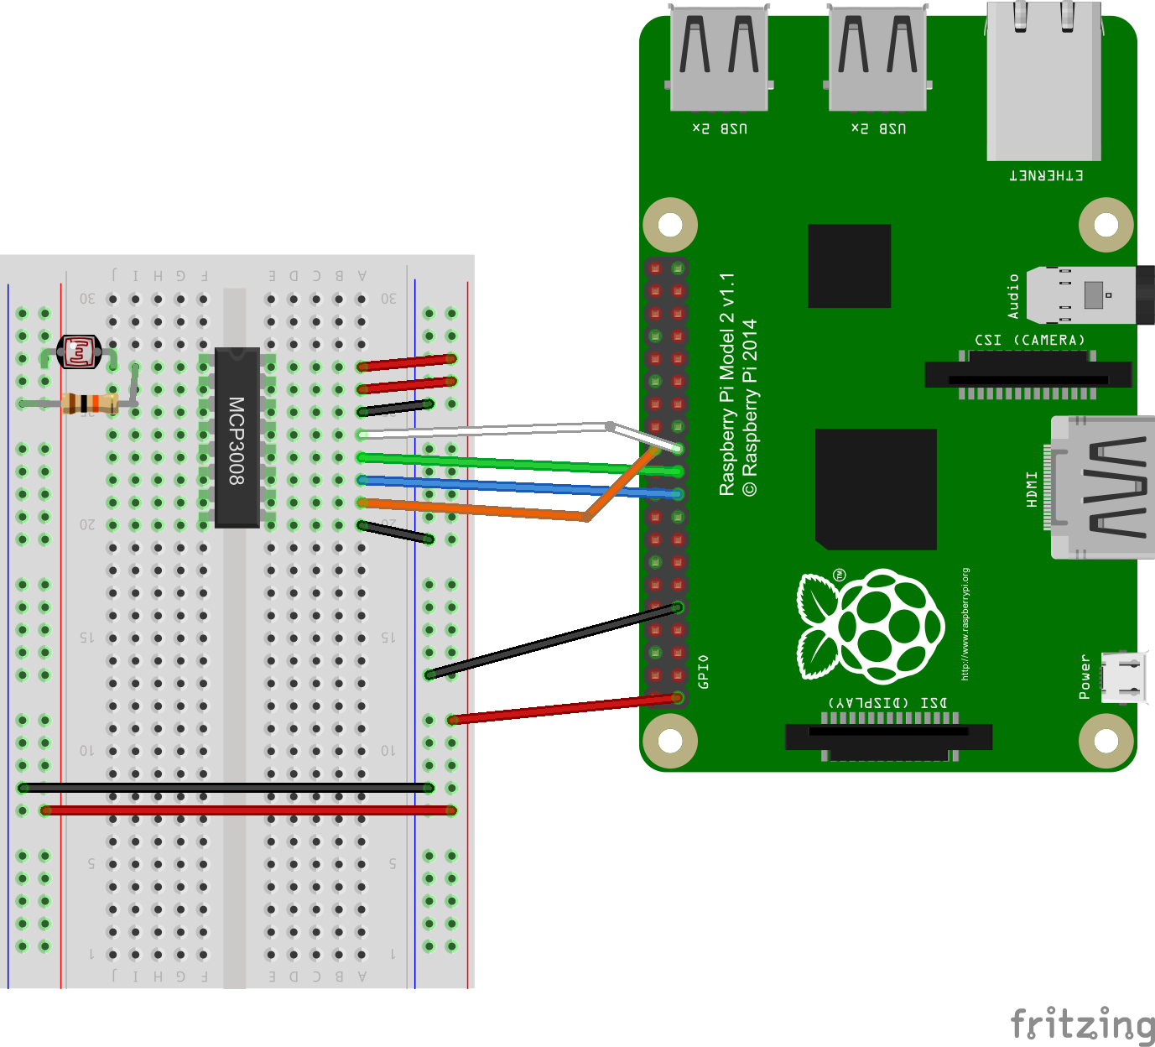

- the ADC uses a chip select of 0
- the reference voltage is 3.3V
- the photoresistor and 10K resistor form a voltage divider, and the result is tapped by channel 0
- as the photoresistor's resistance changes, channel 0's voltage also changes.
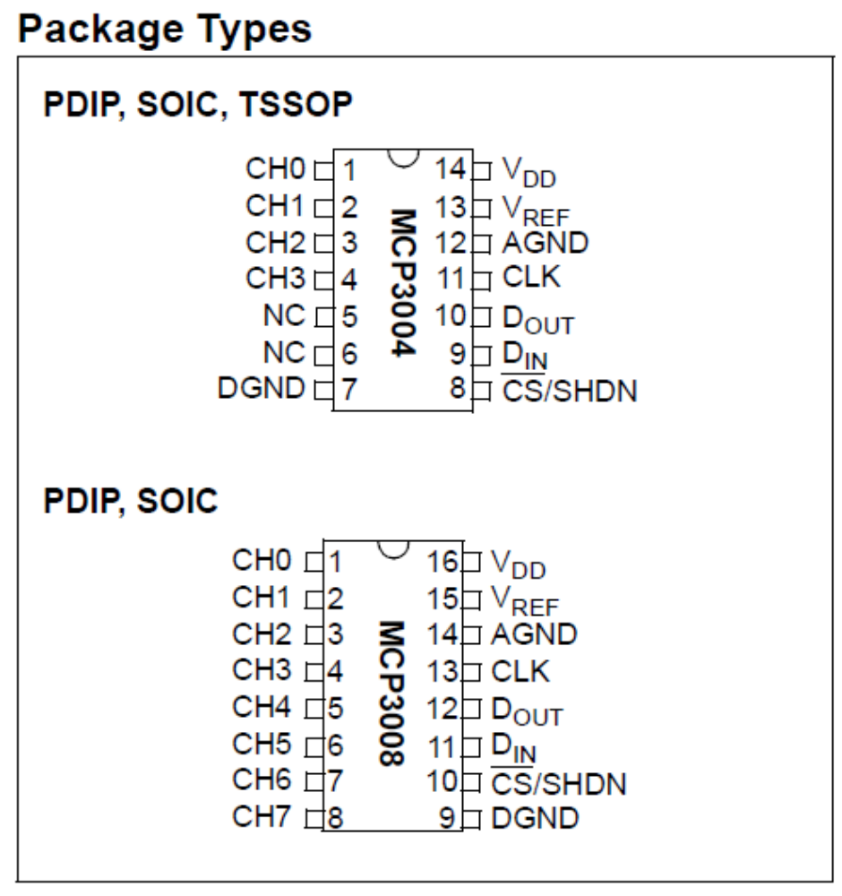

The pinouts of MCP3004 and MCP3008 are very similar. The sensor package, while explicitly supporting MCP3004, can be used to read MCP3008 as well.

$ python

>>> from sensor.MCP3004 import MCP3004
>>> mcp = MCP3004(bus=0, addr=0, vref=3.3)
>>> mcp.voltage(0) # read channel 0

Varying the light intensity, you should notice the voltage changes too.

Infrared Remote Control

Infrared radiation is simply light that we cannot see. It has a slightly longer wavelength than visible light. In remote control applications, a wavelength of 940 nm is typical.

When you hit a button on your TV remote, an IR LED repeatedly turns on and off, 38,000 times a second, to transmit information (like volume or channel control) to an IR photo sensor on your TV.

In following pages, you will learn how to "teach" Raspberry Pi about a remote's signals, in order to emit them later on to control appliances.
VS1838B and IR LED
IR receiver wavelength 940 nm

Connect IR receiver to GPIO 18. | 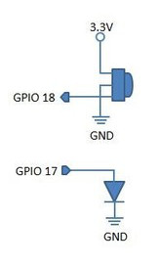
Connect IR LED to GPIO 17. No resistor is needed.

LIRC
Linux Infrared Remote Control

$ sudo apt-get install lirc

$ sudo nano /boot/config.txt

# Add this line
dtoverlay=lirc-rpi,gpio_in_pin=18,gpio_out_pin=17

$ sudo nano /etc/lirc/hardware.conf

# Change these parameters
DRIVER="default"
DEVICE="/dev/lirc0"
MODULES="lirc_rpi"

$ sudo reboot

Check whether LIRC modules are loaded:

$ lsmod | grep lirc

Check the IR receiver:

$ mode2 -d /dev/lirc0

Aim the remote to the IR receiver. Press some buttons. If the IR receiver is working properly, you should see something like this:

pulse 2729290
space 8953
pulse 4475
space 562
pulse 556
space 563
pulse 556

Ctrl-C to exit when you are satisfied.
irrecord

We have to record the keys so Raspberry Pi can reproduce the signals. The keys have different names. Use the following to find out available names:

$ irrecord -list-namespace
$ irrecord -list-namespace | grep VOLUME
$ irrecord -list-namespace | grep POWER
$ irrecord -list-namespace | grep CHANNEL
$ irrecord -list-namespace | grep VIDEO

At first, you may want to record a few keys only. Suppose you want to record for your TV, do this to start the recording process:

$ irrecord -d/dev/lirc0 tv.conf

Read and follow the instructions carefully.

When done, data should be written to the file, tv.conf. Open the file, change the remote's name:

Before | After
begin remote  name tv.conf  ... | begin remote  name tv  ...

You will use the name to refer to the appliance (in this case, the TV) later on. Better not to name it like a file.

Then, append the file content to /etc/lirc/lircd.conf

Finally, restart the lirc service:

$ sudo service lirc restart

irsend

To list all configured remote names:

$ irsend LIST "" ""

To list all codes of <remote-name>:

$ irsend LIST <remote-name> ""

To send a code once:

$ irsend SEND_ONCE <remote-name> <SOME_KEY>

For example:

$ irsend SEND_ONCE tv KEY_VOLUMEUP

Hint: Point the top of IR LED to the appliance. IR radiation is strongest emitted from the top.

Invoke irsend from Python

>>> import subprocess
>>> subprocess.call(['irsend', 'SEND_ONCE', 'tv', 'KEY_VOLUMEUP'])

Note that you have to split the command into words in a list. You may also do this:

>>> subprocess.call('irsend SEND_ONCE tv KEY_VOLUMEUP'.split())

Or this:

>>> subprocess.call('irsend SEND_ONCE tv KEY_VOLUMEUP', shell=True)

