Raspberry Pi
入門體驗

Author: Nick Lee
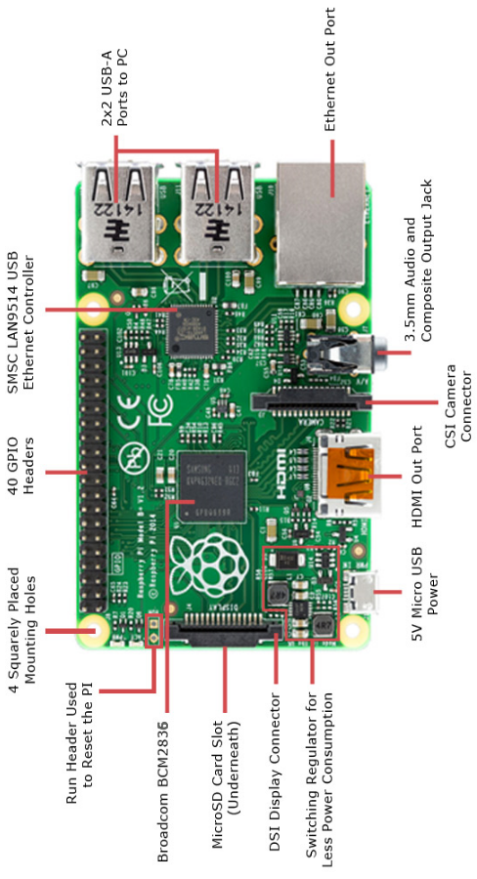
Raspberry Pi 4 Model B vs Arduino

 | 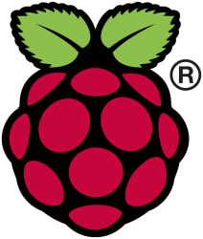 | 
 | Micro-computer | Micro-controller
 | Has OS  Run your program  along with many others | No OS  Run your program  ONLY
 | Python, NodeJS, Ruby,  Java, C, C++, etc. | C++
 | Knowledge of Linux required | Program and debug on Windows
GPIO pins | Digital only | Analog and digital
Processor | BCM2711  (Broadcom) | ATmega  (Atmel)
Speed | 1.5 GHz, quad-core | 8-16 MHz
RAM | 2 GB | 32-256 KB

Media Center, Music Player
OSMC
RuneAudio
Volumio

LibreELEC

FREE Video Add-ons
The Wall Street Journal
CBC.ca News
TED Talks
DIY Network

FREE Game Add-ons
Netwalk Game
Mr. Boom (Bomberman)
2048

懷舊遊戲機
RetroPie
Recalbox

Lakka

Keys: Arrows, Enter, Backspace, Escape

Main Menu
⤷ Information
⤷ Network Information
⤷ System Information

Settings
⤷ WiFi
⤷ Service

SSH login: root, root

Load Core
⤷ 2048

Online Updater
⤷ Content Downloader
⤷ DOS
⤷ Wolfenstein 3D
⤷ Atari-2600
⤷ Sheep It Up
⤷ ChaiLove
⤷ Floppy Bird

Load Content
⤷ Downloads
⤷ Playlists

Raspbian (Raspberry Pi OS)
Wheezy
Jessie
Stretch

Buster

SSH login: pi, raspberry

pi@raspberrypi:~ $ sudo raspi-config

身處資料夾，current directory

機名，hostname

用戶名，username

如何找出IP地址？

- Router：登入路由器管理介面（通常是192.168.?.1），查看DHCP使用者列表之類。

- hostname.local：電腦需要支援multicast DNS

- Network scan：下載一個網絡掃描軟件，掃吓內聯網有什麼電腦、什麼IP。
掃描軟件可試吓Advanced Port Scanner或Angry IP Scanner，或Fing手機應用程式。

- Plug n Pi：下載Plug n Pi手機應用程式，以USB線連接手機及樹莓批，手機就可查看樹莓批的IP地址。
手機必須是Android。樹莓批必須裝有Plug n Pi Server軟件。
VNC

On a PC within the same network:

- Download RealVNC viewer
- Connect to Pi's IP address

You may find the desktop resolution very small. To make it bigger, you may create a new desktop:

$ vncserver -geometry 1000x800

Take note of the IP address:display number printed out, e.g. 192.168.0.103:1

Connect to that <IP address:display number>.

For more tips on using Raspberry Pi:

https://www.raspberrypi.org/documentation
ls
list

ls | What things are there?

ls -l | Give me more details.

ls -a | Show me the hidden stuff (those starting with a dot).

ls –l -a | Chain two options together to double the benefits.

ls –la | You may also chain them like this.

ls –tl | Sort by date.

ls directory | What is in that directory?

man ls | Explain this command.

ls --help | Another way to explain this command.  But the output overflows the page, what can I do?

cd
change directory

cd directory | Go to a directory.

cd .. | Go up a level.  Double-dot means the parent directory.

cd . | Stay in the same directory.  Single-dot means the current directory.  In practice, you never do this. It is here for educational purposes only.

cd ~ | Go back to home directory.  The tilde (~) means home directory.

cd | Go back to home directory. Equivalent to cd ~.

pwd
print working directory

pwd | Where am I?

cp
copy

cp oldfile newfile | Make a copy of oldfile, and name it newfile.

cp -r olddir newdir | Copy an entire directory.  “-r” means “recursive”. That is, copy sub-directories, and their sub-directories, and their sub-directories, and so on.  Type cp --help or man cp to review the options.

mv
move or rename

mv oldfile newfile | oldfile now becomes newfile.

mv file dir | Move file to directory.

rm
remove

rm filename | Delete a file.

rm -r directory | Delete a directory.  “-r” means “recursive”. That is, delete sub-directories, and their sub-directories, and their sub-directories, and so on.

mkdir
make directory

mkdir directory | Create a new directory.

rmdir
remove directory

rmdir directory | You can only remove an empty directory.  Delete everything inside first, or use rm -r.

nano
a text editor

nano | When you want to write something, bring up a text editor.

nano filename | Edit an existing file.  Two shortcuts you need to know, for now:  Ctrl-O to save  Ctrl-X to exit

more or less
show text content, or show output page-by-page

less filename | Display file content.  If content is longer than one page:  - Use ← ↑ ↓ → [Page Up/Down] to navigate  - Type q to quit.

ls --help | less | Display the preceding command’s output in a page-by-page manner.  “|” is called a “pipe”. We will see more of it later.  If you have trouble typing the “|”:  - Enter sudo raspi-config  - Select Internationalisation options  - Select Change Keyboard Layout, this may take a while.  - Linux should have detected the keyboard for you. Press [enter].  - Then, it asks for Keyboard Layout. Default is English (UK). DO NOT trust that. You should select Other, then English (US), then English (US) again.  - Finally, it asks a few more questions. Press [enter] to skip all of them.  - Finish and reboot.

sudo reboot, sudo halt -h
Reboot and shutdown

sudo reboot | “sudo” means “superuser do”.  You cannot reboot the machine as an ordinary user. You must turn yourself into a superuser first.

sudo halt -h | To shutdown the machine, you also have to be a superuser.  Type halt --help or man halt to review the options.  DO NOT unplug the power until Raspberry Pi is completely shut down. The SD card may be corrupted if power is pulled prematurely.  Pay attention to the blinking lights on Raspberry Pi. Wait until only one steady red light is left and all other lights are dead. That’s when you can unplug the power safely.  How do you turn it on again? Just re-plug the power.

