Raspberry Pi Sensors

Author: Nick Lee

Raspberry Pi is a digital computer, and a digital computer only knows two numbers: 1 and 0.

A lot of physical quantities, e.g. temperature, humidity, wind speed, etc., are smooth-varying numbers. They can take on values such as 25.6, 98.76, or 33.3333333333. These are called analog quantities.

For Raspberry Pi to understand analog quantities, a sensor has to convert those analog quantities to digital signals.

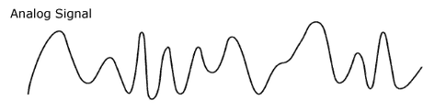

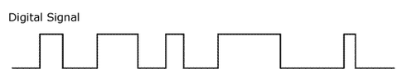

There are many digital "languages", e.g. 1-wire, I2C, and SPI. You have to configure Raspberry Pi to speak the sensor's "language" before they can communicate.

Enable

$ sudo raspi-config

⤷ Interfacing Options

⤷ 1-Wire ?
⤷ I2C ?
⤷ SPI ?

DS18B20
temperature sensor

This is a 1-wire sensor. Wire it up according to the diagram below. You need a 10K pull-up resistor.

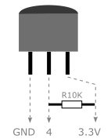

$ cd /sys/bus/w1/devices
$ ls

What do you see?

Install sensor package

$ sudo pip3 install sensor

$ python3

>>> from sensor.DS18B20 import DS18B20
>>> ds = DS18B20('28-ZZZZZZZZZ')
>>> ds.temperature()

What do you see? How do you access different units of the temperature?

>>> t = ds.temperature()
>>> t.C
28.937
>>> t.F
84.0866

Check I2C bus

$ i2cdetect -y 1

0 1 2 3 4 5 6 7 8 9 a b c d e f
00: -- -- -- -- -- -- -- -- -- -- -- -- --
10: -- -- -- -- -- -- -- -- -- -- -- -- -- -- -- --
20: -- -- -- -- -- -- -- -- -- -- -- -- -- -- -- --
30: -- -- -- -- -- -- -- -- -- -- -- -- -- -- -- --
40: -- -- -- -- -- -- -- -- -- -- -- -- -- -- -- --
50: -- -- -- -- -- -- -- -- -- -- -- -- -- -- -- --
60: -- -- -- -- -- -- -- -- -- -- -- -- -- -- -- --
70: -- -- -- -- -- -- -- --

Nothing is on the I2C bus, because nothing has been attached yet.
SHT20
humidity and temperature sensor

$ i2cdetect -y 1

What is the sensor's address?

$ python3

>>> from sensor.SHT20 import SHT20

>>> sht = SHT20(1, ??address??)

>>> h = sht.humidity()
>>> h.RH

>>> t = sht.temperature()
>>> t.C

BMP180
pressure and temperature sensor

$ i2cdetect -y 1

What is the sensor's address?

$ python3

>>> from sensor.BMP180 import BMP180

>>> bmp = BMP180(1, ??address??)

>>> p = bmp.pressure()
>>> p.hPa

>>> t = bmp.temperature()
>>> t.C

# Look up mean sea level pressure from local observatory.
# 1009.1 hPa is only for example.
>>> a = p.altitude(msl=1009.1)
>>> a.m

Deal with Analog Signals

All sensors we have used so far convert analog quantities to a digital format, so Raspberry Pi can read the numbers readily. What if we get a sensor that gives analog signals?

For example, a TMP36 temperature sensor outputs a varying voltage proportional to the temperature measured.

Another example is a photoresistor, whose resistance changes with light intensity.

How could Raspberry Pi read these non-digital values?

The solution is to insert an analog-to-digital converter (ADC) between the sensor and the Pi.



Photoresistor and MCP3008

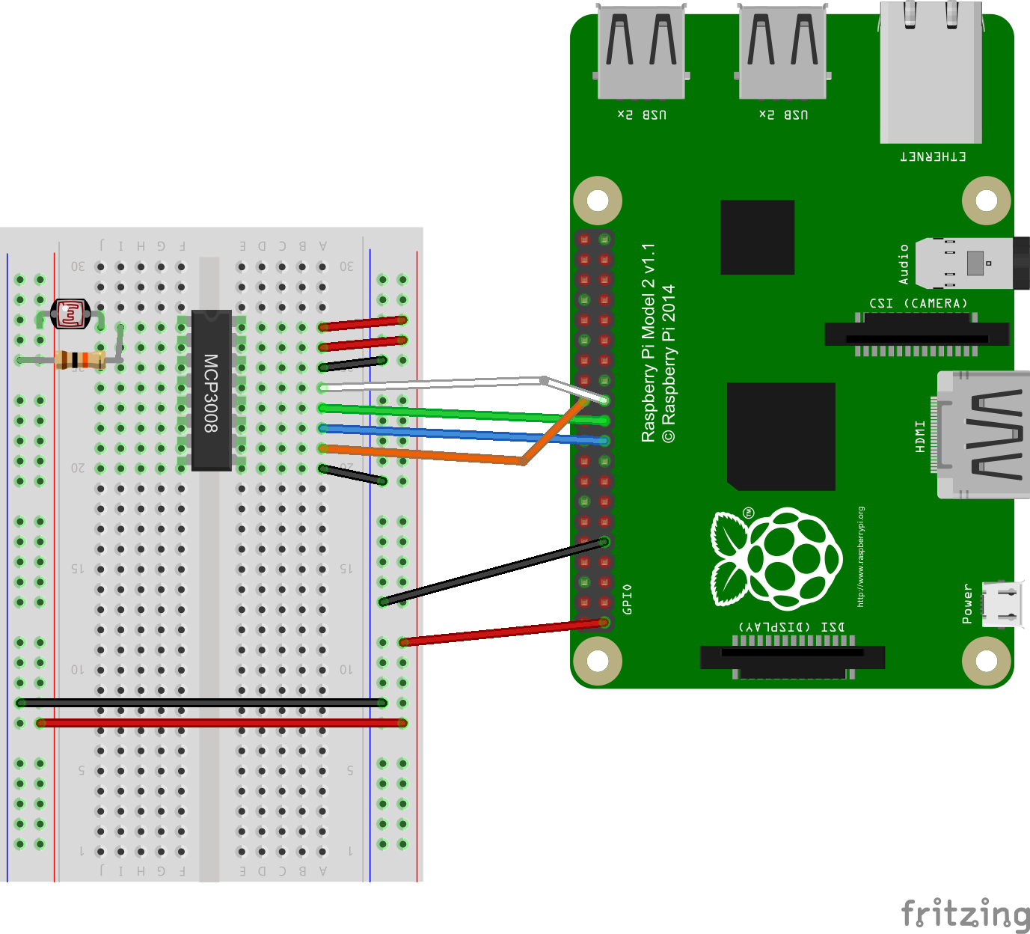

- the ADC uses a chip select of 0
- the reference voltage is 3.3V
- the photoresistor and 10K resistor form a voltage divider, and the result is tapped by channel 0
- as the photoresistor's resistance changes, channel 0's voltage also changes.
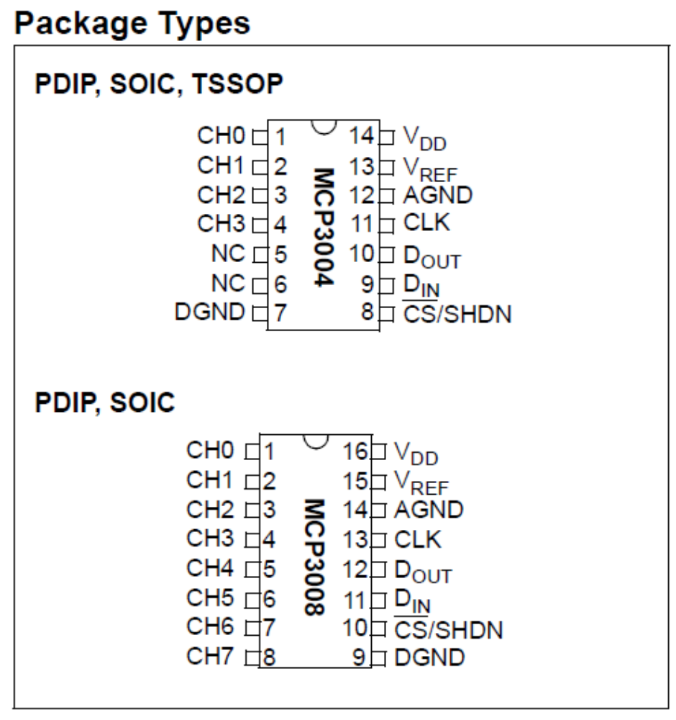

The pinouts of MCP3004 and MCP3008 are very similar. The sensor package, while explicitly supporting MCP3004, can be used to read MCP3008 as well.

$ python3

>>> from sensor.MCP3004 import MCP3004
>>> mcp = MCP3004(bus=0, addr=0, vref=3.3)
>>> mcp.voltage(0) # read channel 0

Varying the light intensity, you should notice the voltage changes too.

