How to use Raspberry Pi

and

Basic Linux Skills

Author: Nick Lee
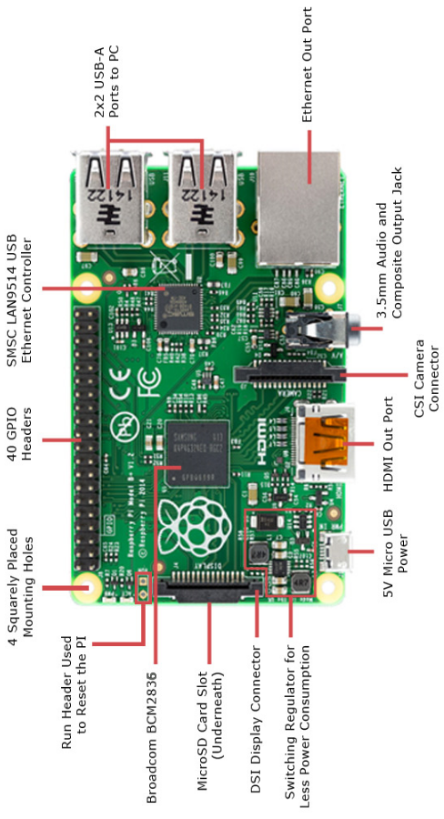
Raspberry Pi 3 Model B vs Arduino

 | 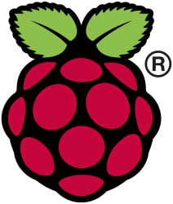 | 
 | Micro-computer | Micro-controller
 | Has OS  Run your program  along with many others | No OS  Run your program  ONLY
 | Python, NodeJS, Ruby,  Java, C, C++, etc. | C++
 | Knowledge of Linux required | Program and debug on Windows
GPIO pins | Digital only | Analog and digital
Processor | BCM2837  (Broadcom) | ATmega  (Atmel)
Speed | 1.2 GHz, quad-core | 8-16 MHz
RAM | 1 GB | 32-256 KB

From Raspberry Pi's official documentations:
[Pi 3] can still be run from a 5V micro-USB power adapter ... we’re recommending a 2.5A adapter if you want to connect power-hungry USB devices to the Raspberry Pi.
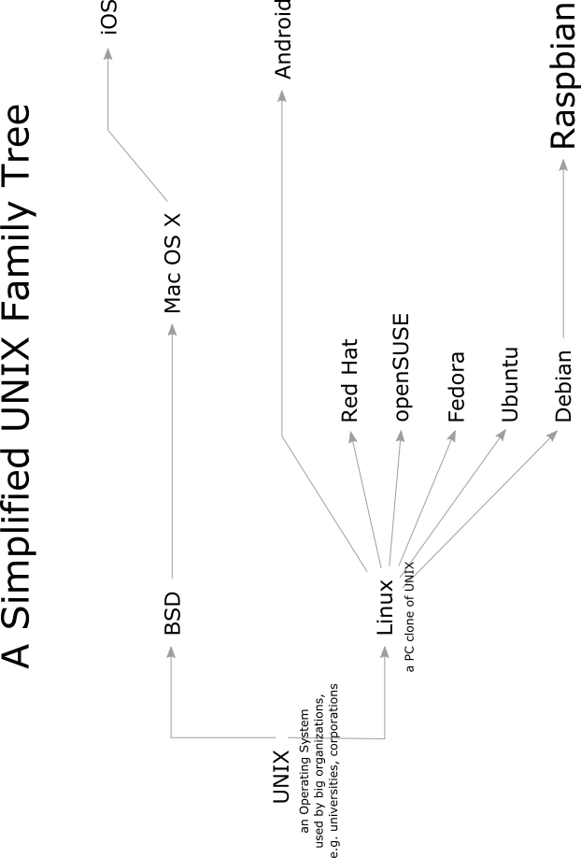
Prepare an SD card

- Download Raspbian, a Linux flavor commonly used for Raspberry Pi.
- Go to the Downloads section on raspberrypi.org
- Find Raspbian. Download its zip file.
- Unzip it. The resulting file is called a disk image.
- Download and install an image burner program.
- On Windows, search for Win32DiskImager.
- On Mac, search for Pi Filler.
- With the program you have just installed, burn the Raspbian image onto an SD card.
- Insert the SD card to a Raspberry Pi.

Beginners like to use it this way ...

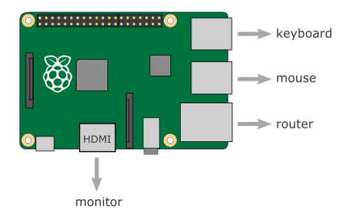

Use it like a normal computer.
Experienced users like to use it this way ...

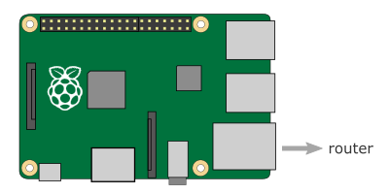

On a PC within the same network:

- Open a browser
  - go to the router interface
  - find the Pi's internal IP address

- SSH using PuTTY
  - username: pi
  - password: raspberry

In a lack of network ...

Use the console cable.

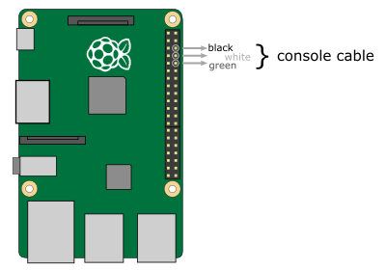

On Pi:

- Edit /boot/config.txt
- Add enable_uart=1

On a PC:

- Install PL2303 Windows driver
- Plug the console cable's USB end to the PC
- Go to Control Panel/Device Manager
- Find the COM port of the console cable
- Connect using PuTTY: Serial, speed=115200

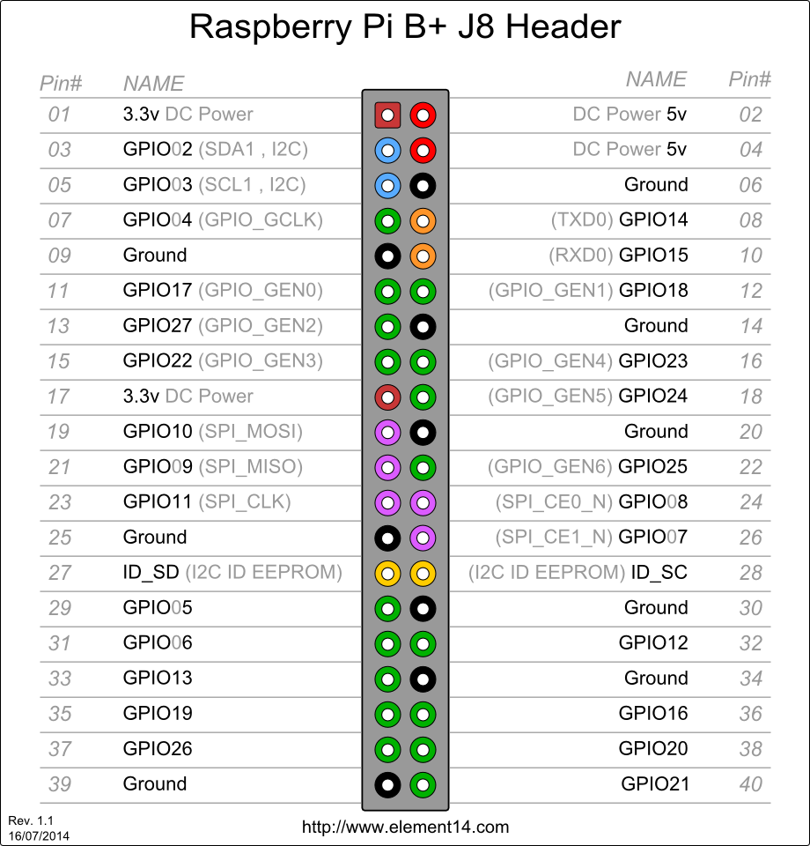
Initial Configuration

$ sudo raspi-config

- Expand Filesystem: Ensure that all space on SD card can be used.
- Change User Password: Doesn’t really matter, but good practice.
Notice that, as you type the password, the cursor NEVER moves. This is normal. Linux does not reveal the length of password as you type. If you type wrong, [backspace] all the way to start anew, or just [enter] to give yourself another chance.
If you do not change password, the default is:
User: pi
Password: raspberry
- Finish and Reboot.

After reboot, update the system:
$ sudo apt-get update
$ sudo apt-get upgrade

If you find it slow responding to SSH login, you may modify the SSH server's configurations as follows:
- Edit /etc/ssh/sshd_config
- Add UseDNS=no

It is nearly impossible to use Raspberry Pi without knowing Linux. You have to be familiar with some basic commands.
ls
list

ls | What things are there?

ls -l | Give me more details.

ls -a | Show me the hidden stuff (those starting with a dot).

ls –l -a | Chain two options together to double the benefits.

ls –la | You may also chain them like this.

ls –tl | Sort by date.

ls directory | What is in that directory?

man ls | Explain this command.

ls --help | Another way to explain this command.  But the output overflows the page, what can I do?

cd
change directory

cd directory | Go to a directory.

cd .. | Go up a level.  Double-dot means the parent directory.

cd . | Stay in the same directory.  Single-dot means the current directory.  In practice, you never do this. It is here for educational purposes only.

cd ~ | Go back to home directory.  The tilde (~) means home directory.

cd | Go back to home directory. Equivalent to cd ~.

pwd
print working directory

pwd | Where am I?

cp
copy

cp oldfile newfile | Make a copy of oldfile, and name it newfile.

cp -r olddir newdir | Copy an entire directory.  “-r” means “recursive”. That is, copy sub-directories, and their sub-directories, and their sub-directories, and so on.  Type cp --help or man cp to review the options.

mv
move or rename

mv oldfile newfile | oldfile now becomes newfile.

mv olddir newdir | Also works on directories.

rm
remove

rm filename | Delete a file.

rm -r directory | Delete a directory.  “-r” means “recursive”. That is, delete sub-directories, and their sub-directories, and their sub-directories, and so on.

mkdir
make directory

mkdir directory | Create a new directory.

rmdir
remove directory

rmdir directory | You can only remove an empty directory.  Delete everything inside first, or use rm -r.

nano
a text editor

nano | When you want to write something, bring up a text editor.

nano filename | Edit an existing file.  Two shortcuts you need to know, for now:  Ctrl-O to save  Ctrl-X to exit

more or less
show text content, or show output page-by-page

less filename | Display file content.  If content is longer than one page:  - Use ← ↑ ↓ → [Page Up/Down] to navigate  - Type q to quit.

ls --help | less | Display the preceding command’s output in a page-by-page manner.  “|” is called a “pipe”. We will see more of it later.  If you have trouble typing the “|”:  - Enter sudo raspi-config  - Select Internationalisation options  - Select Change Keyboard Layout, this may take a while.  - Linux should have detected the keyboard for you. Press [enter].  - Then, it asks for Keyboard Layout. Default is English (UK). DO NOT trust that. You should select Other, then English (US), then English (US) again.  - Finally, it asks a few more questions. Press [enter] to skip all of them.  - Finish and reboot.

sudo reboot, sudo halt -h
Reboot and shutdown

sudo reboot | “sudo” means “superuser do”.  You cannot reboot the machine as an ordinary user. You must turn yourself into a superuser first.

sudo halt -h | To shutdown the machine, you also have to be a superuser.  Type halt --help or man halt to review the options.  DO NOT unplug the power until Raspberry Pi is completely shut down. The SD card may be corrupted if power is pulled prematurely.  Pay attention to the blinking lights on Raspberry Pi. Wait until only one steady red light is left and all other lights are dead. That’s when you can unplug the power safely.  How do you turn it on again? Just re-plug the power.

sudo apt-get
Advanced Package Tool: install and update software

sudo apt-get update | Update your system’s package list.

sudo apt-get upgrade | Upgrade all your installed packages to their latest versions.

sudo apt-get install package_name | You may install any applications, as long as you know the name.
find
look for files with certain properties

find . -name *.wav | Any .wav files in current directory?

find python_games -name *.py | Any .py files in python_games directory?

find . -type d | Any directories in current directory?  “-type d” tells it to show directories only.

find directory -type f | Any files in that directory?  “-type f” tells it to show files only.  Type man find or find --help to learn more.

grep
look for lines with certain words

grep -lr import python_games | Which files in python_games contain the word “import”?

grep -Hr word directory_or_file | Try the command with the -H option. What are the differences?  You may look for any word in any directory or file with this command.

ps aux | It tells you what processes are running on the Raspberry Pi. The output is usually very long. What can you do?

ps aux | less | You may “pipe” it to a less command to read the information page-by-page.

ps aux | grep ssh | Sometimes, you want to look for a process to see if it is running, or how many of it are running.  For example, if you want to list all ssh-related processes, you may “pipe” the output to a grep command that looks for “ssh” and only shows those lines.

which
Which file is a command referring to?

which command | I have introduced many Linux commands so far. But what exactly is a command?  In Linux, a command is just a file that gets executed. For example, when you type ls, Linux executes a file called “ls”. When you type find, Linux executes a file called “find”.  But where are those files?

which ls | Use which to find out.

which find | Also try this.  ls and find live in different locations. How does Linux know where to look?

echo, export
show me the variable, modify the variable

echo $PATH | Linux has an environment variable called PATH. It is a list of directories, separated by colons (:).  Linux looks for executables in those directories.  Linux has many environment variables other than PATH, but PATH is the only one concerning us now.

export PATH=$PATH:/home/pi | You may add a directory to PATH.

chmod
change mode

chmod +x filename | Turn filename into an executable.  After this, filename may be used as a command. Run it by typing:  ./filename  The preceding “./” is to tell Linux to look for filename in current directory. If current directory is included in PATH, there is no need to type “./”.

chmod -x filename | Turn filename into an ordinary, non-executable file.

raspistill
capture photo

raspistill -o out.jpg | Capture photo to a file.

To view the photo, you have to use VNC or connect a monitor through HDMI. Open the file manager, and double-click on the file.

raspistill -o out.jpg -t 1000 | Wait 1 second before capturing. Default is 5 seconds.

raspistill -o out.jpg -hf -vf | Flip image horizontally and vertically.

raspistill | less | Display options.

Interesting options:

-t, --timeout
-hf, --hflip
-vf, --vflip
-w, --width
-h, --height
-ss, --shutter
-ifx, --imxfx

raspivid
capture video

raspivid -o vid.h264 | Record a 5-second video.

omxplayer -p -o hdmi vid.h264 | View the video on an HDMI display. This will not work on VNC because omxplayer makes use of hardware acceleration in the GPU (graphics processing unit), which is only available to HDMI output.

raspivid -o vid.h264 -t 2000 | Record a 2-second video.

raspivid | less | Display options. They are similar to those of raspistill.

mount
add an external drive

Plug in a USB "finger". Then try:

$ ls /dev/sd*

/dev/sda /dev/sda1

Unlike Windows, Linux does not have the concept of drives, e.g. C: or D:. You have to mount the drive as part of the filesystem in order to access files on that drive.

$ mkdir usbfinger
$ sudo mount /dev/sda1 usbfinger

Look into the directory usbfinger. What do you see?

After you finish using the USB finger, unmount it:

$ sudo umount /dev/sda1

Other useful commands

ps - report a snapshot of current processes

top - report current processes in an interactive manner

kill - send a signal to a process. As the name implies, it is often used to kill a process.

dd - convert and copy a file, often used to create backups.

df - report disk space usage

ifconfig - network interface information

wget - download files from the internet

tar - archive and (de)compress files

unzip - decompress zip files

Inspect Pi's network interfaces

$ ifconfig

You should see three network interfaces:

- eth0 - the ethernet adapter (where the LAN cable is plugged in)
- lo - local loopback (a special, virtual interface that your computer uses to communicate with itself)
- wlan0 - the built-in wireless LAN adapter, which you are going to use.

WiFi Scan

$ iwlist wlan0 scan

It spills out a lot of technical stuff. Use grep to find what we need.

$ iwlist wlan0 scan | grep SSID
$ iwlist wlan0 scan | grep -e SSID -e Quality

If you don't see any networks, try restarting the interface:

$ sudo ifdown wlan0
$ sudo ifup wlan0

Or, reboot:

$ sudo reboot

Make a WiFi connection

$ wpa_passphrase <ssid> <passphrase>
network={
......
......
......
}

This is called a network configuration block. You have to append this block to the file /etc/wpa_supplicant/wpa_supplicant.conf

You can copy-and-paste by hand, or do it on command line:

$ wpa_passphrase <ssid> <passphrase> |
sudo tee -a /etc/wpa_supplicant/wpa_supplicant.conf

Check the file content:

$ sudo more /etc/wpa_supplicant/wpa_supplicant.conf

Restart the interface:

$ sudo ifdown wlan0
$ sudo ifup wlan0

Or, reboot:

$ sudo reboot

Check connection status:

$ ifconfig
$ wpa_cli -i wlan0 status

Other types of WiFi networks

The network configuration block generated by wpa_passphrase is for WPA wireless networks. This is the most common type of networks.

There are also WEP (old technology) and open networks (no security key), which require different network configuration blocks.

# WEP
network={
ssid="SSID"
key_mgmt=NONE
wep_tx_keyidx=0
wep_key0="security-key"
}

# Open
network={
ssid="SSID"
key_mgmt=NONE
}

Some wireless networks are hidden and do not advertise themselves. To connect to a hidden network, you need an extra line in the network configuration block:

scan_ssid=1
Run tasks in background

A lot of our programs have an infinite loop at the end. To kill them, we use Ctrl-C.

Another way is to put it into background using Ctrl-Z then bg. For example:

$ python run-forever.py
[Ctrl-Z]
$ bg

Ctrl-Z stops the process, but does not kill it.
bg keeps the process running in the background.

This way, you get the prompt back and can keep working. The program's output will still be printed to screen.

You may run it in the background right from the beginning by appending a & to the command:

$ python run-forever.py &

How to find something to kill

Use ps or pgrep to find the PID (Process ID).

$ ps
$ ps aux
$ ps aux | grep ssh
$ ps aux | grep python
$ pgrep ssh

Use kill (with -9 option if necessary) to kill.

$ kill 1234
$ kill -9 1234

Always remember that you are logged in as the user pi. To kill a process belonging to the user root, you have to sudo.

Think twice before you sudo kill something.

Automatically execute on startup

/etc/rc.local is a shell script that gets run on system startup. Whatever you want to run at that time, just add it to the script.

$ sudo nano /etc/rc.local

Put the command at the end of file, just before exit 0.

If the command is long-running process (like most of our programs in this course), remember to append a & to put it in background. Otherwise, it would block forever.

Discover IP addresses without having access to the router

Suppose you bring a Pi to a school, and have it connected to the school's network. Now, you want to SSH into the Pi, but you have a problem. Having no access to the school's router, how do you know the Pi's IP address?

One method is to use a Port Scanner software installed on a PC. Provided the PC is also connected to the school's network, the port scanner can inspect the network and report neighboring computers and their IP addresses. One of them should be your Pi.

For Windows, I recommend the Advanced Port Scanner.

On Mac or Linux, consider the Nmap utility.
SSH without knowing the IP address

Open PuTTY, try to connect to:

<hostname>.local

For example, if your Pi's hostname is nickpi:

nickpi.local

Can you connect? If yes, congradulations! Your PC already has Bonjour (or Zeroconf) set up.

Bonjour is a group of technologies to "automagically" discover systems and services on a local area network. Mac OS X already has Bonjour baked in. Windows does not have Bonjour support out of the box, but a few popular applications slip it in for their own needs, including Skype, Apple's iTunes and Adobe Photoshop CS3 or later. So you might not need to add anything at all!

Otherwise, it is most easily installed using Bonjour Print Services for Windows, available on Apple's website.

Nano is so ugly!

There is a lot of code to write. Instead of using such a primitive editor as nano, you would much prefer to work in a more user-friendly environment, probably on your PC. There is a few ways to do this.

- SFTP - Do your work on PC, then transfer files to Pi. This is described in the following page.

- Samba - enables a Linux machine to act as if it is a Windows file or print server. Once Samba is installed and configured on Pi, you can see it and access its files from another Windows machine.
Hint: Set masks in config file
create mask=0644
directory mask=0755

- Atom Editor + remote-sync - The remote-sync plugin enables Atom editor to upload a file automatically every time you save a file locally, keeping files on PC and Pi in sync. Sublime Text (another editor) also has a similar plugin.
Hint: Ctrl-Shift P, type remote sync

- Codiad Web IDE - Install this on Pi, then use a browser to edit files on Pi directly.
Hint:
$ sudo usermod -a -G pi www-data
$ chmod g+w /home/pi
Transfer files

You may transfer files between Pi and PC using SFTP, or SSH File Transfer Protocol. Your Pi already has an SSH server running, so there is no need to install additional software on the Pi.

On the PC, you have to install an SFTP client. I recommend FileZilla.

Once installed, you may open FileZilla and try to connect to the Pi:

Host: sftp://<Pi's IP address>
Username: pi
Password: ......

Once connected, drag and drop files or directories to transfer between the two sides.

Remote Desktop using VNC

Install a VNC server on the Pi:

$ sudo apt-get update
$ sudo apt-get upgrade
$ sudo apt-get install tightvncserver

$ vncserver :1

On a PC within the same network:

- Download RealVNC viewer
- Connect → <Pi's internal IP>:1

To start VNC server automatically on startup:

$ cd ~/.config
$ mkdir autostart
$ cd autostart

$ nano tightvnc.desktop

[Desktop Entry]
Type=Application
Name=TightVNC
Exec=vncserver :1
StartupNotify=false

$ sudo raspi-config

Select Boot Options, then Desktop Autologin.

Finish and Reboot.

Remote Desktop using xrdp

On Pi, install a remote desktop protocol server:

$ sudo apt-get install xrdp

On Windows, launch Remote Desktop Connection.

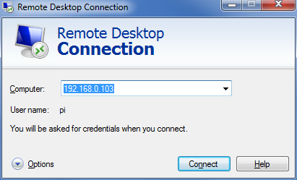

Enter the Pi's IP address, and log in as user pi.

