Raspberry Pi
GPIO and Camera

Author: Nick Lee
$ python3

>>> 1 + 3
>>> 9 - 7
>>> 6 * 3
>>> 3 / 2
>>> 3 // 2
>>> 7 % 3
>>> 4 + 2 * 3
>>> (4 + 2) * 3
>>> 2 ** 3

>>> type(3)
>>> type(3.0)
>>> type('3')

>>> 3.0 == 3
>>> '3' == 3

>>> # comment

>>> x = 1
>>> y = 2
>>> x + y
>>> x * y

>>> import time
>>> time.time()

>>> x = 25
>>> 'I am {} years old'.format(x)

>>> street = 'Nathan Road'
>>> area = 'Mongkok'
>>> 'I live on {} {}, {}'.format(x, street, area)

>>> humidity, temperature = 50.00001, 22.34567
>>> 'Today is {}% {:.2f} degree'.format(humidity, temperature)

LED

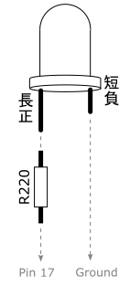
gpiozero basic recipes

- LED
- LED with variable brightness
- Traffic Lights
Button

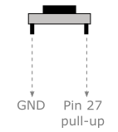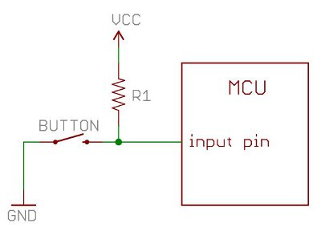

gpiozero basic recipes

- Button

Quick reaction game

Now that you know how to handle LED and push button, let's check how quick your reaction is. Make a reaction timer as follows:

- Turn on LED

- User presses button to "start the clock". LED is turned off.

- After a random number of seconds (say, 2-10 seconds), LED is turned back on!

- User has to press button as soon as he can. Print out his reaction time.

reaction.py

from gpiozero import LED, Button
from time import sleep, time
import random

led = LED(26)
button = Button(12)

led.on()
button.wait_for_press() ❶

led.off()
sleep(random.uniform(2, 10)) ❷

led.on()
on_time = time() ❸

button.wait_for_press() ❹
press_time = time() ❺

print('{:.3f}'.format(press_time - on_time))

❶ Wait for user to get ready

❷ Delay for a random number of seconds (2-10)

❸ Remember the time when LED is turned on

❹ Wait for user to press

❺ Remember the time when user presses the button
Potentiometer
VR, Variable Resistor

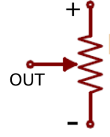

gpiozero basic recipes

- Potentiometer

Problem

- Use a potentiometer to vary an LED's brightness

Joystick 等於兩個 VR，一個X軸，一個Y軸。

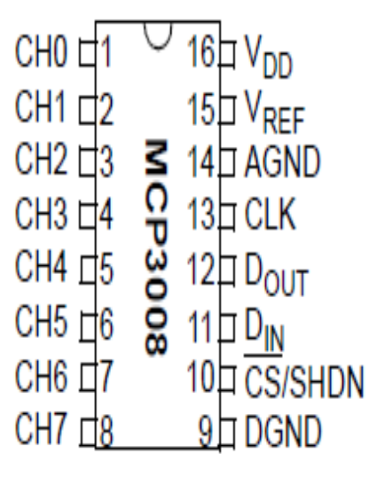

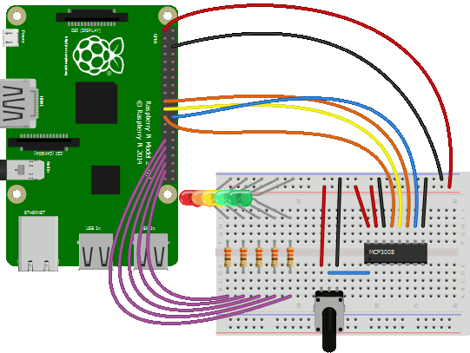

Servo

gpiozero basic recipes:

- Servo

Pulse Width Modulation controlling Servo Motors

Period 20 milliseconds, Frequency 50 Hz

angle | high time | duty cycle
-90⁰ | 0.5 ms | 2.5 % | 20ms
-45⁰ | 1 ms | 5 %
0⁰ | 1.5 ms | 7.5 %
+45⁰ | 2 ms | 10 % | ...
+90⁰ | 2.5 ms | 12.5 % | ...

from gpiozero import Servo
from time import sleep

servo = Servo(17,
min_pulse_width=0.5/1000, ❶
max_pulse_width=2.5/1000)

while True:
servo.value = -1 ❷
sleep(2)
servo.value = 0 ❸
sleep(2)
servo.value = 1 ❹
sleep(2)

❶ 指明最大及最小 pulse width

❷ 停在最小角

❸ 停在中位角

❹ 停在最大角

用joystick控制兩個servo

from gpiozero import Servo, MCP3008
from gpiozero.tools import scaled
from signal import pause

h = Servo(17,
min_pulse_width=0.5/1000,
max_pulse_width=2.5/1000)

v = Servo(27,
min_pulse_width=0.5/1000,
max_pulse_width=2.5/1000)

y = MCP3008(channel=0) ❶
x = MCP3008(channel=1)

h.source = scaled(x, -1, 1) ❷
h.source_delay = 0.1
v.source = scaled(y, 1, -1)
v.source_delay = 0.1

pause()

❶ X，Y軸接入0，1 channel

❷ 0 → 1 map至 -1 → 1

Camera

Plug in the camera module. Update the system:

$ sudo apt-get update
$ sudo apt-get upgrade
$ sudo raspi-config

Select Interfacing Options, enable Camera.

Finish and reboot.

raspistill
capture photo

raspistill -o a.jpg | Capture photo to a file.

On LCD, open the file manager and double-click on the file to view the photo.

raspistill -o a.jpg -t 1000 | Wait 1 second before capturing. Default is 5 seconds.

raspistill -o a.jpg -hf -vf | Flip image horizontally and vertically.

raspistill | less | Display options.

Interesting options:

-t, --timeout
-hf, --hflip
-vf, --vflip
-w, --width
-h, --height
-ss, --shutter
-ifx, --imxfx

raspivid
capture video

raspivid -o b.h264 -t 5000 -fps 25 | Record 5 seconds at 25 frames per second.

omxplayer b.h264 --fps 25 | View the video on an HDMI display. This will not work on VNC because omxplayer makes use of hardware acceleration in the GPU (graphics processing unit), which is only available to HDMI output.

raspivid | less | Display options. Similar to those of raspistill.

Convert h264 to mp4

$ sudo apt-get install gpac

To concatenate many files to a new file (if the destination file exists, its original content will be erased):

$ MP4Box -fps 25 -cat a.h264 -cat b.h264 -new c.mp4

To concatenate many files to an existing file (if the destination file does not exist, it will be created):

$ MP4Box -fps 25 -cat a.h264 -cat b.h264 c.mp4

Capturing to a file

from time import sleep
from picamera import PiCamera

camera = PiCamera()
camera.resolution = (1024, 768)
sleep(2) # Camera warm-up time
camera.capture('foo.jpg')

Change Camera's Output Orientation

camera.hflip = True
camera.vflip = True
camera.rotation = 90

The picamera package has its own very good documentations. Explore it yourself if you want to know more:

http://picamera.readthedocs.io/
Recording video to a file

import picamera

camera = picamera.PiCamera()
camera.resolution = (640, 480)

camera.start_preview()
camera.start_recording('video.h264')

camera.wait_recording(5)

camera.stop_recording()
camera.stop_preview()

Overlaying text on the output

The camera includes a rudimentary annotation facility which permits up to 255 characters of ASCII text to be overlaid on all output.

import picamera

camera = picamera.PiCamera(resolution=(1280, 720), framerate=24)

camera.annotate_background = picamera.Color('black')
camera.annotate_text = 'Hehehehe'

camera.start_preview()
camera.start_recording('video.h264')
camera.wait_recording(3)
camera.annotate_text = 'Wahahahahaha'
camera.wait_recording(3)
camera.stop_recording()
camera.stop_preview()

Camera GUI

https://github.com/Billwilliams1952/PiCameraApp

