Headings:
4 - General Toolbar
4.1 - Sheet Management
4.2 - Research tool
4.3 - Netlist tool
4.4 - Annotation tool
4.5 - E.R.C tool
4.5.1 - Main folder/dialog
4.5.2 - Options folder/dialog
4.6 - BOM (Bill of Material) tool
4.7 - Import tool for back-annotation

General Toolbar

Sheet Management
Access to page settings:
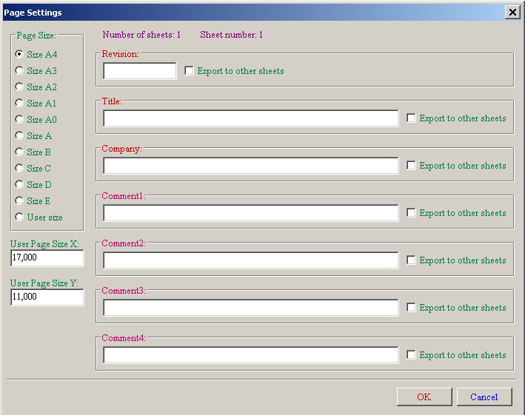
Sheet size and title block editing.
The date is automatically updated.
Total number of sheets and sheet number are automatically updated.

Research tool
To access this tool.
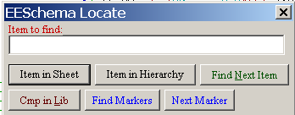
You can search a component, a value, or a text string in the current sheet or in the whole hierarchy.
The cursor will be positioned on the found element, in the concerned sub-sheet.

Netlist tool
Gives access to the netlist tool.
This netlist file can apply to the whole hierarchy (usual option), or only to the current sheet (the netlist is then partial, but this option can be useful for some software).
In a multisheet hierarchy, any local label is known only inside the sheet to which it belongs.
Thus the label TOTO of sheet 3 is different from the label TOTO of sheet 5 (if no connection has been intentionally introduced to connect them).
This is due to the fact that the sheet number (updated by the annotate command) is associated with the local label. In the previous example, the first label TOTO is actually TOTO_3, and the second label TOTO is actually TOTO_5.
This association can be inhibited if it is wished, but be aware of possible undesired connections.
Notice 1:
Label lengths have no limitations in Eeschema, but the software exploiting the generated netlist can be limited on this point.
Notice 2:
Avoid spaces in the labels, because they then appear as separated words. It is not a limitation of Eeschema, but of many netlist formats, which often suppose that a label has no spaces.
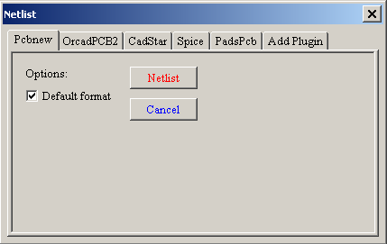
Option:
Default Format :
Check to select Pcbnew as the default format.
Other formats can also be generated :
- Orcad PCB2
- CadStar
- Spice, for the Spice simulator.
External plugins can be launch to extend netlist formats list (a PadsPcb Plugin was added here)

Annotation tool
To access the annotation tool.
This tool performs an auto incrementing designation of the components.
For multi-part components (such as 7400 TTL which contains 4 gates), a multi-part suffix is also allocated (thus a 7400 TTL designated U3 will be divided into U3A, U3B, U3C and U3D).
You can unconditionally annotate all the components, or only the new components, i.e. those which were not previously annotated..
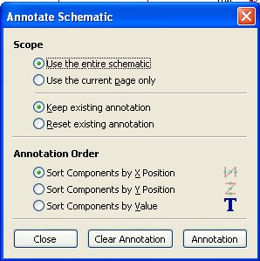
Scope:
Use the entire schematic:
All the sheets are re-annotated (usual Option).
Use the current page only:
Only the current sheet is re-annotated (this option is to be used only in special cases, for example to evaluate the amount of resistors in the current sheet.).

Keep existing annotation:
Conditional annotation, only the new components will be re-annotated (usual option).
Reset existing annotation:
Unconditional annotation, all the components will be re-annotated (this option is to be used after block copy for example, when there are duplicated references).
Order
Sorting option to set the annotation numbers to components

E.R.C tool
To access E.R.C tool.
This tool performs a design verification (known as Electrical Rules Check).
This function is particularly useful to detect forgotten connections, and inconsistencies.
Eeschema places markers on the pins or labels able to pose a problem.
The diagnosis can then be given by left clicking on the marker.
An errors file can also be generated.

Main folder/dialog
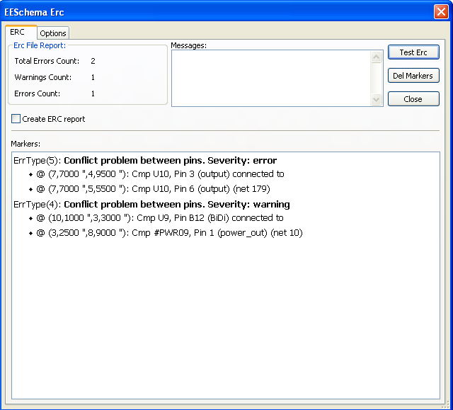
Errors are displayed in the Erc Diags dialog box :
- Errors and warnings count.
- Errors count.
- Warnings count.
Option:
- Create ERC report : check this option to generate an ERC report file.
Commands:
- Test Erc: to perform an Electrical Rules Check.
- Del Markers : to remove all ERC markers.
- Close : to exit this dialog box.
Note:
When clicking on an error message, jump to the corresponding marker in schematic.

Options folder/dialog
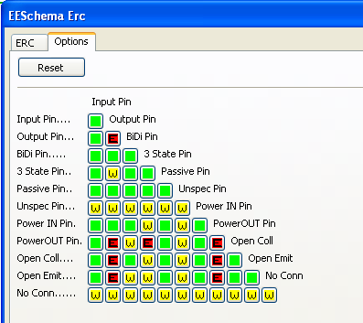
This Setup ERC dialog box allows you to establish connectivity rules between pins; you can choose between 3 options for each case :
- No error
- Warning
- Error
Each square of the matrix can be modified by clicking it.

BOM (Bill of Material) tool
This menu allows the generation of a file listing of the components and/or
hierarchical connections (global labels).

The components can be sorted by : Reference or Value
and multi-part components can be detailed.
The global labels can be sorted by : Alphabetical classification or Sub-sheet

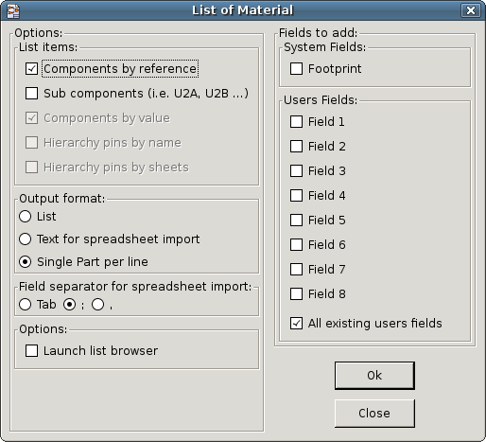
Different sortings can be used simultaneously.
The options are:
Components by Reference | Bill of Material sorted by Reference.
Component by Value | Bill of Material sorted by Value.
Sub components | The BOM shows every device of multi-part components (ex U2A, U2B…).
Hierarchy Pins by name | Hierarchical connections sorted alphabetically.
Hierarchy Pins by Sheet | Hierarchical connections sorted by sheet number.
List | Creates a plain text file ready to print
Text for spreadsheet import | Creates an ASCII file which can be easily imported in a spreadsheet
Single Part per line | Creates a csv file combining components with the same Value into a single line, listing reference designators comma separated.
Launch list browser | Run the text editor to load and display the BOM list file after creating.

A useful set of Component properties to use for a BOM are:
- Value – unique name for each part used
- Footprint – either manually entered or back-annotated (see below)
- Field1 – Manufacture's name
- Field2 – Manufacture's Part Number
- Field3 – Distributor's Part Number
For example:
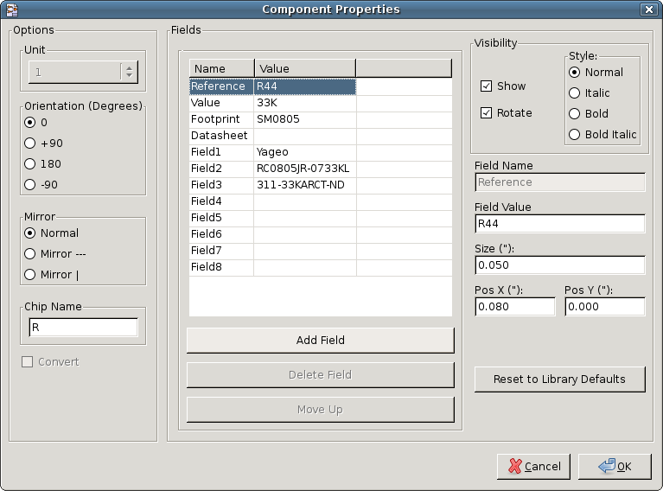
Using the BOM Format – Single Part per line - only requires the Component properties be edited for one Component on the schematic and not all the Components with that same Value.
However, if there exists different parts, both with a Value of 33K, maybe one is 1/10 W and another is ¼ W, or may have a different footprint, specify one as 33K and the other as 33KBig and these will be listed as different parts.
The output is in format than can be imported into a spreadsheet where cost numbers (or optionally even Field4) may be added to derive a board cost and assist with parts procurement.

Import tool for back-annotation
This feature allows a schematic to be captured, make footprint assignments using Cvpcb's table
and browser tools then export that assignment back to the schematic.

This function reads a .stf file previously created by Cvpcb and initialize the footprint field (F3) of components.
This is not yet useful for Pcbnew, but useful to add the footprint field when creating the Bill of Material and
the netlist. This feature keeps the component footprint/reference information in a single source file, the
schematic, which is the source for the netlist and makes the .cmp file redundant. The footprint assignments
will appear in any future netlist export from Eeschema.

