Headers
11 - LibEdit : Complements
11.1 - Overview
11.2 - Positioning the anchor
11.3 - Alias
11.4 - Fields:
11.5 - Component documentation
11.5.1 - Keywords
11.5.2 - Component documentation (Doc)
11.5.3 - Associated documentation file (DocFileName)
11.5.4 - Footprint filtering for CVPCB
11.6 - Symbol library
11.6.1 - Export/Create a symbol
11.6.2 - Import a symbol

LibEdit : Complements

Overview
A component consist of several elements :
- Its graphic representation (geometrical shapes, texts).
- Pins.
- Fields, or associated texts, used by the post processors: netlist, components list…
Two fields are to be initialized : reference and value.
The name of the design associated with the component, and the name of the associated footprint, the other fields are the free fields, they can generally remain empty, and could be filled during schematic capture.
However, managing the documentation associated with any component facilitates the research, use and maintenance of the libraries.
The associated documentation consists of :
- A line of comment.
- A line of key words such as TTL CMOS NAND2…, separated by spaces
- An attached file name (for example an application note, a pdf file…). The default directory for attached files is kicad/library/Doc.

The key words allow you to selectively search for a component according to varying selection criteria.
Comment and key words are displayed in various menus, and particularly when you select a component in a library.
The component also has an anchoring point. A rotation or a mirror is made relatively to this anchor point, and during a placement, this point is used as a reference position. It is thus useful to position this anchor accurately.
A component can also have aliases, i.e. equivalent names. This allows you to considerably reduce the number of components that need to be created (for example, a 74LS00 can have aliases such as 74000, 74HC00, 74HCT00…).
Finally, the components are distributed in libraries (classified by topics, or manufacturer...), in order to facilitate their management.

Positioning the anchor
The anchor is at the co-ordinates 0,0 shown by the blue axes displayed on the screen :
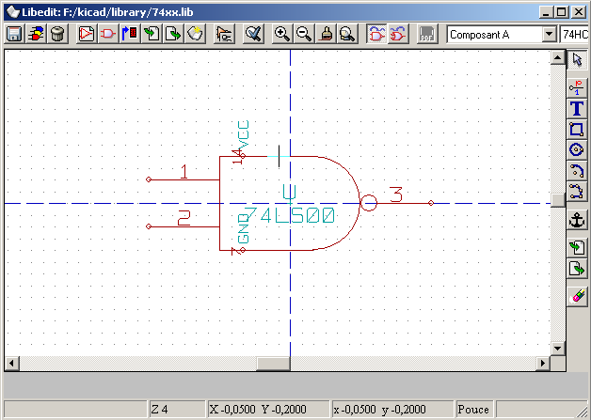
The anchor can be repositioned as follows :
Select the tool and then click on the new desired anchor position. The drawing will be automatically re-centered on this new anchor point.

Alias
An alias is another name corresponding to the same component in the library.
Components with similar pinout and representation can then be represented by only one component, having several aliases (ex: 7400 with alias 74LS00, 74HC00, 74LS37. ).
The use of aliases allows you to build complete libraries much more quickly. In addition these libraries, being much more compact, are loaded more quickly.
To modify the list of aliases, you have to select the main editing window (tool ) and select the Alias folder :
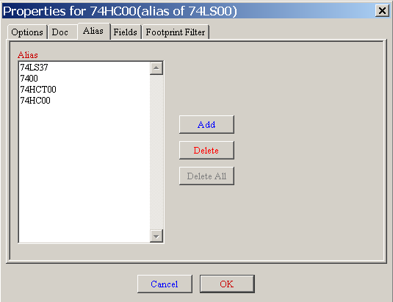

You can thus add or remove the desired alias.
The current alias cannot obviously be removed since it is edited.
To remove all aliases, you have firstly to select the root component (first component in the alias list in the window of selection of the main toolbar).

Fields:
There are 4 special fields (texts attached to the component), et 8 user fields

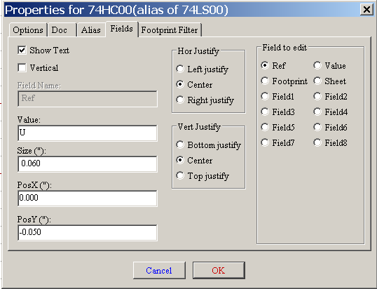

Special fields:
- Reference
- Value: It is the component name in library, and the default value field in schematic.
- Footprint : footprint name used for the board. Not veru usefull when using CVPCB to setup the footprint list.
- Sheet: reserved (not used at this time).

Component documentation
To edit documentation information, it is necessary to call the main editing window of the component (tool ) and to select the Doc. Folder :

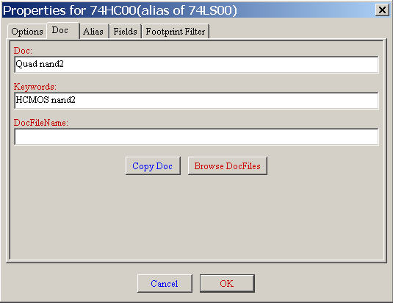

Caution:
Be sure to select the right alias, or the root component, because this documentation is the only characteristic which differs between aliases.
The "Copy Doc" button allows you to copy the documentation information from the root component towards the currently edited alias.

Keywords
The key words allow you to search in a selective way for a component according to specific selection criteria (function, technological family.)
The EESchema research tool isn't case sensitive.
The most current key words used in the libraries are :
- CMOS TTL for the logic families
- AND2 NOR3 XOR2 INV… for the gates (AND2 = 2 inputs AND gate, NOR3 = 3 inputs NOR gate).
- JKFF DFF… for JK or D flip-flop.
- ADC, DAC, MUX…
- OpenCol for the gates with open collector output.
Thus if in the schematic capture software, you search the component: ( note the "=" at the beginning of the command ) =NAND2 OpenCol EESchema will display the list of components having these 2 key words.

Component documentation (Doc)
The line of comment (and key words) is displayed in various menus, particularly when you select a component in the displayed components list of a library and in the ViewLib menu.
If this Doc. file exists, it is also accessible in the schematic capture software, in the popup menu displayed by a right-click on a component.

Associated documentation file (DocFileName)
Indicates an attached file (documentation, application schematic…) available ( pdf file,schematic diagram…).

Footprint filtering for CVPCB
One can enter a list of allowed footprints for the component.
This list acts as a filter used by CVPCB to display the allowed footprints only.
A void list does not filter anything..
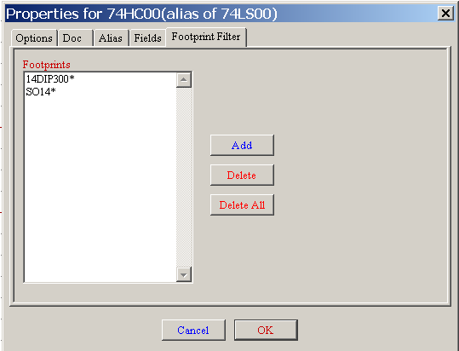
Wild cards are allowed.
S014* allows CVPCB to show all the footprints with a name starting by SO14
For a resistor, R? shows all the footprints with a 2 letters name starting by R.
Here are samples: with and without filtering
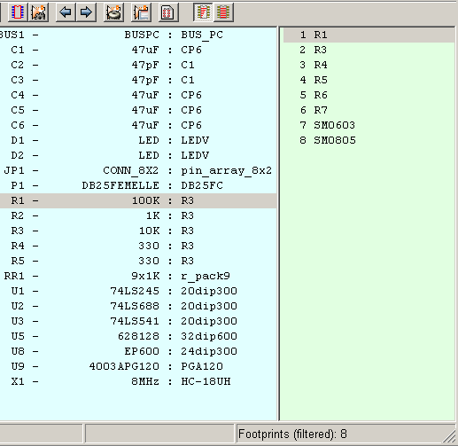 | With filtering
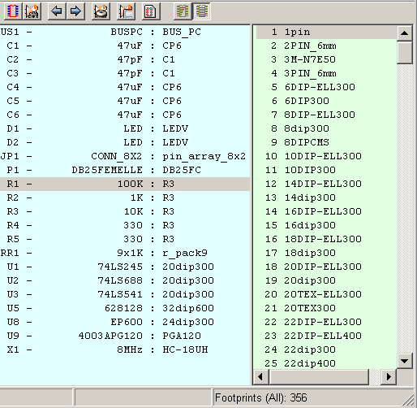 | Without filtering

Symbol library
You can easily compile a graphic symbols library file containing frequently used symbols .This can be used for the creation of components (triangles, the shape of AND, OR, Exclusive OR gates…), for saving and subsequent re-use.
These files are stored by default in the library's directory and have a .sym extension.
The symbols are not gathered in libraries like the components because they are generally not very numerous.

Export/Create a symbol
A component can be exported as a symbol with the tool
You generally create only one graphic, also it will be a good idea to delete all pins, if they exist.

Import a symbol
That allows you to add graphics to a component you are editing.
A symbol is imported with the tool
Imported graphics are added as such as it was created in existing graphics.

