Headings
8 - Design verification (E.R.C.)
8.1 - Overview.
8.2 - Use.
8.3 - Example of ERC :
8.4 - Displaying diagnostics:
8.5 - Powers and Power flags:
8.6 - Configuration
8.7 - ERC report file.

Design verification (E.R.C.)

Overview.
The function “Electrical Rules Check” performs an automatic check.
It points out any errors in a sheet, such as unconnected pins, unconnected hierarchical symbols, shorted outputs…
Naturally, an automatic check is not infallible, and the software that make it possible to detect all design errors was not written yet.
But, such a control is very useful, because it allows you to detect many oversights and small errors.
In fact all the detected errors must be checked and then corrected before proceeding as normal.
The quality of check is directly related to the care taken in declaring electrical pin properties during library creation.
ERC errors are reported as “errors” or “warnings”.
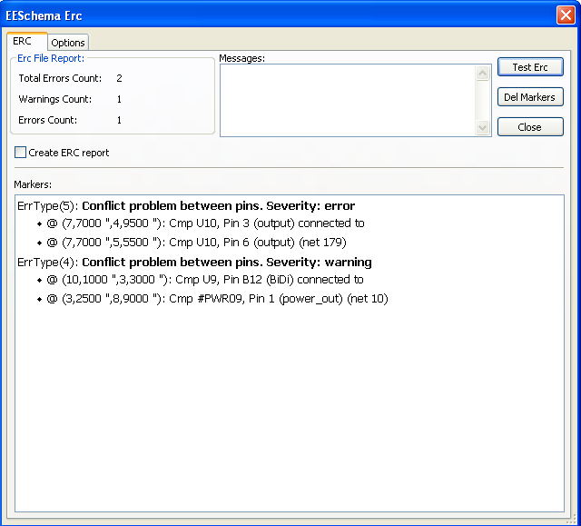

Use.
The Control of E.R.C. is launched by the icon .
Markers are placed on the elements causing an ERC error (pins, or labels).
Notes:
- In this dialog window, when clicking on an error message, one jump to the corresponding marker in schematic.
- In schematic, right click on a marker, to access the corresponding diagnostic.

You can also delete error markers from this dialog.

Example of ERC :

One can see 4 errors :
- Two outputs connected together.
- Two inputs left unconnected.
- An error on an invisible power port (power flag is missing).

Displaying diagnostics:
On a right click on a marker, the pop menu allows to access the ERC marker diagnostic.
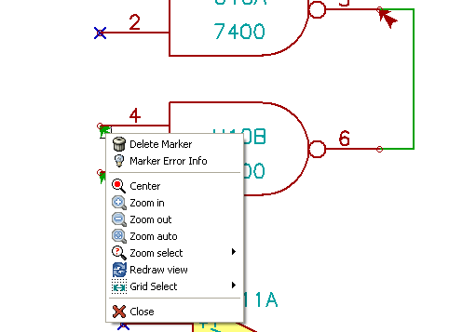
and when clicking on Marker Error Info :
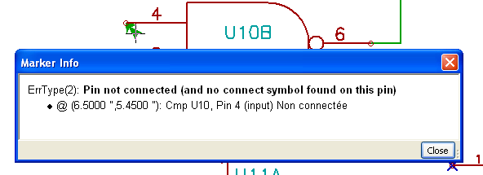

Powers and Power flags:
It is common to have an error (warning) on power pins, whereas all seems normal (see example above).
This is because, in most designs, the power is provided by connectors, that aren't power sources (like regulator output, which is declared as Power out).
The ERC thus won't detect any Power out pin to control this wire and will declare them not driven (not driven by a power source).
You have to place a “PWR_FLAG” on such a power port (which symbolizes in fact power output).

The error marker then disappears.
Most of time, a PWR_FLAG must be connected to gnd, because usually regulators have outputs declared as power out, but ground pins are never power out (the normal attribute is power in), so grounds never appear connected to a power source without a pwr_flag.

Configuration
The Options panel allows you to configure connectivity rules to define electrical conditions for errors and warnings :

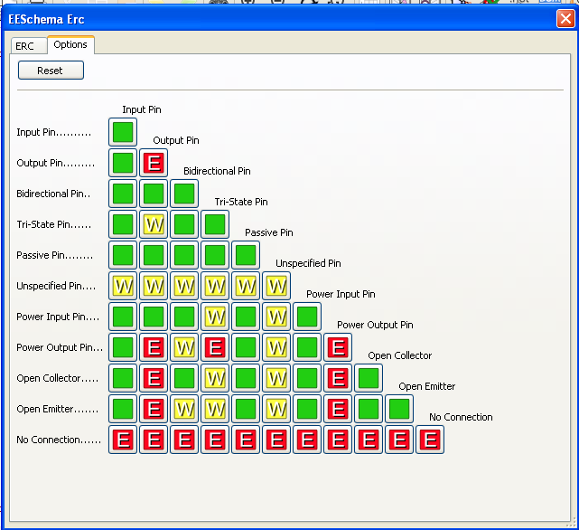
Rules can be changed by clicking on the desired square of the matrix, causing it to cycle through the choices : normal, warning, error.

ERC report file.
An ERC report file can be saved by checking the option Write ERC report.
The file extension for ERC report files is .erc.
Here is an example:

ERC control (4/1/1997-14:16:4)

***** Sheet 1 (INTERFACE UNIVERSAL)
ERC: Warning Pin input Unconnected @ 8.450, 2.350
ERC: Warning passive Pin Unconnected @ 8.450, 1.950
ERC: Warning: BiDir Pin connected to power Pin (Net 6) @ 10.100, 3.300
ERC: Warning: Power Pin connected to BiDir Pin (Net 6) @ 4.950, 1.400

>> Errors ERC: 4

