Headings:
9 - Netlist Creation.
9.1 - Overview.
9.2 - Netlist formats.
9.3 - Examples.
9.4 - Note.
9.4.1 - Precautions.
9.4.2 - PSPICE netlists.
9.5 - Other formats, using « plugins »
9.5.1 - Init the Dialog window:
9.5.2 - Command line format:
9.5.3 - The converter or the sheet style (plug in)
9.5.4 - Format of the intermediate netlist text file:

Netlist Creation.

Overview.
This command allows you to create the netlist file for your design.
A netlist is a file which describes electrical connections between components.
One thus finds there
- The list of the components
- The list of connections between components, called equipotential nets.
There are different netlist formats. Sometimes the component list and equipotential list are two separate files.
This netlist is fundamental in the use of schematic capture software, because the netlist is the link with other electronic CAD software, like:
- PCB software.
- Simulators.
- CPLD (and other programmable IC's) compilers.

Eeschema supports several netlist formats :

- PCBNEW format (printed circuits).
- ORCAD PCB2 format (printed circuits).
- CADSTAR format (printed circuits).
- Spice format, for the simulators. ( format Spice is also used by other simulators).

Netlist formats.
Select the tool  to open the netlist creation dialog box :

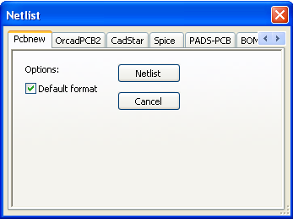 | Pcbnew selected
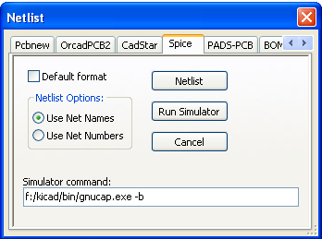 | Spice selected

Using the different tabs, you can select the desired format as the default format.
In Spice format, you can generate netlists with either equipotential names (it is more legible) or net numbers (old Spice versions accept numbers only)

By clicking the Netlist button, you will be asked for a netlist file name.
Note :
With big projects, the netlist generation can take a few minutes.

Examples.
You can see below a schematic design using the PSPICE library :
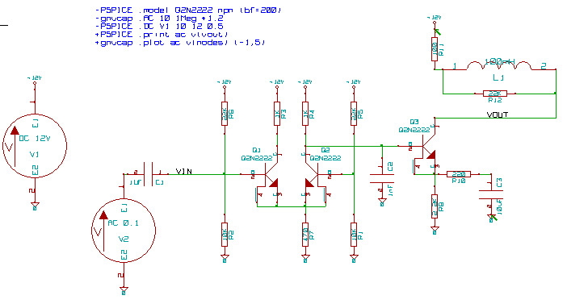

Structure of a PCBNEW netlist :

# EESchema Netlist Version 1.0 generee le 21/1/1997-16:51:15
(
(32E35B76 $noname C2 1NF {Lib=C}
(1 0)
(2 VOUT_1)
)
(32CFC454 $noname V2 AC_0.1 {Lib=VSOURCE}
(1 N-000003)
(2 0)
)
(32CFC413 $noname C1 1UF {Lib=C}
(1 INPUT_1)
(2 N-000003)
)
(32CFC337 $noname V1 DC_12V {Lib=VSOURCE}
(1 +12V)
(2 0)
)
(32CFC293 $noname R2 10K {Lib=R}
(1 INPUT_1)
(2 0)
)
(32CFC288 $noname R6 22K {Lib=R}
(1 +12V)
(2 INPUT_1)
)
(32CFC27F $noname R5 22K {Lib=R}
(1 +12V)
(2 N-000008)
)
(32CFC277 $noname R1 10K {Lib=R}
(1 N-000008)
(2 0)
)
(32CFC25A $noname R7 470 {Lib=R}
(1 EMET_1)
(2 0)
)
(32CFC254 $noname R4 1K {Lib=R}
(1 +12V)
(2 VOUT_1)
)
(32CFC24C $noname R3 1K {Lib=R}
(1 +12V)
(2 N-000006)
)
(32CFC230 $noname Q2 Q2N2222 {Lib=NPN}
(1 VOUT_1)
(2 N-000008)
(3 EMET_1)
)
(32CFC227 $noname Q1 Q2N2222 {Lib=NPN}
(1 N-000006)
(2 INPUT_1)
(3 EMET_1)
)
)
# End

In PSPICE format, the netlist is as follows:

* EESchema Netlist Version 1.1 (Spice format) creation date: 18/6/2008-08:38:03

.model Q2N2222 npn (bf=200)
.AC 10 1Meg *1.2
.DC V1 10 12 0.5

R12 /VOUT N-000003 22K
R11 +12V N-000003 100
L1 N-000003 /VOUT 100mH
R10 N-000005 N-000004 220
C3 N-000005 0 10uF
C2 N-000009 0 1nF
R8 N-000004 0 2.2K
Q3 /VOUT N-000009 N-000004 N-000004 Q2N2222
V2 N-000008 0 AC 0.1
C1 /VIN N-000008 1UF
V1 +12V 0 DC 12V
R2 /VIN 0 10K
R6 +12V /VIN 22K
R5 +12V N-000012 22K
R1 N-000012 0 10K
R7 N-000007 0 470
R4 +12V N-000009 1K
R3 +12V N-000010 1K
Q2 N-000009 N-000012 N-000007 N-000007 Q2N2222
Q1 N-000010 /VIN N-000007 N-000007 Q2N2222

.print ac v(vout)
.plot ac v(nodes) (-1,5)

.end

Note.

Precautions.
Many versions of software that exploit netlists do not accept spaces in the component names, pins, equipotentials or others.
Systematically avoid spaces in labels, or names and value fields of components or their pins.
In the same way, certain characters other than letters and numerals can induce problems.
Note that this limitation is not related to Eeschema, but to netlist formats that can then become untranslatable, or to software which uses these netlists.

PSPICE netlists.
For the Pspice simulator, you have to include some command lines in the netlist itself (.PROBE, .AC…).
Any text line included in the schematic diagram starting with the keyword -pspice or -gnucap will be inserted (without the keyword) at the top of the netlist.
Any text line included in the schematic diagram starting with the keyword +pspice or +gnucap will be inserted (without the keyword) at the end of the netlist.
Here is a sample, using many one line texts and one multiline text:

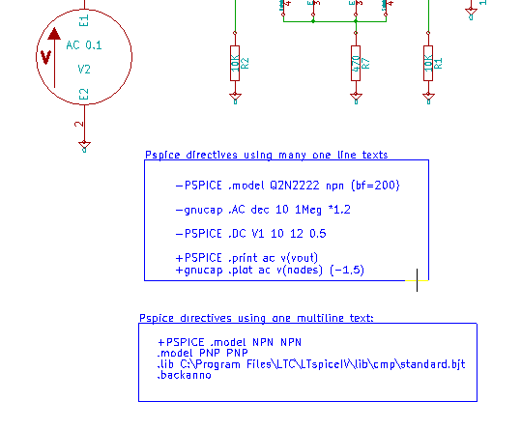

For example: if you type the following text (do not use a label!):
-PSPICE .PROBE
a line .PROBE will be inserted in the netlist.
In the previous example, three lines were inserted at the beginning of the netlist and two at the end with this technique.

If you are using multiline texts, +pspice or +gnucap keywords are needed only once:
+PSPICE .model NPN NPN
.model PNP PNP
.lib C:\Program Files\LTC\LTspiceIV\lib\cmp\standard.bjt
.backanno
creates the four lines:
.model NPN NPN
.model PNP PNP
.lib C:\Program Files\LTC\LTspiceIV\lib\cmp\standard.bjt
.backanno

Besides, also note that the equipotential GND must be named 0 (zero) for Pspice.

Other formats, using « plugins »
For other netlist formats one can add netlist converters.
These converters are automatically launched by Eeschema
Chapter 14 gives some explanations and examples of converters.
Principe:
A converter is a text file (xsl format) (but one can use other languages like PYTHON).
When using the xsl format, a tool ( xsltproc.exe or xsltproc ) read the intermediate file created by Eeschema, and the converter file to create the output file.
In this case, the converter file (a sheet style) is very small and very easy to write.

Init the Dialog window:
One can add a new netlist plug-in by « Add Plugin »
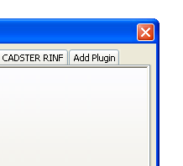
Here is the plug-in « PadsPcb » setup:
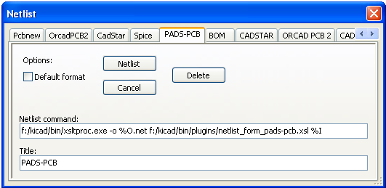
The setup needs::
- A title (for instance: the name of the netlist format)
- The plug-in to launch.
On activate the Netlist button: :
- Eeschema creates an intermediate file *.tmp, for instance test.tmp
- Eeschema run the plug-in, what read test.tmp and creates test.net

Command line format:
Here is an example, using « xsltproc.exe » as tool to convert .xsl files, and a file « /netlist_form_pads-pcb.xsl » as converter sheet style:
f:/kicad/bin/xsltproc.exe -o %O.net f:/kicad/bin/plugins/netlist_form_pads-pcb.xsl %I
With:
f:/kicad/bin/xsltproc.exe | A tool to read and convert xsl file
-o %O.net | Output file: %O sera remplacé part le nom de la netliste (nom du schéma « racine »)
f:/kicad/bin/plugins/netlist_form_pads-pcb.xsl | File name converter (a sheet style, xsl format).
%I | Will be replaced by the intermediate file created by Eeschema (*.tmp).
For a schematic named test.sch, the actual command line is:
f:/kicad/bin/xsltproc.exe -o test.net f:/kicad/bin/plugins/netlist_form_pads-pcb.xsl test.tmp.

The converter or the sheet style (plug in)
This is a very simple software, because his purpose is only to convert an input text file ( the intermediate text file ) to an other text file
Moreover, from the intermediate text file, one also can create B.OM. lists.
When using xsltproc as converter tool, just a « sheet style » must be written.

Format of the intermediate netlist text file:
See Chapter 14 for more explanations about xslproc, the descriptions of intermediate file format, and some examples of sheet style for converters.

