- Generic Eeschema commands

Table of Contents
2 - Generic Eeschema commands 1
2.1 - Access to Eeschema commands 1
2.2 - Mouse Commands 2
2.2.1 - Basic commands 2
2.2.2 - Operations on blocks 2
2.3 - Hot keys 3
2.4 - Selecting grid size 5
2.5 - Zoom selection 5
2.6 - Displaying cursor coordinates 5
2.7 - Top menu bar 6
2.8 - Upper toolbar 6
2.9 - Right toolbar icons 8
2.10 - Left toolbar icons 10
2.11 - Pop-up menus and quick editing 10

  - Access to Eeschema commands
You can reach the various commands by:
- Clicking on the menu bar (top of screen).
- Clicking on the icons on top of the screen (general commands).
- Clicking on the icons on the right side of the screen (particular commands or “tools”).
- Clicking on the icons on the left side of the screen (display options).
- Clicking on the mouse buttons (important complementary commands). In particular a right click opens a contextual menu that depends on the element under the cursor (Zoom, grid and edition of the elements).
- Function keys of the keyboard (F1, F2, F3, F4, Insert and space keys).
Specifically:
The “Escape” key often allows the canceling of a command in progress.
The ”Insert” key allows the duplication of the last element created.
Here are the various possible accesses to the commands.
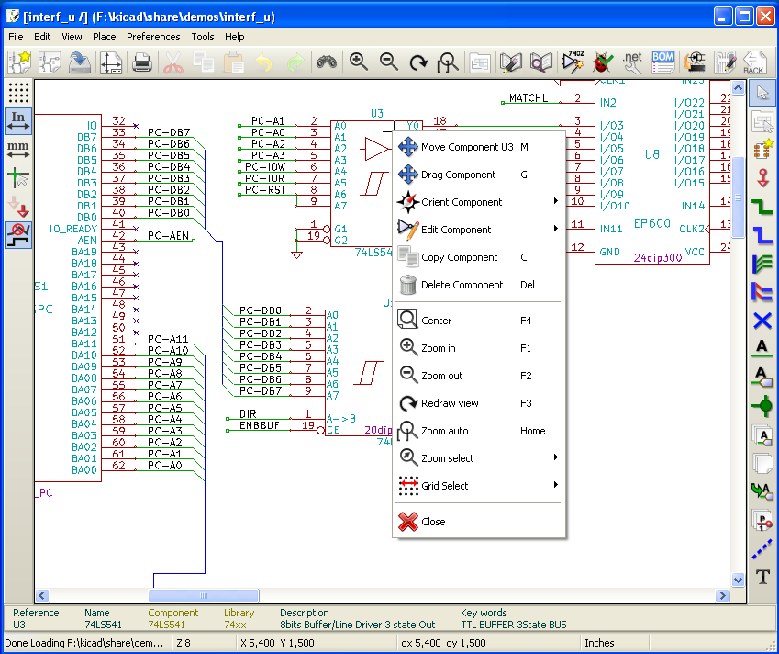

  - Mouse Commands
    - Basic commands
Left button
- Single click : displays the characteristics of the component or text under the cursor.
- Double click: edit (if the element is editable) the component or text.
Right button
- Opens a pop-up menu.
    - Operations on blocks
You can move, drag, copy and delete selected areas in all Eeschema menus.
Areas are selected with the left mouse button. The command is completed with the release of the button.
By holding one of the keys “Shift”, “Ctrl”, or the 2 keys “Shift and Ctrl”, during selection this results in the copying, dragging or deletion of the selected area.
Commands summary:
left mouse button | Move selection.
Shift + left mouse button | Copy selection.
Ctrl + left mouse button | Drag selection.
Control + Shift + left mouse button | Delete selection.

The command is executed at button release.
During selection you can:
- Click again to place back the elements.
- Click the right button to cancel.
If a move block command has started, an other command block can be deselected via the pop-up menu (mouse, right button):
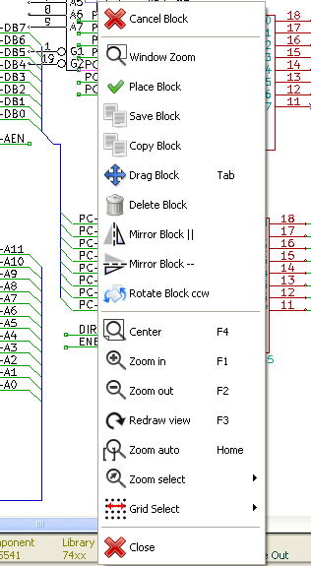
  - Hot keys
The hot keys are not case sensitive.
- The “?” key displays the current hot keys list.
- The Preference menu manage the hot keys.
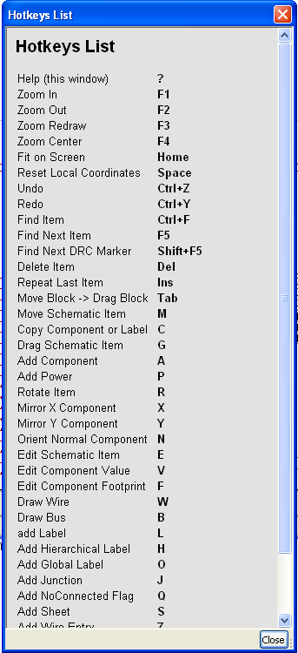 | Here is the default hot key list.

All hot keys can be redefined by the user via the hotkey editor.
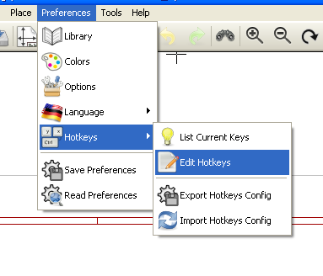
  - Selecting grid size
In Eeschema, the cursor moves over a grid, which can be displayed or not. The grid is always displayed in the library management menus.
You can change the grid size via the pop-up menu or via the Preferences/Options menu. The default grid size is 50 mil (0.050 ") or 1,27 millimeters.
One can also work with the average (20 mil) or a finer grid (10 mil). This is however not recommended for usual work. The average or fine grid is especially intended to design or handle components with large numbers of pins like several hundreds pins.
  - Zoom selection
To change the zoom level:
- Right click to open the Pop-up menu and select the desired zoom.
- Or use the function keys:
  - F1: Zoom in.
  - F2: Zoom out.
  - F3: Redraw.
  - F4: Center around the cursor
Or simple click on the mouse middle button (without moving the mouse)
- Window Zoom: Mouse drag, with the middle button.
  - Mouse weel: Zoom in / Zoom out
  - SHIFT+Mouse weel: Up/down panning
  - CTRL+Mouse weel: Left/Right panning
  - Displaying cursor coordinates
The display units are in inches or millimeters. However, Eeschema always works internally with 1/1000 of an inch.
The following information is displayed at the bottom right hand side of the window :
- The zoom factor.
- The absolute position of the cursor.
- The relative position of the cursor.
- The relative coordinates (x, y) can be reset with the space bar.
- The coordinates posted will then relate to this point.

  - Top menu bar
The top menu bar allows the opening and saving of schematics, the program configuration, and it also contains the help menu.

  - Upper toolbar
This toolbar gives access to the main functions of EESchema.

 | Create a new schematic.
 | Open a schematic.
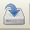 | Save complete schematic (with the whole hierarchy).
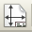 | Select the sheet size and title block editing.
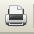 | Open print menu.
 | Remove the selected elements during a move block.
 | Copy selected elements in the clipboard during a move block.
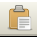 | Copy last selected element or block in the current sheet.
 | Undo: Cancel the last change (up to 10 levels).
 | Redo (up to 10 levels).
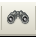 | Call the menu of components localization and texts.
 | Zoom in and out, around the center of screen.
 | Redraw of the screen and optimal Zoom.
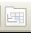 | Call the navigator window, to display the tree structure of the diagram hierarchy (if it contains sub sheets) and the immediate selection of any sheet of the hierarchy.
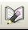 | Call component editor Libedit (Examination, modification, and editing of library components).
 | Display libraries (Viewlib).
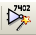 | Component annotation.
 | ERC (Electrical Rules Check). ERC automatically checks for electrical connections.
 | Creation of the netlist (Pcbnew , Spice format and other formats).
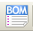 | Generate the BOM (Bill of materials) and/or hierarchical labels.
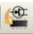 | Call CVPCB.
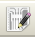 | Call PCBNEW.
 | Import a stuff file from Cvpcb (fill the footprint field of components)

  - Right toolbar icons
This toolbar gives access to tools for:
- Component placement, wires and buses, junctions, labels,text, etc.
- Navigation in the sheets hierarchy menu.
- Creation of hierarchical sub-sheets and connection symbols.
- Component deletion.

The detailed use of these tools is described in the chapter “ Diagram Creation/Editing”. An outline of their use is given below.
 | Stop the order or tool in progress.
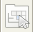 | Navigation in the hierarchy: this tool makes it possible to open the subsheet of the displayed schematic (click in the symbol of this subsheet), or to go back up in the hierarchy (click in a free area of the subsheet)
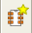 | Call the component placement menu.
 | "Powers" placement menu.
 | Wire placement.
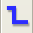 | Bus placement.
 | Wire to bus connections. These elements have only a decorative role and do not allow connection; thus they should not be used for connections between wires.
 | Bus to bus connections. They can only connect two buses between themselves.
 | “No connection” symbols. These are to be placed on component pins which are not to be connected. This is useful in the ERC function to check if pins are intentionally left not connected or are missed.
 | Local label placement. Two wires may be connected with identical labels in the same sheet. For connections between two different sheets,you have to use global symbols.
Global label placement.
All global labels are connected (even between different sheets).
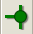 | Junction placement. To connect two crossing wires, or a wire and a pin, when it can be ambiguous. (i.e. if an end of the wire or pin is not connected to one of the ends of the other wire).
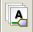 | Hierarchical label placement. This makes it possible to place a connection between a sheet and the root sheet which contains this sheet symbol.
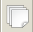 | Hierarchical subsheet symbol placement (resizable rectangle). You have to specify the file name to save the data of this “subsheet”.
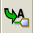 | Global label importation from subsheet, in order to create a connection on a subsheet symbol. Global labels are supposed to be already placed in this subsheet.  For this hierarchy symbol, the created connection points are equivalent to a traditional component pin, and must be wired.
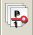 | Global label creation in subsheets to create connection points. This function is similar to the previous one which does not require already defined global symbols.
 | Lines for framings… Only decorative, and does not perform a connection.
 | Placement of comment text. Only decorative.
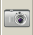 | Insert à bitmap image.
 | Delete selected element.  if several superimposed elements are selected, the priority is given to the smallest (in the decreasing priorities : junction, NoConnect, wire, bus, text, component). This also applies to hierarchical sheets. Note: the “Undelete” function of the general toolbar allows you to cancel last deletions.

  - Left toolbar icons
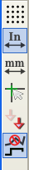 | This toolbar manages the display options :  - Grid.  - Units.  - Cursor.  - Invisible pins.  - Allowed directions of wires and buses.

  - Pop-up menus and quick editing
A right click opens a pop-up menu which content depends on the element selected, if any. You have immediate access to:
- Zoom factor.
- Grid adjustment.
- And according to the case, editing of the most usually modified parameters.

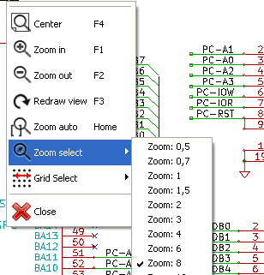 | Pop-up without selected element.
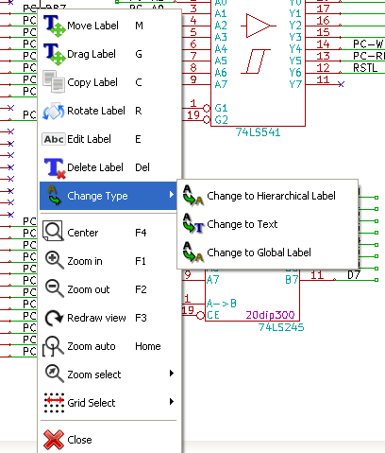 | Editing of a label.
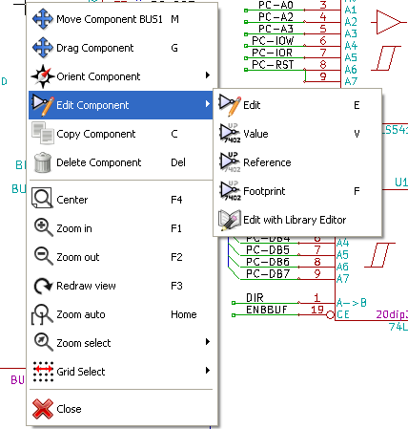 | Editing a component.

