What's all this about RS274X Anyway?

Steve DiBartolomeo
Applications Manager
Artwork Conversion Software, Inc.
© 1995 Artwork Conversion Software, Inc.

Index:
1 - RS274X Infos:
1.1 - Introduction
1.1.1 - Benefits of RS274X
1.1.2 - What is RS274X anyway?
1.1.3 - Where to Get the Official RS274X Spec?
1.2 - Embedding Format Info in the 274X Header
1.2.1 - Examples
1.2.2 - Embedded Units
1.2.3 - Image Polarity
1.2.4 - Embedded Aperture Definitions
1.2.4.1 - Aperture Definitions
1.2.4.2 - The Basic Aperture Definitions
1.2.4.3 - Standard Circle
1.2.4.4 - Circle Examples
1.2.4.5 - Standard Rectangles
1.2.4.6 - Aperture Macros
1.2.4.7 - Macro Primitives
1.2.4.8 - Aperture Macro Example - Thermal Relief
1.2.5 - Multiple Layers
1.2.6 - G36/G37 Polygons
1.2.6.1 - Sample Usage of G36/G37

RS274X Infos:

Introduction
If you're a PCB designer you're probably hearing more and more about extended Gerber - RS274X. The latest versions of many PCB layout programs either offer RS274X as an option or only output RS274X-- such as Cadence's Allegro.

Benefits of RS274X
RS274X includes many high level commands and controls that let the creator of the Gerber data specify the photoplot very precisely - much more so than RS274D which entailed passing a lot of critical information separately from the data file.

What is RS274X anyway?
It is an extension to standard RS274D (commonly known as Gerber) that includes:
- embedded format, unit and data information
- embedded apertures
- custom aperture definitions
- film control statements
- multiple layers embedded in a single file
- special polygon definitions
This document assumes that you are familiar with the basic Gerber commands - if not you may wish to first review the article Apertures, D-Codes and Plot Files which summarizes basic Gerber.
Some of the embedded information we mention here is actually available, although rarely used, in the RS274D specification.

Where to Get the Official RS274X Spec?
The RS274X specification was developed by Gerber Systems.
Gerber was purchased by Barco, a Belgian company. The 427X spec is now available at:
http://www.barco.com/ets/data/rs274xc.pdf

Embedding Format Info in the 274X Header
RS274X includes a statement that embeds key information about the format, zero suppression and data mode into a single line:
- format (x,y)
- zero suppression (leading, trailing or none)
- coordinates (absolute or incremental)

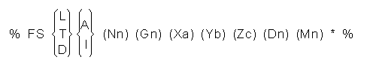
where:
L = leading zeros omitted
T = trailing zeros omitted
D = explicit decimal point (i.e. no zeros omitted)
A = absolute coordinate mode
I = incremental coordinate mode
Nn = sequence number, where n is number of digits (rarely used)
Gn = prepartory function code (rarely used)
Xa = format of input data (5.5 is max)
Yb = format of input data
Zb = format of input data (Z is rarely if ever seen)
Dn = draft code
Mn = misc code

Examples
%FSLAX24Y24*%
Format Statement Leading Zeros Suppression, Absolute Coordinates format=2.4
%FSTIX44Y44*%
Format Statement Trailing Zero Supression, Incremental Coordinates, format=4.4

Embedded Units
RS274X files can use coordinate and aperture units of either inches or millimeters. The statements:
%MOIN*% indicates inches
%MOMM*% indicates millimeters

Image Polarity
With the old RS274D one had to instruct the photoplot operator manually on the desired polarity of the film. If the operator didn't pay attention or got confused then your film came out wrong. With RS274X a command near the beginning of the file can invert the film's polarity.


%IPPOS*% - positive (left)
%IPNEG*% - negative (right)
Do not confuse image polarity with individual layer polarity. It is possible to build up a very complex plot by combining individual dark and clear plots and then setting the overall polarity of the film.

Embedded Aperture Definitions
One of the major shortcomings of the old RS274D spec was that the definition of each aperture was not part of data file; instead it was transferred manually on paper or as a text file similar to what is seen below:

Aperture Definitions
D-code Shape SizeX Size Y
d10 round 0.010
d11 square 0.030
d12 rect 0.060 0.020
d13 thermal 0.050
d14 oblong 0.060 0.025
Some apertures are obvious - the round, square and rectangle. But both the oblong and the thermal are subject to the photoplot operator's interpretation as shown below.

Basic Thermal --- Rotated Thermal --- Square Thermal
With 274D, building the exact thermal shape was a job for the photoplot operator; there was significant amount of effort and expense involved in creating these custom apertures and libraries had to be maintained.
With 274X even complex apertures are described using macros that the photoplotter (and hopefully your CAM software) synthesizes on-the-fly.

The Basic Aperture Definitions
RS274x includes several "standard" apertures since these represent more than 90 percent of the flash types used:
- circle
- rectangle
- obround
- polygon
These are all assumed to be centered and can be defined with a round or rectangular hole if desired.

Standard Circle
%ADD{code}C,{$1}X{$2}X{$3}*%

where

AD - aperture description parameter
D{code} d-code to which this aperture is assigned (10-999)
C tells 274X this is a circle macro

$1 value (inches or mm) of the outside diameter
$2 optional, if present defines the diameter of the hole
$3 optional, if present the $2 and $3 represent the size of
a rectangular hole.

Circle Examples
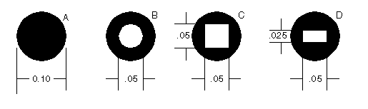
%ADD21C,.100*% (a) 0.10 diameter circle on d21

%ADD22C,.100X.050*% (b) 0.10 dia circle with 0.05 hole
on d22.

%ADD23C,.100X.050X.050*% (c) 0.10 dia circle with 0.05 square
hole on d23

%ADD24C,.100X.050X.025*% (d) 0.10 dia circle with 0.05 x 0.025
rectangular hole on d24

Standard Rectangles
%ADD{code}R,{$1}X{$2}X{$3}X{$4}*%

where

AD - aperture description parameter
D{code} d-code to which this aperture is assigned (10-999)
R tells 274X this is a rectangle macro

$1 value (inches or mm) of rect's length in X
$2 value if rect's height in Y
$3 optional, if present defines the diameter of the hole
$4 optional, if present the $2 and $3 represent the size of
a rectangular hole.
For details on the obround and polygon (which are rarely used) see Gerber Format Guide, Doc 0000-000-RM-00.

Aperture Macros
The more general aperture macro can be thought of as a type of programming language where one builds up a complex aperture definition from a series of simpler primitives. While this is a very powerful feature of RS274X, using it has its drawbacks.
Remember that 274X is essentially Gerber Scientific's standard - photoplotter's from other manufacturer's may not read 274X at all - even if they do implement a subset of 274X it is usually the simpler commands that are supported and complex commands such as aperture macros may not translate correctly or at all. Therefore most PCB layout programs do not make use of complex aperture macros.
However macros are almost required defining thermal reliefs - and since thermal reliefs are very important in power and ground planes we'll do a detailed example of macros using the thermal primitive.

Macro Primitives
Remember we said a macro is like a programming language - the complex aperture is built from one or more shapes called primitives. Available primitives include:

Primitive Name Primitive Number Description and Parameter Number

Circle (1) round

Line Vector (2 or 20) rectangle defined by endpoints
width and rotation. Square ends.

Line Center (21) rect - defined by center and length, width
and rotation. Square ends.

Line-Lower Left (22) rect - defined by lower left coordinate,
length, width and rotation.

Outline (4) outlines an area defined by coordinate pairs.
max vertice=50.

Polygon (5) a regular polygon with 3-10 sides. defined
by center, outer diameter and rotation.

Moire (6) target defined by center, number of circles
circle thickness, cross hair length, thickness
and rotation.

Thermal (7) thermal relief defined by outer diameter, inner
diameter, crosshair thickness and rotation.

Aperture Macro Example - Thermal Relief
The thermal relief is so important that it has its own primitive - even though it could be built from other primitives.
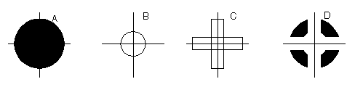
%AMTHERM100*7,0,0,0.100,0.050,0.025,0.0*%

%ADD32THERM100*% assigns THERM100 to d-code 32

where

AM - aperture macro
THERM100 - name of the macro
* - terminates name
7 - primitive 7, which is a thermal relief
0,0 - first two parms: x,y center
0.100 - third parm: outer diameter (solid black see (a) above)
0.050 - fourth parm: inner diameter (clear see (b) above)
0.025 - fifth parm: crosshair width (clear see (c) above)
0.0 - sixth parm: crosshair rotation (not used here)

Multiple Layers
It's been pretty standard practice in the PCB industry to build up a phototool from multiple Gerber files. However the instructions to the photoplotter operator have always been manual - leaving room for errors and omissions. Here's how it used to be done:

Plotting Instructions for XYZ

Film1: top
targets.gbr pos
comp.gbr pos
padmaster.gbr pos

Film2: bottom
targets.gbr pos
sold.gbr pos
padmaster.gbr pos

Film3: vcc
vcc1.gbr neg
clearance.gbr neg
traces.gbr pos
RS274X includes two special commands, %LPD*% and %LPC*% that organizes data inside the file by layer. With a few judicious LPD/LPC commands combined with the IP (image polarity) command one can build up complex ground planes quickly and easily. In the example below we will show how the LPD/LPC can be used to put a circuit trace easily on a power plane.
The main difficulty with putting a circuit trace on a power plane is clearing away the metal around the circuit trace and it's associated pads. With standard Gerber the layout software often had to fill in with small strokes the entire powerplane metal area except where the clearance would be. This results in a very large and unwieldy Gerber file.
When creating such a Gerber file in 274X we can use the LPC (clear layer) to draw the trace.
G04 Image Parameters ***
%MOIN*%
%FSLAX24Y24*%
%IPNEG*% this will reverse polarity of the entire film,
eliminating the need to stroke the metal area
of the powerplane.

%ADD10C,,,*% here we define some round apertures and a thermal
%ADD11C...*%
%ADD12C...*%
%AMTHERMAL*...*%
%ADD13THERMAL*%
G04*
%LNINTERNAL_VCC*% this is our basic vcc powerplane layer consisting
of clearance pads, thermal reliefs, the outer trace
that defines the board edge, and the clearance
for the inner trace.

%LPD*% indicates digitized data is dark. However when the
entire film is reversed the digitzied data will be
clear.
G54D10*
data
data
data

G04 NEW LAYER ***
%LNTRACE_VCC*% this defines the circuit trace and two pads A,B

%LPC*% note that the data here is clear or reversed out.
however when the entire film is negated the digitized
data will be black on the film.
G54D12*
data
data
data
M02* end of the job

The series of images below show how a ground plane can be easily drawn, a trace within the ground plane is placed and substracted, and the entire image is then reversed.
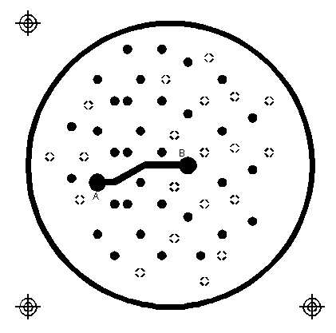 | Internal_VCC data. Note the large pads at A,B and the fat clearance trace.

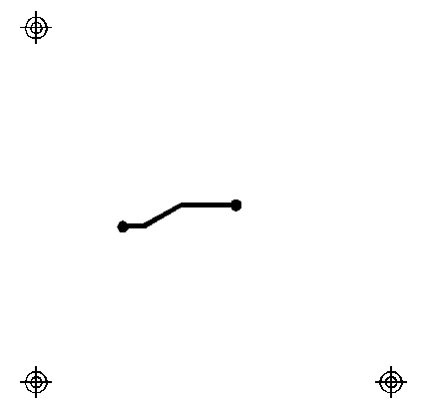 | The inner TRACE data. Since the layer is defined as LPC it will be subtracted from the INTERNAL_VCC plane data.

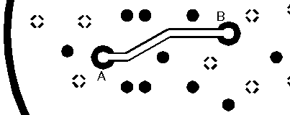 | The dark VCC layer merged with the clear TRACE layer but before polarity reversal.

 | The dark VCC layer merged with the clear TRACE layer after polarity reversal.

G36/G37 Polygons
The G36/G37 polygon command precedes the RS274X spec but only the newer Gerber photoplotters supported it. However it is a very powerful command and will see more use in the future for describing complex data often encountered in IC packages, RF and microwave circuits and analog devices.
When the photoplotter sees a G36* command it immediately changes mode - it now ignores any aperture setting and treats each draw command as the edge of a polygon to be filled in. The application creating the Gerber file should create simple clean polygons.
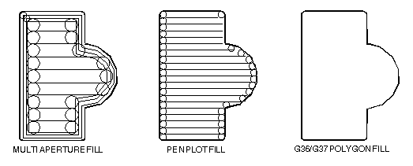

Sample Usage of G36/G37
G04 G36/G37 Polygon Example ***
%MOIN*%
%FSLAX24Y24*%
%IPPOS*%

%ADD10C,,,*% here we define some apertures
%ADD11C...*%
%ADD12C...*%
G04*
%LPD*%
G54D10* select D10
G01*
G36* switch into polygon mode. The diameter and
shape of D10 no longer matters.
X123Y123D02* move to initial position with pen up
X234D01* draw a line (edge)
Y456D01* draw a line (edge)
X234D01* draw a line (edge)
Y123D01* draw a line (edge) back to original start
G37* end polygon mode.

ARTWORK CONVERSION SOFTWARE, INC. Company Profile
417 Ingalls St., Santa Cruz, CA 95060 Tel (831) 426-6163 Fax 426-2824 email: info@artwork.com

