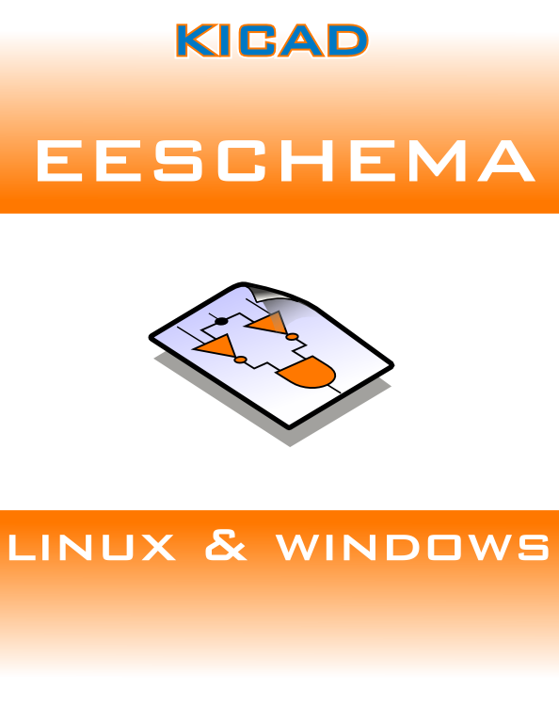

Author: Jean-Pierre Charras
Version: January, 2011

