Preparation of files for circuit fabrication
Headings:
10 - Preparation of files for circuit fabrication
10.1 - Note:
10.2 - Final preparations
10.3 - Final DRC test:
10.4 - Setting the coordinates origin:
10.5 - Generating files for photo-tracing
10.5.1 - GERBER format:
10.5.2 - HPGL Format:
10.5.3 - POSTSCRIPT Format:
10.5.4 - Plot options:
10.6 - Global clearance settings for the solder stop and the solder paste mask:
10.6.1 - Solder mask clearance:
10.6.2 - Solder paste clearance
10.7 - Generating the drill file(s)
10.8 - Generating the cabling documentation:
10.9 - Generation of file(s) for automatic component insertion:
10.10 - Advanced tracing options:

Note:
All of the files generated are placed in the working directory, i.e., in the same directory as the file xxxxxx.brd of the printed circuit board.

Final preparations
It is necessary to:
- Indicate the layer (e.g., 'top or front' and 'bottom or back') and project names by placing appropriate text upon each of the layers.
- All text on the 'copper' (sometimes called 'solder' or 'bottom') side must be mirrored.
- Create any (ground)planes, modifying traces as required to ensure they are contiguous.
- Place alignment crosshairs and possibly the dimensions of the board outline (these are usually placed on one of the general purpose layers).
Here is an example showing all of these elements, except the ground planes, which have been omitted for better visibility:

A color key for the 4 copper layers has also been included:

Final DRC test:
Before generating the output files, a global DRC is very strongly recommended.
Note:
Zones are filled or refilled when starting a DRC.
Press the button to launch the DRC dialog:
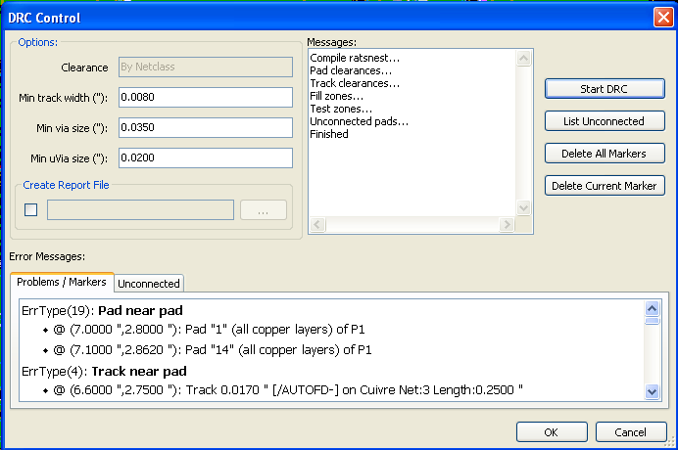
Adjust parameters, and then press .
This final check will prevent any unpleasant surprises...

Setting the coordinates origin:
Set the coordinates origin for the photo plot and drill files, one must place the auxiliary axis on this origin.
Activate .
Move the auxiliary axis to the chosen location by clicking on this location:
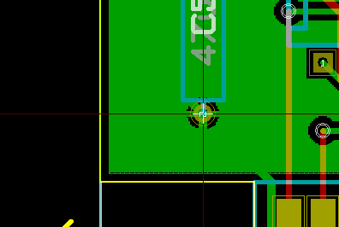 Here is the auxiliary axis on the pad

Generating files for photo-tracing
This is done via the Files/Plot menu option.
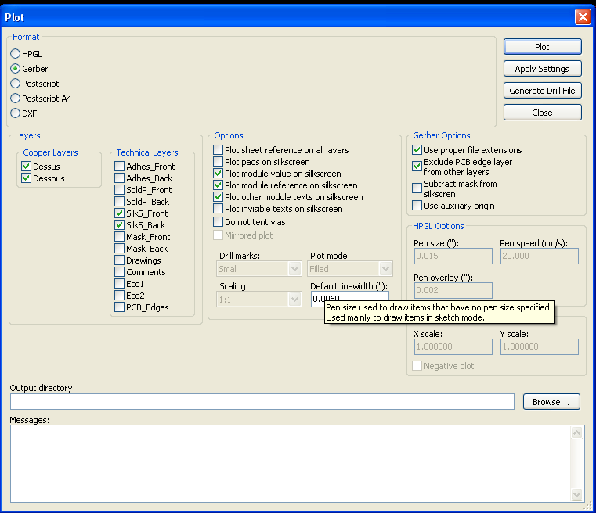
Usually, the files are in the GERBER format.
Nevertheless, it is possible to produce output in both HPGL and POSTSCRIPT formats.
In these formats, a fine scale adjust can be used to compensate the plotter accuracy and to have a true scale 1 for the output:
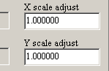

GERBER format:
For each layer, Pcbnew generates a separate file following the GERBER 274X standard, by default in 3.4 format (each coordinate in the file is represented by 7 digits, of which 3 are before the decimal point and 4 follow it; the units are inches).
The tracing is always drawn to scale 1)
It is normally necessary to create files for all of the copper layers and, depending on the type of circuit, for the solder stop, solder mask, and silkscreen (component markings) layers. All of these files can be produced in one go, by selecting the appropriate check boxes.

For example, for a double-sided circuit with solder stop, silkscreen and solder mask (for CMS components), 8 files would be generated ('xxxx' represents the name of the .brd file), something like (real names depending on the default language, and the Pcbnew version):
- xxxx.copper.pho for the copper side.
- xxxx.cmp.pho for the component side.
- xxxx.silkscmp.pho for the component-side silkscreen markings.
- xxxx.silkscu.pho for the copper-side silkscreen markings.
- xxxx.soldpcmp.pho for the component-side solder mask.
- xxxx.soldpcu.pho for the copper-side solder mask.
- xxxx.maskcmp.pho for the component-side solder stop mask.
- xxxx.maskcu.pho for the copper-side solder stop mask.

GERBER files format:
The format used by Pcbnew is:
RS274X
format 3.4, Imperial, Leading zero omitted, Abs format
This is very usual settings.

HPGL Format:
The standard extension for the output files is .plt.
The tracing can be done at user-selected scales and can be mirrored.
The Print Drill Opt list offers the option of pads that are filled, drilled to the correct diameter or drilled with a small hole (to guide hand drilling).
If the Print Sheet Ref option is active, the sheet cartridge is traced.

POSTSCRIPT Format:
The standard extension for the output files is .ps in the case of postscript output.
As for HPGL output, the tracing can be at user-selected scales and can be mirrored.
If the Org = Centre option is active, the origin for the coordinates of the tracing table is assumed to be in the centre of the drawing.
If the Print Sheet Ref option is active, the sheet cartridge is traced.

Plot options:

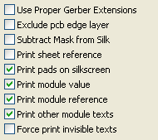
Gerber format | other formats

GERBER format specific options:
Use Proper Gerber Extensions | use .gbl .gtl... instead of .pho for file name extensions.
Exclude Pcb Edge Layer | Do no draw items on Edge layer onto other layers
Subtract Mask from Silk | Remove all Silk from solder paste areas.

Global clearance settings for the solder stop and the solder paste mask:
Masks clearances values can be set globally for the solder mask layers and the solder paste layers.
These clearances can be set:
- At pads level
- At footprint level
- Or globally.
And Pcbnew uses by priority order:
- Pad values. If null:
- Footprint values. If null:
- Global values.

The menu option for this is accessed via Preferences/Dimensions:
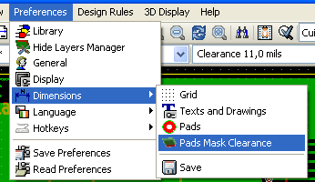
And the dialog is:
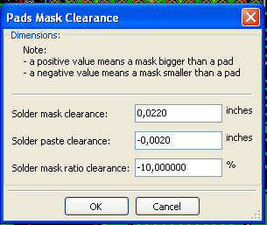

Solder mask clearance:
A value near to 10 mils is usually good.
This value is positive because the mask usually is bigger than the pad

Solder paste clearance
The final clearance is the sum of the solder paste clearance and a percentage of the pad size.
This value is negative because the mask usually is smaller than the pad

Generating the drill file(s)
The creation of a drill file xxxxxx.drl following the EXCELLON standard is always necessary.
One can also produce an optional drill plan, which will be in HPGL (xxxxxx.plt) or POSTSCRIPT (xxxxxx.ps) format, and/or an optional drill report (a plain text file)
However, this is only occasionally useful, as an additional check.
The generation of these files is controlled via :
- the button
- or the Files/Fabrication Outputs/Drill file menu selection.

The Drill tools dialog box is:
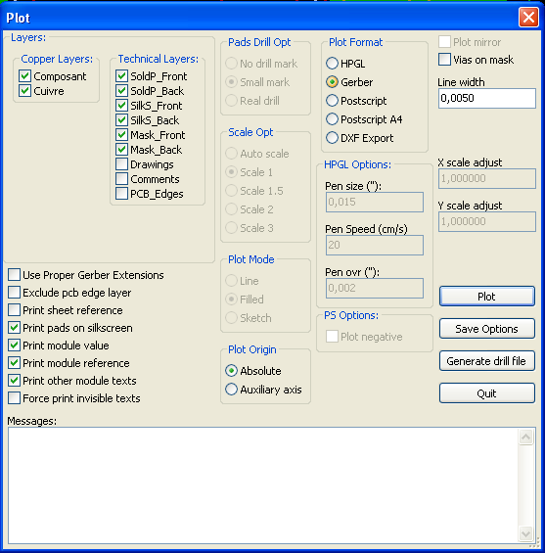
For the HPGL tracing of the drill plan, it is possible to define the n°. and speed of the pen used.
Coordinate origin:
The dialog box is:
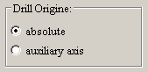
- Absolute: absolue coordinates are used
- Auxiliary axis: coordinates are relative to the auxiliary axis (use the tool (right toolbar) to put it in good place.

Generating the cabling documentation:
To produce these files, the component and copper silkscreen layers can be traced. Usually, just the component-side silkscreen markings are sufficient for cabling a PCB. If the copper-side silkscreen is used, the text it contains should be mirrored in order to be readable.

Generation of file(s) for automatic component insertion:
This option is accessed via the Postprocess/Create Cmp file menu option. However, no file will be generated unless at least one module has the Normal+Insert attribute activated (see Editing Modules). One or two files will be produced, depending upon whether insertable components are present on one or both sides of the PCB. A dialogue box will display the names of the file(s) created.

Advanced tracing options:
The options described below (part of the Files/Plot dialogue) allow for fine-grained control of the tracing process. They are particularly useful when printing the silkscreen markings for cabling documentation.
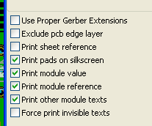
The options are:

Use Proper Gerber Extensions | GERBER format specific.  When creating files, use specific extensions foe each file.  If disabled the Gerber file extension is .pho
Exclude pcb edge layer | GERBER format specific.  Do not plot graphic items on edge layer.

Print Sheet Ref | Trace sheet outline and the cartridge.
Print Pads on Silkscreen | Enables/disables printing of pad outlines on the silkscreen layers (if the pads have already been declared to appear on these layers). In fact useful for preventing any pads from being printed, in the disabled mode.
Print Module Value | Enables printing of VALUE text on the silkscreen.
Print Module Reference | Enables printing of the REFERENCE text on the silkscreen.
Print other module texts | Enables the printing of other text fields on the silkscreen.
Force Print Invisible Texts | Forces printing of fields (reference, value) declared as invisible. In combination with Print Module Reference and Print Module Value, this option enables production of documents for guiding cabling and repair. These options have proven necessary for circuits using components that are too small (CMS) to allow readable placement of two separate text fields.

