- Installation

Table of Contents
2 - Installation 1
2.1 - Installation of the software 1
2.2 - Modifying the default configuration 1
2.3 - Initialize the footprint library list : initial version : 1
2.4 - Managing Footprint Libraries 3
2.4.1 - Global Footprint Library Table 3
2.4.2 - Project Specific Footprint Library Table 3
2.4.3 - Initial Configuration 4
2.4.4 - Adding Table Entries 4
2.4.5 - Environment Variable Substitution 4
2.4.6 - Usage Patterns 4

  - Installation of the software
The installation procedure is described in the kicad documentation.
  - Modifying the default configuration
A default configuration file kicad.pro is provided in kicad/share/template. This file is used as the initial configuration for all new projects.

This configuration file can be modified to change libraries to be loaded

To do this:
- Launch Pcbnew using kicad or directly. On Windows is in c:\kicad\bin\pcbnew.exe and on Linux you can run /usr/local/kicad/bin/kicad or /usr/local/kicad/bin/pcbnew if the binaries are located in /usr/local/kicad/bin.
- Select Preferences - Libs and Dir.
- Edit as required.
- Save the modified configuration (Save Cfg) to kicad/share/template/kicad.pro.

  - Initialize the footprint library list : initial version :
You can access to the library list initialization from :

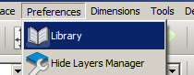
lThe dialog which allows you to set the library list in use is:
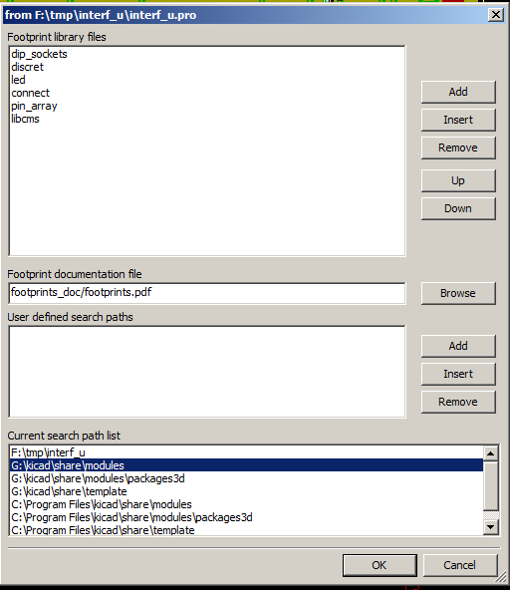

You have to add useful libraries or remove useless libraries for new projects.
A common mistake is to load all existing libraries.
In fact it creates a lot of wasting time each time you have to choose a footprint among a long list.

  - Managing Footprint Libraries
As of release rXXXX, Pcbnew uses the new footprint library table implementation to manage footprint libraries.
The library table manager is accessible by:
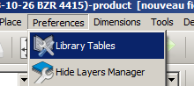
The image below shows the footprint library table editing dialog which can be opened by invoking the “Library Tables” entry from the “Preferences” menu.

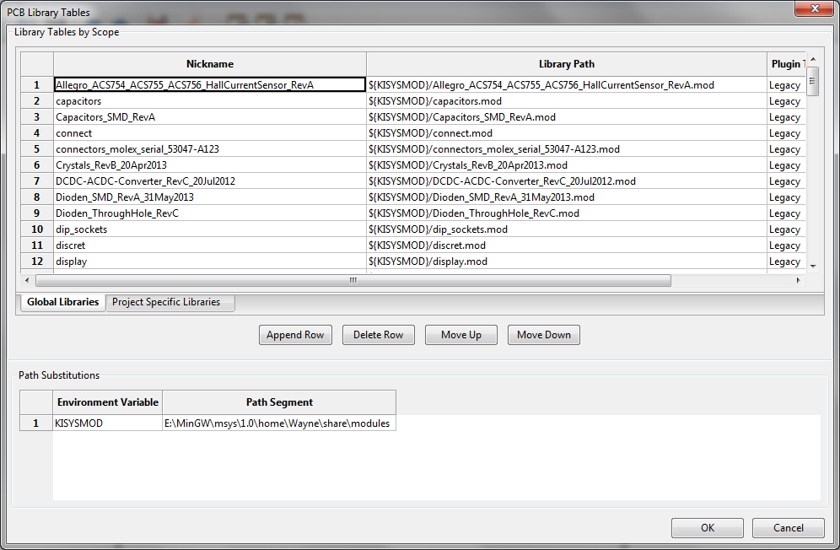
The footprint library table is used to map a footprint library of any supported library type to a library nickname. This nickname is used to look up footprints instead of the previous method which depended on library search path ordering. This allows Pcbnew to access footprints with the same name in different libraries by ensuring that the correct footprint is loaded from the appropriate library. It also allows Pcbnew to support loading libraries from different PCB editors such as Eagle and GEDA.
    - Global Footprint Library Table
The global footprint library table contains the list of libraries that are always available irregardless of the currently loaded project file. The table is saved in the file fp-lib-table in the user's home folder. The location of this folder is dependent on the operating system.
    - Project Specific Footprint Library Table
The project specific footprint library table contains the list of libraries that are available specifically for the currently loaded project file. The project specific footprint library table can only be edited when it is loaded along with the project board file. If no project file is loaded or there is no footprint library table file in the project path, an empty table is created which can be edited and later saved along with the board file.
    - Initial Configuration
The first time CvPcb or Pcbnew is run and the global footprint table file fp-lib-table is not found in the user's home folder, Pcbnew will attempt to copy the default footprint table file fp_global_table stored in the system's KiCad template folder to the file fp-lib-table in the user's home folder. If fp_global_table cannot be found, an empty footprint library table will be created in the user's home folder. If this happens, the user can either copy fp_global_table manually or configure the table by hand. The default footprint library table includes all of the standard footprint libraries that are installed as part of KiCad.
    - Adding Table Entries
In order to use a footprint library, it must first be added to either the global table or the project specific table. The project specific table is only applicable when a board file is open. Each library entry must have a unique nickname. This does not have to be related in any way to the actual library file name or path. The colon `:` character cannot be used anywhere in the nickname. Each library entry must have a valid path and/or file name depending on the type of library. Paths can be defined as absolute, relative, or by environment variable substitution (see section 4.5.3 below). The appropriate plug in type must be selected in order for the library to be properly read. Pcbnew currently supports reading KiCad legacy, KiCad Pretty, Eagle, and GEDA footprint libraries. There is also a description field to add a description of the library entry. The option field is not used at this time so adding options will have no effect when loading libraries. Please note that you cannot have duplicate library nicknames in the same table. However, you can have duplicate library nicknames in both the global and project specific footprint library table. The project specific table entry will take precedence over the global table entry when duplicated names occur. When entries are defined in the project specific table, an fp-lib-table file containing the entries will be written into the folder of the currently open net list.
    - Environment Variable Substitution
One of the most powerful features of the footprint library table is environment variable substitution. This allows you to define custom paths to where your libraries are stored in environment variables. Environment variable substitution is supported by using the syntax ${ENV_VAR_NAME} in the footprint library path. By default, at run time Pcbnew defines the $KISYSMOD environment variable. This points to where the default footprint libraries that were installed with KiCad are located. You can override $KISYSMOD by defining it yourself which allows you to substitute your own libraries in place of the default KiCad footprint libraries. When a project netlist is loaded, Pcbnew also defines the KICAD_PRJ_PATH. This allows you to create libraries in the project path without having to define the absolute path to the library in the project specific footprint library table.
    - Usage Patterns
Footprint libraries can be defined either globally or specifically to the currently loaded project. Footprint libraries defined in the user's global table are always available and are stored in the fp-lib-table file in the user's home folder. Global footprint libraries can always be accessed even when there is no project net list file opened. The project specific footprint table is active only for the currently open net list file. The project specific footprint library table is saved in the file fp-lib-table in the path of the currently open board file. You are free to define libraries in either table. There are advantages and disadvantages to each method. You can define all of your libraries in the global table which means they will always be available when you need them. The disadvantage of this is that you may have to search through a lot of libraries to find the footprint you are looking for. You can define all your libraries on a project specific basis. The advantage of this is that you only need to define the libraries you actually need for the project which cuts down on searching. The disadvantage is that you always have to remember to add each footprint library that you need for every project. You can also define footprint libraries both globally and project specifically. One usage pattern would be to define your most commonly used libraries globally and the library only require for the project in the project specific library table. There is no restriction on how you define your libraries.

