Headings:
3 - Main menu
3.1 - File menu
3.2 - Preferences menu
3.2.1 - Preferences menu / Libs and Dir
3.2.2 - Preferences menu / Colours
3.2.3 - Preferences / Options
3.2.4 - Preferences / Language
3.3 - Help menu

Main menu

File menu
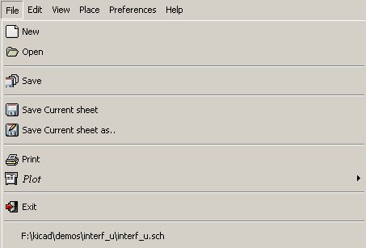

Load Schematic Project | Load a diagram and its hierarchy
Save Schematic project | Save current sheet and all its hierarchy.
Save Current sheet | Save current sheet.
Save Current sheet as... | Save current sheet with a new name.
Print | Access to print menu (See also chap “Print and Plot”).
Plot | Plot in Postscript HPGL or SVF format (See chap “Print and Plot”).
Exit | Quit without saving.

Preferences menu
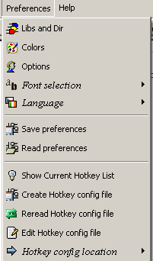
Libs and Dir | Select libraries and the library's path
Colours | Select colours.
Options | Display options (Units, Grid size.).
Read preferences  Save preferences | Read and Save configuration file.
Show Current Hokey List | Shows the current hotkeys, Same as ?
Create Hotkey config file | Create a hotkey config file, which can be modified (by a text editor), for those who want change the default hotkeys
Reread Hotkey config file | Read the current hotkey file, after editing.
Edit Hotkey config file | Launches a text editor and edit the hotkey config file préviously created
Hotkey config file | Set the directory used to read/store the hotkey config file  (Home directory or kicad/template)

Preferences menu / Libs and Dir
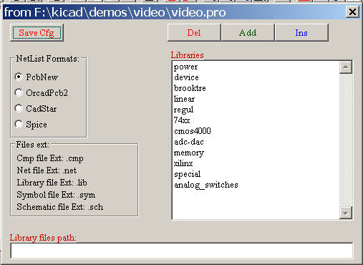
Eeschema configuration is essentially :
- Library's path.
- Library's list.
- Netlist format.

The configuration parameters are saved in the .pro file.
Different config files in different directories are possible.
Eeschema seeks and uses by decreasing priorities :
- The configuration file (project>.pro) in the current directory.
- The kicad.pro configuration file in the kicad directory. This file can thus be the default configuration.
- Default values if no file is found. It will at least then be necessary to fill out the list of libraries to load, and then save the configuration.

Preferences menu / Colours
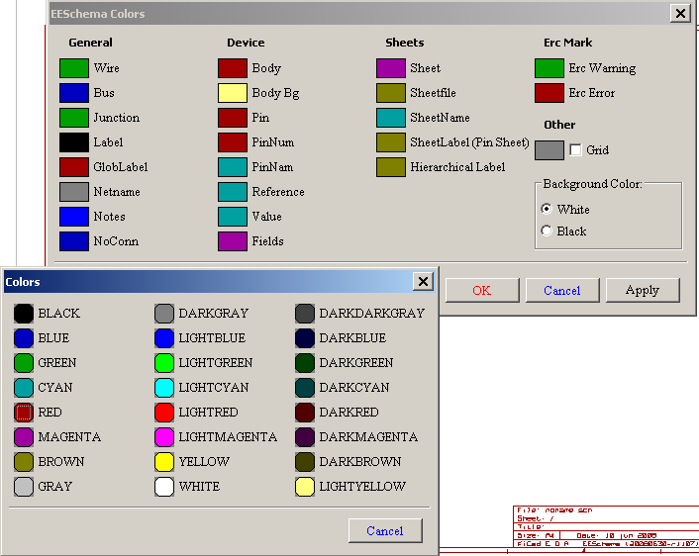
Various drawing elements, colour selection and background colour (black or white only).

Preferences / Options
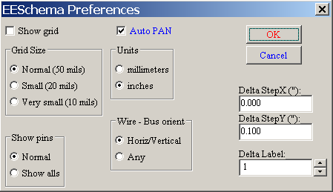
Display Grid :
If checked : display grid.
Grid Size:
To work with normal grid (0,050 inches or 1,27 mm). Smaller grids are used for component building.
Show Pins:
Display invisible pins if checked (allows the display of power pins).
Units:
Select the display and the cursor coordinate units (Inches or Millimetres).
Wire / Bus orientation
Horiz/vertical checked : only horizontal or vertical wires or buses are allowed.
Active Any : all orientations are allowed.
Auto Pan :
If checked, automatically shifts the window if the cursor leaves the window, during wire drawing, or element moving.

Element repeat:
X Step :
shift value on X axis during element duplication (usual value 0)
Y Step :
shift value on Y axis during element duplication (usual value is 0,100 inches or 2,54 mm)
Label Step :
Increment during duplication of texts ending in a number, such as bus members (usual value 1 or - 1).

Preferences / Language
Use default mode.
Other languages are available.
Eeschema has to be restarted.
Useful mainly for maintenance purpose.

Help menu
Access to online help (this document) and also for checking the current version of Eeschema (Eeschema about).

