- Setting up working layers

Table of Contents
5 - Setting up working layers 1
5.1 - Select copper layers 1
5.1.1 - Introduction 1
5.1.2 - Select number of layers 1
5.2 - Copper layers 2
5.3 - Auxiliary technical layers 3
5.3.1 - Paired layers 3
5.3.2 - Layers for general use 3
5.3.3 - Special layer 3
5.4 - Selection of the active Layer 3
5.4.1 - Selection using the layer manager 4
5.4.2 - Selection using the upper toolbar 4
5.4.3 - Selection using the pop-up window 5
5.5 - Selection of the Layers for Vias: 5
5.6 - Using the high-contrast mode 6
5.6.1 - Copper layers in high contrast mode 6
5.6.2 - Technical layers 7

Pcbnew can work on 28 different layers:
- 16 layers of copper (or of routing of tracks)
- 12 auxiliary technical layers.
The number of copper layer, and, if needed, their names and attributes should be set.
Unused technical layers can be disabled.
  - Select copper layers
    - Introduction
Copper layers are the usual working layers used by the automatic router to place and re-arrange tracks. Layer 1 is the copper (solder) layer. Layer 16 is the component layer. Other layers are the inner layers, from L2 to L15.
    - Select number of layers
To enable navigation between layers, it is necessary to select the number of working layers. To do this you can use the menu bar and select Preferences - Layers Setup.
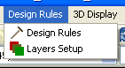
Then select the number of layers wanted, from 2 to 16.
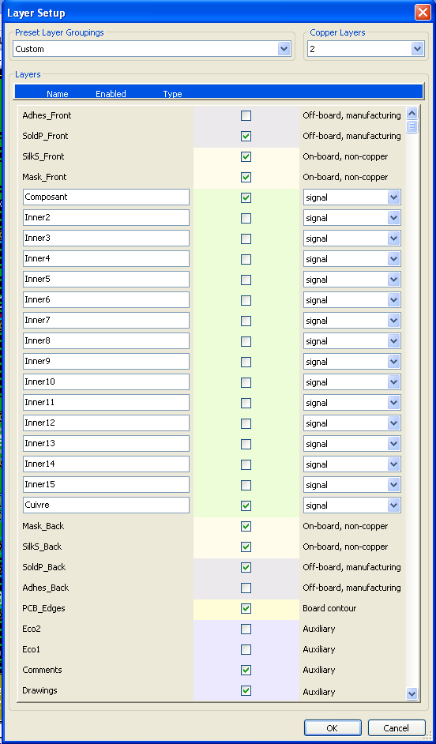

  - Copper layers
The name of any copper layer is editable. Copper layers have attributes useful when using the external router FreeRouter.
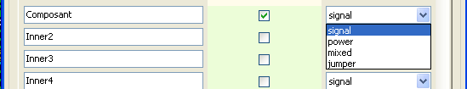
  - Auxiliary technical layers
Some are associated in pairs, others not. When they appear as a pair this affects the behaviour of modules. The elements making up a module (pads, drawing and text) appearing on a layer (solder or component), appear on the other complementary layer when the module is inverted (mirrored).
The technical layers are:
    - Paired layers
- The Adhesives layers (Copper and Component):
These are used in the application of adhesive to stick SMD components to the circuit board, generally before wave soldering.
- The Solder Paste layers paste SMD (Copper and Component):
Used to produce a masks to allow solder paste to be placed on the pads of surface mount components, generally before reflow soldering. In theory only surface mount pads occupy these layers.
- The Silk Screen layers (Copper and Component):
They are the layers where the drawings of the components appear.
- The Solder Mask layers (Copper and Component):
These define the solder masks. Normally all the pads appear on one or the other of these layers (or both for through pads) to prevent the varnish covering the pads.
    - Layers for general use
- Comments
- E.C.O. 1
- E.C.O. 2
- Drawings
These layers are for any use. They can be used for text such as instructions for assembly or wiring, or construction drawings, to be used to create a file for assembly or machining.
    - Special layer
Layer Edges PCB:
this layer is reserved for the drawing of circuit board outline. Any element (graphic, texts…) placed on this layer appears on all the other layers.
Use this layer only to draw board outlines.
  - Selection of the active Layer
The selection of the active working layer can be done in several ways:
- Using the right toolbar (Layer manager).
- Using the upper toolbar.
- With the Pop-Up window (activated with the right mouse button).
- Using the + and – keys (works on copper layers only).
- By hot keys.
    - Selection using the layer manager

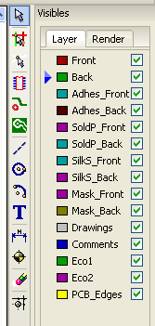 | The layer manager also allows you to change color layers and their visibility
    - Selection using the upper toolbar
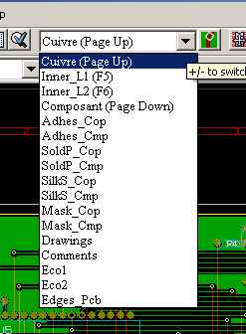
This directly selects the working layer.
Hot keys to select the working layer are displayed.
    - Selection using the pop-up window
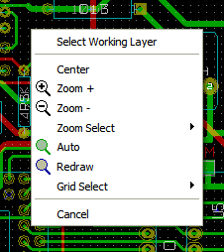
The Pop-up window opens a menu window which provides a choice for the working layer
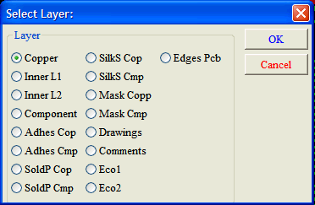
  - Selection of the Layers for Vias:
If the Add Tracks and Vias icon is selected on the right hand toolbar, the Pop-Up window provides the option to change the layer pair used for vias:
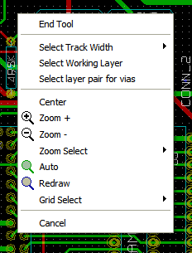
This selection opens a menu window - which provides choice of the layers used for vias.
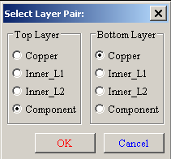
When a via is placed the working (active) layer is automatically switched to the alternate layer of the layer pair used for the vias.
One can also switch to an other active layer by hot keys, and if a track is in progress, a via will be inserted.
  - Using the high-contrast mode
This mode is entered when the tool (left toolbar ) is activated.
When using this mode, the active layer is displayed like in the normal mode,but all others layers are displayed in gray color.
There is two useful cases:
    - Copper layers in high contrast mode
When a board uses more than four layers, this option allows the design to seen more easily the active copper layer:
- Normal mode normal (back side copper layer active)
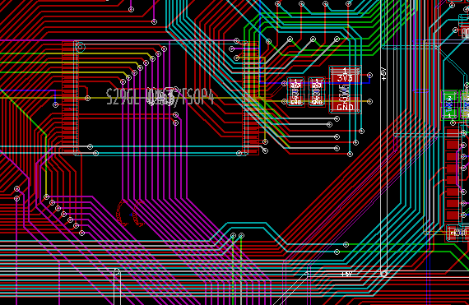

- High Contrast mode (back side copper layer active):
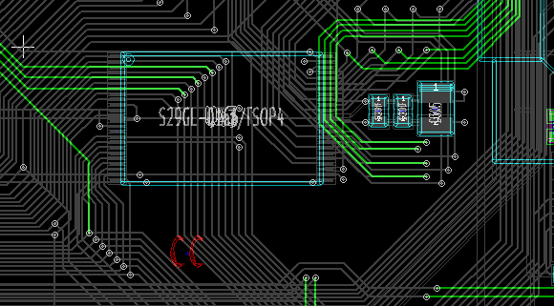

    - Technical layers
The other case is when it is necessary to examine solder paste layers and solder mask layers, that are usually not displayed.
Masks on pads are displayed if this mode is active:
- Normal mode (front side solder mask layer active):
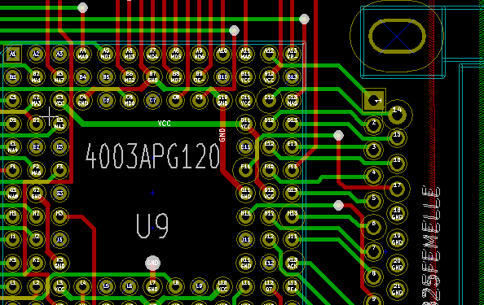
- High Contrast mode (front side solder mask layer active):
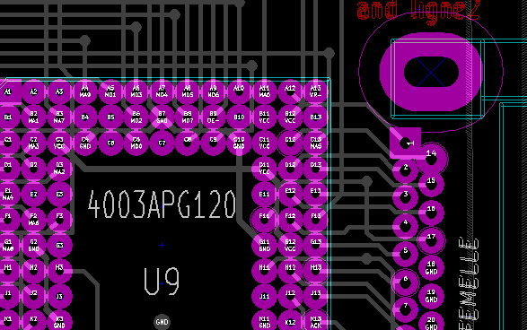
This layer is now displayed, and pads sizes on this layer can be checked.

