Headings:
10 - Plot and Print
10.1 - Overview
10.2 - Common commands:
10.3 - Plot / Plot HPGL
10.3.1 - Sheet size selection
10.3.2 - Offset adjustments
10.4 - Plot / Plot Postscript
10.5 - Plot / Plot SVG
10.6 - Plot / Plot DXF
10.7 - Print:

Plot and Print

Overview
You can access both commands via the file menu:
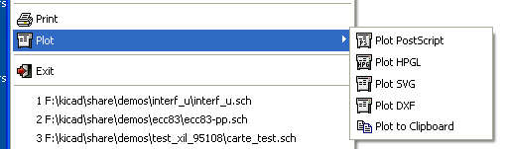
The output formats are POSTSCRIPT,HPGL.,SVG or DXF.
You can also print directly on your printer.

Common commands:
Plot All allows you to plot the whole hierarchy (a file is generated for each sheet).
Plot CURRENT generates a file for the current sheet only.

Plot / Plot HPGL
This command allows you to create an HPGL file.
In this format you can define:
- Pen number
- Pen thickness (in 0,001 inch).
- Drawing speed (in cm/S).
- Sheet size.
- Print offsets.

Plotter setup dialog box :

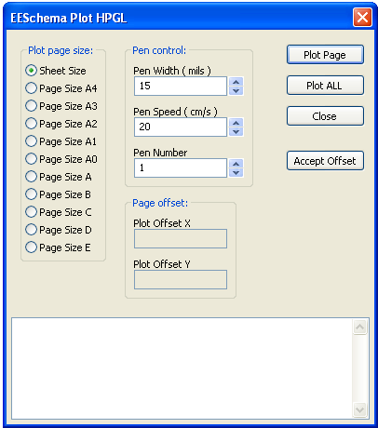
The file name is the sheet name with the extension .plt.

Sheet size selection
Sheet Size is normally checked. In this case, the sheet size defined in the title block menu will be used and the scale is 1.
If another sheet size is selected (A4 with A0, or A with E), the scale is automatically adjusted to fill the page.

Offset adjustments
For all standard dimensions, one can adjust “offsets”, to center the drawing as accurately as possible.
Because plotters have an origin point at the center or at the lower left corner of the sheet, it is necessary to be able to introduce an offset, in order to plot properly.
Generally:
- For plotters having their origin point at the center of the sheet, the offsets must be negative and set at half of the sheet dimension.
- For plotters having their origin point at the lower left corner of the sheet, the offset must be set close to 0.

Set an offset:
- Select sheet size.
- Set Offset X and Offset Y.
- Click on Accept Offset.

Plot / Plot Postscript
This command allows you to create PostScript files.
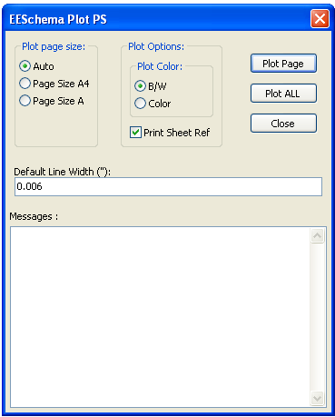
The file name is the sheet name with an extension .ps.
You can uncheck the option : Print title block. This is useful if you want to create a postscript file for encapsulation (format .eps) to insert a diagram in a word processing software.
The message window displays the file names created.

Plot / Plot SVG
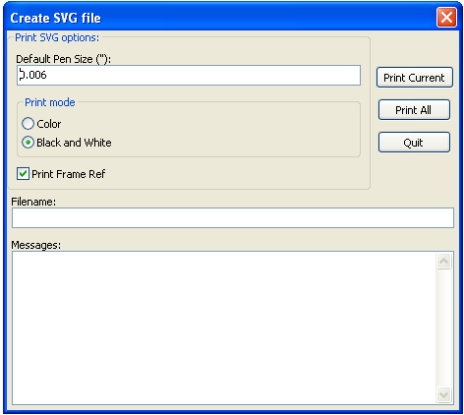
Allows you to create plot files using the vectored format SVG.
The file name is the sheet name with an extension .svg.

Plot / Plot DXF
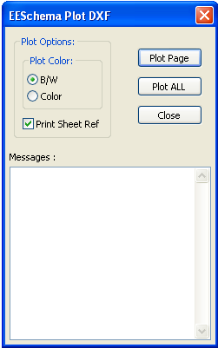
Allows you to create plot files using the format DXF.
The file name is the sheet name with an extension .dxf.

Print:
This command, similar to the toolbar icon command, allows you to visualize and generate design files on the standard printer under LINUX. and under Windows.

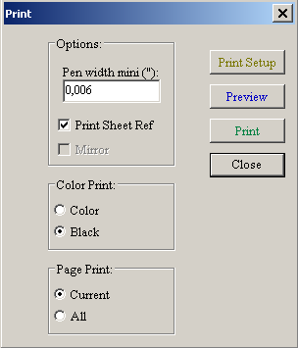
The Page Print option allows you to print :
- Current creates a file for the current sheet only.
- All allows you to plot the whole hierarchy (a .ps file is generated for each sheet).

The Color Print options allow you to choose a color or black and white printing.
In black and white, any color other than white is printed in black. This option is generally necessary if you uses a black and white laser printer, because colors are printed into not very readable half-tones.

