ProperTkt
Functional & Technical Specification
Maintenance tickets and notices for small landlords
Audience: senior application developer building the desktop and mobile builds.
Web reference: Next.js 14 + Prisma + SQLite/Postgres + Resend.

1. Overview
ProperTkt is a thin operations app for a single small landlord (1–10 units). Tenants submit maintenance tickets from any device with email-only authentication; the landlord triages tickets and sends notices (rent reminders, trash pickup, repair windows) from an admin portal. The product is intentionally narrow so the desktop and mobile builds can ship quickly on top of the existing API.

Goals (v1)
- Tenants can sign in by email and file a maintenance ticket in under 30 seconds.
- Landlord can manage tenants, triage tickets, and email notices from one place.
- All status changes by the landlord automatically email the tenant.
- The desktop and mobile builds reuse the same HTTP API and data model; no UI parity is required.

Out of scope (v1)
- SMS / push notifications (architected for later — see §7).
- Payments, rent ledger, lease document storage.
- Multi-property / multi-landlord tenancy. The app assumes one landlord.
- Tenant-to-tenant messaging or public listing pages.

Reference stack
Layer | Implementation
Frontend | Next.js 14 (App Router), React 18, TypeScript, Tailwind CSS
API | Next.js Route Handlers (REST/JSON)
Database | Prisma ORM; SQLite for dev, Postgres for prod
Auth | Signed JWT cookie (jose, HS256); admin password from env; tenant magic link
Email | Resend (REST). Console fallback when API key is unset.
Hosting | Vercel + Vercel Postgres (target)

2. Personas & user flows

Personas
- Tenant — non-technical, mobile-first. Opens link from email or app, reports an issue, checks status.
- Landlord (admin) — one user. Manages 1–10 tenants, triages tickets, sends notices. Equally likely on phone or laptop.

Tenant flow
- Tenant opens app → enters email → receives one-time sign-in link (15 min TTL, single-use).
- Clicks link → session cookie set (30 days) → lands on tenant dashboard.
- Selects category (Plumbing, Appliance, HVAC, Electrical, Pest, Other), urgency, types title + details, submits.
- Sees ticket in their list with status pill. Receives email when landlord updates status or adds a note.

Admin flow
- Admin signs in with email + password (single account, stored in env).
- Dashboard shows tenant count, open ticket count, recent activity.
- From Tenants page: add / edit / delete tenants (cascade deletes their tickets).
- From Tickets page: filter active / closed / all, expand a ticket, change status, add a private note → tenant is emailed.
- From Send notice page: choose a template (rent / trash / repair / custom), edit subject + body, pick recipients, send. Each send is audit-logged.

Email touchpoints (v1)
Trigger | Recipient
Tenant requests sign-in link | Tenant
Tenant submits a ticket | Landlord (admin email)
Admin updates ticket status | Tenant
Admin sends notice blast | Selected tenants

3. UI specification — tenant
All tenant routes are responsive web pages today. The mobile build should mirror the same information architecture (sign-in → dashboard with form + ticket list). Tenant pages are gated by a session cookie; an unauthenticated visitor is redirected to /tenant/login by middleware.

3.1 Landing & login
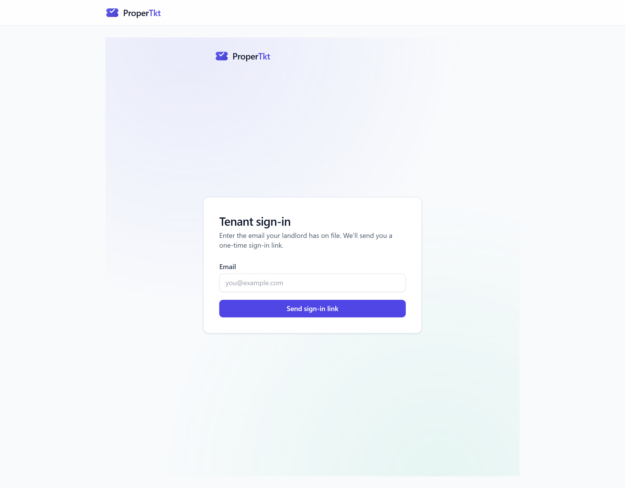
Email-only sign-in (left). The API always returns 200 to avoid revealing which addresses are on file. In dev mode (NODE_ENV=development) the request endpoint signs the user in immediately so testing is fast. The public landing route (/) is a static marketing splash with two role cards; the native builds can skip it and deep-link to tenant or admin sign-in.

3.2 Tenant dashboard
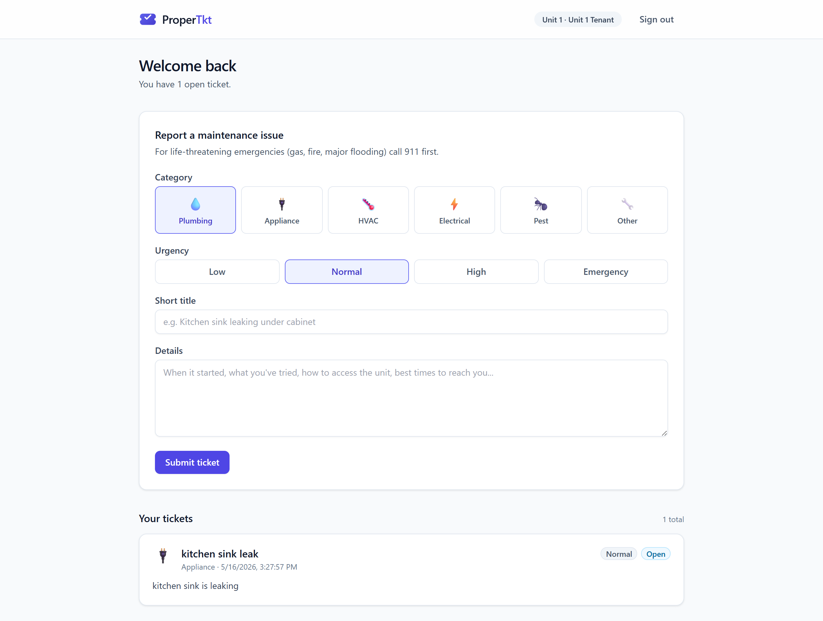
One screen: hero summary ("You have N open tickets"), maintenance form (category tiles + urgency segmented control + title + details), and a reverse-chronological list of the tenant's tickets with category icon, urgency pill, status pill, and any landlord note.

4. UI specification — admin
Admin sign-in is email + password (credentials in env: ADMIN_EMAIL, ADMIN_PASSWORD; constant-time comparison). After sign-in the sticky header exposes four destinations: Dashboard, Tenants, Tickets, Send notice. Below: the dashboard and the three working surfaces.

4.1 Dashboard
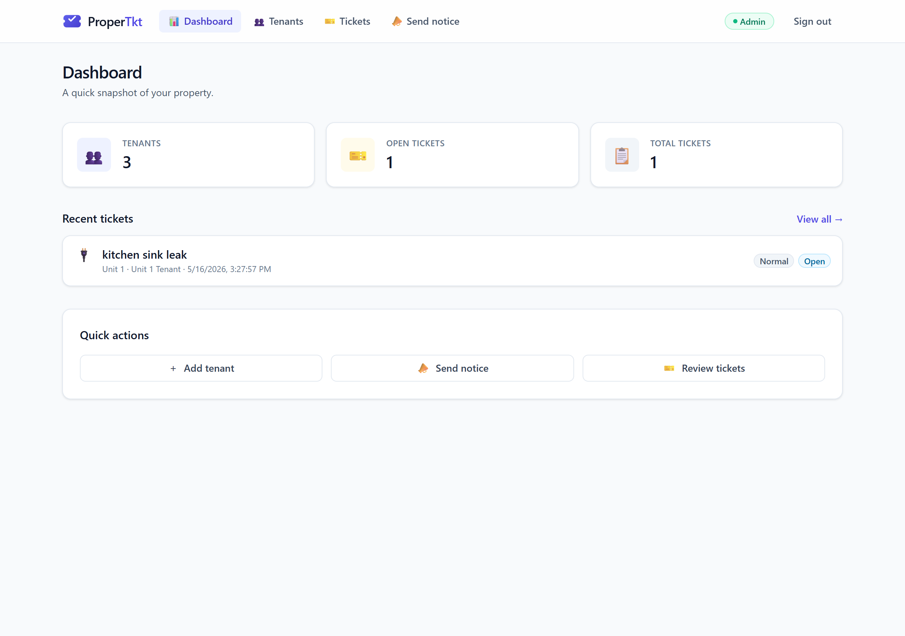
Three stat tiles link to detail pages; recent tickets list reuses the ticket card pattern; quick-action row provides one-tap routes.

4.2 Tenants
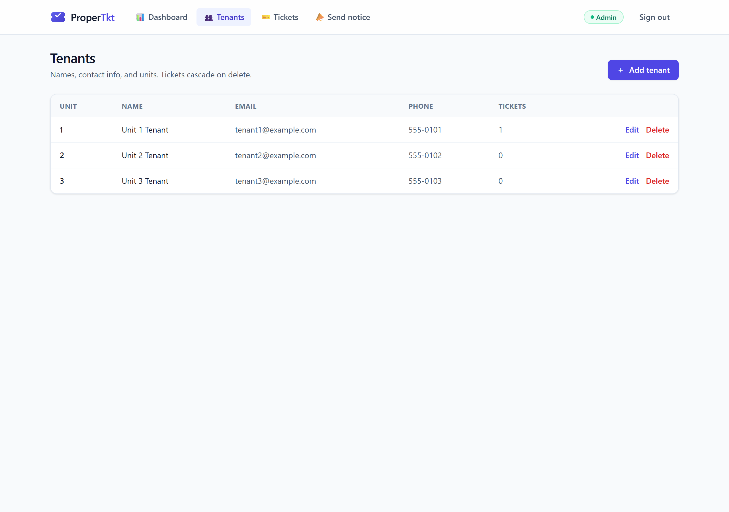
Table of unit, name, email, phone, and ticket count. Add/Edit opens a modal with backdrop blur; delete cascades to tickets after a confirm.

4.3 Tickets
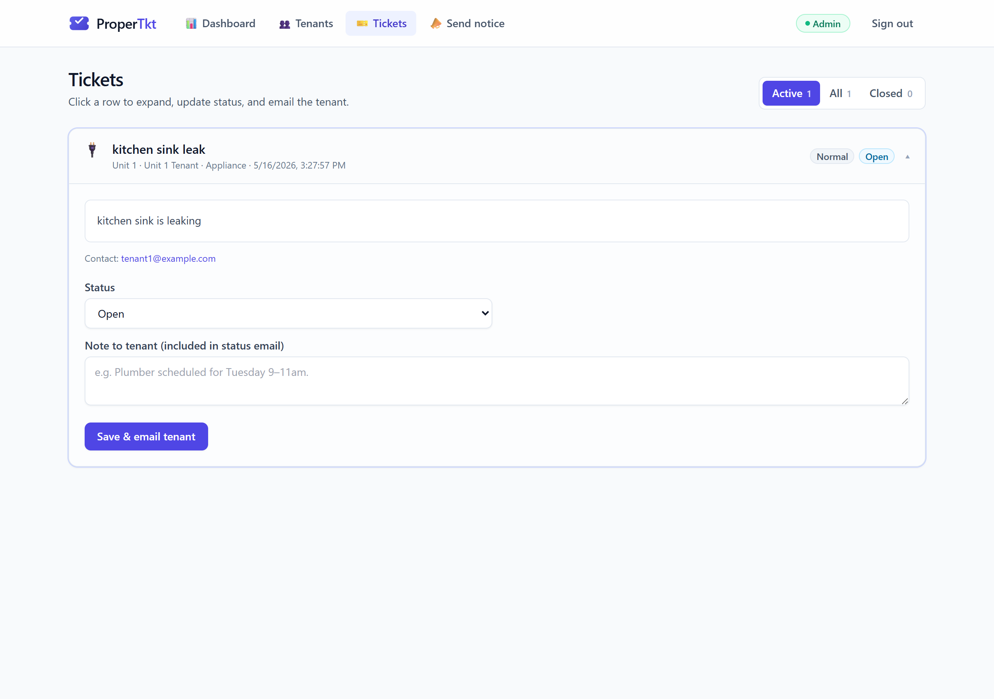
Segmented filter (Active / All / Closed) with live counts. Rows expand inline to show full description, status dropdown, and a free-form note that is emailed to the tenant on save.

4.4 Send notice
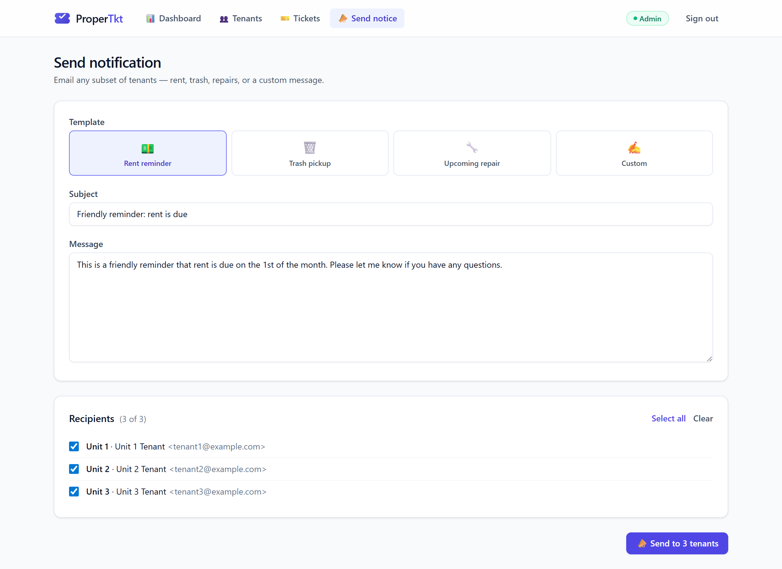
Template tiles (rent, trash, repair, custom) populate subject + body; admin edits, picks recipients (preselected to all), and sends. Every blast is logged to a Notification row.

5. Design system

Palette
Token | Hex | Usage
brand-600 | #4F46E5 | Primary buttons, active nav, focus rings
brand-50/100 | #EEF2FF / #E0E7FF | Selected states, badge backgrounds
slate-50/100/200 | #F8FAFC / #F1F5F9 / #E2E8F0 | Surfaces, hover, borders
emerald-600 | #059669 | Success, online indicator
amber-700 | #B45309 | In-progress status, warnings
red-600 | #DC2626 | Emergency urgency, destructive

Type
- System UI sans (Segoe UI / SF / Roboto). H1 24–32px / 700; H2 18px / 600; body 14px / 400.
- Tracking-tight on H1; numeric lining figures for stat tiles.

Components
- Card: rounded-xl, border-slate-200, soft shadow; hover variant lifts and tints border.
- Pill: rounded-full, 12px, ring-1 inset; one variant per state and urgency.
- Button: 14px, rounded-lg, primary / secondary / ghost / danger. All have :focus-visible ring.
- Modal: fixed overlay 40% slate-900 with backdrop-blur; close on overlay click or ✕.
- Status & urgency tokens live in src/lib/ticket-ui.ts and should be ported verbatim to native builds.

Mobile reference
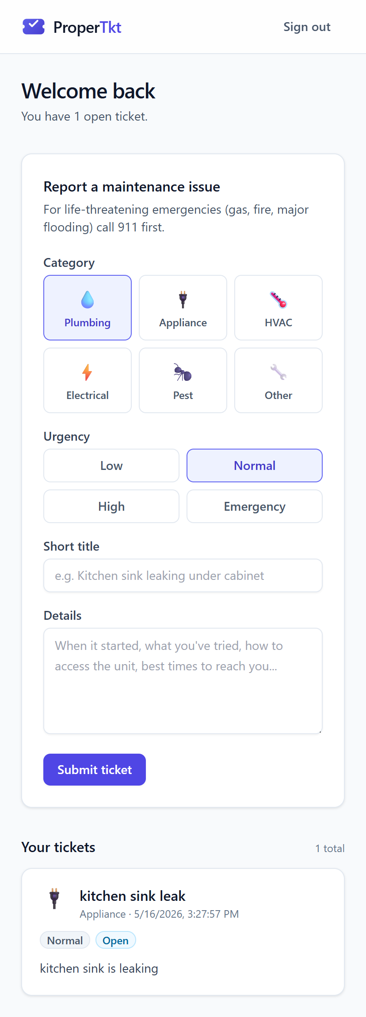
The web build is already mobile-responsive at 414px. The native mobile build should preserve the category-tile picker and pill metaphors but consider replacing the dashboard form with a full-screen "New ticket" sheet.

6. API specification
All endpoints are JSON over HTTPS, hosted under /api. The session is carried in the pm_session cookie (HS256 JWT, httpOnly, 30-day max-age, SameSite=Lax). Native clients should reuse this exact contract; the cookie can be replaced with an Authorization: Bearer <jwt> header in v1.1 (see §9).

6.1 Auth model
Role | Acquisition
admin | POST /api/auth/admin/login with { email, password }. Server compares against env values (constant-time) and sets cookie.
tenant | POST /api/auth/tenant/request with { email }. Server issues a single-use, 15-min token; emails a magic link. GET /api/auth/tenant/verify?token=… exchanges it for a session cookie.
logout | POST /api/auth/logout clears the cookie.

6.2 Endpoints
Method | Path | Role | Purpose
POST | /api/auth/admin/login | public | Admin password sign-in. 401 on mismatch.
POST | /api/auth/tenant/request | public | Issue a magic link (always 200, even if email unknown).
GET | /api/auth/tenant/verify | public | Exchange token → session cookie → 307 to /tenant.
POST | /api/auth/logout | any | Clear session cookie.
GET | /api/tenants | admin | List all tenants with ticket counts.
POST | /api/tenants | admin | Create tenant { name, email, unit, phone?, notes? }.
PATCH | /api/tenants/{id} | admin | Partial update of a tenant.
DELETE | /api/tenants/{id} | admin | Delete tenant; cascades tickets.
GET | /api/tickets | admin|tenant | Admin: all tickets. Tenant: own tickets only.
POST | /api/tickets | tenant | Create ticket. Emails admin.
PATCH | /api/tickets/{id} | admin | Update status / adminNotes. Emails tenant on status change.
POST | /api/notify | admin | Send blast { subject, body, recipientIds[] }. Returns { sent, total, failures[] }.

6.3 Validation & errors
- Every body is parsed with Zod; 400 returns { error, issues? }.
- 401 with { error: "Unauthorized" } for missing/invalid session.
- 5xx returns { error: string } with no stack traces in production.

6.4 Example: create ticket
POST /api/tickets Cookie: pm_session=<JWT>
{ "category": "Plumbing", "urgency": "high", "title": "…", "description": "…" }
→ 200 { "ticket": { id, tenantId, category, urgency, status, createdAt, … } }

7. Backend specification

7.1 Data model
Prisma schema lives at prisma/schema.prisma. All IDs are CUIDs.
Entity | Fields
Tenant | id, name, email (unique), phone?, unit, notes?, createdAt, updatedAt → has many Tickets (cascade delete)
Ticket | id, tenantId, category, title, description, urgency (low|normal|high|emergency), status (open|in_progress|resolved|closed), adminNotes?, createdAt, updatedAt
MagicLink | id, email, tokenHash (SHA-256, unique), expiresAt (15 min), usedAt?, createdAt
Notification | id, subject, body, recipients (JSON), sentCount, sentAt — audit log of every blast

7.2 Sessions
- Cookie name pm_session. Value is a HS256 JWT { role, email, tenantId? } signed with SESSION_SECRET (≥32 bytes).
- Token expiration 30 days; rotated on each successful sign-in.
- Middleware (src/middleware.ts) gates /admin/* and /tenant/* in front of route handlers.

7.3 Email
- Single abstraction src/lib/email.ts → Resend. When RESEND_API_KEY is unset, messages print to stdout (dev mode).
- EMAIL_FROM must be on a verified Resend domain in production.
- All outbound mail is plain-text with optional HTML twin for the magic link.

7.4 Business rules / invariants
- Magic links: single-use, hashed at rest (only the hash is stored), TTL 15 min.
- Tenant-login endpoint always returns 200 — never leak existence of an email.
- Tenants can only read their own tickets; admin can read all.
- Deleting a tenant cascades their tickets but does not delete past Notification audit rows.
- Status updates from admin always trigger a tenant email — there is no "silent" change in v1.

7.5 Configuration
Env var | Purpose
DATABASE_URL | Prisma connection string (file:./dev.db for SQLite; postgres://… for prod)
SESSION_SECRET | 32+ byte HMAC key for JWT signing
ADMIN_EMAIL / ADMIN_PASSWORD | Single admin credential
RESEND_API_KEY | Email transport; blank ⇒ console mode
EMAIL_FROM | From: header, must be on a verified domain in prod
APP_URL | Public base URL used inside magic-link emails

8. Desktop & mobile build guidance
Both builds should be thin clients of the existing HTTP API. Treat the web app as the API host and reference UI.

8.1 Recommended stacks
Target | Recommended | Why
Desktop (Win/Mac) | Tauri 2 (Rust shell + web UI) | Small bundles (~3 MB), single codebase shared with web, secure IPC, code-sign on both platforms.
Desktop (alt.) | Electron | Pick only if the team already ships Electron — heavier bundles but more docs and integrations.
Mobile (iOS/Android) | React Native + Expo | Reuses TS types from /src/lib/ticket-ui.ts; first-class push, deep-linking, and OTA updates via EAS.
Mobile (alt.) | Flutter | Choose if the team prefers Dart or already has Flutter staff. The API is identical.

8.2 What to reuse
- HTTP contract from §6 — do not fork.
- Status/urgency/category constants and colors from src/lib/ticket-ui.ts (port verbatim).
- Email templates and subject lines from src/app/admin/notify/notify-client.tsx.

8.3 What changes vs. web
- Authentication. Replace the cookie with an Authorization: Bearer <JWT> header. Add POST /api/auth/tenant/exchange that returns the raw JWT (instead of Set-Cookie) so native clients can store it in OS keychain / Keystore.
- Magic link → universal/app link. Configure Apple Associated Domains and Android App Links so /tenant/verify deep-links into the app.
- Push notifications. Add a Device model { id, tenantId|adminId, platform, pushToken } and a POST /api/devices endpoint. Trigger push instead of (or in addition to) email when a ticket status changes.
- Offline. Cache the tickets list (last 30 days) and the new-ticket form; queue submissions when offline. Use SQLite (Tauri) / WatermelonDB (RN).
- File attachments. Plan for photo uploads on tickets in v1.1 — see §10. Mobile should pre-wire the camera permission.

8.4 Build / release
- Desktop: Tauri's tauri build produces signed installers; ship via GitHub Releases + auto-update.
- Mobile: Expo EAS for builds and OTA. TestFlight for iOS, internal track for Play Console.
- Versioning: align native app build number to the API minor version it requires.

9. Non-functional requirements

Security
- Session JWT signed HS256 with rotated 32-byte secret. Cookie httpOnly + Secure + SameSite=Lax.
- Magic-link tokens hashed (SHA-256) before persistence; single-use; 15-min TTL.
- Constant-time password comparison; rate-limit /api/auth/* in production (target 10/min/IP).
- Input validated with Zod at every route; SQL access only via Prisma.
- PII (tenant emails, phones) never appears in URLs or logs.

Performance
- Web TTFB < 300 ms on Vercel edge; pages ship < 80 KB JS gzipped at p50.
- Database: single-property load (<10 tenants, <1k tickets/yr) easily fits SQLite/Postgres free tier.
- Native: cold start < 2 s on a midrange phone; first paint < 800 ms.

Accessibility
- All controls keyboard reachable; visible focus rings retained.
- Color contrast meets WCAG AA against slate-50 background.
- Form errors announced via aria-live and associated with their input.

Internationalization
- Current copy is en-US. Native builds should externalize strings to a JSON catalog and plan for es-US (NJ market).

Observability
- Server logs: every email send (id, recipient, result) and every notification audit row.
- Add Sentry or Logflare for production error capture before launching mobile.

10. Roadmap & open questions

v1.1 (next 6–8 weeks)
- Bearer-token auth endpoint for native clients (§8.3).
- SMS via Twilio behind the same email.ts abstraction; recipient picker grows a channel toggle.
- Push notifications with FCM/APNs.
- Photo attachments on tickets (S3 / Vercel Blob).

v2 (later)
- Rent ledger and payment recording (read-only first).
- Multi-property support — promotes the schema from one landlord to many.
- Contractor accounts (read tickets assigned to them, mark complete).

Open questions for the senior dev
- Should desktop be a Tauri wrapper around the existing web build, or a fully native Tauri+React UI?
- Do we want one mobile codebase (RN) or split iOS/Android native? Recommend RN unless we need deep platform features.
- Acceptable cold-start budget for the offline cache (target 30 days of tickets)?
- Does the landlord need an on-call mode (forward emergency tickets to SMS even on weekends)?

