# Beam Propagation in an Optical Microscopy Setup

**Nickolay Erin Titov, Ahmet Osman Ölçer, Parviz Elahi, Burak Aslan\***

*Department of Physics, Bogazici University, Rumeli Hisarı, Nispetiye Cd No:7, Kuzey Kampüs Kare Blok, Bebek, Istanbul 34342, Turkey*

*\*E-mail address: aslan@boun.edu.tr*

**Keywords:** Gaussian beam, wave propagation, optical microscopy

## Abstract

In this work, we investigate the propagation of a Gaussian beam in our optical microscopy setup. We perform a combined experimental and computational study to model a HeNe continuous wave laser in our optical microscopy system. We measure the shape of the laser beam at specific locations on the optical path of our setup. We then perform simulations and well fit the experimental results. We find that we can calculate the propagation of the laser beam throughout our setup.

## Introduction

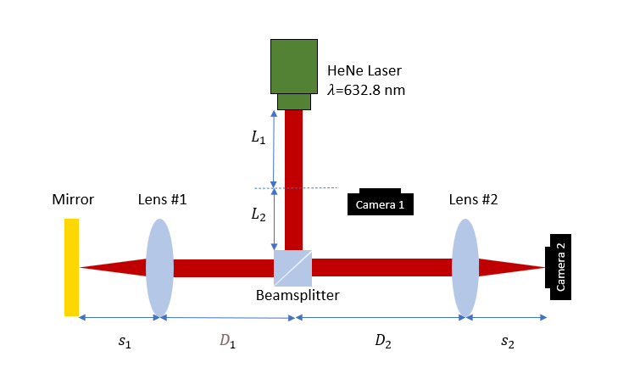

Figure : Simplified schematic of the optical path used in the simulation.

We model the initial beam emitted by the laser source as a Gaussian beam. To reduce the computation power, we assume that the laser’s output is nearly symmetric around the direction of propagation. We take the beam waist at the laser output as 0.34 mm from the manufacturer’s datasheet. To determine the lengths, step by step on our optical path, we remove some of the optical elements and perform measurements. First, we remove lens #1 and lens #2 and measure the laser beam at 3 locations; at a distance of $L_{1}$ from the laser, at the location before lens #1 (at a distance of $L_{1}+L_{2}+D_{1}$), and at camera #2 after the laser goes through the whole setup (at a distance of $L_{tot}=L_{1}+L_{2}+{2D}_{1}+{2f}_{1}+D_{2}+f_{2}$), as shown in Figure 2.

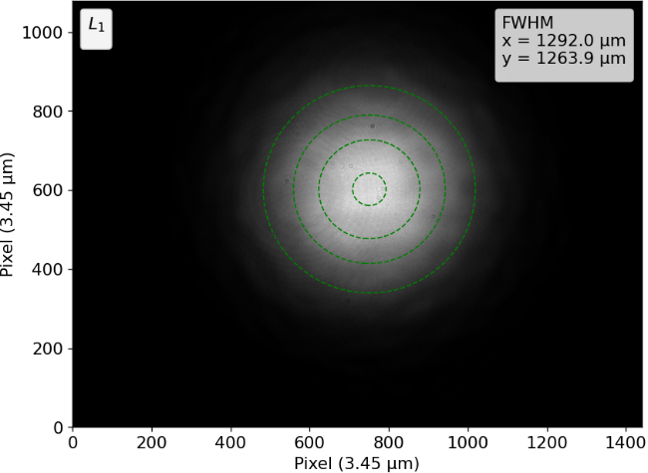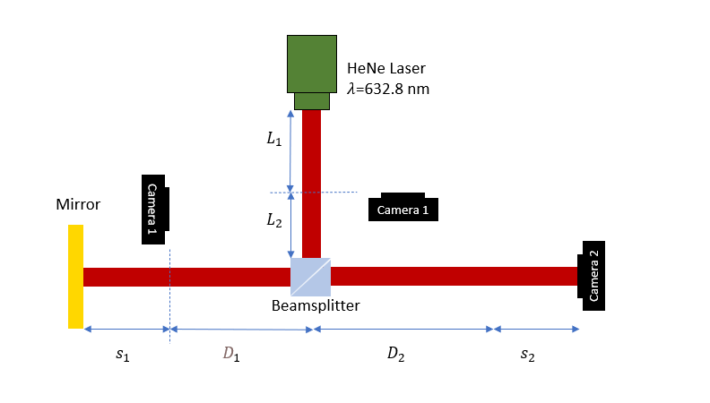

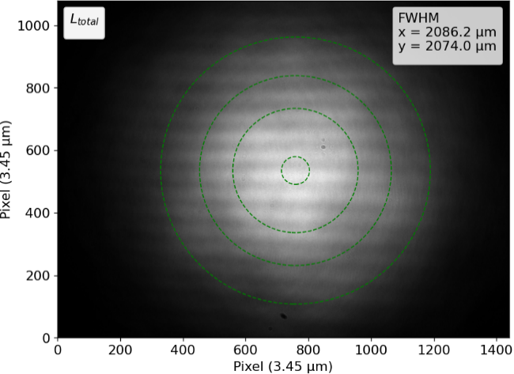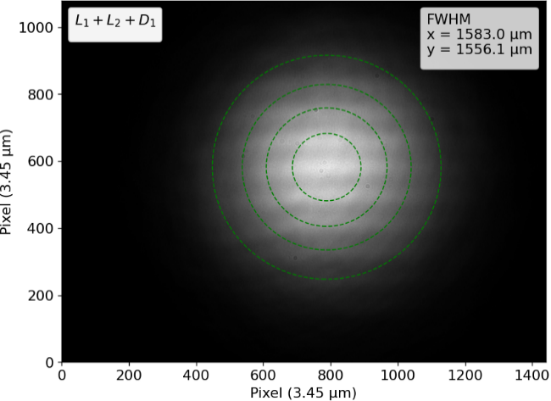

Figure : (Top Left) Schematic of the setup with objective and lens removed. Image obtained (Top Right) on camera #1 at a distance of $L_{1}$, (Bottom Left) on camera #1 at a distance of $L_{1}+L_{2}+D_{1}$, (Right) on camera #2 at a distance of $L_{total}$.

The beams-splitter is a cube with a 25 mm edge size and a refractive index of about 1.515 at 632.8 nm. We ignore the effect of the beam-splitter on the laser in our simulations. The electric field amplitude of a Gaussian beam (with a large Rayleigh length) can be written as follows [1]:

|  |  |  |
| --- | --- | --- |
|  |  | () |

Here, is the direction of propagation, $x,$ and $y$ axes are perpendicular to the $z$ axis in the standard convention, $r=\sqrt{x^{2}+y^{2}}$, and $w_{0}$ is the minimum beam waist. We calculate the propagation of the wave in free space by a distance of $L_{total}$ using the Rayleigh-Sommerfeld integral as follows  [2]:

|  |  |  |
| --- | --- | --- |
|  |  | () |

where $R=\sqrt{{(ξ-x)}^{2}+{(η-y)}^{2}+z^{2}}$, $cosθ=\frac{z}{R}$, $k=\frac{2π }{λ}$ is the wavevector, $λ$ = 632.8 nm is the wavelength of light in air.

We compute the Rayleigh–Sommerfeld diffraction integral by implementing a fast-Fourier-transform (FFT) based direct integration method (FFT-DI) [3]. This method is valid when the aperture size of the light field is much larger than the wavelength of light. The integral is calculated by numerical integration as a Riemann sum: where are sampling intervals on the aperture plane and means element-by element multiplication. The Riemann sum can be regarded as a discrete linear convolution which can be calculated effectively by means of a FFT. The discrete linear convolution can is computed by two 2D FFT and one 2D IFFT. We performed the calculations in the Python programming language within a library called “Diffractio”. Our Python code will be available on our GitHub repository (github.com/link), with a modular structure, enabling its integration into various setup.

Using equation (2), we obtain $L_{1}$, $L_{1}+L_{2}+D_{1}$ and $L_{total}$ to be 1800, 2261 and 3068 mm by matching the simulations with experimental results shown in Figure 2.

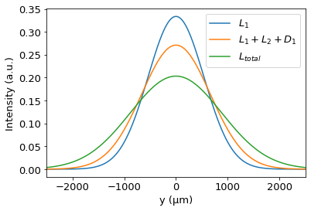

Figure : Simulated beam profiles at $L_{1}$, $L_{1}+L_{2}+D_{1}$ and $L_{total}$ to fit the measurements shown in Figure 2.

We removed lens #1 from the setup shown in Figure 1 and did the following computations:

The wave propagates by a distance of $L_{total}-s_{2}$ in free space, This propagation can be obtained by changing $(L_{total})$ to $L_{total}-s_{2}$ in equation 1, giving $U_{1}(x,y,z= L_{total}-s_{2},t)$

The wave arrives at the front surface of the lens after this propagation. The modification of the incoming wavefront by a lens with a focal length of $f_{2}$ is given as follows  [1]:

|  |  |  |
| --- | --- | --- |
|  |  | () |

Consequently, right after the Lens #2, the wave has the form:

|  |  |  |
| --- | --- | --- |
|  |  | () |

As the beam is not collimated, the focus is achieved at a shifted distance other than the given focal lengths of the lenses; at a distance of $s_{2}=f_{2}+Δf_{2}$. After lens #2, the wave propagates by a distance of $s_{2}$ in free space. This propagation can be obtained by changing $(L_{total})$ to $s_{2}$ in equation (2), with $U_{2}(x,y)$ as the input:

|  |  |  |
| --- | --- | --- |
|  |  | () |

is the wave that reaches the camera. We matched the simulation with the experiment result to find $Δf_{2}$ which gives +14.3 mm.

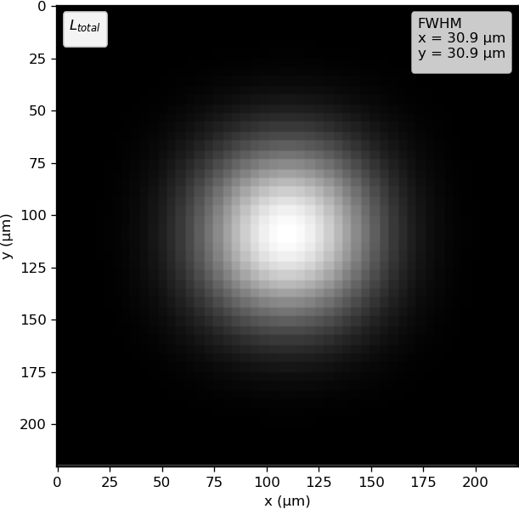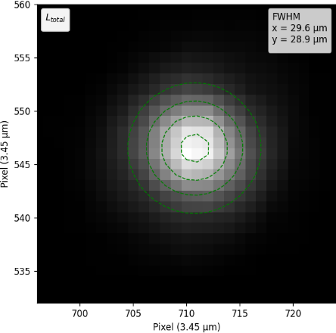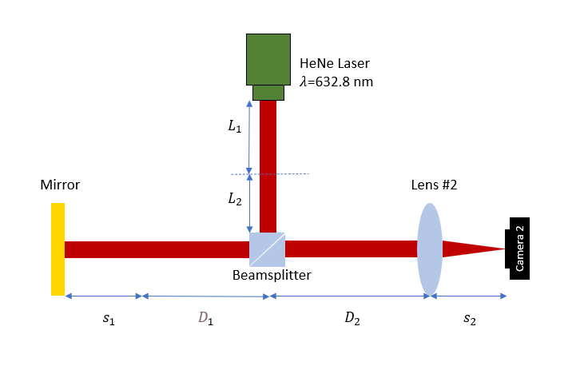

Figure : (a) Schematic of the current state of the setup. (b) Measured and (c) simulated image on camera #2 as the setup is as shown in (a).With a 14.3 mm shift.

Thirdly, we put back the lens #1 and adjusted $s_{1}$ according to the simulation, as shown in Figure 1. The calculations are as follows:

The wave propagates by a distance of $L_{1}+L_{2}+D_{1}$ in free space, the effect of the propagation of the wave in free space can be calculated by

|  |  |  |
| --- | --- | --- |
|  |  | () |

The wave arrives at the front surface of the lens #1 after this propagation. The modification of the incoming wavefront by a lens with a focal length of $f_{1}$ is given as follows:

|  |  |  |
| --- | --- | --- |
|  |  | () |

Consequently, right after the objective, the wave has the form:

|  |  |  |
| --- | --- | --- |
|  |  | () |

After the lens #1, the wave propagates by a distance of $s_{1}$ in free space, then it gets reflected by the sample, then it propagates back to the Lens #1 by a distance of $s_{1}$. We assume that the sample is a perfectly flat mirror such that it does not alter the shape of the wave as it reflects the wave at the focal point of the Lens #1. Thus, we skip that step and simply propagate the wave, $U_{1}'\left(x,y,z\right)$, after lens #1 by a distance of 2 $s_{1}$.

This propagation can be obtained by changing $(L_{1}+L_{2}+D_{1})$ to 2 $s_{1}$ in equation (3), with ${U'}_{1}$ as the input giving $U_{2}'$.

$U_{2}'$ is the wave right before it reaches lens #1. We modify the wave using lens #1 once again with the lens modulation $O_{1}.$ We now have our wave in the form of

|  |  |  |
| --- | --- | --- |
|  |  | () |

We must propagate the wave to the lens over the distance of $D_{1}+ D_{2}$ and modulate it with lens #2, $O_{2}\left(x,y\right)$. Then, we will have our wave in the form of,

|  |  |  |
| --- | --- | --- |
|  |  | () |
|  |  | () |

Now, we propagate the wave after lens #2 to the camera in free space for a distance of $s_{2}$ which was adjusted and labelled the resultant wave .

|  |  |  |
| --- | --- | --- |
|  |  | () |

We measure the intensities of each pixel on the camera. We matched the simulation with the experiment result to find .

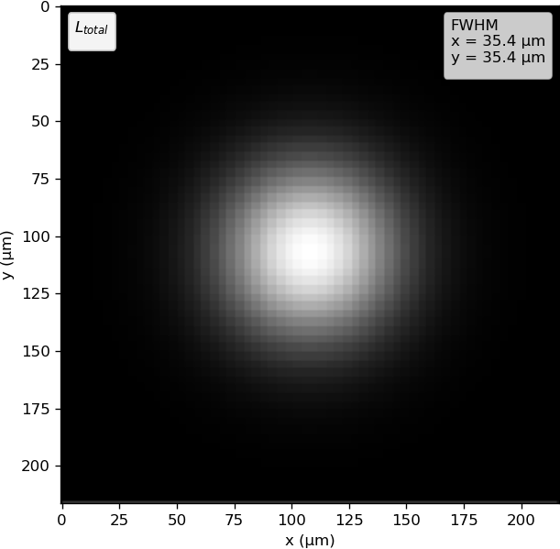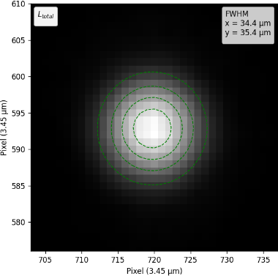Figure 5: (a) Schematic of the current state of the setup. (b) Measured and (c) simulated image on camera #2 as the setup is as shown in (a).

## Application

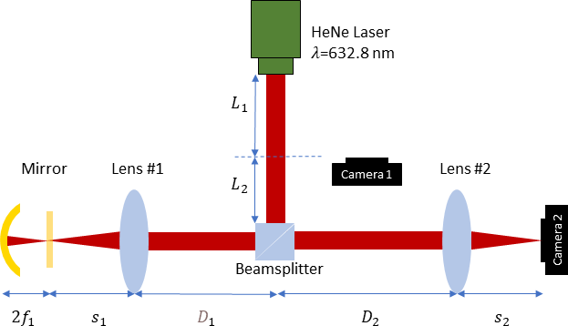

Figure 6: Schematic of optical setup with the flat mirror replaced with an ideal lens

After verifying the simulation through experimentation and calibrating our setup, we proceeded to examine various applications using the simulation. In this configuration, we expanded our previous setup with a concave mirror. Since the simulation only propagates light in forward direction we used ideal lens to model concave mirror. We positioned ideal lens at a distance of 2f from a s1 to ensure that it reflects incident light as if it were a concave mirror. We compared this setup to the one with a flat mirror, as shown in Figure 1. To minimize the deviation of the focused light from the focal point, we adjusted our light source to a collimated beam. To achieve this, we increased the beam waist of the Gaussian beam, thereby reduce the divergence problem. Since the gaussian beam is collimated, we initiated the light from the very base of Lens #1 and Lens #2 to find the focal shifts in Lens #1 and Lens #2. By minimizing spot size, we found focal shifts -0.035 mm and -0.11 mm respectively. Due to the collimated nature of our beam, the focal lengths (f1 and f2) turned out to be significantly smaller than those in the previous setup. After calibrating our setup, similar to our previous arrangement, we propagated the light passing through Lens 1 over a distance of 2s1, then passed it through Lens 1 again, covered the distance D1 + D2, and finally focused it using Lens 2 onto Camera 2.

To verify that our ideal lens with a diameter of 1.14 mm and a focal length of 720 µm behaves like a concave mirror, the beam entering Lens #1 and the beam focused by Lens #1# (at distance s1) were compared with the beam passing through ideal lens at corresponding locations.

Figure 7: Corresponding locations were matched to find focal length.

After testing that our ideal lens behaves like a concave mirror, we initiated the beam from the bottom of lens 1 in a manner like the flat mirror setup. Following the focusing of lens 1 as shown in Figure 7, the beam traveled a distance equal to the focal length of the ideal lens and passed through it. Subsequently, after repeating the same steps, we covered the distance D1 + D2 and focused on camera 2 by lens 2. The light reflected from the flat mirror and the concave mirror generated beams with FWHM values of 36.09 and 35.69, respectively, when observed at camera 2.

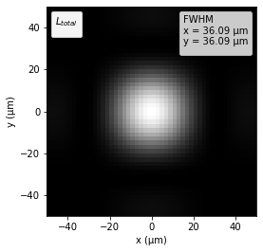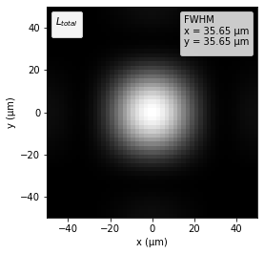

Figure 8: (a) Simulated image on camera #2 with flat mirror (b) with ideal lens with 720 µm focal length

**Data availability statement**

All data that support the findings of this study are available from the corresponding author upon reasonable request

**Acknowledgments**

This project has been supported by Boğaziçi Üniversitesi Bilimsel Araştırma Projeleri (21B03SUP4) and TÜBİTAK (Project No: 118C325). TÜBİTAK’s support does not imply any endorsement of the scientific content of this work.

**References**

[1] B. E. A. Saleh and M. C. Teich, *Fundamentals of Photonics* (John Wiley & Sons, Inc., New York, USA, 1991).

[2] J. W. Goodman, *Introduction to Fourier Optics*, 2nd ed. (McGraw-Hill, 1996).

[3] F. Shen and A. Wang, *Fast-Fourier-Transform Based Numerical Integration Method for the Rayleigh-Sommerfeld Diffraction Formula*, Appl. Opt. **45**, 1102 (2006).