
imobilare
experience real hip hop
learn to breakdance
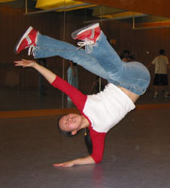
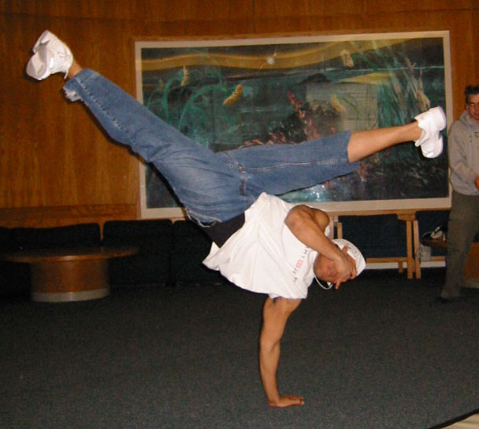

All levels welcome!
http://www.mit.edu/~imobilare/
Contact imobilare-exec@mit.edu for more info

