基于restful风格spring集成Mybatis的通用mapper以及分页助手

1. 基本环境

IDE：Eclipse Java EE IDE for Web Developers Version: Neon Release (4.6.0)  
JDK：1.8

Mysql：mysql-5.6.24  
maven：maven3.3.9  
Tomcat：tomcat9

1. 项目基本搭建
2. 建立数据库

首先建立一个测试数据库mybatis,在该数据库中建立一个数据表tb_user,创建语句如下：

CREATE TABLE `tb_user` (

`id` bigint(20) NOT NULL AUTO_INCREMENT,

`user_name` varchar(100) DEFAULT NULL COMMENT '用户名',

`password` varchar(100) DEFAULT NULL COMMENT '密码',

`name` varchar(100) DEFAULT NULL COMMENT '姓名',

`age` int(10) DEFAULT NULL COMMENT '年龄',

`sex` tinyint(1) DEFAULT NULL COMMENT '性别，1男性，2女性',

`birthday` date DEFAULT NULL COMMENT '出生日期',

`created` datetime DEFAULT NULL COMMENT '创建时间',

`updated` datetime DEFAULT NULL COMMENT '更新时间',

PRIMARY KEY (`id`),

UNIQUE KEY `username` (`user_name`)

) ENGINE=InnoDB AUTO_INCREMENT=14 DEFAULT CHARSET=utf8

1. 建立maven的父项目

建立一个pom工程：kang-parent，其pom.xml内容如下：

<project xmlns="http://maven.apache.org/POM/4.0.0" xmlns:xsi="http://www.w3.org/2001/XMLSchema-instance"

xsi:schemaLocation="http://maven.apache.org/POM/4.0.0 http://maven.apache.org/xsd/maven-4.0.0.xsd">

<modelVersion>4.0.0</modelVersion>

<groupId>com.kang.parent</groupId>

<artifactId>kang-parent</artifactId>

<version>0.0.1-SNAPSHOT</version>

<packaging>pom</packaging>

<!-- 集中定义依赖版本号 -->

<properties>

<junit.version>4.10</junit.version>

<spring.version>4.1.3.RELEASE</spring.version>

<mybatis.version>3.2.8</mybatis.version>

<mybatis.spring.version>1.2.2</mybatis.spring.version>

<mybatis.paginator.version>1.2.15</mybatis.paginator.version>

<mysql.version>5.1.32</mysql.version>

<slf4j.version>1.6.4</slf4j.version>

<jackson.version>2.4.2</jackson.version>

<druid.version>1.0.9</druid.version>

<httpclient.version>4.3.5</httpclient.version>

<jstl.version>1.2</jstl.version>

<servlet-api.version>2.5</servlet-api.version>

<jsp-api.version>2.0</jsp-api.version>

<joda-time.version>2.5</joda-time.version>

<commons-lang3.version>3.3.2</commons-lang3.version>

<commons-io.version>1.3.2</commons-io.version>

</properties>

<dependencyManagement>

<dependencies>

<!-- 单元测试 -->

<dependency>

<groupId>junit</groupId>

<artifactId>junit</artifactId>

<version>${junit.version}</version>

<scope>test</scope>

</dependency>

<!-- Spring -->

<dependency>

<groupId>org.springframework</groupId>

<artifactId>spring-context</artifactId>

<version>${spring.version}</version>

</dependency>

<dependency>

<groupId>org.springframework</groupId>

<artifactId>spring-beans</artifactId>

<version>${spring.version}</version>

</dependency>

<dependency>

<groupId>org.springframework</groupId>

<artifactId>spring-webmvc</artifactId>

<version>${spring.version}</version>

</dependency>

<dependency>

<groupId>org.springframework</groupId>

<artifactId>spring-jdbc</artifactId>

<version>${spring.version}</version>

</dependency>

<dependency>

<groupId>org.springframework</groupId>

<artifactId>spring-aspects</artifactId>

<version>${spring.version}</version>

</dependency>

<!-- Mybatis -->

<dependency>

<groupId>org.mybatis</groupId>

<artifactId>mybatis</artifactId>

<version>${mybatis.version}</version>

</dependency>

<dependency>

<groupId>org.mybatis</groupId>

<artifactId>mybatis-spring</artifactId>

<version>${mybatis.spring.version}</version>

</dependency>

<!-- MySql -->

<dependency>

<groupId>mysql</groupId>

<artifactId>mysql-connector-java</artifactId>

<version>${mysql.version}</version>

</dependency>

<dependency>

<groupId>org.slf4j</groupId>

<artifactId>slf4j-log4j12</artifactId>

<version>${slf4j.version}</version>

</dependency>

<!-- Jackson Json处理工具包 -->

<dependency>

<groupId>com.fasterxml.jackson.core</groupId>

<artifactId>jackson-databind</artifactId>

<version>${jackson.version}</version>

</dependency>

<!-- 连接池 -->

<dependency>

<groupId>com.jolbox</groupId>

<artifactId>bonecp-spring</artifactId>

<version>0.8.0.RELEASE</version>

</dependency>

<!-- httpclient -->

<dependency>

<groupId>org.apache.httpcomponents</groupId>

<artifactId>httpclient</artifactId>

<version>${httpclient.version}</version>

</dependency>

<!-- JSP相关 -->

<dependency>

<groupId>jstl</groupId>

<artifactId>jstl</artifactId>

<version>${jstl.version}</version>

</dependency>

<dependency>

<groupId>javax.servlet</groupId>

<artifactId>servlet-api</artifactId>

<version>${servlet-api.version}</version>

<scope>provided</scope>

</dependency>

<dependency>

<groupId>javax.servlet</groupId>

<artifactId>jsp-api</artifactId>

<version>${jsp-api.version}</version>

<scope>provided</scope>

</dependency>

<!-- 时间操作组件 -->

<dependency>

<groupId>joda-time</groupId>

<artifactId>joda-time</artifactId>

<version>${joda-time.version}</version>

</dependency>

<!-- Apache工具组件 -->

<dependency>

<groupId>org.apache.commons</groupId>

<artifactId>commons-lang3</artifactId>

<version>${commons-lang3.version}</version>

</dependency>

<dependency>

<groupId>org.apache.commons</groupId>

<artifactId>commons-io</artifactId>

<version>${commons-io.version}</version>

</dependency>

</dependencies>

</dependencyManagement>

<build>

<finalName>${project.artifactId}</finalName>

<plugins>

<!-- 资源文件拷贝插件 -->

<plugin>

<groupId>org.apache.maven.plugins</groupId>

<artifactId>maven-resources-plugin</artifactId>

<version>2.7</version>

<configuration>

<encoding>UTF-8</encoding>

</configuration>

</plugin>

<!-- java编译插件 -->

<plugin>

<groupId>org.apache.maven.plugins</groupId>

<artifactId>maven-compiler-plugin</artifactId>

<version>3.2</version>

<configuration>

<source>1.8</source>

<target>1.8</target>

<encoding>UTF-8</encoding>

</configuration>

</plugin>

</plugins>

<pluginManagement>

<plugins>

<!-- 配置Tomcat插件 -->

<plugin>

<groupId>org.apache.tomcat.maven</groupId>

<artifactId>tomcat7-maven-plugin</artifactId>

<version>2.2</version>

</plugin>

</plugins>

</pluginManagement>

</build>

</project>

1. 建立子项目

创建一个war工程kang-usermanage，其pom.xml文件内容如下：

<project xmlns="http://maven.apache.org/POM/4.0.0" xmlns:xsi="http://www.w3.org/2001/XMLSchema-instance"

xsi:schemaLocation="http://maven.apache.org/POM/4.0.0 http://maven.apache.org/xsd/maven-4.0.0.xsd">

<modelVersion>4.0.0</modelVersion>

<parent>

<groupId>com.kang.parent</groupId>

<artifactId>kang-parent</artifactId>

<version>0.0.1-SNAPSHOT</version>

</parent>

<groupId>com.kang.usermanage</groupId>

<artifactId>kang-usermanage</artifactId>

<version>1.0.0-SNAPSHOT</version>

<packaging>war</packaging>

<dependencies>

<!-- 单元测试 -->

<dependency>

<groupId>junit</groupId>

<artifactId>junit</artifactId>

<scope>test</scope>

</dependency>

<dependency>

<groupId>org.springframework</groupId>

<artifactId>spring-webmvc</artifactId>

</dependency>

<dependency>

<groupId>org.springframework</groupId>

<artifactId>spring-jdbc</artifactId>

</dependency>

<dependency>

<groupId>org.springframework</groupId>

<artifactId>spring-aspects</artifactId>

</dependency>

<!-- Mybatis -->

<dependency>

<groupId>org.mybatis</groupId>

<artifactId>mybatis</artifactId>

</dependency>

<dependency>

<groupId>org.mybatis</groupId>

<artifactId>mybatis-spring</artifactId>

</dependency>

<dependency>

<groupId>com.github.pagehelper</groupId>

<artifactId>pagehelper</artifactId>

<version>3.7.5</version>

</dependency>

<dependency>

<groupId>com.github.jsqlparser</groupId>

<artifactId>jsqlparser</artifactId>

<version>0.9.1</version>

</dependency>

<!-- 通用Mapper -->

<dependency>

<groupId>com.github.abel533</groupId>

<artifactId>mapper</artifactId>

<version>2.3.4</version>

</dependency>

<!-- MySql -->

<dependency>

<groupId>mysql</groupId>

<artifactId>mysql-connector-java</artifactId>

</dependency>

<dependency>

<groupId>org.slf4j</groupId>

<artifactId>slf4j-log4j12</artifactId>

</dependency>

<!-- Jackson Json处理工具包 -->

<dependency>

<groupId>com.fasterxml.jackson.core</groupId>

<artifactId>jackson-databind</artifactId>

</dependency>

<!-- 连接池 -->

<dependency>

<groupId>com.jolbox</groupId>

<artifactId>bonecp-spring</artifactId>

</dependency>

<!-- JSP相关 -->

<dependency>

<groupId>jstl</groupId>

<artifactId>jstl</artifactId>

</dependency>

<dependency>

<groupId>javax.servlet</groupId>

<artifactId>servlet-api</artifactId>

<scope>provided</scope>

</dependency>

<dependency>

<groupId>javax.servlet</groupId>

<artifactId>jsp-api</artifactId>

<scope>provided</scope>

</dependency>

<!-- Apache工具组件 -->

<dependency>

<groupId>org.apache.commons</groupId>

<artifactId>commons-lang3</artifactId>

</dependency>

<dependency>

<groupId>org.apache.commons</groupId>

<artifactId>commons-io</artifactId>

</dependency>

</dependencies>

<build>

<!-- 配置插件 -->

<plugins>

<plugin>

<groupId>org.apache.tomcat.maven</groupId>

<artifactId>tomcat7-maven-plugin</artifactId>

<configuration>

<url>http://localhost:8081/manager/text</url>

<server>tomcat7</server>

<port>8081</port>

<path>/</path>

<username>tomcat</username>

<password>123456</password>

</configuration>

</plugin>

</plugins>

</build>

</project>

1. 配置文件详解
2. mysql的外部属性文件:jdbc.properties

jdbc.driverClassName=com.mysql.jdbc.Driver

jdbc.url=jdbc:mysql://127.0.0.1:3306/mybatis?useUnicode=true&characterEncoding=utf8&autoReconnect=true&allowMultiQueries=true

jdbc.username=root

jdbc.password=root

1. 编写Mybatis的全局配置文件：mybatis/mybatis-config.xml

在这里集成了分页助手和通用mapper。注意，分页助手的配置要放在通用mapper之前。

<?xml version="1.0" encoding="UTF-8" ?>

<!DOCTYPE configuration

PUBLIC "-//mybatis.org//DTD Config 3.0//EN"

"http://mybatis.org/dtd/mybatis-3-config.dtd">

<configuration>

<plugins>

<!-- 配置分页助手 -->

<plugin interceptor="com.github.pagehelper.PageHelper">

<property name="dialect" value="mysql" />

<!-- 设置为true时，使用RowBounds分页会进行count查询 -->

<property name="rowBoundsWithCount" value="true" />

</plugin>

<!-- 通用Mapper -->

<plugin interceptor="com.github.abel533.mapperhelper.MapperInterceptor">

<!--主键自增回写方法,默认值MYSQL,详细说明请看文档 -->

<property name="IDENTITY" value="MYSQL" />

<!--通用Mapper接口，多个通用接口用逗号隔开 -->

<property name="mappers" value="com.github.abel533.mapper.Mapper" />

</plugin>

</plugins>

</configuration>

1. 编写spring整合Mybatis的xml文件。spring/applicationContext-mybatis.xml

<beans xmlns="http://www.springframework.org/schema/beans"

xmlns:context="http://www.springframework.org/schema/context" xmlns:p="http://www.springframework.org/schema/p"

xmlns:aop="http://www.springframework.org/schema/aop" xmlns:tx="http://www.springframework.org/schema/tx"

xmlns:xsi="http://www.w3.org/2001/XMLSchema-instance"

xsi:schemaLocation="http://www.springframework.org/schema/beans http://www.springframework.org/schema/beans/spring-beans-4.0.xsd

http://www.springframework.org/schema/context http://www.springframework.org/schema/context/spring-context-4.0.xsd

http://www.springframework.org/schema/aop http://www.springframework.org/schema/aop/spring-aop-4.0.xsd http://www.springframework.org/schema/tx http://www.springframework.org/schema/tx/spring-tx-4.0.xsd

http://www.springframework.org/schema/util http://www.springframework.org/schema/util/spring-util-4.0.xsd">

<bean class="org.mybatis.spring.SqlSessionFactoryBean">

<!-- 指定数据源 -->

<property name="dataSource" ref="dataSource"/>

<!-- 指定mybatis的全局配置文件 -->

<property name="configLocation" value="classpath:mybatis/mybatis-config.xml"/>

<!-- 指定mapper.xml文件，扫描所有的文件 -->

<property name="mapperLocations" value="classpath:mybatis/mappers/**/*.xml"/>

<!-- 指定别名包 -->

<property name="typeAliasesPackage" value="com.kang.mybatis.pojo"/>

</bean>

<!-- 定义Mapper接口的扫描器 -->

<bean class="org.mybatis.spring.mapper.MapperScannerConfigurer">

<property name="basePackage" value="com.kang.mybatis.mapper"/>

</bean>

</beans>

1. 编写spring的事务管理配置文件spring/applicationContext-transaction.xml

<beans xmlns="http://www.springframework.org/schema/beans"

xmlns:context="http://www.springframework.org/schema/context" xmlns:p="http://www.springframework.org/schema/p"

xmlns:aop="http://www.springframework.org/schema/aop" xmlns:tx="http://www.springframework.org/schema/tx"

xmlns:xsi="http://www.w3.org/2001/XMLSchema-instance"

xsi:schemaLocation="http://www.springframework.org/schema/beans http://www.springframework.org/schema/beans/spring-beans-4.0.xsd

http://www.springframework.org/schema/context http://www.springframework.org/schema/context/spring-context-4.0.xsd

http://www.springframework.org/schema/aop http://www.springframework.org/schema/aop/spring-aop-4.0.xsd http://www.springframework.org/schema/tx http://www.springframework.org/schema/tx/spring-tx-4.0.xsd

http://www.springframework.org/schema/util http://www.springframework.org/schema/util/spring-util-4.0.xsd">

<!-- 定义事务管理器 -->

<bean id="transactionManager"

class="org.springframework.jdbc.datasource.DataSourceTransactionManager">

<property name="dataSource" ref="dataSource" />

</bean>

<!-- 定义事务策略 -->

<tx:advice id="txAdvice" transaction-manager="transactionManager">

<tx:attributes>

<!--所有以query开头的方法都是只读的 -->

<tx:method name="query*" read-only="true" />

<!--其他方法使用默认事务策略 -->

<tx:method name="*" />

</tx:attributes>

</tx:advice>

<aop:config>

<!--pointcut元素定义一个切入点，execution中的第一个星号 用以匹配方法的返回类型，

这里星号表明匹配所有返回类型。 com.abc.dao.*.*(..)表明匹配com.kang.mybatis.service包下的所有类的所有

方法 -->

<aop:pointcut id="myPointcut" expression="execution(* com.kang.mybatis.service.*.*(..))" />

<!--将定义好的事务处理策略应用到上述的切入点 -->

<aop:advisor advice-ref="txAdvice" pointcut-ref="myPointcut" />

</aop:config>

</beans>

1. 编写spring关于bean的配置文件spring/applicationContext.xml

<beans xmlns="http://www.springframework.org/schema/beans"

xmlns:context="http://www.springframework.org/schema/context" xmlns:p="http://www.springframework.org/schema/p"

xmlns:aop="http://www.springframework.org/schema/aop" xmlns:tx="http://www.springframework.org/schema/tx"

xmlns:xsi="http://www.w3.org/2001/XMLSchema-instance"

xsi:schemaLocation="http://www.springframework.org/schema/beans http://www.springframework.org/schema/beans/spring-beans-4.0.xsd

http://www.springframework.org/schema/context http://www.springframework.org/schema/context/spring-context-4.0.xsd

http://www.springframework.org/schema/aop http://www.springframework.org/schema/aop/spring-aop-4.0.xsd http://www.springframework.org/schema/tx http://www.springframework.org/schema/tx/spring-tx-4.0.xsd

http://www.springframework.org/schema/util http://www.springframework.org/schema/util/spring-util-4.0.xsd">

<!-- 使用spring自带的占位符替换功能 -->

<bean

class="org.springframework.beans.factory.config.PropertyPlaceholderConfigurer">

<!-- 允许JVM参数覆盖 -->

<property name="systemPropertiesModeName" value="SYSTEM_PROPERTIES_MODE_OVERRIDE" />

<!-- 忽略没有找到的资源文件 -->

<property name="ignoreResourceNotFound" value="true" />

<!-- 配置资源文件 -->

<property name="locations">

<list>

<value>classpath:jdbc.properties</value>

</list>

</property>

</bean>

<!-- 扫描包 -->

<context:component-scan base-package="com.kang"/>

<!-- 定义数据源 -->

<bean id="dataSource" class="com.jolbox.bonecp.BoneCPDataSource"

destroy-method="close">

<!-- 数据库驱动 -->

<property name="driverClass" value="${jdbc.driverClassName}" />

<!-- 相应驱动的jdbcUrl -->

<property name="jdbcUrl" value="${jdbc.url}" />

<!-- 数据库的用户名 -->

<property name="username" value="${jdbc.username}" />

<!-- 数据库的密码 -->

<property name="password" value="${jdbc.password}" />

<!-- 检查数据库连接池中空闲连接的间隔时间，单位是分，默认值：240，如果要取消则设置为0 -->

<property name="idleConnectionTestPeriod" value="60" />

<!-- 连接池中未使用的链接最大存活时间，单位是分，默认值：60，如果要永远存活设置为0 -->

<property name="idleMaxAge" value="30" />

<!-- 每个分区最大的连接数 -->

<!--

判断依据：请求并发数

-->

<property name="maxConnectionsPerPartition" value="100" />

<!-- 每个分区最小的连接数 -->

<property name="minConnectionsPerPartition" value="5" />

</bean>

</beans>

1. 编写springMVC的xml配置文件spring/kang-usermanage-servlet.xml

<?xml version="1.0" encoding="UTF-8"?>

<beans xmlns="http://www.springframework.org/schema/beans"

xmlns:xsi="http://www.w3.org/2001/XMLSchema-instance" xmlns:p="http://www.springframework.org/schema/p"

xmlns:context="http://www.springframework.org/schema/context"

xmlns:mvc="http://www.springframework.org/schema/mvc"

xsi:schemaLocation="http://www.springframework.org/schema/beans http://www.springframework.org/schema/beans/spring-beans-4.0.xsd

http://www.springframework.org/schema/mvc http://www.springframework.org/schema/mvc/spring-mvc-4.0.xsd

http://www.springframework.org/schema/context http://www.springframework.org/schema/context/spring-context-4.0.xsd">

<!-- 定义注解驱动 -->

<mvc:annotation-driven/>

<!-- 定义Controller的扫描包 -->

<context:component-scan base-package="com.kang.mybatis.controller"/>

<!-- 定义试图解析器 -->

<!--

Example: prefix="/WEB-INF/jsp/", suffix=".jsp", viewname="test" -> "/WEB-INF/jsp/test.jsp"

-->

<bean class="org.springframework.web.servlet.view.InternalResourceViewResolver">

<property name="prefix" value="/WEB-INF/views/"/>

<property name="suffix" value=".jsp"/>

</bean>

</beans>

1. 编写web.xml完成项目整体配置

<?xml version="1.0" encoding="UTF-8"?>

<web-app xmlns:xsi="http://www.w3.org/2001/XMLSchema-instance"

xmlns="http://java.sun.com/xml/ns/javaee"

xsi:schemaLocation="http://java.sun.com/xml/ns/javaee http://java.sun.com/xml/ns/javaee/web-app_2_5.xsd"

id="WebApp_ID" version="2.5">

<display-name>kang-usermanage</display-name>

<!-- 加载spring的配置文件 -->

<context-param>

<param-name>contextConfigLocation</param-name>

<param-value>classpath:spring/applicationContext*.xml</param-value>

</context-param>

<!--Spring的ApplicationContext 载入 -->

<listener>

<listener-class>org.springframework.web.context.ContextLoaderListener</listener-class>

</listener>

<!-- 编码过滤器，以UTF8编码，避免中文乱码 -->

<filter>

<filter-name>encodingFilter</filter-name>

<filter-class>org.springframework.web.filter.CharacterEncodingFilter</filter-class>

<init-param>

<param-name>encoding</param-name>

<param-value>UTF8</param-value>

</init-param>

</filter>

<filter-mapping>

<filter-name>encodingFilter</filter-name>

<url-pattern>/*</url-pattern>

</filter-mapping>

<!-- 添加spring对REST风格的支持 -->

<filter>

<filter-name>HttpMethodFilter</filter-name>

<filter-class>org.springframework.web.filter.HttpPutFormContentFilter</filter-class>

</filter>

<filter-mapping>

<filter-name>HttpMethodFilter</filter-name>

<url-pattern>/*</url-pattern>

</filter-mapping>

<!-- 将POST请求转化为DELETE或者是PUT 要用_method指定真正的请求参数 -->

<filter>

<filter-name>HiddenHttpMethodFilter</filter-name>

<filter-class>org.springframework.web.filter.HiddenHttpMethodFilter</filter-class>

</filter>

<filter-mapping>

<filter-name>HiddenHttpMethodFilter</filter-name>

<url-pattern>/*</url-pattern>

</filter-mapping>

<!-- 配置SpringMVC框架入口 -->

<servlet>

<servlet-name>kang-usermanage</servlet-name>

<servlet-class>org.springframework.web.servlet.DispatcherServlet</servlet-class>

<init-param>

<param-name>contextConfigLocation</param-name>

<param-value>classpath:spring/kang-usermanage-servlet.xml</param-value>

</init-param>

<load-on-startup>1</load-on-startup>

</servlet>

<servlet-mapping>

<servlet-name>kang-usermanage</servlet-name>

<!-- 可用： *.xxx，/，/xxx/* . 不可用：/* -->

<url-pattern>/rest/*</url-pattern>

</servlet-mapping>

<welcome-file-list>

<welcome-file>index.html</welcome-file>

</welcome-file-list>

</web-app>

1. 添加日志属性文件log4j.properties

log4j.rootLogger=DEBUG,A1

log4j.logger.com.taotao = DEBUG

log4j.logger.org.mybatis = DEBUG

log4j.appender.A1=org.apache.log4j.ConsoleAppender

log4j.appender.A1.layout=org.apache.log4j.PatternLayout

log4j.appender.A1.layout.ConversionPattern=%-d{yyyy-MM-dd HH:mm:ss,SSS} [%t] [%c]-[%p] %m%n

1. 业务代码编写
2. 通用页面跳转

package com.kang.mybatis.controller;

import org.springframework.stereotype.Controller;

import org.springframework.web.bind.annotation.PathVariable;

import org.springframework.web.bind.annotation.RequestMapping;

import org.springframework.web.bind.annotation.RequestMethod;

//通用的页面跳转Controller

@RequestMapping("page")

@Controller

public class PageController {

@RequestMapping(value = "{pageName}", method = RequestMethod.GET)

public String toPage(@PathVariable("pageName") String pageName) {

return pageName;

}

}

1. 封装EasyUIResult

package com.kang.mybatis.bean;

import java.util.List;

public class EasyUIResult {

private Long total;

private List<?> rows;

public EasyUIResult() {

}

public EasyUIResult(Long total, List<?> rows) {

this.total = total;

this.rows = rows;

}

public Long getTotal() {

return total;

}

public void setTotal(Long total) {

this.total = total;

}

public List<?> getRows() {

return rows;

}

public void setRows(List<?> rows) {

this.rows = rows;

}

}

1. 编写mapper接口，此接口继承通用mapper

package com.kang.mybatis.mapper;

import com.github.abel533.mapper.Mapper;

import com.kang.mybatis.pojo.User;

public interface NewUserMapper extends Mapper<User>{

}

1. 添加pojo类

package com.kang.mybatis.pojo;

import java.util.Date;

import javax.persistence.GeneratedValue;

import javax.persistence.GenerationType;

import javax.persistence.Id;

import javax.persistence.Table;

@Table(name = "tb_user")

public class User {

@Id

@GeneratedValue(strategy = GenerationType.IDENTITY)

private Long id;

// 用户名

private String userName;

// 密码

private String password;

// 姓名

private String name;

// 年龄

private Integer age;

// 性别，1男性，2女性

private Integer sex;

// 出生日期

private Date birthday;

// 创建时间

private Date created;

// 更新时间

private Date updated;

public Long getId() {

return id;

}

public void setId(Long id) {

this.id = id;

}

public String getuserName() {

return userName;

}

public void setuserName(String userName) {

this.userName = userName;

}

public String getPassword() {

return password;

}

public void setPassword(String password) {

this.password = password;

}

public String getName() {

return name;

}

public void setName(String name) {

this.name = name;

}

public Integer getAge() {

return age;

}

public void setAge(Integer age) {

this.age = age;

}

public Integer getSex() {

return sex;

}

public void setSex(Integer sex) {

this.sex = sex;

}

public Date getBirthday() {

return birthday;

}

public void setBirthday(Date birthday) {

this.birthday = birthday;

}

public Date getCreated() {

return created;

}

public void setCreated(Date created) {

this.created = created;

}

public Date getUpdated() {

return updated;

}

public void setUpdated(Date updated) {

this.updated = updated;

}

@Override

public String toString() {

return "User [id=" + id + ", userName=" + userName + ", password=" + password + ", name=" + name

+ ", age=" + age + ", sex=" + sex + ", birthday=" + birthday + ", created=" + created

+ ", updated=" + updated + "]";

}

}

1. 编写service方法

package com.kang.mybatis.service;

import java.util.Date;

import java.util.List;

import org.springframework.beans.factory.annotation.Autowired;

import org.springframework.stereotype.Service;

import com.github.abel533.entity.Example;

import com.github.pagehelper.PageHelper;

import com.github.pagehelper.PageInfo;

import com.kang.mybatis.bean.EasyUIResult;

import com.kang.mybatis.mapper.NewUserMapper;

import com.kang.mybatis.pojo.User;

@Service

public class NewUserService {

@Autowired

private NewUserMapper newUserMapper;

public EasyUIResult queryUserList(Integer page, Integer rows) {

// 设置分页参数

PageHelper.startPage(page, rows);

// 设置查询条件

Example example = new Example(User.class);

example.setOrderByClause("created DESC"); // 设置排序条件

List<User> users = this.newUserMapper.selectByExample(example);

PageInfo<User> pageInfo = new PageInfo<User>(users);

return new EasyUIResult(pageInfo.getTotal(), pageInfo.getList());

}

public User queryUserById(Long id) {

return this.newUserMapper.selectByPrimaryKey(id);

}

public void saveUser(User user) {

user.setCreated(new Date());

user.setUpdated(new Date());

this.newUserMapper.insertSelective(user);

}

public void updateUser(User user) {

this.newUserMapper.updateByPrimaryKeySelective(user);

}

public void deleteUserById(Long id) {

this.newUserMapper.deleteByPrimaryKey(id);

}

}

1. 编写controller方法

package com.kang.mybatis.controller;

import org.springframework.beans.factory.annotation.Autowired;

import org.springframework.http.HttpStatus;

import org.springframework.http.ResponseEntity;

import org.springframework.stereotype.Controller;

import org.springframework.web.bind.annotation.PathVariable;

import org.springframework.web.bind.annotation.RequestMapping;

import org.springframework.web.bind.annotation.RequestMethod;

import org.springframework.web.bind.annotation.RequestParam;

import org.springframework.web.bind.annotation.ResponseBody;

import com.kang.mybatis.bean.EasyUIResult;

import com.kang.mybatis.pojo.User;

import com.kang.mybatis.service.NewUserService;

@RequestMapping("user")

@Controller

public class UserController {

// @Autowired

// private UserService userService;

@Autowired

private NewUserService userService;

@RequestMapping(value = "list", method = RequestMethod.GET)

@ResponseBody

public EasyUIResult queryUserList(@RequestParam(value = "page", defaultValue = "1") Integer page,

@RequestParam(value = "rows", defaultValue = "5") Integer rows) {

return this.userService.queryUserList(page, rows);

}

//查询数据

@RequestMapping(value="{userId}",method=RequestMethod.GET)

public ResponseEntity<User> quseryUserById(@PathVariable("userId") Long userId){

try {

User user=this.userService.queryUserById(userId);

if(null==user){

//返回404资源不存在

return ResponseEntity.status(HttpStatus.NOT_FOUND).body(null);

}

//返回200，成功

//return ResponseEntity.status(HttpStatus.OK).body(user);

return ResponseEntity.ok(user);

} catch (Exception e) {

e.printStackTrace();

}

//查询出错，返回500

return ResponseEntity.status(HttpStatus.INTERNAL_SERVER_ERROR).body(null);

}

//新增数据

@RequestMapping(method=RequestMethod.POST)

public ResponseEntity<Void> saveUser(User user){

try {

this.userService.saveUser(user);;

return ResponseEntity.status(HttpStatus.CREATED).build();

} catch (Exception e) {

e.printStackTrace();

}

//查询出错，返回500

return ResponseEntity.status(HttpStatus.INTERNAL_SERVER_ERROR).body(null);

}

//更新数据

@RequestMapping(method=RequestMethod.PUT)

public ResponseEntity<Void> updateUser(User user){

try {

this.userService.updateUser(user);

return ResponseEntity.status(HttpStatus.NO_CONTENT).build();

} catch (Exception e) {

e.printStackTrace();

}

//查询出错，返回500

return ResponseEntity.status(HttpStatus.INTERNAL_SERVER_ERROR).body(null);

}

//删除数据

@RequestMapping(method=RequestMethod.DELETE)

public ResponseEntity<Void> deleteUser(@RequestParam(value="id",defaultValue="0") Long id){

try {

if(id.intValue()==0){

//参数有误

return ResponseEntity.status(HttpStatus.BAD_REQUEST).build();

}

this.userService.deleteUserById(id);

return ResponseEntity.status(HttpStatus.NO_CONTENT).build();

} catch (Exception e) {

e.printStackTrace();

}

//查询出错，返回500

return ResponseEntity.status(HttpStatus.INTERNAL_SERVER_ERROR).body(null);

}

}

1. 编写对通用mapper的单元测试文件

package com.kang.mabatis.test;

import static org.junit.Assert.fail;

import java.util.ArrayList;

import java.util.Date;

import java.util.List;

import org.junit.Before;

import org.junit.Test;

import org.springframework.context.ApplicationContext;

import org.springframework.context.support.ClassPathXmlApplicationContext;

import com.github.abel533.entity.Example;

import com.kang.mybatis.mapper.NewUserMapper;

import com.kang.mybatis.pojo.User;

public class NewUserMapperTest {

private NewUserMapper newUserMapper;

@Before

public void setUp() throws Exception {

ApplicationContext applicationContext = new ClassPathXmlApplicationContext(

"classpath:spring/applicationContext*.xml");

this.newUserMapper = applicationContext.getBean(NewUserMapper.class);

}

@Test

public void testSelectOne() {

User record = new User();

// 设置查询条件

record.setuserName("zhangsan");

record.setPassword("123456");

User user = this.newUserMapper.selectOne(record);

System.out.println(user);

}

@Test

public void testSelect() {

User record = new User();

// 设置查询条件

record.setuserName("zhangsan");

List<User> list = this.newUserMapper.select(record);

for (User user : list) {

System.out.println(user);

}

}

@Test

public void testSelectCount() {

System.out.println(this.newUserMapper.selectCount(null));

}

@Test

public void testSelectByPrimaryKey() {

//注意selectByPrimaryKey的输入参数必须是Long型，不能是string类型。new Long(1)

User user = this.newUserMapper.selectByPrimaryKey(new Long(1));

System.out.println(user);

}

@Test

public void testInsert() {

User record = new User();

// 设置查询条件

record.setuserName("test_username_3");

//record.setAge(20);

//record.setBirthday(new Date());

record.setCreated(new Date());

//record.setName("test_name_1");

//record.setPassword("123456");

record.setSex(1);

record.setUpdated(new Date());

//使用所有的字段作为插入语句的字段

int count = this.newUserMapper.insert(record);

System.out.println(count);

System.out.println(record.getId());

}

@Test

public void testInsertSelective() {

User record = new User();

// 设置查询条件

record.setuserName("test_username_2");

//record.setAge(20);

// record.setBirthday(new Date());

record.setCreated(new Date());

// record.setName("test_name_1");

// record.setPassword("123456");

record.setSex(1);

record.setUpdated(new Date());

//将不为null的字段作为插入语句的字段

int count = this.newUserMapper.insertSelective(record);

System.out.println(count);

System.out.println(record.getId());

}

@Test

public void testDelete() {

// this.newUserMapper.delete(null);

}

@Test

public void testDeleteByPrimaryKey() {

System.out.println(this.newUserMapper.deleteByPrimaryKey(9L));

}

@Test

public void testUpdateByPrimaryKey() {

fail("Not yet implemented");

}

@Test

public void testUpdateByPrimaryKeySelective() {

User record = new User();

record.setId(1L);

record.setAge(24);

this.newUserMapper.updateByPrimaryKeySelective(record);

}

@Test

public void testSelectCountByExample() {

fail("Not yet implemented");

}

@Test

public void testDeleteByExample() {

fail("Not yet implemented");

}

@Test

public void testSelectByExample() {

Example example = new Example(User.class);

List<Object> values = new ArrayList<Object>();

values.add(1L);

values.add(2L);

values.add(3L);

//批量查询

//example.createCriteria().andIn("id", values);

//单个查询

example.createCriteria().andEqualTo("id", 1L);

List<User> list = this.newUserMapper.selectByExample(example);

for (User user : list) {

System.out.println(user);

}

}

@Test

public void testUpdateByExampleSelective() {

fail("Not yet implemented");

}

@Test

public void testUpdateByExample() {

fail("Not yet implemented");

}

}

1. 项目测试
2. 查询所有信息

数据库内容如下：

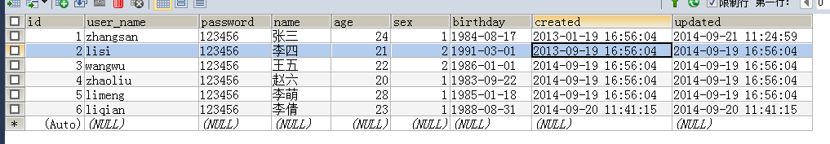

在浏览器中输入: <http://127.0.0.1:8081/rest/page/users>

得到页面如下：前端页面基于easyUI实现，数据按照更新时间排序。

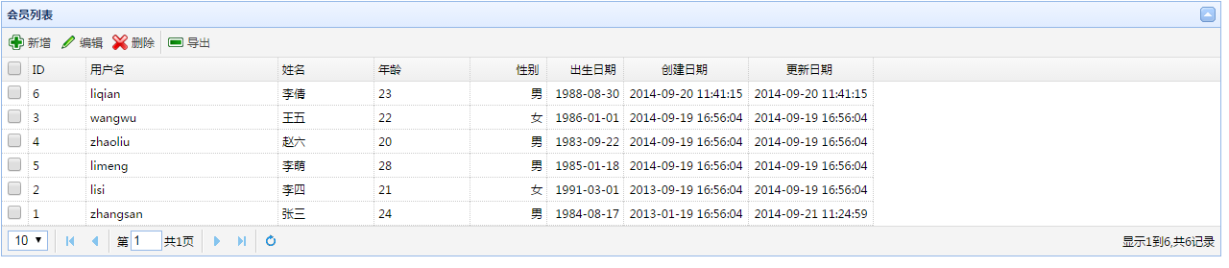

1. restful的相关测试

(1)使用get获取数据

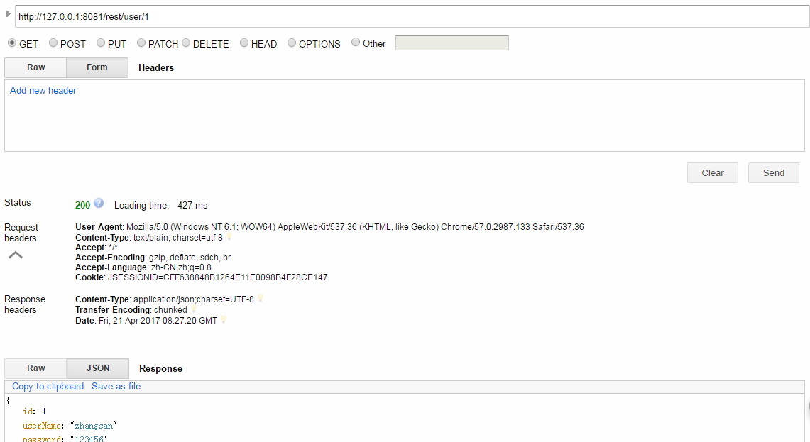

(2)使用post提交数据

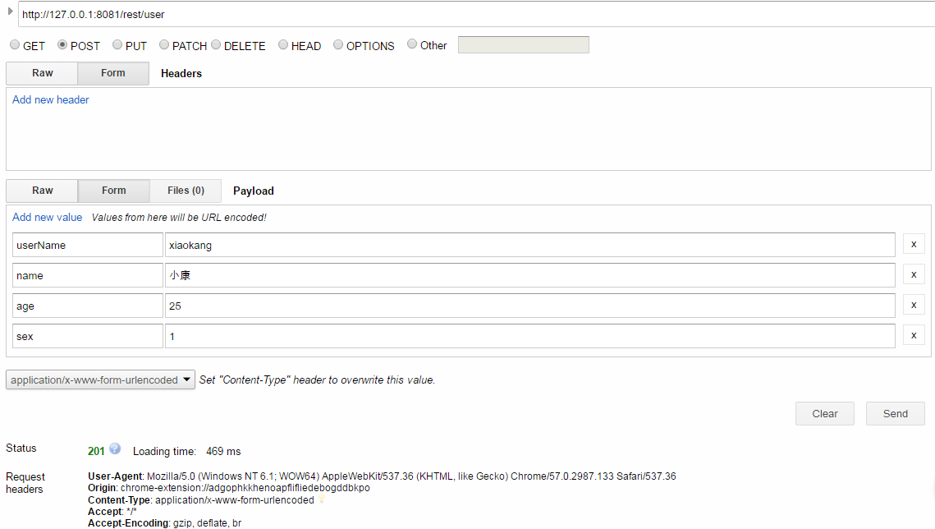

数据库数据：

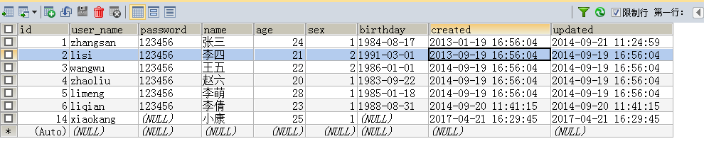

(3)使用put更新数据

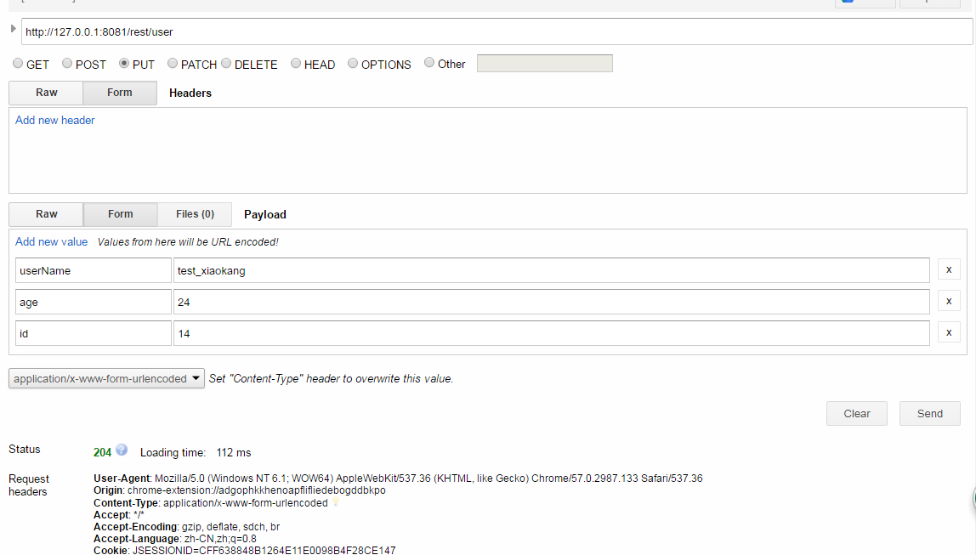

数据库数据：

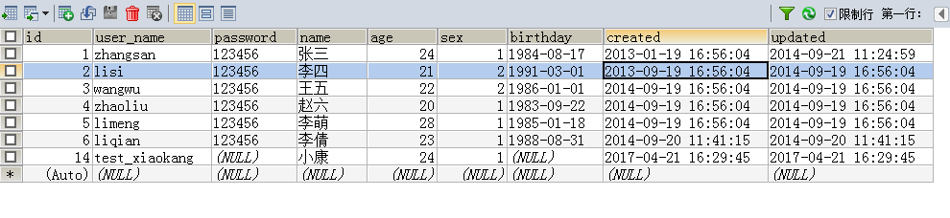

（4）使用delete删除数据

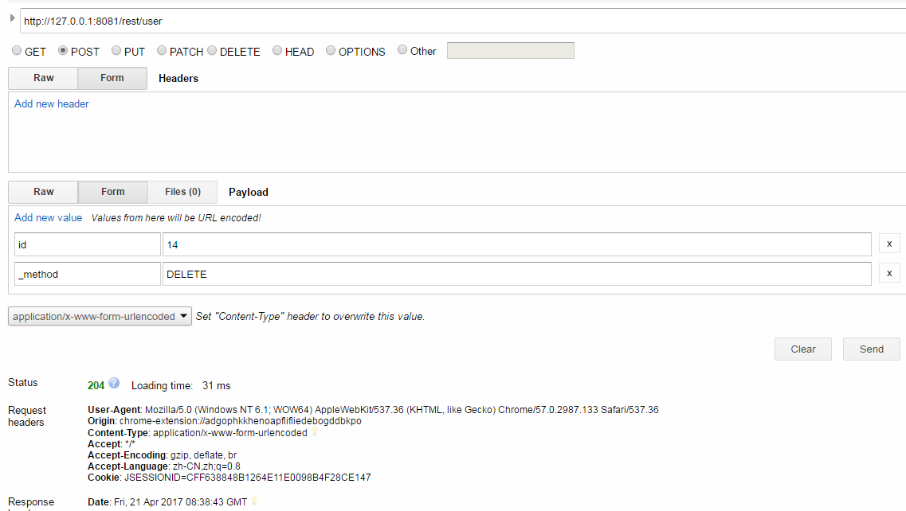

数据库数据：

