Connected Mobility Basics   
**REPORT**

Assignment 2: TUM Mobility Model

Names: Ismail Muzhaqi, Matthias Mögerle, Nikolas Promponas-Kefalas Date: 11.12.2015

horizontal line

Description (Abstract)

This paper is the result of the work we have done using the ONE Simulator. The task at hand was to create a mobility model for the Fakultät für Mathematik und Informatik building. Even though the scale of the simulation is small compared to projects aimed to model entire cities, it still presented several challenges. Things like additional floors, all the rooms, seating arrangements and obstacles had to be omitted in order to avoid over complicating the simulation. So in the end we have only a skeleton selection of the most important rooms, combined with social and temporal characteristics which result in an efficient simulation of the movement in the building.

# 

Introduction

The best way to tackle a problem is to divide it into smaller pieces. We decided to do exactly that based on the lectures. We divided the model into three parts: Social, Spatial and Temporal.

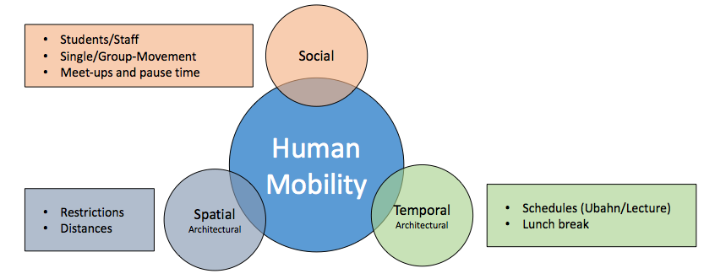

Even with these division there were still things to be cleared. We started working by making some simple presumptions:

There are only two main groups of people in the building that are relevant statistically: Students & Staff. Students are considerably larger in number. Also, there should always be one professor in a class.

Student’s have relationships with each other, this means that these relationships affect the way they move. So we thought that when they are in proximity there should be a possible change to the movement.

The way people come to the building is through either private ways (eg. cars, bicycles) or public transportation(UBahn, Bus). At first look, this would be way unorganized, but the majority of students come with the UBahn and most of the time before the classes start. The U-Bahn comes every 10 minutes and classes start every 2 hours. So that’s when the majority of nodes should appear in the simulator.

Students don’t only go to classes when they are in the building. They also have lunch either in the cafeteria or the MENSA. The second case means that they have to leave. They can also study in the library or stay and talk to each-other.

When it comes to the spatial part of the project, we decided that the majority of the movement in the building happened on the ground floor. So we decided to focus only on this floor.

The main rooms such as the Auditorium, Hörsaal 2 and 3, Rechnerhalle, Cafeteria, Library are all included in our model. The fingers on the other hand had to be simplified. Each finger contains bathrooms and seminar rooms. We thought that 1 seminar room would be enough to represent all others in the finger, since the students just stand there.

The position that the students have when they stay in one location, such as in a seminar room, is not relevant. We are trying to model the mobility of the people not when they are standing still, so whether they stay in line or in a circle, it doesn’t matter.

Based on these presumptions we started working with the ONE Simulator.

Mobility Model

Simulation Design

# After we gathered the basic knowledge of different movement model approaches, we analysed the daily behaviour of students to see for which actions what model could apply.

# A usual day of a student starts with the action to go to the university by bike, car or public transportation. At the campus students mainly have some common habits which in our observation appear on a random regular basis. Such habits will from now on be called state. Students are usually in a lecture, or studying somewhere in the building. Other human needs are to eat and to go to the toilet. In addition, the social interaction at the university is very high. This is explicitly addressed by our simulation. Students have to do group assignments, go together to the Mensa or just meet for a short conversation after a lecture has taken place. The day at the university ends by going back home.

# 

Figure X: Ares contained by human mobility

Mobility Model - Student

This usual student day dresses three main areas as can be seen in (Figure X) and was introduced by (Slides). These areas should now be addressed in detail:

- **Spatial:** This mainly address the architectural model of the building. The faculty building of computer science and mathematics contains university typical facilities. These are three lecture halls, several toilets, a cafeteria, offices, as well as a library and many other places to study. To enter the building, entrances are available. The movement is heavily determined through the architectural environment - since students can’t walk through walls.

- **Temporal:** Each student signs up for classes where lectures can be taken. Through this every student has its own schedule of lectures. This plan is enriched with planned group exercises and tutorials. These three elements create a schedule each student usually knows when he arrives at the university and tries to follow it as good as possible. This is the planned behaviour of a student.

The unforeseen or unplanned behaviour of a student is containing trivial things like to go to meet other friends (see social behaviour) and have a talk with them. It is also possible to decide visiting the Mensa together to have lunch. Other unplanned events are going to the toilet and searching a room in the building.

- **Social:** As mentioned before, the social interaction between students and staff is very high compared to working environments or social interactions on a regular street. It is quite common to meet other students while changing rooms or studying at the same places. Lectures enable students to come together on a regular basis and in same groups which creates networks between students. The amount of how many other students are known by student varies from his social interactivities. When we observed the movement of students we observed a very high rate of people moving in groups, mostly between two and six students.

Mobility Analysis of FMI Scenario

A lot of models can be used for analyzing the different characteristics of the human mobility. Some of them focus on specific categories of characteristics, while other follow a more combinatorial approach.

*Below, all the useful/common properties of each model, regarding our case.*

* Location Preference:
  + SLAW: Flight and Pause times, Bounded Mobility Areas, Inter-contact times
  + SMOOTH: Communities w/ Different Popularity Levels, Nodes Visit Them Based on Popularity and Distance, Many Common Input Parameters
* Social Graph:
  + Community Based Model (*Musolesi et al.2007*): Relationships as input, Movement Driven by Social Attraction.
  + Heterogenous Human Walk Model (*Yang et al.2010*): Synthetically Constructed Communities (or social groups in our case)
* Agenda Modeling:
  + ParkSim: Walking Areas, Activity Areas (like lecture halls), Activity Matrix (hunger, event schedule, fastpass) (like toilet, lunch time, lectures etc), Shortest Path Routing with Collision Avoidance
  + Working Day Movement: Combine as many Characteristics as Possible, Visiting Different Places (home->library, office->hall, evening activity->cafeteria), Use of Real Maps.

Following the approach of Working Day Movement, we tried to combine as many characteristics in our model as possible.

The ONE Simulator and Simulation Implementation

The ONE Simulator

To simulate the mobility model within the faculty building, we have been advised to use the ONE Simulator (Reference) which was invented by Keränen, Ott and Kärkkäinen. The simulator contains nodes which following movement models and can be assigned to connectivity models. Between nodes, so called inter-node contacts are implemented. This approach is agent-based and evolve through regular updates per time increments. Various movement models are implemented, which focus on the transition from point A to a predefined point B. These are random-movements as well as movements on paths and within specific areas. Furthermore, routing functionalities and message handling is implemented, which is not required in terms of mobility movement.

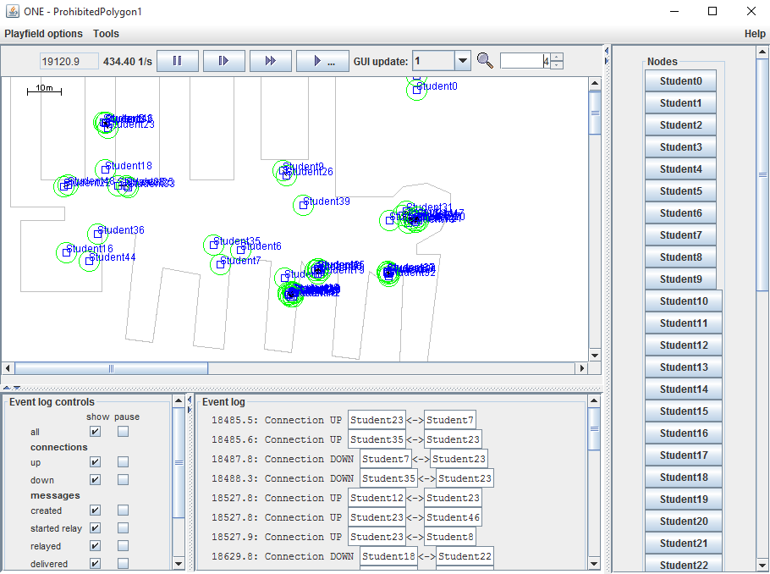

Figure Y : Graphical User Interface of - The ONE Simulator (Maybe use helsinki Map)

The simulation is equipped with a practical graphical user interface which displays the position of nodes within the simulation area, shown in figure Y. This visualization is one possibility to gather results from the simulation. In addition reports and outputs for post-processing tools are implemented. The fact that all report entities implemented in a separate module makes it very simple to adapt them to the outputs the user is interested which will be shown in chapter Z.

Implementation and Special Features

Based on the ONE Simulator, we designed our architecture and split the implementation into different modules (Figure z). The main elements of our movement model are spatial, temporal and social elements. These are guarded by the mobility model which contains the details about the implemented map and calculate movements from A to B in order to go around walls.

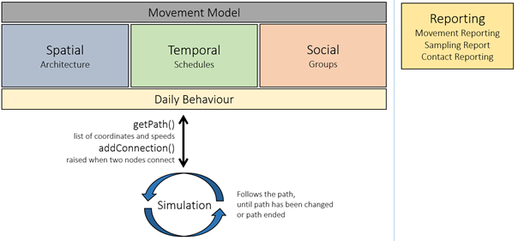

Figure Z: Architecture of Implementation Modules

Details of each module and specific knowledge about the implementation are addressed in the following paragraphs subchapters.

Spatial

The architecture of the building is generated through the map material OpenStreetMap (Link). Unfortunately we did not have exact plans of the building. Considering this, we decided to only simulate the ground level. Because we focused on the behaviour of the nodes and their behaviour, this does not influence the collected results tremendously. Changes of the building could mostly be seen in the extracted density map.

Movement Model

Outside the building nodes are moving on given sectors to reach the metro station, parking spots or the Mensa. The faculty building itself is implemented as a polygon, which allows nodes to move freely. Furthermore, we added an algorithm to find best ways from one finger to the other. The movement model is checking if the node is in a finger of the building and wants to move to another finger as shown in figure A. The movement model then calculates the path going from the current position to the entrance point of the source-finger and adding another point at the destination-finger. The last point in the path is set at the final destination within the finger. We did not add obstacles nor collision detection. To conclude, the movement model does get the source-coordinates and destination-coordinates from the model and calculates a path from source to destination.

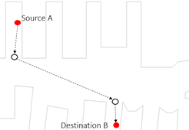

Figure A: Movement from one finger to another finger

This path can always be changed whenever the node changes, for example meets another node and decides to follow them to the Mensa instead to study.

Temporal

Schedule

Social

Groups

Simulation Results

The ONE Simulator provides us with numerous and different kind of reports. Each of these reports focuses on specific characteristics of the human mobility and mobile connectivity. For the purpose of this assignment, we decided that we should focus only in the mobility part, and take advantage of all the simulator classes that are meaningful to our mobility model.

In this section we describe all the characteristics we extracted by simulating our implemented scenario, and what kind of meta-information it is possible to acquire depending on these characteristics.

Contacts Per Hour

In this kind of report, the duration of the simulation (in seconds) is divided into hours, and for each hour of the simulation, the total number of connection establishments is recorded.

This information can help us understand the periods of time that the users are more active and moving around in large areas. For example, during lunch time (*see Plot X1, time XX*), users tend to either visit the MENSA or have lunch at the FMI cafeteria. In any case, they are more active than when they are attending a lecture. and as a result, they tend to establish more connections with other students.

*Plot X1: Contacts Per Hour*

Encounters vs Unique Encounters

This report presents for each node in the simulation a) the total number of encounters with other nodes, and b) the number of distinct encounters with other nodes (i.e. how many different nodes).

The information in this report can be used in order to recognise which nodes are more ‘*social*’ than others, which in turn might reveal which nodes move the most around the simulation area.

*Plot X2: Encounters vs Unique Encounters*

Contact Times

The information contained in this report is a distribution of the time that two arbitrary nodes of the simulation where in contact. In other words, it distributes the duration of any connection between any two different nodes.

From a statistical point of view, the Contact Times report reveals what is the usual duration for a connection between two nodes.

*Plot X3: Contact Times*

Inter-Contact Times

The Inter-Contact time between two nodes A and B, is the duration between 2 consecutive connections between them, i.e. how much time takes before 2 nodes meet again with each other. This report is similar to “Contact Times” report, but it contains a distribution of inter-contact times.

*Plot X4: Inter-Contact Times*

Contacts During an Inter-Contact Time

If *T* is the inter-contact time between two nodes *A* and *B*, then this report counts how many contacts *A* and *B* had with other nodes, during this time *T*.   
In other words this information refers to how many other nodes have a contact with A and B, before A and B meet again. The information is exported in the form of a distribution.

Again, it is very difficult to extract meta-information from a distribution, except statistical results.

*Plot X5: Contacts Between an Inter-Contact Time*

Total Contact Time

In this report, the simulation total time is divided into intervals of *X* seconds, and for every interval it calculates the total contact time of all active connections. In the end, the information for the time is presented in an accumulative way.

If we observe *Plot X6*, we can realise that the accumulated time increases more rapidily during rush hours, or during times where the users are more social and carefree (e.g. lunch time).

*Plot X6: Total Contact Time*

Node Density

This report ‘*slices*’the simulation area into an *A x B* grid, and then it takes *N* samples of the simulation, equally distributed in time. In our case, we use this report to export an average density based an all *N* samples.

We used these results to create a *heat map* of the node distribution in the simulation area. With the help of this map, the node density is more easily interpreted.

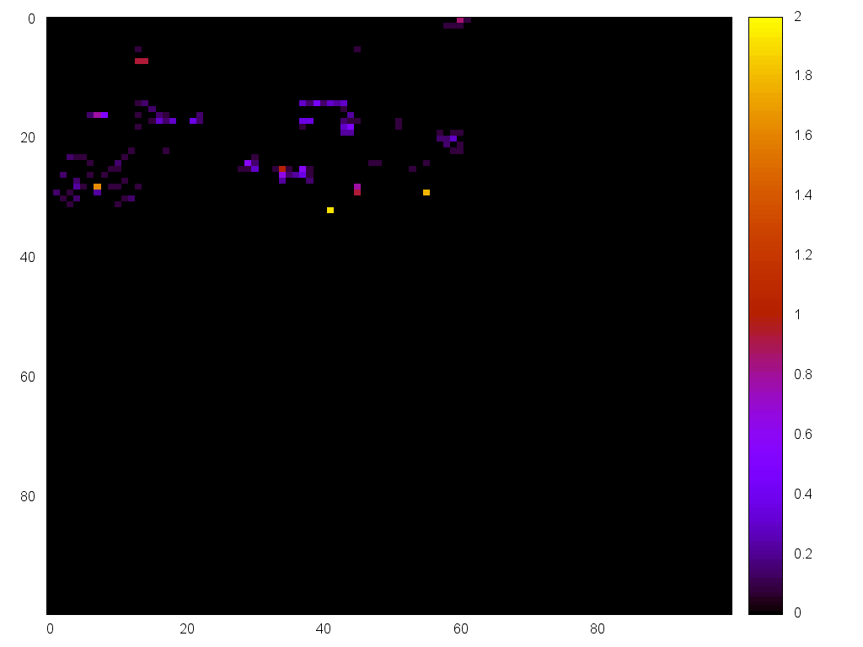

*Plot X7: Node Density (heat map)*

Conclusion

Lorem ipsum dolor sit amet, consectetuer adipiscing elit, sed diam nonummy nibh euismod tincidunt ut laoreet do

References