Information Governance and Cyber Security Part B (LD7087)

By

Rory Burke
24056162

Northumbria University
Master of Science
Cyber Security Technology
January 2025

Tutor: Usman Butt
Word Count:
2500 words

Executive Summary

Quality Higher Education (QHE) in the United Kingdom is committed to providing a wide range of higher education services and training programs to both domestic and international students. QHEs works with universities and training institutions throughout the UK to efficiently deliver these services. Because QHEs maintains a complete database containing personal information about applicants, students, and alumni, this collaboration requires a strong data-sharing architecture. This information is critical for providing personalized support, analysing educational trends, and satisfying the expanding demand for higher education.
Given the extensive network of training centers and campuses, sharing sensitive information such as enrolment details and academic records is important. However, this emphasizes the importance of regulatory, legal, and contractual requirements for data privacy and security. QHEs acknowledges the growing dangers posed by cyber security concerns and recognizes the importance of information governance in protecting the personal data of its stakeholders.
To address these issues, QHEs intends to create a strong Information Governance policy that is consistent with legal and regulatory standards. This policy will create clear principles for data management, protecting confidentiality, integrity, and availability of personal information. The purpose of this policy is to reassure QHEs management on data protection and to educate workers on best practices in data handling and information security.
This information governance policy will be developed by justifying its contents, selecting a suitable structure, and applying risk assessment procedures. A strategy plan for implementation will also be defined, with a focus on encouraging personnel to use ethical data management methods, maintaining compliance with information assurance processes, and protecting data subjects' rights.

Table of Contents

List of Figures 5
List of Tables 5
1. Introduction 6
2. Scope 6
3.1 Latest Cyber Security Threats To Information Assets 7
3.2 The Need for Information Governance 9
3.3 Social, Ethical and Legal Responsibilities of Auditors………………………...……………10
4.Frameworks 11
4.1 Information Governance Principles 11
4.2 ISO 27001 12
4.3 NIST 13
5. Risk Assessment Methodology 15
5.1 Risk Identification 15
5.2 Qualatative Risk analysis 17
5.2 Risk evaluation 17
5.3 Recommended Management Options 20
Table of References 21

- Critically evaluate the key information governance principles, practices and security frameworks to demonstrate your understanding in the design, development, implementation and monitoring of information security management system of an organisation.

- Ability to critically evaluate the risk assessment methodology to determine appropriate control objectives for a given organisational scenario.

- Demonstrate ability to work as a member of a team and make contributions to team success and effectiveness.

- Critically appraise, social, ethical and legal responsibilities of an Information security auditor to comply with.

- Introduction

The security of UK Quality Higher Education institutions is seriously threatened by the growing digitalization of higher education and the surge in cyberthreats. A big contributor to this was the COVID Pandemic which shifted learning techniques towards remote. According to (Sinha, n.d.) Educational institutions are adopting technology in an increasingly digital world to improve administrative, instructional, and learning effectiveness. Technology integration in education has changed the way administrators, teachers, and students interact, from digital record-keeping to online learning platforms. Nevertheless, this quick uptake of digital tools has also brought serious issues with cybersecurity and data privacy. Schools and postsecondary education Institutions hold a great deal of private data, including the personal information of employees, instructors, and students, which makes them appealing targets for cyber criminals.

Scope.
This study will help support and contextualize the Information governance (IG) policy that QHE was advised to implement. To state the necessity of IG, an evaluation of the most recent risks to the operations of the organization was conducted. To inform the reader of the assurance process from a social, ethical, and legal perspective, the role of auditors was then covered. By comparing the essential information governance practices and principles to widely used security frameworks, ISO/IEC 27001 and NIST were compared. Finally, a summary of the risk assessment procedure was provided to clarify how the methods used to identify the controls included in QHE’s information governance policy complied with ISO/IEC 27001 and NIST.

3.1Latest cyber security threats to information assets.

QHE’s cyber security model heavily relies on the CIA Principles (figure 1), the Data Security Act of 2018's provisions safeguard students, employees and customer data confidentiality. In the field of information protection, threats and the organisations that carry the danger of suffering a loss from them have always existed. Since the beginning, it was crucial to preserve the information's availability and integrity. component of all record-keeping technologies, including digital records today and cuneiform on clay tablets. As information owners attempted to protect privacy and maintain secret, the quality of confidentiality was added to the list of essentials.(Ulven, 2020)

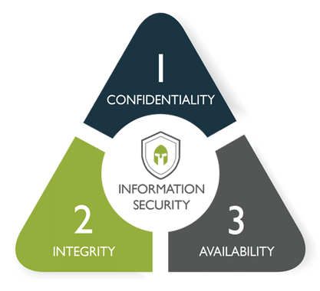
Figure 1, (What Is the CIA Triad_ _ CyberOne, n.d.)

Figure 2 represents the industry breakdown in financial loss within a 2-month window(2021), the results are staggering.
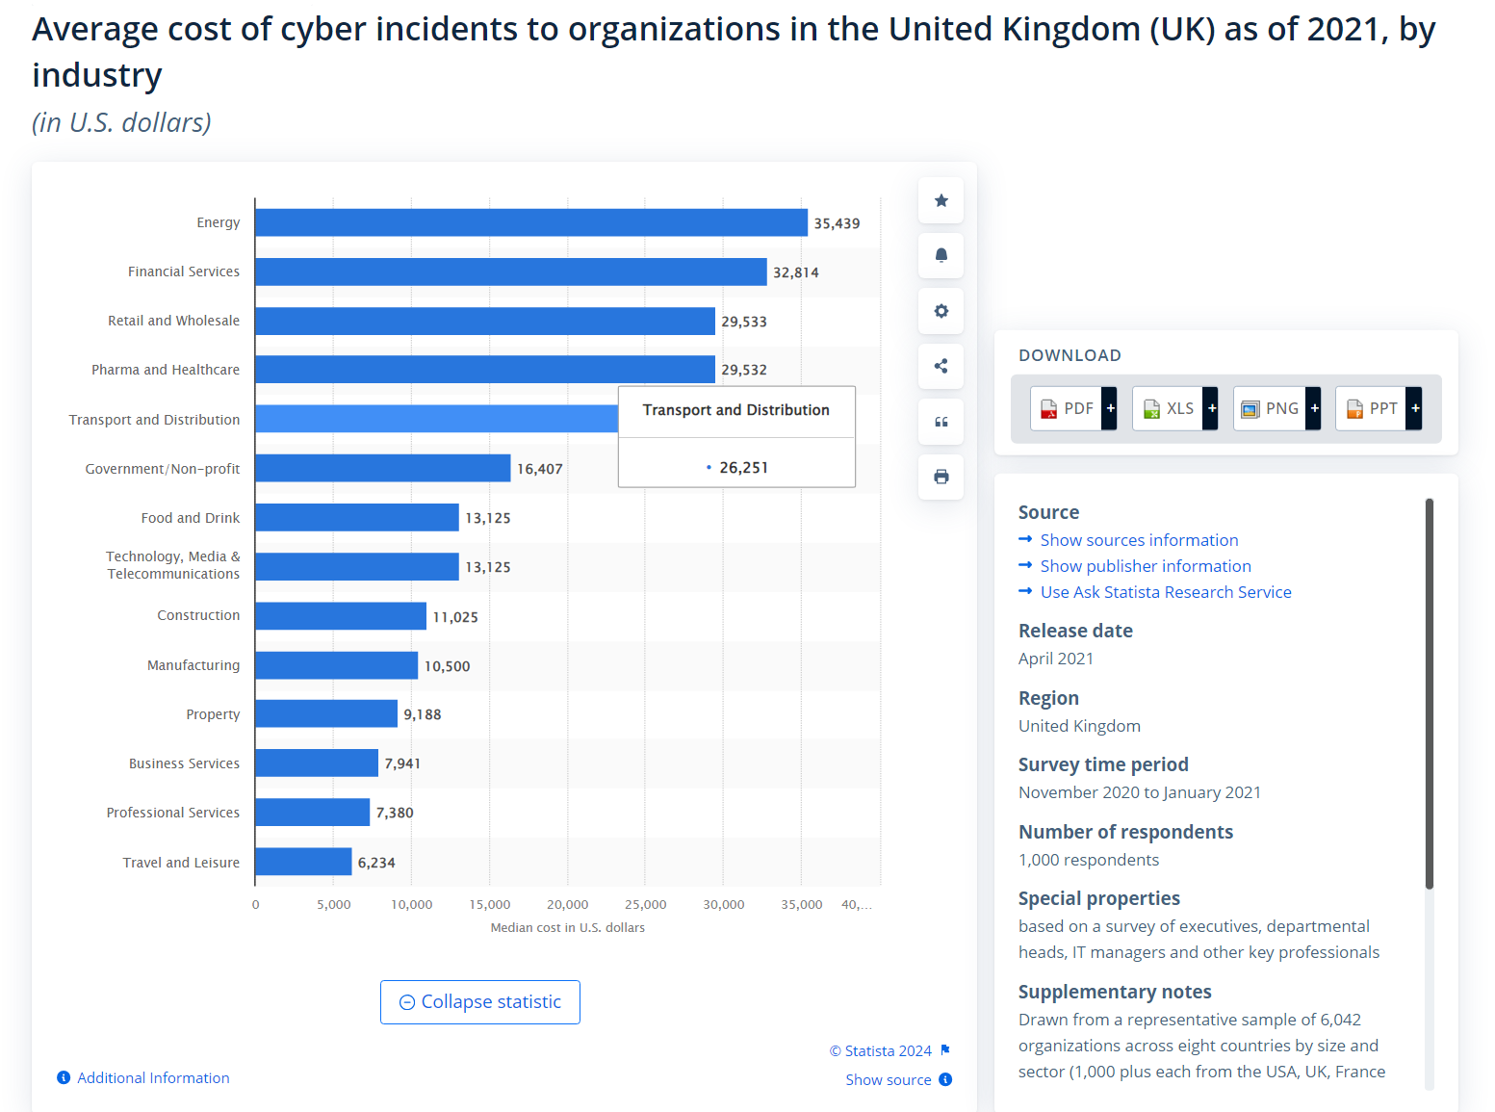
Figure 2, (Cost of Cyber Incidents to UK Industries 2021 _ Statista, n.d.)

In 2011, RSA, a secure division of EMC Software announced a sophisticated cyber-attack on its systems that involved the compromise of information associated with its SecureID, a 2 factor authentication token product. This is another attack that infiltrated an organization’s network through phishing emails sent to the organization’s employers.(Alshamrani et al., 2019) Similar to RSA, phoney emails intended to distribute malware or steal credentials could be sent to QHE employees and students.

More recently On 2 March 2021, Microsoft made public that sophisticated actors had attacked a number of Microsoft Exchange servers, which are used by organisations worldwide to manage their email, scheduling and collaboration. Microsoft assessed that the initial intrusions commenced as early as January 2021 and were Chinese state-sponsored. (National Cyber Strategy 2022 (HTML), 2022)
The fact that Chinese state-sponsored entities executed the attack suggests that Advanced Persistent Threats (APTs) were involved. Higher education institutions are popular targets for APT organisations because they frequently possess private information, research data, and sensitive intellectual property.

3.2 The Need for Information Governance.

Organisations like QHE, who manage sensitive personal data, have various locations, and exchange information with external partners and Vendors, need to have effective information governance.

Gartner (2021) defines IG as the specification of decision rights and an accountability framework to ensure appropriate behavior in the valuation, creation, storage, use, archiving, and deletion of information. It includes the processes, roles, policies, standards, and metrics that ensure the effective and efficient use of information in enabling an organization to achieve its goals. In other words, IG incorporates a wide set of subjects that covers information protection, information quality, and information lifecycle management. The essence of the IG policy at the University of Cambridge Clinical Medicine School is to provide a comprehensive IG system for managing identifiable information relevant to science. The policy's purpose is to put in place the appropriate framework, tools, and processes to ensure that the information necessary to support the research carried out by clinical school participants is properly collected and stored in compliance with all current legislation and guidelines (ICO, 2018). (Mohd Nordin et al., 2022)

3.3 Social, ethical and legal responsibilities of auditors.

In order to make sure that IG policies are in line with corporate objectives, legal requirements, and moral principles, information security auditors are essential. Their duties have a big impact on how policies are created and carried out (Fakeyede et al., 2023)

Auditors are required to confirm compliance with regulations like the GDPR, which require protections for personal information. Comprehensive compliance checklists must be a part of policies in order to make auditors' assessments easier.

The school’s leadership team is responsible for making sure the school’s data protection activities meet its requirements. The team needs to ensure that everyone else knows how to handle personal data, which means it should have policies and procedures that anyone can follow and lead a culture of data privacy. At least one member of the leadership team should get some more specialised training on the GDPR, such as a GDPR Practitioner qualification. The data protection officer (DPO) is responsible for checking that the school is handling data properly and advising on how to do so. They need to have a strong grasp of both data protection law and how the school uses personal data(GDPR for Schools-a Quick Intro, n.d.)

In addition to significant fines, noncompliance with GDPR may harm one's reputation. Thus, it is crucial for all QHE to cultivate a culture of data protection knowledge and compliance.

Among the educational institutions that have detected any breaches or attacks in the past 12 months, Figure 3 shows the percentage that detected the following kinds of attacks or breaches (Cyber Security Breaches Survey 2024: Education Institutions Annex, 2024)

Type of breach or attack | Businesses | Primary Schools | Secondary Schools | Further education colleges | Higher education institutions
Phishing attacks | 84% | 92% | 89% | 97% | 100%
Others impersonating organisation in emails or online | 35% | 29% | 58% | 78% | 90%
Viruses, spyware or malware (excluding ransomware) | 17% | 14% | 21% | 32% | 77%
Hacking or attempted hacking of online bank accounts | 7% | 1% | 5% | 8% | 10%
Denial of service attacks | 5% | 3% | 14% | 41% | 40%
Takeover of organisation’s user accounts | 8% | 4% | 5% | 11% | 20%
Unauthorised accessing of files or networks by staff | 1% | 4% | 11% | 19% | 27%
Ransomware | 6% | 3% | 2% | 8% | 10%
Unauthorised accessing of files or networks by outsiders | 1% | 1% | 3% | 0% | 20%
Unauthorised listening into video conferences or instant messages | 1% | 0% | 0% | 3% | 3%
Any other breaches or attacks | 3% | 2% | 3% | 16% | 47%
Figure 3, (Cyber Security Breaches Survey 2024: Education Institutions Annex, 2024)

With phishing attacks occurring in 100% of higher education institutions, phishing is the most prevalent attack type across all industries. This emphasises how important it is to have strict awareness and follow email security guidelines.
(Alkhalil et al., 2021) States in their study Human nature is considered one of the most affecting factors in the process of phishing. Everyone is susceptible to phishing attacks because phishers play on an individual’s specific psychological/emotional triggers as well as technical vulnerabilities (KeepnetLABS, 2018; Crane, 2019). For instance, individuals are likely to click on a link within an email when they see authority cues (Furnell, 2007). Due to their substantial connection with students and other partners, 90% of higher education institutions are heavily impacted by impersonation attacks.

4.1 Information Governance Principles.

Higher education IT governance, risk, and compliance (GRC) programs are in the development stage. Few institutions have all three programs in place, and many institutions are unclear where they should start when instituting or maturing their IT GRC programs. (Bichsel et al., 2014) QHEs must comply with GDPR by making sure that personal data is handled legally, openly, and for justifiable reasons. In countries where the GDPR does not apply, data sharing between universities and companies might be even more prevalent.(Komljenovic, 2022)

QHEs must manage and provide access to public records responsibly in line with freedom of information act 2000, compliance with the information commissioners office is also mandatory. Information governance is not only a legal duty but also a strategic imperative for reputable QHEs. Sensitive data is safeguarded, compliance is guaranteed, risks are reduced, trust is developed, and ethical standards are maintained. QHEs can encourage academic achievement and prosper in a fast evolving digital and regulatory environment by integrating IG into their day-to-day business.

4.2 ISO27001

The ISO 27001 standard offers a comprehensive framework for establishing, implementing, maintaining, and improving information security in an organization (Muhammad Rijal et al., 2024a)

The ISO 27001 is an globally recognized and certifiable information security management system (ISMS). QHEs would benefit from attaining this certificate for many reasons, one being continuity, if the QHEI decided to make this mandatory there will be an recognizable “level playing field” for information security.

The procedure to get ISO 27001 Certification is illustrated in the below figure4 From the above findings, the clear steps that are required for an ISO 27001 certification are presented.(Muhammad Rijal et al., 2024b)
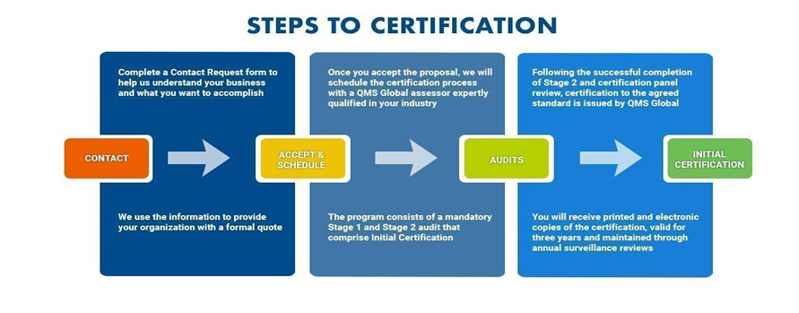
Figure 4, (Muhammad Rijal et al., 2024b)
Given the requirement for thorough risk assessments, data-sharing networks and employee training, the certification procedure should take six to twelve months. QHEs can cooperate with outside experts and make use of current IT governance frameworks to speed up the process.

ISO 27001 uses The PCDA (Plan-Do-Check-Act) model plays a significant role in the information security audit, this methodology for improving processes that can be used in various industries, including information security. In the context of information security, the PCDA model can be used to implement and maintain an effective information security audit system (Ziro et al., 2023)

4.3 NIST

The NIST Cybersecurity Framework (CSF) 2.0 provides guidance to industry, government
agencies, and other organizations to manage cybersecurity risks. It offers a taxonomy of high-
level cybersecurity outcomes that can be used by any organization — regardless of its size,
sector, or maturity (Institute of Standards, 2024)
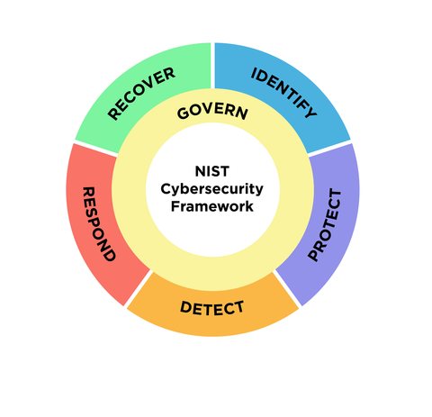
The five primary roles covered by NIST CSF are Identify, Protect, Detect, Respond, and Recovery, they align nicely with QHE's requirement for a comprehensive cybersecurity plan. These functions support QHE's top priorities of data availability, integrity, and confidentiality.

4.4 Framework Selection

ISO 27001 is often considered the "gold standard" for ISMS, but its resource-intensive nature may make it less practical for the premature stages of implementation for QHEs as previously stated. Adopting NIST CSF today offers a practical, affordable, and adaptable framework to handle QHE's current cybersecurity issues, even though ISO 27001 is still the ultimate objective. When the time is appropriate, it facilitates a more seamless transition to ISO 27001.

5.Risk Methodology
The QHEs strategy was considered when establishing the risk acceptability criteria. To preserve network security, the CIA of sensitive data, and the provision of necessary services to meet contractual, regulatory, and legal duties, this includes the implementation of automated procedures in the threat climate that was previously studied. The criteria for conducting risk assessments in accordance with clause IR 8286A of the NISTCSF 2.0 are described in this section, together with the procedures to guarantee that repeated information security risk assessments yield reliable, consistent, and comparable results.

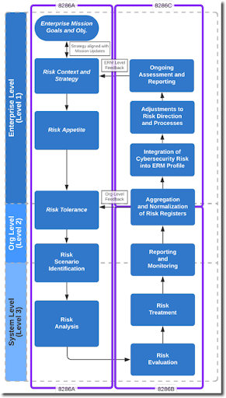
(Quinn et al., 2021)

An organization-wide risk management strategy includes an expression of the security and privacy risk tolerance for the organization, security and privacy risk mitigation strategies, acceptable risk assessment methodologies, a process for evaluating security and privacy risk across the organization with respect to the organization’s risk tolerance, and approaches for monitoring risk over time (Security and Privacy Controls for Information Systems and Organizations, 2020)

5.1Risk Identification

According to (Smejkal et al., n.d.) a crucial role is played by the importance of secured assets, whether it is sensitive data or not. There is no point in introducing a highly secure technology for data the loss or misuse of which would result in less damage than the cost of deploying a security system.
Firstly, QHEs need to define the scope of the ISMS to include all campuses, student data, partner institutions, and IT systems. Then Identify compliance requirements such as GDPR, UK Data Protection Act, and contractual duties. NIST uses the Identify function to highlight organisational dependencies such as emailing systems, research data and academic results. The identify function is related to asset management, the business environment, governance, risk assessment, and risk management strategy.(Webb & Hume, 2018)

5.2 Qualitative Risk Analysis

Identifying the right trade-offs when deciding how to reduce the attack surface that is, how to reduce risk across all attack vectors, cost-effectively, and with an acceptable negative impact on QHEs operations is one of the most difficult aspects of threat modelling, according to the NIST document. To make comparisons easier, the document suggests using scoring and weighting approaches to further prioritise attack vectors and controls based on risk appetite and the impact on sets of characteristics, such as costs, functionality and usability.

To assess the likelihood of an incident, NIST CSF suggests utilising threat intelligence and organisational knowledge. Because phishing is so common in the educational field and frequently targets email systems, it is quite likely to occur for QHE. Assess the possible effects on availability, CIA, The impact on QHE is high because compromised credentials have the potential to reveal private student information and interfere with academic procedures. Phishing Risk Rating = High (Very Likely × High)

 | Very Likely | Likely | Unlikely | Very Unlikely
Critical | Extreme | High | Moderate | Low
High | High | High | Moderate | Low
Medium | Moderate | Moderate | Low | Low
Low | Low | Low | Low | Very Low

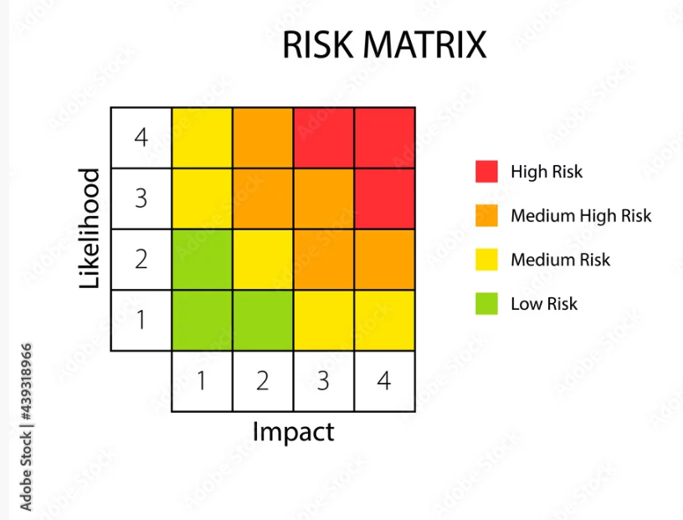
(4x4 Risk Matrix Model. Clipart Image Stock Vector _ Adobe Stock, n.d.)
RISK | ASSET | THREAT | VULNERABIY | LIKELIHOOD | IMPACT | RISK LEVEL | NIST CONTROLS | RESIDUAL RISK
Phishing Attack | Email accounts, LMS, records | Credential threat | Lack of filtering, user awareness | Very likely | high | high | PR.DS-1  PR.AC-7 | Moderate
Unauthorized Access | Academic records, IT systems | Insider misuse of privileges | Excessive user privileges, no monitoring | unlikely | high | moderate | PR.AC-4  DE.CM-3 | Low
Asset Type | Specific Assets | Description | NIST Controls
Information Assets | - Student Records | Personal and academic data (names, grades, attendance, financial aid, health information). | PR.DS-1: Protect data at rest.  PR.DS-2: Protect data in transit.  PR.AC-6: Limit access based on roles.
 | - Research Data | Proprietary research outputs and intellectual property (papers, datasets, experiments). | PR.DS-6: Ensure data integrity.  PR.IP-4: Perform regular backups.  PR.DS-3: Securely distribute research data.
 | - Alumni Data | Personal and employment information of alumni. | PR.AC-5: Manage access permissions.  ID.GV-3: Ensure governance policies for data-sharing agreements.
 | - Partner Institution Data | Data shared with or received from partner institutions and training centers. | ID.AM-3: Identify third-party dependencies.  PR.AT-3: Ensure third-party awareness of security policies.
Hardware Assets | - Servers | Centralized servers hosting email, LMS, databases, and student portals. | PR.PT-3: Harden systems against unauthorized changes.  DE.CM-8: Detect unauthorized activity on systems.
 | - Workstations and Laptops | Devices used by staff and faculty for teaching, administration, and research. | PR.DS-7: Ensure endpoint encryption.  PR.AC-2: Use strong authentication mechanisms.
 | - Network Devices | Routers, firewalls, and switches supporting internet and intranet connectivity. | PR.PT-5: Protect network infrastructure.  DE.CM-7: Monitor network traffic for anomalies.
 | - Backup Systems | On-premises or cloud-based systems for data backups. | RC.RP-1: Establish a recovery plan.  PR.IP-4: Perform and verify regular backups.
Software Assets | - Learning Management System (LMS) | Platform for online learning, grading, and assignment submissions (e.g., Moodle, Blackboard). | PR.AC-4: Enforce access control.  DE.CM-1: Monitor user activity for anomalies.
 | - Email and Collaboration Tools | Email servers and tools like Microsoft Exchange, Teams, or Zoom. | PR.AC-7: Implement MFA.  DE.CM-8: Monitor emails for phishing attempts.
 | - Financial Systems | Platforms for managing student payments, payroll, and budgets. | PR.DS-6: Ensure financial data integrity.  DE.CM-3: Monitor access and usage logs.
 | - Database Management Systems | Databases for storing academic, financial, and operational data. | PR.DS-1: Encrypt sensitive data.  PR.IP-5: Ensure system configuration management.
Physical Assets | - Data Centers | Physical locations housing IT infrastructure. | PR.PT-2: Ensure physical access restrictions.  ID.AM-2: Maintain an inventory of physical assets.
 | - Campus Buildings | Facilities for administrative, academic, and research activities. | PR.PT-1: Enforce security policies for physical locations.

