Dissertation Report:
Evaluating Organisational Readiness for Predictive Risk Intelligence Integration

By

Nicholas Quinn
22073641

Supervised By

Dr Usman Javed Butt

Module: Computing and Digital Technologies Project LD7083FLZ31

Northumbria University

Master of Science

Cyber Security Technologies

Submission Date: 15/01/25

Acknowledgements

I would like to express my deepest gratitude to the following individuals whose guidance, support, and encouragement have been instrumental in my academic journey over the past two years during my MSc studies.
First and foremost, I would like the thank Dr. Usman Javed Butt whose insightful guidance has been invaluable throughout various modules and as my supervisor for this dissertation project. As my first major academic endeavour, higher education has at times been a daunting challenge for me. However, Dr. Butt’s calm, encouraging and professional instructional manner played a key role in maintaining my motivation, focus, and belief in my ability. For this, I am deeply grateful.
I would also like to acknowledge the Third Battalion, the Parachute Regiment for their flexibility in managing my workload which has enabled me to maintain a consistent focus on my studies. I hope that the successful completion of this dissertation reflects the high standards of our great unit.
Finally, I would like to thank my partner Laura for her unwavering support and for the sacrifices she has made to support our family while I pursued my studies. I dedicate this dissertation to my daughters, whose presence in my life has been a constant source of inspiration and a reminder of the importance of lifelong development.

Table of Contents

Acknowledgements 2
List of Figures 5
List of Tables 5
Abstract 6
1. Introduction 7
1.1 Contextualisation 7
1.2 Problem Statement 7
1.3 Research Questions and Objectives 9
2. Systematic Literature Review of PRI 9
2.1 Search strategy 9
2.2 Inclusion and Exclusion criteria 10
2.3 Study selection process 10
2.4 Data Extraction 11
2.5 Data synthesis and analysis 12
2.5.1 The focus of ML in SIS 12
2.5.2 Accuracy and Bias 13
2.5.2 Privacy, Transparency and Accountability 14
2.5.3 Security 14
2.5.4 Research Gaps 17
3. Discussion and recommendations for future research 17
4. Research Design and Methodology 18
4.1 Theoretical Foundation 18
4.2 Framework Justification 18
4.3 Research Method 19
4.3.1 Philosophical Approach 19
4.3.2 Research Method 19
4.3.3 Interview Design Framework 20
4.3.3 Data collection 20
5. Results and Analysis 21
5.1 Coding Review 21
5.2 Categorisation 22
5.3 Findings 23
5.3.1 Cluster 1 23
5.3.2 Cluster 2 25
5.3.3 Cluster 3 27
5.3.4 Cluster 4 28
5.4 Summary of Findings in Relation to Research Objectives 31
6. Discussion 31
6.1 Action Outline to Address Social, Ethical and Legal issues 31
6.2 Organisational Governance Gaps 31
6.3 Barriers for PRI integration 32
6.4 The Role of leadership 33
6.5 The Need for Greater Organisational Robustness 33
6.6 Validity of Research 35
7 Conclusion 36
7.1 Summary 36
7.2 Contribution and limitations 36
7.3 Final Recommendations 36
Final Reflection 37
Table of References 38
Annex A: Systematic Literature Review Quality Assessment Checklist 42
Annex B Data Extraction Format 44
Annex C: Table of Related Work 45
Annex D: Questions Framework Matrix 47
Annex E: Ethics Review Form 49

List of Figures

Figure 1: ISO/IEC 38507 modification of ISO/IEC 38500 Model for Governance of IT (Source: ISO/IEC 38507:2022) 8
Figure 2: PRISMA Flow diagram (Source: Quinn, N, 2025) 10
Figure 3: Summary of open and axial codes (Source: Quinn, N, 2025) 11
Figure 4: Machine Learning as a subset of broader AI (Source: Quinn, N, 2025) 12
Figure 5: Model Overfitting (Source: Quinn, N, 2025) 13
Figure 6: Data Bias Throughout System Lifecycle (Source: Quinn, N, 2025) 13
Figure 7: Inference Attack (Source: Quinn, N, 2025) 15
Figure 8: Coding Iterations (Source: Quinn, N, 2025) 21
Figure 9: Cluster 1 Analytical Framework (Source, Quinn, N, 2025) 23
Figure 10: Cluster 2 Analytical Framework (Source: Quinn, N, 2025) 25
Figure 11: Cluster 3 Analytical Framework (Source, Quinn, N, 2025) 27
Figure 12 Cluster 4 Analytical Framework (Source, Quinn, N, 2025) 30

List of Tables
Table 1: Principles of Security for Machine learning 14
Table 2: Participant Sample Composition 20
Table 3: Coding Categorisation 22
Table 4: Quality Evaluation Table 41
Table 5: Data Extraction Format 43
Table 6: Related Work and Research Gaps 44
Table 7: Questions Framework Matrix 46

Abstract

Predictive Risk Intelligence is an AI use case currently deployed across various domains to forecast potential risks before they occur. At the heart of its predictive engine, is a confluence of machine learning and big data technologies referred to as smart information systems. Optimal utilization of this use case is expected to bring benefits to organisations and contribute to the drive towards sustainable development goals outlined by the United Nations. However, these advantages are hindered by system threats and vulnerabilities which are accompanied with ethical implications. There is a limited corpus of empirical academic work in this particular field that related to the governance of PRI and the wider applications of SIS. It is the aim of this paper to review the state of the art and contribute to empirical findings to evaluate how ready organizations are to integrate PRI as a driver towards SDGs whilst mitigating the ethical implications.

Keywords: Predictive Risk intelligence, Smart Information Systems, Artificial Intelligence, Machine Learning, Big Data.

Introduction

1.1 Contextualisation
Predictive risk intelligence (PRI) using Smart Information Systems (SIS) is an Artificial Intelligence (AI) use case adopted across several domains, that leverages advanced technologies and data analytics to identify, assess, and forecast potential risks. SIS are a broad technological concept which describe the combination of AI and advanced Big Data Analytics (BDA) to collect, process and analyse large and complex datasets, from various sources, in an intelligent and automated manner. Ryan et al (2020, p. 3) uses the term "SIS" to categorize Socio-Technical Systems (STS) that leverage a specific AI technique called Machine Learning (ML) often employing artificial neural networks, to extract insights from vast quantities of typically unstructured data. STS are a concept that denotes the design of a system that optimises the confluence of social arrangements and technical components (Bauer & Herder, 2009). The interplay between SIS components is evident in activities like sentiment analysis and trend prediction, where vast amounts of data generated by STS are processed by ML algorithms, to augment and automate delineated tasks such as predictive modelling and sentiment classification (Ryan et al., 2020, p. 3). Akin to similar emerging technologies, the discourse surrounding the employment of SIS, is often directed towards the issue of managing and optimizing the consequences of innovation. Central to this discussion are the human rights affected by SIS as expressed United Nation’s (UN) Universal Declaration of Human Rights and their implementation by the attainment of actionable and measurable Sustainable Development Goals (SDG’s) (Ryan et al., 2020, p. 3). To ensure that AI systems work towards SDG’s, requires a carefully co-ordinated global collaborative effort involving the use of dynamic and agile policy frameworks to safeguard and guide their implementation (Miailhe et al., 2020, pp. 214-216).

1.2 Problem Statement
The ISO/IEC TR 24030 is a technical report that takes one step towards achieving Miailhe et al’s (2020) collaborative effort. The report fosters collaboration between stakeholders in AI applicability by gathering information to inform and guide AI standardization efforts, thus demonstrating how standardisation can be applied across various domains SDG’s (ISO-IEC TR 24030, 2024). Another aim of this report is to identify new technical requirement to accelerate scientific and technological advancements, which as stated by Ryan et al (2020) and Miailhe et al (2020) is measured for success in terms of the attainment specific SDG’S. The document is organized inter alia 7 clauses that define, a diverse range of application domains, where examples include Supply chain Management (SCM), Fintech and Healthcare as well as AI applications which include demand forecasting, loan screening, diagnosis support, before evidencing and referencing the actual use cases of these applications in active deployment (ISO-IEC TR 24030, 2024). Referenced as Use Case 164, PRI is in deployment across multiple domains and applications, including the aforementioned examples as a potential driver, specifically towards the contribution of SDG 9: Industry, Innovation and Infrastructure. The core technology at the heart of this use case, is a predictive engine that uses SIS to provide the foresight to clients, so that they can detect risks on a global scale days, sometimes weeks in advance of an unwanted occurrence (ISO-IEC TR 24030, p. 85). The rapid adoption of SIS and its enabling technologies like Internet of Things (IoT), ML, Cloud Computing and social media brings tremendous benefits, however, also introduce a number of system security threats and vulnerabilities that raise ethical considerations over Unauthorised Access and Misuse of Data, algorithmic integrity, fairness, accountability, transparency, bias, and accuracy (Tilimbe, 2019).
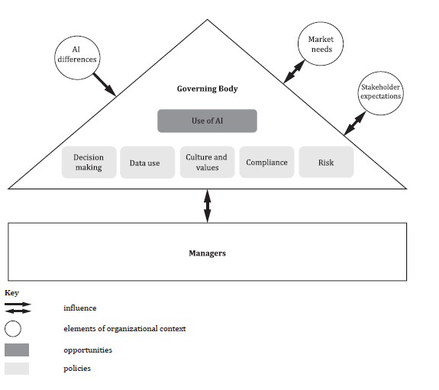
These system vulnerabilities can disrupt upstream which can contribute to a lack of trust. However, there is still a requirement for researchers to develop a comprehensive, actionable frameworks to resolve these conflicting ethical issues (ISO-IEC TR 24030, p. 87). UN funded Project Sherpa (n.d.) is a collaborative effort between a diverse range of stakeholders to investigate the ethical and human rights implications of SIS, develop solutions, and advocate for their responsible implementation. However, any tangible ethical guidelines are in a drafting phase and this use case is currently in deployment across various domains (ISO-IEC TR 24030, 2024). Figure 1 shows how the absence of such guiderails, along with other external factors, has the potential to impact on various aspects of the ISO/IEC 38500:2015 theoretical model for governance of IT as applied by the ISO-IEC 38507's (2022) implications of the use of artificial intelligence by organizations. Thus, this has the potential to have a cascading affect for organisations, with implications for data security, privacy rights, system integrity, and resilience at the intersection of the SIS used and the data subjects

Figure 1: ISO/IEC 38507 modification of ISO/IEC 38500 Model for Governance of IT (Source: ISO/IEC 38507:2022)
Despite the growing importance of security, privacy, and ethics in SIS, a comprehensive review of the risks and potential solutions remains elusive. A systematic literature review (SLR) is a useful tool for consolidating scattered knowledge, identifying research gaps, and future research agendas (Kitchenham et al., 2009). However, the search string ("systematic literature review") AND ("smart information systems") AND ("security") OR ("privacy") OR (“ethical concerns”) which yielded 189 results in the google scholar database that did not provide a comprehensive review analysis of existing research on security and privacy or ethical concerns along this intersection. The search string was refined to "smart information systems" AND "risk intelligence" AND “systematic literature review” to yield 0 results. Therefore, before a potential solution could be addressed it was necessary to conduct an SLR to gain clarity with respect to the following Research Questions (RQs) and Objectives.

1.3 Research Questions and Objectives
Given the complex interplay of technologies within SIS and the identified lack of comprehensive understanding of their associated ethical challenges, it was first necessary to establish a clear understanding of the system's technical foundation. Therefore, the first (OB1) was to gain a comprehensive understanding of the driving technical components that underpin SIS, specifically used for PRI. This laid the foundation for a further investigation into the potential security threats and vulnerabilities associated with these components. OB2 was to identify the specific security issues and vulnerabilities that arise from the technical components of SIS, particularly when those systems are used for PRI. OB 3 was to identify and define areas where existing research or knowledge are insufficient or lacking in addressing the ethical implications of SIS application of PRI and identify the agenda for the current study. This was achieved in the SLR by addressing the following Research Questions:
RQ1 was: What are the enabling and driving technical components of SIS, particularly in the context of PRI?
RQ2: What are the associated system threats, vulnerabilities and ethical implication related to the technical components of SIS, particularly in the context of PRI?
RQ3: What are the current knowledge gaps in understanding of the system threats and vulnerabilities implications of SIS, particularly in the context of PRI and what agenda for research should be undertaken by this study?
The analysis suggested that the theoretical foundation for the scope of the ethical implications for SIS, was evolving in a growing field of research, thus highlighting a gap for a more structured and holistic corporate approach in the literature and practice. Such an approach should encompass not only the technical aspects of ML, but broader societal implications by adopting processes such oversight, data management and risk management. Another gap was whether the alignment of the use case was consciously aligned with SDG 9, as this factor was not explored in the research, despite being assigned to the use case in the ISO/IEC TR 24030
Therefore, the OB (4) of this study was to use a relevant standard for Governance Risk and Compliance (GRC) as a benchmark to assess the maturity and preparedness of corporate approaches to GRC for organisations that use PRI and whether they were consciously aligning its usage with SDG 9. Therefore, the aim of the study was to provide a contribution to the existing body of work by answering the following:
RQ4 How ready are organisations for integrating PRI and managing the ethical implications of SIS technologies?

Systematic Literature Review of PRI

2.1 Search strategy
This study uses the Preferred Reporting Items for Systematic Reviews and Meta-Analyses (PRISMA) framework to guide and structure the SLR. PRISMA is becoming a widely accepted methodology in computing research, to ensure transparency and rigor in the review process (Patterson et al., 2023, p. 2). A bottoms-up approach was used in the search strategy to enable the emergence of findings from an inductive process. To identify key the relevant search terms, the search string Search String: "smart information systems" AND "risk intelligence" was entered into the Google Scholar Database, yielding 12 results. A preliminary examination of the keywords across these papers revealed that synonyms for SIS included Artificial intelligence and Machine Learning combined with, big data or big data analytics to represent the composite technologies for SIS. This resulted in the search string (("Predictive Risk intelligence") AND ((“smart information systems”) OR (“Artificial intelligence" OR "Machine Learning”) AND (“Big data" OR "Big data analytics”)).

2.2 Inclusion and Exclusion criteria
The database selection initially aligned with the review strategies of Birkstedt et al (2023), Patterson et al (2023), Laato et al (2022) Sharma et al (2020), Tandon et al (2020). This strategy immediately ruled out domain specific medical science databases and would include multidisciplinary databases to facilitate an examination of the complex interplay between, technology, people, organizations and society from a socio-technical perspective. The inclusion criteria and exclusion criteria (Annex A- upper) for this SLR followed the guidance of Carrera-Rivera et al (2022, p. 4) and the QE checklist, which is to be assessed using a Likert scale in Annex A-lower is adapted from the Quality Assessment criteria described by Zhou et al (2015) as these methodological approaches are specifically align to computer science SLR’s

2.3 Study selection process

The search execution commenced on the 9^{th of} September 2024 following the PRISMA flow diagram in figure 3. The inspection of Association of Computing Machinery (ACM) Digital Library database, which was chosen for its focus on computer science, using the both the initial string and Boolean extensions yielded 1 result. The search of Scopus which according to Birkstedt et al (2023), is commonly used in SLR’s for similar topics due to its broad coverage also yielded limited results (4), Science Direct also yielded unsatisfactory results. To address this issue the search terms were isolated and run through the databases, revealing that despite PRI being addressed an emerging concept in the field of computer science, it was relatively under-researched. The synonym “predictive risk analytics” was considered, however, a careful analysis of this term revealed a definitional association with the ML and statistical techniques as a subset used to enable PRI (Wilhelmina Afua Addy et al., 2024). Therefore, it was determined that that Google Scholar, which identified 48 search results encompassing the results found on the previous databases should be included to supplement the search. The initial 52 search results were reduced to 24 documents for screening after the removal of duplicates and articles written in non-English languages. The initial abstract and key word screening was carried out by the author, using QE tool (Annex A), resulting in the exclusion of 11 articles, a further review of the full text articles resulted in the further exclusion of 6 articles. From the 7 remaining articles, a backwards snowballing technique of identified 2 further articles, which were screened and included in the review.
Figure 2: PRISMA Flow diagram (Source: Quinn, N, 2025)

2.4 Data Extraction
The qualitative extraction followed a format designed to obtain data points relevant to the QE criteria and RQ’s 1 and 2 so that research gaps (RQ3) and a suitable agenda for the current study (RQ 4) could be identified. The theme for quality evaluation was preset to aid the mapping of the studies to the QE tool (Annex A) for the quality assessment. The data form (Annex B) aligns with the computer science classification scheme presented by Ramesh et al (2004). The data extraction itself was performed after an initial review of the articles by the author who then used NVivo 14 software to develop open and axial codes as part of an iterative process as described by Williams & Mose (2019). These codes which are contained in Annex B, are summarized in the figure below, with open codes extending from the axial codes, denoted by the RQ’s.
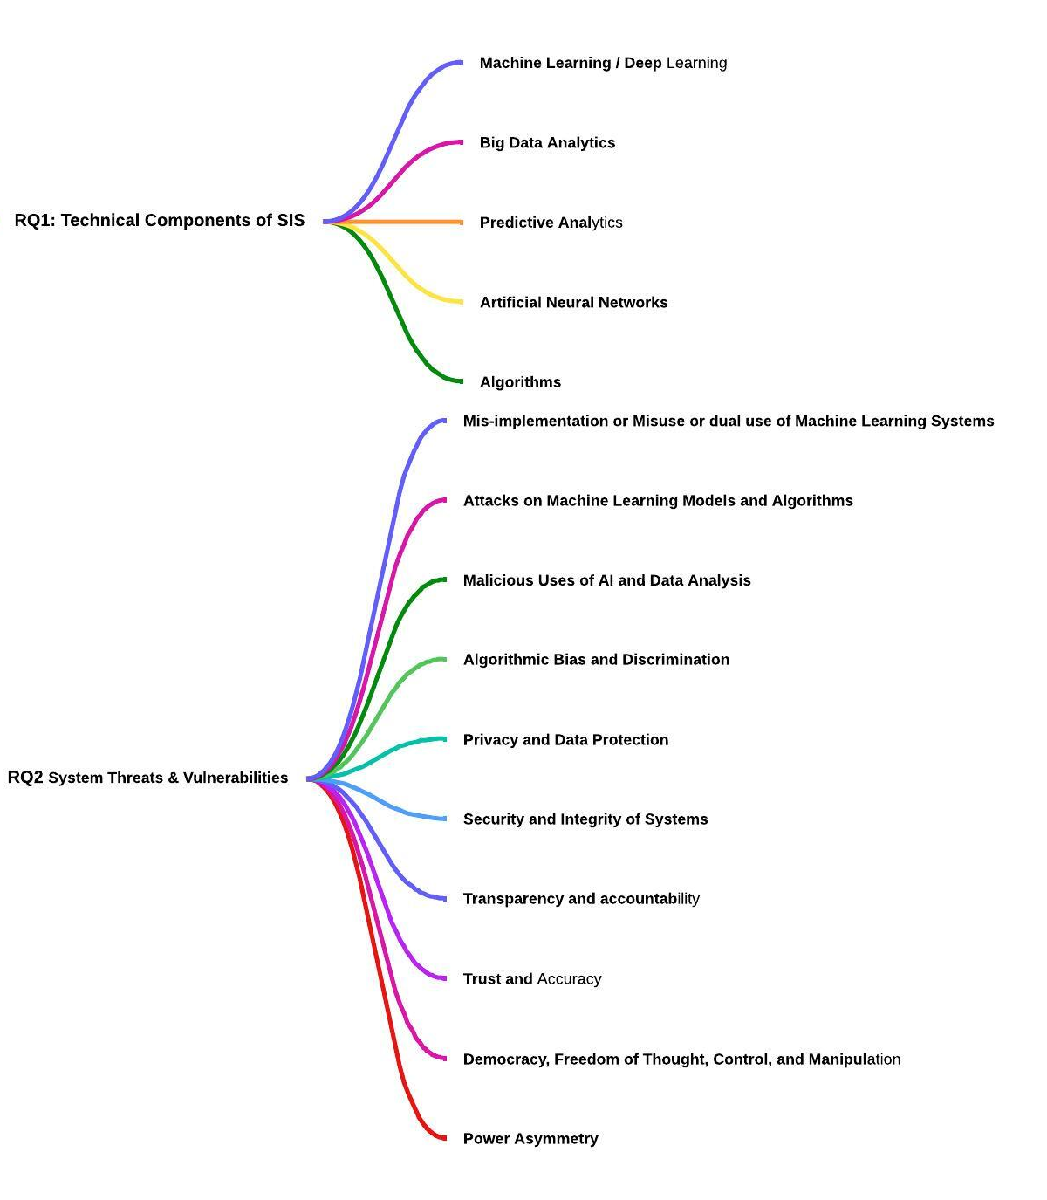

Figure 3: Summary of open and axial codes (Source: Quinn, N, 2025)

2.5 Data synthesis and analysis
The aim of the previous section was to extract data from the selected article relevant to SIS for PRI to answer RQ’s 1 and 2 for the purpose of identifying research gaps and a research agenda for the current study (RQ 3). The initial review followed by the thematic analysis identified the following recurring themes in the selected literature. The following section outlines the themes generated by RQ1 What are the enabling and driving technical components of SIS, particularly in the context of PRI? And RQ2: What are the associated system threats and vulnerabilities related to the technical components of SIS, particularly in the context of PRI?

The focus of ML in SIS
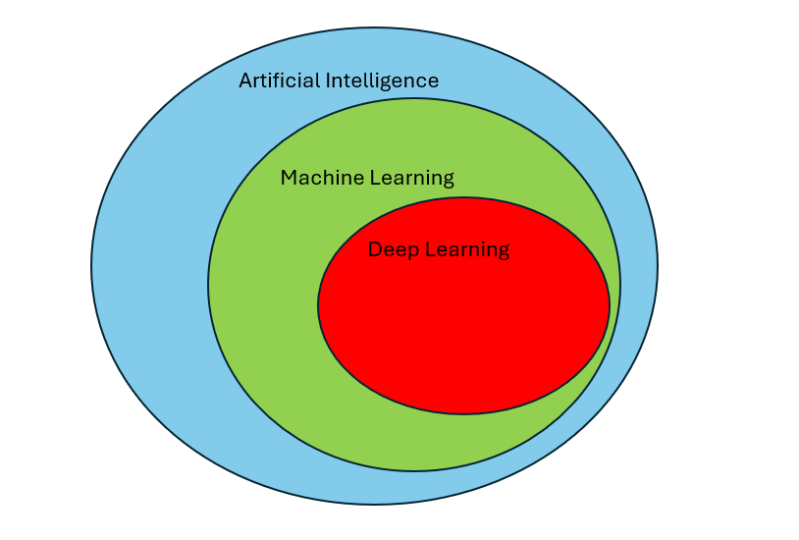
The sample clearly makes a distinction between ML, and AI as one of the main drivers of SIS. The term SIS is consistent throughout the research as a way to describe STS that use ML, which is recognised as a subset of AI (denoted in figure 2) (Tilimbe, 2019, pp. 3-4, Stahl et al., 2021, p. 385, Trim & Lee, 2022, p. 5, Ryan et al., 2019, p. 2, Stahl et al., 2022. p. 24).The application of SIS in PRI often leverages advanced ML algorithms to predict similar future events (Trim & Lee, 2022, p. 6). These include supervised learning algorithms such as artificial neural networks (ANN’s), linear and logistic regression, support vector regression (SVR), naïve Bayes (NB), random Forest, decision tree, and k-nearer neighbourhood (KNN) which are trained on labelled data to map input features to target variables, enabling accurate predictions on new data (Trim & Lee, 2022, pp. 6-8, Tilimbe, 2019, p. 4), as well as unsupervised algorithms such as factor analysis (FA) and K-means clustering that can facilitate pattern discovery (Trim & Lee, 2022, p. 6). Deep learning (DL) identified by Trim & Lee (2022, pp.6-8) as a subset of ML, described as a family of algorithms such as convolutional neural networks (CNN), recurrent neural networks (RNN) and natural language processing (NLP), which have played a pivotal role in SIS since increase in computing power and advances of big data, due to its ability to handle heterogeneous data and make accurate predictions.
Figure 4: Machine Learning as a subset of broader AI (Source: Quinn, N, 2025)

2.5.2 Accuracy and Bias

In the context of PRI, the ethical issue stakeholder trust is contingent on the accuracy of the SIS, however, there a number of common flaws inherent in in models that are trained improperly. This can arise from designed flaws where input features are engineered poorly (Patel & Ryan, 2019) According to Patel & Ryan (2019), models can be overfit (figure below). This, where the model is trained on data such as random anomaly data accurately, but fail to generalise on real-world data, leading to false positives. This could threaten data accuracy in domains such as cyber-security, where to is imperative avoid false negatives and positives to avert cyber threats (Trim & Lee, 2022).
Figure 5: Model Overfitting (Source: Quinn, N, 2025)
SIS for PRI in SCM is reliant on social media, where misinformation/disinformation can be propagated (Tilimbe, 2019, p. 19), often by fake accounts (bots), posing threats to accuracy of the data itself. However, because models often use ill designed input features such as “name-length”, “date of creation” or “number of posts” which are insufficient for detecting bots, meaning that accuracy in areas of misinformation/disinformation is at risk. This closely links the issue threat of biases in the data which can be integrated into the technology at any stage of the systems development cycle (Stahl et al., 2022b, p. 27). The image below highlights stages in a ML models development cycle such as: the sample of a target population, the measurement features, training and test data, the model description and the output, where bias may occur that across ML project workflows.
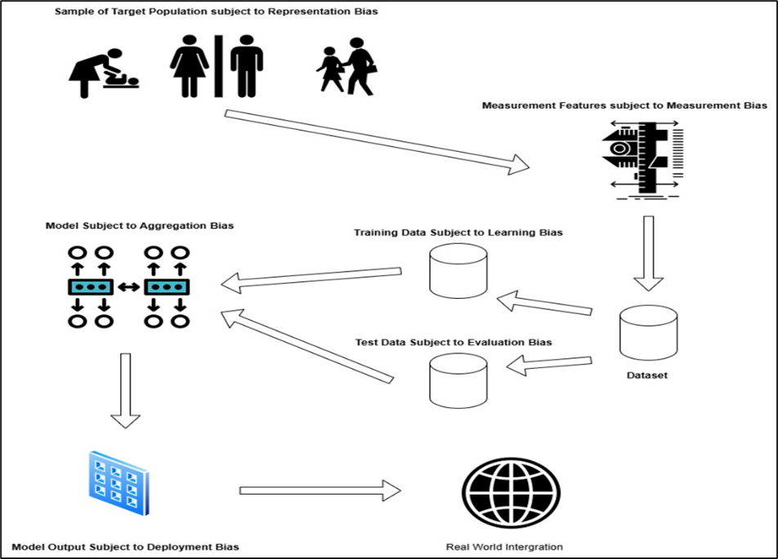

Figure 6: Data Bias Throughout System Lifecycle (Source: Quinn, N, 2025)

Privacy, Transparency and Accountability
The right to privacy is broadly defined under existing legal instrument such as the General Data Protection Regulation (GDPR) as an individual’s right to control access to one’s own personally identifiable information (PII), with PII defined as any information that relates to an identified or identifiable living individual (Andreou et al., 2019, pp. 41-46). As the confluence of advanced ML algorithm such as DNN’s and big data becomes increasingly reliant on large training datasets, the implications individual rights for privacy become concerning when they contain PII (Stahl et al., 2022, p. 26). Privacy was the most prevalent issue in the empirical work, most likely as a result of the implications of the GDPR (Ryan et al., 2021, p. 16). Transparency is consistent throughout the research as a way to improve trust by evidencing accountability and fairness, however issues arise in ML due to the opaque nature of complex algorithms (Stahl et al., 2021, p. 385) , moreover in the case of PRI, there have been cases such as the Wonga payday loan lender, where a lack of transparency over the actual data used had detrimental consequences for borrowers. These issues are extended by Ryan et al's (2019) review of medical case studies with include scrutiny over the processes used to collect medical data, as well as raising questions of informed consent for employee monitoring. In the context of PRI for SCM these issues overlap causing some discrepancy. Social media data used to gain intelligence on issues like labour unrest to predict supply chain disruptions is largely open sourced, meaning that data subjects are responsible for the data uploaded to platforms (Tilimbe, 2019. p.13), however article 6 of the GDPR stipulates informed consent as a requirement for lawful processing activities (Andreou et al., 2019, p. 44). This means that in European Union regions, data subjects have a right to know how their data is use and to hold data providers accountable for misuse, but it is questionable as to whether the data providers are fully transparent of processing activities to the extent where subjects are fully aware of the fact that it is being delineated for PRI (Tilimbe, 2019. p.13). In-fact, Tilimbe’s (2019. p.13) case study reveals that algorithmic opacity is implemented, to protect business interests, as some adversaries are motivated by intellectual property theft. According to Ryan et al (2021, p.16) there is an inconsistency across multiple case studies, as a result of over reliance of the principle of informed consent without a full understanding of its intricacies, calling for a more nuanced understanding around societal issues, such as the regulatory approach to privacy in regard to PRI and wider SIS applications.

2.5.3 Security
Where data is not open-sourced, legal instruments such as the GDPR, holds organizations accountable for the security of sensitive data privacy (Andreou et al., 2019), by placing responsibility on the processer to implement suitable technical and organisational measures appropriate to the risks. The same principles of security apply to SIS applications of ML as do common information security (IS) assets as shown in table 4, however, item 4 is peculiar to ML, which involves the substitution of a model, fed on target model outputs by an attacker motivated by intellectual property theft, iteratively querying the target model (Patel & Ryan, 2019).

Table 1: Principles of Security for Machine learning
Item | Principle | Description
1 | Confidentiality | Prevention of unauthorised access to ML model data
2 | Integrity | Prevention of unauthorised modification of ML model data
3 | Availability | Protection of ML model users from unauthorised denial of use
4 | Replication | Protection of ML model from unauthorised replication, for the purposes of data theft.
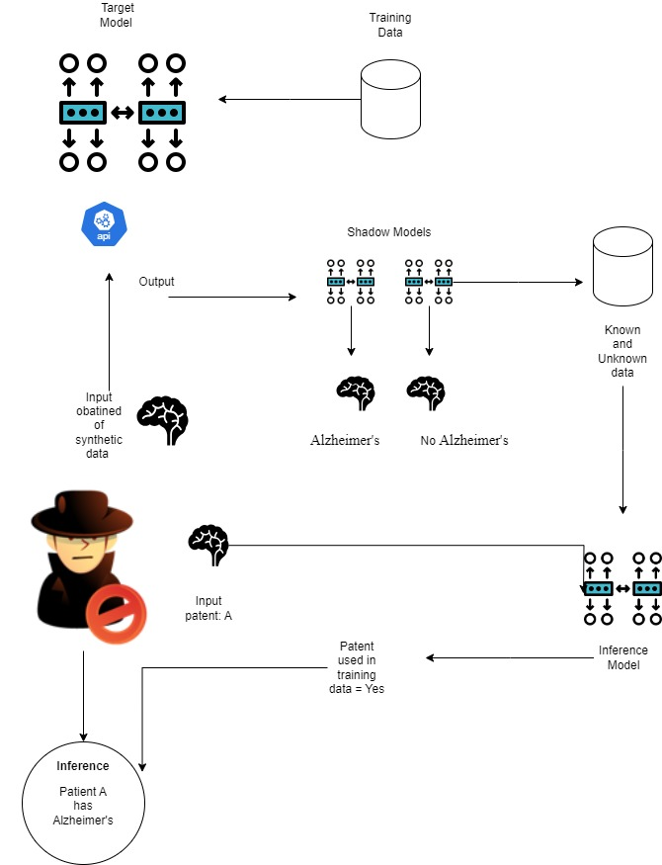
The most wide-spread security concerns across the literature, arose from the possibility compromised sensitive data confidentiality. For example, empirical work in the medical case study, highlighted that compromised systems used to process health records for neuroscience that could reveal confidential patient information (Ryan et al., 2019, p. 4). Adversaries could be achieved this by an inference attack, which is particularly effective against cases in medical fields, which share computational power, often outsourced by Cloud Service Providers (CSP’s) due to low availability of ML experts (Patel & Ryan, 2019). This is because inference techniques do not require direct access to the model, instead the attacker can access query models through application programmable interfaces (API) with obtained or synthetic data, such as images of brain scans to a CNN Model for Alzheimer's disease detection, to see how it makes predictions (example depicted in figure 7). These inputs and outputs could then be used to train binary classifier (shadow) models for each of the target models’ output. An inference model is then trained on a mix of pre-classified output data from the target model and unknown data (Patel & Ryan, 2019) . This would enable an attacker to violate patient confidentiality by using the inference model to classify real patient data used to train the target model. Data poisoning attacks where malicious actors threaten manipulate the training data itself threaten the integrity of the systems (Trim & Lee, 2022, p. 16). These attacks are effective against algorithms used in PRI for anomaly detection applications, by feeding false data points into an algorithm that is trained to fit normal patterns, thus compromising wider systems availably with an overwhelming volume of false positives (Patel & Ryan, n.d., p. 46). From an alternative perspective, the misuse of the SIS itself can empower malign actors to breach security and violate privacy, by providing advanced techniques such as automated spear phishing to gain access to sensitive information (Tilimbe, 2019) . Andreou et al (2019) examines the misuse of SIS through the lens of human rights frameworks, identifying scenarios where such as illegally accessed data that can and used to the advantage of malicious actors such as human traffickers (Andreou et al., 2019, p. 35). The most widely discussed misuse of SIS in the literature with regards to the Cambridge Analytical scandal, which used advanced algorithms to harvest data for targeted political campaigns. This incident shows that SIS has broad ethical implications such as the manipulation of democratic processes (Andreou et al., 2019), raising questions about living in a digital world (Stahl et al., 2021)
Figure 7: Inference Attack (Source: Quinn, N, 2025)
This creates a second discrepancy between in the literature as current research in SIS application of PRI appears to be at a stage of grounded theory development, derived from case studies, working to identify and refine key concepts and theories related to the ethical implications of SIS technology. There is a divergence in the theoretical framing of the early literature and later work which aims to address the scope of SIS as a confluence of ML as a subset of AI and Big data. The work of Ryan et al (2020) favours a focus on Machine Learning (ML), or narrow AI, over broad AI. This preference stems from the fact that broad AI remains largely speculative, however there is some discrepancy through a lack of consensus regarding the role of Big Data and its enabling technologies, such as IoT, cloud computing, and social media platforms. In contrast Andreou et al (2019) provides a more balanced approach towards ML, Big data and the driving technologies in their review of SIS technology in relation to the relevant legal and ethical frameworks. The rational for this Ryan et al's (2020, p. 3) focus on narrow AI is an attempt is to avoid some of the wider issues associated with broad AI like consciousness, superintelligence, and the singularity, however this leads to a missed opportunity for discussion in the theoretical framework around crucial aspects that relate to wider societal concerns of SIS which may have led to a more in depth discussion of the mitigation strategies once these issues surfaced in Ryan et al's (2020) empirical case studies. Later work by Ryan et al (2021, pp. 4-15) and Stahl et al (2021, p. 383) and categorises these issues as ‘general questions about living in a digital world’ or ‘Medium term issues’ that require a collective effort of organizational and regulatory effort of governance mechanisms to manage, in contrast to issues that relate solely to ML which can be addressed at organisational (micro) level and metaphysical issues at to be addressed at the macro level. This discrepancy is reflected in the work of Tilimbe (2019, p. 8), which is the only empirical study in the corpus that focuses on the SIS application of PRI and is conducted almost chronologically parallel to the earlier work of Ryan et al (2020). Thus, this study is theoretically framed through the lens of narrow AI and fails to recognise the full extent the wider societal concerns associated with SIS, such as the potential misuse of these systems to consolidate economic and political power, as highlighted by Stahl et al (2021), in reference to the Cambridge Analytica scandal. Despite this, Tilimbe (2019) case study reveals that there are broader societal issues, some that are consistent with Stahl et al’s (2021, p. 383) categories of issues, others that highlight the discrepancy by demonstrating that issues related to ML can emerge as wider societal issues.

2.5.4 Research Gaps
Despite the disparity in the literatures conceptual understanding of the scope of SIS technology and its implications, it is worth noting that that a commonly agreed notion that SIS has wider societal implications converges as a result of empirical finding across the literature. This suggests that as the corpus of knowledge gathers empirical momentum, the exact nature of ethical implication is still in the process of being realised in the research which is a contributing factor to the absence of a tangible ethical framework for the PRI use case of SIS. In relation to this papers problem statement, this may have cascading implications for the organisational governance approach PRI, which highlights the need for a more structured and holistic corporate approach that considers both the technical aspects of AI and its broader societal implications However, the body of work in the related work and research gaps table (Annex C), indicates that there is little understanding of governance mechanisms currently implemented by organisations to manage these issues. Another prominent gap in the research lies within the literary discourse in relation to PRI as a driver towards SDG’s. Despite the analysis of SDGs in relation to SIS technologies, there is no exploration of SDG 9 Industry, Innovation and Infrastructure, which is interconnected with effective governance best practices. Therefore, this literature review should conclude with a discussion that sets the agenda for the current study, with the intent of making contribution to the body of work, by gathering empirical evidence that can give future researchers a reflection of the current state of organisational readiness to in terms of effective governance mechanism, to adopt PRI.

Discussion and recommendations for future research
In summary, section 2.5 addressed RQ1 (enabling and driving technical components of SIS) and RQ2 (the associated system threats and vulnerabilities related to the technical components of SIS). In relation to these RQ’s, the analysis found that there were discrepancies over the theoretical scope of SIS technology, particularly between the earlier work and later publications. This had implications the analysis in relation to RQ 2, as much of the empirical findings suggest that as PRI uses a technology known as SIS, which itself uses a confluence of ubiquitous STS and ML, the Security, privacy and ethical implications are in fact, much wider reaching than issues that relate solely on ML at the micro or organisational level, as suggested by the earlier theoretical work. This may explain the delay in the establishment of an ethical framework, for organisations that employ PRI technology to use as standards, despite this use case being in deployment for a substantial amount of time, calling for organisations to exercise due diligence for complex societal issues which are inherently accompanied the use of enabling STS such as social media data to make predictions. These societal issues could be in direct conflict with this AI use cases associated SDG (9). However, the current body of work, despite focussing on how various applications of SIS can drive SDG’s, shows a gap in the attainment of SDG 9 for PRI or wider applications, as well as gap in structured governance processes such as risk management and impact which are imperative to the attainment of the underpinning goals of SDG 9, such as resilient infrastructure and inclusive and sustainable industrial industrialisation. Therefore, in relation to RQ 3 there is a gap to explore how structured approaches to governance of PRI, that holistically addresses the technical aspects of ML as well as the wider societal issues actually align with SDG’s, particularly in respect to SDG 9.

Research Design and Methodology

4.1 Theoretical Foundation
The research for this study focused on the intersection of a framework of processes and controls for managing the principles of organisational Information Governance (IG), Risk, and Compliance and the PRI use case. In study context, the principle of IG aligns with Yusif & Hafeez-Baig's (2021) concept of cyber-security (CS) governance; as a set of policies, procedures and guidelines to achieve the organisations objectives and protect digital assets. Across domains such as CS and Information Security (IS), organisations may choose to adopt governance best practises that meet the requirements laid out by standards to successfully achieve and demonstrate policy compliance (Yusif & Hafeez-Baig, 2021, pp. 15-16). Risk Management (RM) best practices are fundamental to IG policy, therefore provide the foundation for standards such as the International Organization for Standardization (ISO) 27001, and National Institute of Standards and Technology (NIST) Cybersecurity Framework (CSF), (McIntosh et al., 2024). This is particularly relevant to organizations that adopt PRI as this reports previous sections have identified system threat and vulnerabilities that pose significant risks to organisations adopting this use case, potentially with implications for wider society. Policy should be aligned with a wider demonstration of compliance with the organisation's contractual, ethical, and regulatory obligations. This may take the form of various hard and soft regulatory instruments, (Birkstedt et al., 2023, p. 148). Hard regulation includes the provisions from instruments such as the GDPR and the newly in force EU AI act, which although span the EU jurisdiction, have set an international regulatory precedent (McIntosh et al., 2024). Soft regulation refers to guidance such as the IEEE 700 series of standards of transparency of autonomous systems and the Principles for the Ethical Use of Artificial Intelligence in the United Nations System (Birkstedt et al., 2023). These ethical principle, represent a synthesis of commonly agreed upon shared values within wider international AI discourse (Jobin et al., 2019), often forming the basis for both hard and soft regulation. Whilst these, principles are widely adopted, it is argued that they are theoretical in nature, addressing the question of ‘what’, which means that the next logical question relates to ‘how’ these concepts are implemented, a question addressed through the exploration of tangible governance processes (Birkstedt et al., 2023), and ‘where’ the benchmark is for which the effectiveness of these are measured, which is widely discussed in the previous sections SLR as through the attainment of measurable SDG’s. Therefore, whilst UN SDG’s do not necessarily constitute a direct compliance requirement, the universal call to action to end poverty, protect the planet and ensure that all people enjoy peace and prosperity are increasing becoming important factors in organisational social and sustainability responsibility (ISO-IEC TR 24030-2024). Thus, the final objective (4) of this study was to use a relevant standard for GRC as a benchmark to assess the maturity and preparedness of corporate approaches to GRC for organisations that use PRI and whether they were consciously aligning its usage with SDG 9.

4.2 Framework Justification
The are numerous governance frameworks with various strengths and limitations that would be applicable to the various aspects of this use case, however the for the scope of this study, it is necessary to justify the focus on the applicability of standard based on firstly those that provided comprehensive coverage across governance, risk management and compliance. This evaluation had already been undertaken by the work of McIntosh et al (2024, p. 4) who had determined the, NIST CSF, and Control Objectives for Information and Related Technology (COBIT) 2019, ISO/IEC 27001, ISO/IEC, 42001 were the only 4 frameworks with suitable coverage across 16 leading information governance frameworks in the context of Large Language Models for cyber security, with the latter providing the most comprehensive framework for facilitating integration of AI associated technologies. ISO 42001 is the world’s first AI management system specifically designed for the integration of AI systems such and the adaptation of organisational governance, with an espoused contribution to SDG 9 (British Standards Institution (BSI), 2023; ISO/IEC, 2023). Therefore, for the context of the current study, this standard was adopted as the most suitable framework to address the following RQ (4):
How ready are organisations for integrating PRI and managing the ethical implications of SIS technologies, according to the ISO/IEC 42001 standard?

4.3 Research Method

4.3.1 Philosophical Approach
There are several valid philosophical approaches to this study such as positivism, post-positivism and interpretivism. After careful consideration it was determined that this study should proceed with an interpretivist philosophy. This was motivated by the ontological metaphysical interpretation that the mechanisms of governance, risk and compliance are grounded in relativism. This is because it is believed that governance processes, perceptions of risk and at times, of laws and regulations are grounded in societal, cultural and historical phenomena which are subjective, open to interpretation from multiple perspectives and changeable throughout the course of time (Aşuroğlu and Gemci, 2016). The epistemological approach of this study is inductive and assumes that diverse multiple perceptions play a pivotal role in the processes that govern AI. It assumes that as a relatively new phenomena in the context of governance, that there will be perceptive variance in how this AI use case can be leveraged to achieve organizational objectives, the risks that AI poses to those objectives and the selection of appropriate technical and organisational controls requires to manage such risks to meet compliance requirements.

4.3.2 Research Method
A mixed methods approach was taken through the generation of a questions framework to conduct qualitative research using semi-structured interviews. It was determined that the former would enhance the validity of the research by presenting consistent and relevant questions framework, however the latter was preferable over a deductive approach due to scarcity of predefined theories in the existing literature, therefore it was hoped that the inductive approach from which varying subjective observations are derived (Ameen et al., 2024), would enable a contribution of new theories. The rationale for semi structured interviews was largely due to suitability to qualitative research, enabling the SLR to inform a general guide, whilst at the same time, allowing flexibility for the researcher to adapt the questions to the flow of the interview accordingly (Saunders et al., 2015). This would allow for adjustments to be made for various domains and levels of expertise. Semi-structured interviews are less often used for exploration between two or more variables in both inductive and deductive research (Saunders et al., 2015). Therefore, it was hoped that this method would facilitating deeper and additional insights into the themes already addressed by the SLR in relation to the ethical implications of PRI and SIS, but not expected. Semi-structured interviews are often used for explaining and evaluating the relationship between two or more variables (Saunders et al., 2015), therefore it was expected that this method would explain how the organisation is addressing ethical concerns and using PRI to drive SDG 9. By using the ISO/IEC 42001 as a benchmark, the researcher could evaluate as how well organisation were implementing processes such as oversight, data management and risk management to handle these challenges.

4.3.3 Interview Design Framework
Interview Questions were extracted from a content analysis of the ISO/IEC 42001 standard obtained from the BSI website. This content analysis followed a deductive approach comprising of themes derived from the ISO/IEC 38500:2015 theoretical model for governance of IT, with codes generated from the previous section SLR. Annex D provides a matrix that outlines this process, which is denoted by corresponding theme and code colours used to generate the corresponding-coloured categories of interview questions, that followed the critical aspects of ISO/IEC 42001 implementation, as relevant to the PRI use case, determined by the SLR synthesis.

4.3.3 Data collection
The study aim is to make an empirical contribution to the existing literature derived from industry experts and practitioners as lacking in the previous research. Due to the multidisciplinary stakeholder involvement in PRI, the participant recruitment strategy followed the duo approach of Purpose and Snowball sampling used by Hendry et al (2023). The purposive sampling selected participants based on specific criteria: a): Experts in IGRC b): AI and ML Specialists c): Privacy Officers or Data Protection Officers, or d): Executives or Managers in Organizations Using or Considering PRI. Key considerations for social, ethical and legal considerations in relation to the collection of the data included the anticipation that organisations would not be willing to disclose confidential information in relation to proprietary use of algorithms to protect business interests, therefore, risk assessments determined that all data collected should be anonymised and no sensitive information in relation to participants should be discussed. Further controls are outlines in the ethics review form (Annex E) which was submitted for approval on the 31^{st of} October 2024. The Data collection commenced on the 1st of November 2024 with a planned deadline of the 1^{st of} December, however this was extended to the 18th of December to meet a sufficient level of data saturation which was achieved at 13 interviews. The recruitment strategy targeted stakeholders via the LinkedIn platform whereby potential participants were contacted to assess suitability. Those that met the screening criteria, provided email details to receive a project overview explaining the research objectives and detailing the questions framework. With the exception of one participant who chose to submit written responses, the remaining 12 participants provided a preferred date for the interview to take place, whereby they received a Microsoft Teams invite to secure the date. The details of the interview participants are shown in table 2.

Table 2: Participant Sample Composition
Participant | Role | Domain
1 | Information Security Executive | Healthcare
2 | Operational Resilience Manager | Fintech
3 | Associate Analyst | Cyber Security
4 | Head of Risk Control | AI Predictive Analytics, GRC
5 | Cyber Security Consultant | Cyber Security
6 | Data Protection Officer | Healthcare
7 | Cyber Security Executive | Fintech
8 | GRC Professional | Supply Chain Security
9 | Weapons Engineer | Royal Navy
10 | NLP Project Manager | Muti-domain
11 | Solutions Director | Healthcare
12 | Incidence Response Manager | Ministry of Defence
13 | GRC Expert | Cyber Security

4.3.4 Analysis Technique and considerations
Thematic analysis followed the recommendations of Braun and Clarke (2022) to identify unexpected emerging themes with the following considerations: With the exception of written responses, interviews taken place via Microsoft Teams were transcribed verbatim to avoid bias, with notes made for non-verbal ques for data-completeness. Recordings were re-listened to, and transcription re-read to ensure data accuracy. Thematic coding would be conducted with NVivo 14 software following an inductive approach to ensure objectivity and mitigate bias. With this approach data would be segmented and divided data into meaningful analytical units from the larger transcription text base. Data would be synthesised into an analytical framework consisting of themes/codes, sub theme/code substantiated by data extracts. The application of the framework should be used to extend on the themes identified. This should aim to comprehensively address questions such as what were the perceived ethical concerns for the use case identified? Where are these problems in relation to the organisations or wider society? what can be done to mitigate the problems? And how does this approach contribute to Industry, Innovation and Infrastructure? The aim of the synthesised was to provide solutions and recommend future directions for research. The framework was then validated conducting an evaluation of the overall credibility, confirmability, dependability and transferability of the research.

Results and Analysis

5.1 Coding Review
On completion of the initial coding, the codes were reviewed and recoded using an iterative process to consolidate and rename codes for ease of categorisation. The image below shows the first iteration in contrast to the final code base uses for the thematic analysis.


Figure 8: Coding Iterations (Source: Quinn, N, 2025)

Due the issues raised throughout the discussions, it was important to make distinction between transparency as a mechanism for compliance and transparency as a means to aide stakeholder awareness. In a number of participants, there was an overlap between what the literature describes as issues related to ML and wider societal concerns. Therefore, whilst this was not made clear to the participants, it was preferable to delineate these issues in the analysis to in assess where their respect organisations viewed the scope of responsibility at an organisational level. In the majority of responses, if the role of addressing public concerns was not viewed as a government responsibility, it was viewed as a leadership responsibility and was largely related to stakeholder engagement, therefore the code; value proposition for stakeholders, was encompassed in the leadership code. The issue of informed consent with regards to the processing of personally identifiable information, however this was closely associated with the discussions that related to compliance with GDPR provisions, therefore this code was integrated with ‘Compliance’. In the majority of discussions where participants described what they perceived as barriers to the adoption of PRI technologies the issues of investment at executive level and lack of expertise through insufficient training and awareness at all levels was an overwhelmingly dominant factor. Therefore, the code ‘Barriers for entry’ was annotated to ‘Training and Investment’.

5.2 Categorisation

The extraction of codes was exported from the NVivo software and categorized in relation to RQ4. Dominant codes were initially extracted from the excel spreadsheet using a top-down approach. To ensure credibility each codes characteristics were reviewed manually to assess the relevance to the research question. To develop emerging themes, the relationship between various codes was analysed. If it was determined that the code characteristic was not relevant to the research question the code was discarded, if the code was relevant the research question but unrelated to the previous code, it was placed into a new cluster.

Table 3: Coding Categorisation
Cluster 1 | Cluster 2 | Cluster 3 | Cluster 4
Documented Policies  Roles (Responsibilities)  SDG 9 | Compliance  Training and investment for organisational readiness  Intended use and Intended role  Transparency and Compliance | Leadership  The value of SIS  Education, transparency and stakeholder awareness  Role of the government | Issues related to ML  Data Quality Management for Machine Learning  Societal Concerns
Emerging Themes
Governance Framework | Blockers | Value Realization and Stakeholder Trust | Ethical concerns

5.3 Findings

5.3.1 Cluster 1
Cluster 1 found that most of the participants, reported gaps in governance frameworks of either the organisations they worked for or the organisations they had provided consultation services. Both participants 4 and 13 who are employed as GRC consultants, emphasize the importance of moving beyond generic AI principles and policies:
“Policies that outline principles are talking about statements, public statements, but then companies need to move from these public statements to the internal policies that they are allocating responsibilities and finally standard operating procedures so that they are particularly embedded, and controls, accompanied by tasks with the proper attributes so they are crystal clear.”- Participant 4
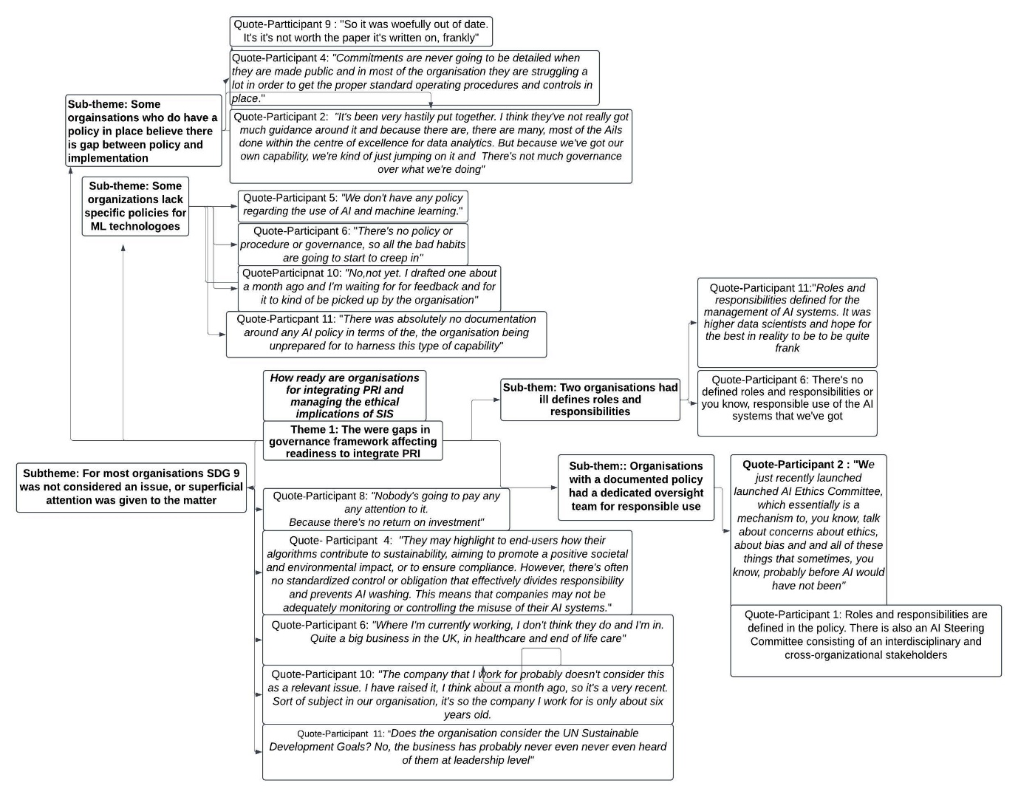
“In order to know where to begin with the AI policy, you have to understand what tool you're going to use and what the purpose of it is. You have to define the parameters, the scope of what it is that you want to achieve with that AI tool.” – Participant 13
Figure 9: Cluster 1 Analytical Framework (Source, Quinn, N, 2025)
These statements stress the need for organizations to develop specific and tailored policies for each AI tool they deploy, focusing on concrete mechanisms and actions, such as the allocation of roles and responsibilities, the creation of detailed procedures, and the implementation of robust controls to ensure responsible and effective AI use. However, the analysis charted in the figure below found that that many participants either did not have a generic AI/ML policy in place and for those that did, the adopted policy was not adequately tailored to the specific application of PRI.
The analysis found a discrepancy between the participants 9 and 12 who both worked at separate departments within the Ministry of Defence and identified their policy document as the publicly available Joint Service Publication (JSP) 936 titled; Dependable Artificial Intelligence in Defence (Ministry of Defence, 2024). However, these two participants express fundamentally different views on the value and utility of JSP 936:
“If you if you refer to 936, it ties into a lot of policies, in particular regarding risk management.
And other cyber defensive policies. Also, data protection policies. It just blends into the bigger framework from literal operations to make it everything more coherent” – Participant 12
“It's not a modern document, it's just a summary of a lot of old paperwork and a lot of old doctrine. So, it was woefully out of date. It's not worth the paper it's written on, frankly”- Participant 9
According to participant 4, it is imperative that roles are segregated between those responsible for model development and operational deployment, it is also critical that cyber security professionals are involved throughout the lifecycle of the model:
“I divide responsibilities into two areas, development and operation. However, if company has these two areas divided into different things and they are not talking each other, the developers are going to create something that is going to be a model that is going to be very hard to maintain. You have these two big areas, and you need to clearly articulate who owns what. In terms of all these roles, as they are defined in the organisation, they're going to be also people working in the supporting for intense cybersecurity. One tool I use to define them is the RACI matrix: Responsible, Accountable, Consulted, Informed. This matrix helps you identify who is responsible for each task”- Participant 4
For participant 1 who stated that their organisation had an effective policy these roles were present, however in the organisations with less maturity such as participant 11, did not have clearly defined roles
“The AI Steering Committee has oversight while cybersecurity and data governance teams have operational responsibilities” – Participant 1
“There was absolutely no documentation around any AI policy in terms of the, the organisation being unprepared for to harness this type of capability. How does this relate to existing policies? Well, our policies are very generic. I think if you read a corporate governance handbook, you'd probably. Understand what our policy, our policy structure looks like. Roles and responsibilities defined for the management of AI systems. It was higher data scientists and hope for the best in reality to be to be quite frank” – Participant 11
One dominant sub-theme to emerge was related to the question relating to SDG 9 compliance. The dominant sentiment was that this issue was not considered, and that a lack of controls for adherence to SDGs in general resulted in superficial attention being given to this issue, largely for marketing purposes:
“Nobody's going to pay any attention to it. Because there's no return on investment” – Participant 8
“They do, but I would say it's more paying lip service to it. You know, my opinion this SDG stuff is more of a marketing thing “- Participant 2

5.3.2 Cluster 2

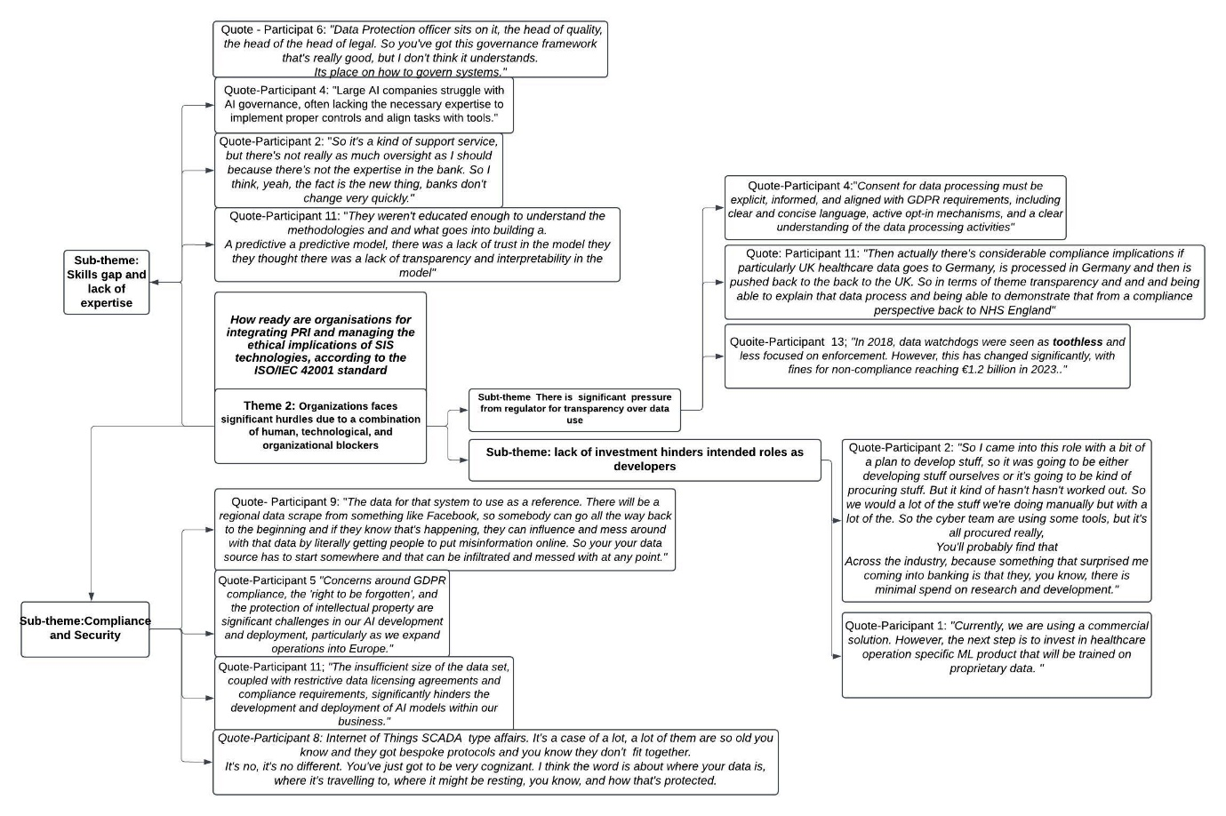
Cluster 2 found that a number of participants reported significant hurdles due to a combination of human, technological, and organizational blockers as charted in the figure below.
Figure 10: Cluster 2 Analytical Framework (Source: Quinn, N, 2025)

According to one GRC expert a major blocker having a negative impact on the integration of PRI, was the current level of expertise within the organisation, notably at executive leadership level where the selection of use cases was misaligned with expected return of investments:
“It is very important that they are able to select use cases that they have a positive return of investments. This is another struggle, because most of the investment is not producing the nice value that it was once presented in a PowerPoint. So, being able to have a budget, a return of investment for that particular systems shapes what is important and what is not?”– Participant 4
This statement from participant 4 was evidenced by participant 11 who worked for a healthcare organisation that attempted to build a predictive model for disease forecasting:
“We were trying to build a predictive model ourselves with the intended use was to look at disease areas in the future, use all of our historical and current data to predict what is going to happen in disease areas in the NHS in the future and look at things like patient burden. The business wasn't prepared. They weren't educated enough to understand the methodologies and what goes into building a predictive a predictive model, there was a lack of trust in the model. They thought there was a lack of transparency and interpretability in the model, and that when there were meetings around how the models that have been built were being explained and demonstrated and progress was being demonstrated, they weren't. They didn't understand it, they didn't get what the data scientist was trying to do. It was unsuccessful because the leaders in the business weren't seeing the return on investment that they were looking for.” – Participant 11
The lack of investment in research and development was another inhibiting factor for organizations developing their own PRI solutions:
“So, I came into this role with a bit of a plan to develop stuff, so it was going to be either developing stuff ourselves or it's going to be kind of procuring stuff. But it’s kind of hasn't worked out. The cyber team are using some tools, but it's all procured really. You'll probably find that across the industry, because something that surprised me coming into banking is that they, you know, there is minimal spend on research and development.”- Participant 2
When asked if there were any data constraints there were a number of responses that indicated that data acquisition and processing was hindered compliance in the light of increasingly stringent regulatory provisions:
“The data watchdogs they were kind of toothless, you know, they weren't really in for the scrap. Oh, my God, that has changed. The pendulum has swung the entirely the other way, and quite right too. For example, Meta got a €1.2 billion fine for infringements of things such as the right to be forgotten and misuse of information” – Participant 13
“Constraints include classified and sensitive data. Which will obviously require more stringent controls and secure handling” – Participant 12
“PII is a big thing, now that we are expanding operations into Europe. So obviously GDPR is a is a big concern and some of the things like, you know, right to be forgotten is currently not easy to be embedded into our models” – Participant 5
“The problem about data is that people want to have as much as they can, and they want to do a scraping, and they want to use the full Internet knowledge into whatever that they are using.
And this is where of course you need to comply with. The regulations the AI act, for instance, you are not expecting to scrape data from the Internet.” – Participant 4
Another issue which hindered data use was issues related to security, particularly those that affected the accuracy of PRI and SIS through data poisoning:
“There will be a regional data scrape from something like Facebook, so somebody can go all the way back to the beginning and if they know that's happening, they can influence and mess around with that data by literally getting people to put misinformation online. So, your data source has to start somewhere and that can be infiltrated and messed with at any point.” – Participant 9
Both issues surrounding compliance and security emphasised the need for transparency over processing activities. However, this also raised concerns of difficulties when exercising due diligence over supply chain dependencies with Participant 13 explaining concerns over the integrity of data sourcing and Participant 11 describing a scenario where data was nearly mishandled throughout the supply chain:
“You know, and then of course, it's like, well, what's the integrity of the supply chain? Can you imagine if you have a PRI that's pumping out results, but the integrity of the data is in a dire state?” -Participant 13
“Fortunately, we had quite robust due diligence processes in place, which highlighted this issue, which would have been a serious breach of compliance because had the data been sent to Germany, that would have been a significant breach of UK healthcare data” – Participant 11

5.3.3 Cluster 3
Cluster 4 found that despite the barriers to PRI adoption, it was perceived that the potential value of SIS technologies was shaping the competitive landscape for most industries:
“These systems are reshaping the competitive landscape by enabling unprecedented data collection, analysis, and dissemination. They also provide businesses with deeper insights into consumer behaviour, market trends, and operational efficiencies, promoting informed decision-making and strategic planning.” – Participant 1
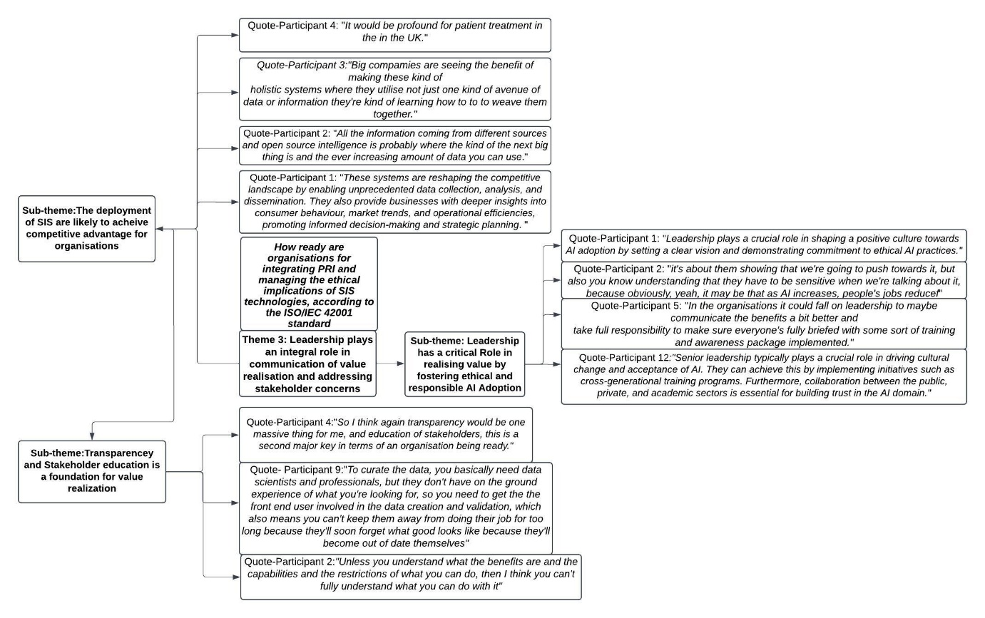
Figure 11: Cluster 3 Analytical Framework (Source, Quinn, N, 2025)

The foundation for realising this value was perceived to be transparency and the education of stakeholders to facilitate this value realisation:
"Unless you understand what the benefits are and the capabilities and the restrictions of what you can do, then I think you can't fully understand what you can do with it." – Participant 2
Ultimately its was seen as the responsibility of senior leadership to foster a culture that embraces the integration of AI/ML by demonstrating responsible AI practices and address workforce concerns, most prominently, concerns that relate to automation resulting in job losses:
"it's about them showing that we're going to push towards it, but also you know understanding that they have to be sensitive when we're talking about it, because obviously, yeah, it may be that as AI increases, people's jobs reduced"- Participant 2

5.3.4 Cluster 4

Cluster 4 indicated that there is a need for greater organizational robustness and a comprehensive framework for trustworthy and responsible AI/ML development and deployment. This was due to the convergence of subthemes across the various organisations identified in the image below.
The first sub-theme identified a heterogenous array ethical issues that closely with Stahl et al’s (2021) issues relating to ML, questions around living in a digital world, linking in with metaphysical issues, namely concerns relating to ‘Super-intelligence’ and identifying contemporary issues such not previous discussed in the literature such as the emergence of ‘Deepfakes’ a vector for misinformation which can poison the data for PRI:
"So, making deepfakes. And again, whether it's fraud, whether it's spreading misinformation or disinformation, that can be very damaging."- Participant 7
As well as growing societal and organizational concerns over ML and data supply chain security:
"Everyone understood supply chain. When discussing any system now, it doesn't matter the specific system driving the PRI. I'm assuming there are multiple types, meaning more than one tool. Therefore, it's crucial to know who built the system and assess potential backdoors." – Participant 13
Despite the heterogeneity, it was plausible to state that all of the erosion of public trust in emerging technologies was an underlying factor through real or perceived public concerns over security issues and a lack of transparency and accountability from organizations and regulators as well as public awareness of how their personal data was processed:
"I think people are probably fairly oblivious until they get caught out on then they might be a bit more worried. But I think until governments and regulators kind of are able to enforce that more and kind of control them a bit more than that's not going to happen" - Participant 2

The following emerging subtheme indicated that existing risk management frameworks require significant adaptation and augmentation to effectively address the unique and evolving challenges posed by AI/ML development and deployment. This was because organizations who aligned with governance frameworks such as ISO/IEC 27001 for legacy systems expressed a requirement to adopt tailored control options for AI/ML:
"There is a well-documented process for data protection and preventing security issues. However, processes specifically addressing AI models are in the conversation stages. Most of the risk controls in place is implemented to ensure data protection, privacy and integrity. Future plan is to focus on AI model development security to avoid some of the adverse occurrences identified"- Participant 1
This overlaps with the third re-occurring sub-theme which indicated that current practices may not fully meet the requirements for a robust data supply chain and comprehensive security necessary for trustworthy PRI:
"You need our supply chain for security to prevent data poisoning, prevent that information being shared around copy houses and various other things like that. So yeah, literally it's just stringent supply chain security. The fact is we don't have data supply chains yet, so they need to be designed and built." – Participant 9

The following subthemes closely overlapped with previously mentioned issues regarding a lack of expertise, which hindered ongoing efforts to implement controls to ensure data accuracy and mitigate data bias across organisations. The implementation of technical controls for algorithmic opacity was rarely discussed within the sample with only one participant expressing aspirations to develop predictive models in alignment with explainability frameworks to increase the stakeholder transparency:

"Explainability and transparency are crucial, and we can utilize frameworks for it. I believe this aligns with the LIME and SHAP frameworks, which can effectively demonstrate the transparency of your models." – Participant 7

The final sub-theme overlaps with a lack of training and awareness, indicating a need to enhance the human element and organizational culture in ML/Data Security. This was largely associated with control implementation for prevention of misuse or dual use of the SIS used to enable PRI which largely identified human controls such as training and awareness, as well as personnel vetting to shape an ethical and security concourse organisational culture as paramount:
"There's a risk that its model is going to be completely inadequate for that, in which case the system will fail, and you'll have a lot of problems in the background. So, I think culturally that this is where the education piece comes in" – Participant 9
"Our employees should be vetted. Teams should be centralised dealing with the process in place.
I would just say most stringent processes leading up to the releasability of data. Controls in regard to personnel should be on top”- Participant 12
"I believe achieving significant progress in security relies heavily on fostering the right organizational culture. I think our organization already has a strong security-conscious culture. However, ongoing training and awareness building across the entire organization will be crucial in preventing misuse"- Participant 7

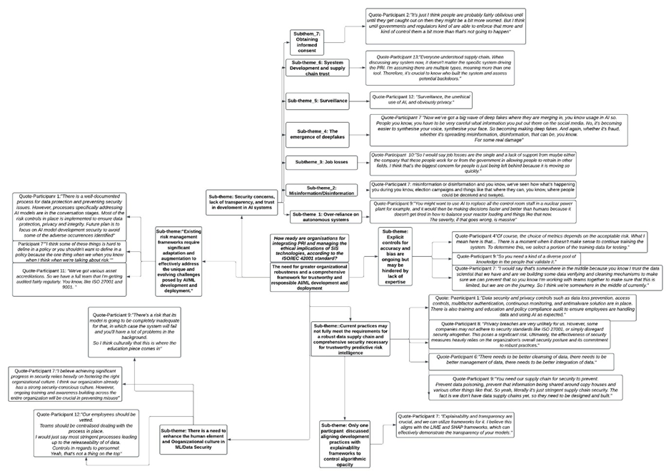
Figure 12 Cluster 4 Analytical Framework (Source, Quinn, N, 2025)

5.4 Summary of Findings in Relation to Research Objectives

To answer RQ4, the research carried out the objective of adopting the newly published ISO/IEC 42001 standard as a benchmark to assess the maturity and preparedness of corporate approaches to GRC for organisations that use PRI and whether they were consciously aligning its usage with SDG 9. This was achieved through a mixed method, comprising of a deductive approach towards the generation of a questions framework and an inductive approach through semi-structured interviews. It was hoped, but not expected that semi-structured interviews, which are less than often used for exploratory research would reveal deeper insights into the themes already addressed by the SLR in relation to the ethical implications of PRI and SIS. This was achieved to the extent whereby the cross-sample analysis identified ethical concerns consistent with the SLR, going into greater depth with regards to the implications for their organisations and wider society and additional societal concerns over the use of SIS (discussed in section 6.6). It was expected that this method would explain how the organisation is addressing ethical concerns and using PRI as a driver, towards SDG 9. This was achieved to the extent where organisations were able to identify governance processes and mechanisms to manage the issues associated with machine ML and some wider societal issues, as well as identifying gaps in governance frameworks and barriers for successful integration, however, these negative perception regarding the significance of SDG’s as a relevant issue, meant that there was little explanation of how policies were aligned towards SDG 9, the implications of this for current research discussed further in section 6.2.

Discussion

6.1 Action Outline to Address Social, Ethical and Legal issues

From the thematic analysis of the clusters, 4 themes emerged which were relevant RQ (4) and objective (4), revealing wider social, ethical and legal issues for organisations integrating PRI tools. The following sub-sections will address these issues by synthesising the emerging themes from the analysis, thus highlighting key gaps in organisational readiness, their wider implications and providing recommendations for future research. In the concluding section of this study will make final recommendations to for practitioners to mitigate the issues outlined.

6.2 Organisational Governance Gaps

The lack of maturity in AI/ML specific policies for the integration of PRI technologies, is significant because this demonstrates deviance between that the state of current practice and the guidance outlined in the ISO-IEC 38507 model adaption and as implemented by alignment with the ISO/IEC 42001 standard. The implications of this suggest that organisations who lack a comprehensive AI policy, or a policy that does not align courses of action with the specifications of the use case risk non-compliance or unwanted outcomes unforeseen by policies tailored to legacy system (ISO-IEC 38507, p. 11).The findings from the least mature organisations substantiated this by demonstrating that lack of clear policy objectives has had a cascading effect leading to further deviance from ISO/IEC 38507 guidance and ISO/IEC 42001 standard best practice, by contributing to structural and operational siloing, ultimately resulting in a complete failure to sustain PRI integration. Despite most organisations with higher levels of maturity having a policy in place, it was observed that most were perceived as high-level documents for responsible AI use, with ongoing discussions tailor policy objectives to specific PRI tools. These responses corroborate the concerned of GRC professionals interviewed throughout the course of the current study who perceive that current state of high-level AI policies to be insufficient for the PRI use case which required policies that outline clearly defined parameters, roles, actionable standard operating procedures and embedded controls to be effective. This also overlaps the findings of previous research that strongly suggests that the application of high-level principles outlined in the fields of AI ethics by researchers such as Jobin et al (2019), currently lack clear implementation inter alia clear governance rules, guidelines, processes, practices and technological tools to ensure these principles are met in practice (Birkstedt et al., 2023, p. 134; Hagendorff, 2020, pp. 113-114).
This sentiment of the ‘what’ should be done at being a high level not really being addressed by the tangible ‘how’, is reflected by the responses to the questions in relation to employment of PRI tools in alignment with SDG 9, as this was overwhelmingly viewed sceptically throughout the sample, with most of the participants stating this this was not considered seriously, suggesting limited conscious progress toward the attainment of SDG 9. However, his study was conducted within a broader scope, therefore imposing a limited focus on how organisations align governance objectives towards SDG 9 attainment within the context of the PRI use case. Future research could adopt a narrower scope on organizations that integrate PRI technologies with an explicit contribution to SDG 9 attainment in their policy objectives. The limited understanding of SDG 9 alignment revealed by the current study proposes that such research endeavour would be invaluable for two reasons. Firstly, the findings suggest that scepticism around SDG attainment lies grounded in what is perceived by most as a course of action lacking in return on investment (ROE). Therefore, by focusing on organisations who actively pursue attainment, my offer an alternate perspective, thereby offering ROE incentives to drive SDGs. Secondly, this may reveal deeper insights into the policies, procedures, guidelines and processes that effectively align PRI with SDG 9 attainment, thus contributing to a wider and more comprehensive framework for responsible use.

6.3 Barriers for PRI integration

This study has provided evidence of organisations who have placed considerable investment in the development PRI technologies being unable to overcome human, technological, and organizational to sustain operational integration. This confirms the finding of Department for Science, Innovation and Technology (2023, pp. 44-48) Artificial Intelligence Sector Study which also identified limited expertise, skills gaps, transparency concerns, data access limitations, quality concerns, compliance issues, as well as insufficient investment in research and development (R&D) and challenges to wider AI adoption. This is significant because the latter and the current study have used separate varying methodologies to derive similar findings, thus enhancing the validity of the current research. The current study has also shown that internal organisational barriers currently across industries which stem from a lack of consideration prior to PRI integration, whereby leadership has not clearly established the ROI metrics associated with the use case. Instead, organizations are adopting AI/ML technologies driven by a perceived urgency to remain competitive, referred to by some of the study sample as ‘Fear of missing out’ or ‘FOMO’. The implications for organisations adopting this hasty approach, are investments may be concentrated on outsources technical expertise, who do not fully understand the wider business context, and cannot be fully transparent with the remaining stakeholders, including strategic decision makers who lack the necessary education to interpret technical explanations and integrate them with wider strategy. The lack of investment of R&D, are that organizations who use PRI tools, will for the foreseeable future, by reliant on procurement. Once of the biggest implication of this, are these organizations are vulnerable to what is an increasingly growing societal concern of supply chain risks, including data supply chain disruptions and SIS data poisoning through widescale misinformation, as well as external barriers, such as the inability to outsource third parties for data handling, otherwise risk in compliance violations. The biggest external barrier came from the compliance requirements of the GDPR, which had implications such as embedding provisions such as the right to be forgotten into model development and organisations such as those in UK healthcare who had compliance issues with cross-border data flows when outsourcing third party data handlers. However, there was minimal discussion surrounding the implications of the anticipated provisions of the European Union's (EU) Artificial Intelligence (AI) Act (2024). This is likely due to the study limitations, whereby the sample was restricted to organisations who operated within the UK. However, as the EU AI act (2024) comes increasingly into effect with a broader, risk-based focus the AI/ML system robustness, transparency, human oversight (Panigutti et al., 2023, p. 1147), it is likely that this will have affect EU cross-border organisations. Therefore, future research that investigates the added implications for UK organisations who affectively consider the provisions of the EU Act (2024) throughout the deployment of PRI tools would be valuable as this act becomes a significant consideration in the wider regulatory landscape.

6.4 The Role of leadership

Despite the barriers to PRI integration, the value of this use case was perceived as profoundly capable of enabling a competitive advantage, largely due to the ability of SIS to derive large data sets from STS, thus giving organisations the ability to make actionable decisions in real-time. However, it was commonly agreed that leadership played the most significant role in addressing the barriers, as well as communicating the value of PRI to internal and external stakeholders whilst addressing concerns. The implications of this, are that organisations require top-down and cross-generational approach to address the of lack of expertise and workforce education as a precursor to stakeholder communication. This is consistent with Ramadas & Reema's (2023, p. 25) study which finds that the developing tailored programs that enhance cognitive abilities is effective at bridging gaps when integrating AI into a multigenerational workforce. Upskilling of the entire workforce, was seen by a number of participant key to addressing the most prominent concerns over automation replacing human labour, resulting in job-loss. The main argument for leadership to take an active role in addressing these aspects of PRI integration, is that leadership was a catalyst, having the for responsibility for culture change. However, the role of government was also raised throughout numerous responses related to addressing stakeholder concerns, which was disregarded to the limitations of the scope of this report which aimed to focus on the organisation’s perspective. The UK regulatory approach has been developed to foster innovation by reducing regulatory restrictions (Great Britain. Department for Science, 2023.). Therefore, future research in how organisations perceive the role of current levels of government intervention in shaping the innovation would be valuable for regulatory bodies targets courses of action to have a positive impact on PRI and wider SIS adoption.

6.5 The Need for Greater Organisational Robustness

This theme confirmed the findings of the previous sections SLR, as well as introduced several new societal concerns such as the increasing threats to the AI/ML and data supply chains, as well as the use of Deepfakes as a vector for misinformation-based data poisoning. This has multiple implications from a security perspective; however, the most significant common sub-theme was the perception lack of public trust had a negative impact of PRI, SIS. This is especially valid since the UK has adopted a regulatory approach to foster innovation of AI/ML technologies, because the UK National AI Strategy explicitly acknowledges that public trust forms the basis for future investments in the AI/ML ecosystem (GOV.UK, 2021, p. 10). The qualitative findings of the Alan Turing report that informed the UK national strategy has indicated that negative public perception, real or perceived, is likely to significantly impact the adoption of emerging technologies (The Alan Turing Institute & UK AI Council, 2021, p. 21) . This factor largely overlaps with the role of leadership because it the sample responses of both the Alan Turing report and the current study emphasise the need for showcasing successful AI/ML applications and use cases and engaging in positive public dialogue through media and internal organisational channels to counter concerns such as job displacements, surveillance, and broad AI issues, such as super-intelligence, which was commonly referred to by this current sample as a ‘Skynet’ scenario. Internal transparency concerns were largely based on the inability for stakeholders to understand the algorithms, with was largely viewed as a human centric issue. However, the current study found that the technological aspect of transparency was largely overlooked by the participants, with only one participant referring to alignment with explainability frameworks as a control measure to make their algorithms more transparent. The role of Explainable AI (XIA) has gained traction in the research field of AI ethics in recent years. Shand et al's (2024) exploration of this technical solution to make complex ML based intrusion detection more interpretable to cyber analysts demonstrate how XIA can be used across various applications for enabling transparency towards stakeholders. The significance of this technology is reinforced by combined legislation such as DPA (2018) and the Equality Act (2010) which stipulate that satisfactory level of transparency is required to protect lawful human rights, this should be enabled by explainable systems, which are interpretable by those subject to the algorithms to ensure fair outcomes (Kazim, Denny and Kashiyama, 2021). The findings of the current study are consistent with Vainio-Pekka et al's (2023) systematic mapping study which suggests that although there is a sharp incline in recent years in research relating to the development of technical solutions for applications of XIA, there is a lack of understanding of how XIA is implemented at an organisational level and integrated into processes and workflows. However, this was only observed as a finding through the current study’s thematic analysis and due to the limitations of the study scope, there was no real investigation as to why this gap currently exists. Therefore, future research into the organisational/managerial perspective of XIA remains a worthy research endeavour. In terms of managing the issues directly related to ML tools used for PRI identified in the previous sections SLR, in was apparent number of organizations maintained a security posture inherited from legacy systems, albeit with consideration to mandatory data protection impact assessments for PRI tools. This approach focused on applying appropriate controls commonly associated with information security frameworks such as the ISO/IEC 27001 and NIST CSF such as data loss prevention, access controls, multifactor authentication, continuous monitoring, and antimalware solutions to comply with data protection and industry specific regulations. However, most noted that this approach was insufficiently tailored to address the challenges unique to PRI integration which included a higher degree of reputational damage, flawed decision making and wider ethical implication through misuse of SIS. This was arguably the most significant finding because in addition to the absence of clearly defined processes such oversight, it was apparent that risk management processes were divergent from ISO/IEC 42001 best practices with the absence of impact assessment and risk treatment options for the AI/ML and incomplete data management processes as evidenced by the lack of mechanism such the development secure data supply chains by most of the study sample. In relation the research objectives of this study, this suggests that when the ISO/IEC 42001 is used as a benchmark to evaluate the organisational readiness for PRI integration, the organisations interviewed in the current study are lacking a structured and holistic organisational approach that considers both the technical aspects of AI and its broader societal concerns. However, it should be noted that the study sample size was restricted to n=13 participants, primarily based in the UK. Whilst this is was sufficient to achieve data saturation, it is important to acknowledge the potential limitations of generalizability. Another important consideration is that the ISO/IEC 42001 is a newly developed standard for AI management and none of the participants interviewed throughout this study had stated that their respective organizations had aligned there best practices the standard requirements. There is also limited empirical research the time of writing the current study in relation to the effectiveness of the ISO/IEC 42001 due its infancy, with recent literature consisting primarily of content analysis (McIntosh et al., 2024), which is subjective in nature. Therefore, as the ISO/IEC becomes more prominent, further research should be carried out across wider samples and across various regions to evaluate the effectiveness of AI management system compliance. This would be valuable for organisations looking to adopt best practices across various regulatory jurisdiction including the UK and regions where the provisions of the EU AI act are applicable.

Validity of Research
The ability to critically appraise sources is fundamental for evidence-based research and practice. Enabling the various stakeholders of this report to ability to evaluate the validity of the study findings is imperative to significantly improving PRI integration for organizations. The current study is assessed according to the most commonly used evaluation criteria for qualitative research as purported by Lincoln & Yvonna S (1985) as credibility, dependability, confirmability, and transferability. The credibility of this research is determined by the invariance between the authors interpretation of the problem statement as derived from relevant sources such as the IS0/IEC 24030 (2024) in relation to supporting literature presented in the previous sections SLR and the views expressed by the study sample as represented in the framework analysis. Dependability was achieved by the mixed methods with deductive approach to the formulation of the questions framework to maintain a consistent line of questioning for interview participants, as well as an inductive approach to analysis to mitigate bias in the emergence of thematic findings. As demonstrated, in the discussion section, many of the themes addressed through the data synthesis support their findings of independent research, which supported the confirmability of this research by indicating that alternative methods will yield similar results, strengthening many of the arguments made throughout the study. However, despite the supporting similarities to other study findings, to the best of the authors knowledge this is the first study, to understand the GRC processes adopted, to integrate PRI technologies driven by SIS, contributing to empirical findings for the corpus of wider AI/ML research. However, one major limitation to this research lies with the nature of qualitative research which is prone to academic bias. Due to the constraints of the authors dissertation requirements, all forms of collaboration and outsourcing were prohibited, thus the coding and thematic analysis was subject to the authors individual bias of interpretation. In order to mitigate this, the author has used standardised and transparent methods, which may be easily reproduced by future researchers, and it is suggested that future research of a similar nature is carried out by collaborative research projects to address evaluate organisational readiness to integrate PRI, as well as any of the other research agendas discussed in the previous section.

Conclusion

7.1 Summary
In the light of the complexities surrounding PRI use case, this research has aimed to contribute to the wider corpus of knowledge by answering the research question: How ready are organisations for integrating PRI and managing the ethical implications of SIS technologies? To answer this question the research carried out the objective of adopting the newly published ISO/IEC 42001 standard as a benchmark to assess the maturity and preparedness of corporate approaches to GRC for organisations that use PRI and whether they were consciously aligning its usage with SDG 9.This objective was achieved by firstly adopting a deductive approach consisting of a content analysis of the ISO/IEC 42001 with pre-defined thematic framework derived from the ISO/IEC 38500:2015 theoretical model for governance of IT and codes generated from the systematic review of the existing corpus. With the questions matrix generated to ensure relevance to all aspects of the PRI use case, an inductive approach was used by using this theoretical framework to conduct semi-structured interviews across a sample size of n=13 participants.

7.2 Contribution and limitations
The analysis of the interview transcripts found that there was an emergence significant themes, which achieved its research aims by contributing to the corpuses empirical evidence, gaining a deeper understanding of GRC processes used for PRI, identifying governance gaps and emphasising the need for greater levels of organisational robustness to mitigate ethical concerns. This highlighted social, ethical and legal implications for policymakers and researchers which was largely addressed in alignment with the stated action plan in section 6.1 by outlining future directions for researchers. Many of the future research agendas were set the limitations of the current study, many of which were determined by the project scope and selected participation sample. Discussions surrounding the integration of PRI in alignment with SDG’s were not substantial enough to make practical recommendations for the achievement of SDG 9. This was largely due to the scepticism of the sample size with regard to how seriously organisations considered SDGs as a relevant issue. There was also limited discussion in relation to the implications of the EU AI act, which was largely due to the sample being primarily based in the UK. The report was focused on governance processes at the organisational level, meaning that many of the issues raised by the sample such as the role of government and regulators in building public trust were outside of the study scope. At the time of writing the current study, the ISO/IEC 42001:2023 is a newly developed standard, meaning that although this standard was used in the current study as a benchmark to evaluate organizational readiness for PRI adoption it should be noted that evaluation of the effectiveness of the standard itself as a framework for AI governance is itself in its infancy. The greatest limitation of the current study lies in the overarching biases of thematic coding/analysis. This is commonly mitigated through iterative rounds of coding whereby independent researchers agree on codes to generate themes. However, constraints of the current study were determined by dissertation requirements meaning that no independent researchers could be outsourced for the purpose of collaborative coding.

7.3 Final Recommendations
In conclusion and in alignment with the stated action plan (section 6.1) this report makes the following final recommendations for policy makers based off the study findings:
Establish a Use Case: Prior to making any substantial investments in PRI adoption, organizations should assess current business processes to identify where AI/ML and big data technologies will improve existing gaps. Prioritisation of use-case should be assessed on where adoption can deliver a return on investment that meets stakeholder expectation. This can be aided by use of the ISO/IEC TR 24030 (published as ISO/IEC 24030:2024 at the time of this study), which provides detailed information including technical information, data requirements, stakeholder expectations, KPI’s for various AI/ML applications across various domains. Policy Development: Policy should align with the specific tools and intended purpose to avoid hi-level principle-based policies. Policies must clearly define roles and responsibilities, internal controls and standard operating procedures that ensure responsible use. Process: Policy should inform processes for regular auditing, stakeholder management, upskilling of the workforce including leadership, regular staff training. Risk management should be informed by policy, including risk treatment options and controls tailored to the PRI use-case to prevent deviation from the intended use of the system and the organisations objectives. Impact assessments should extend beyond mandatory data protection impact assessments, to include comprehensive PRI specific impact assessments that follow the requirements laid out by the ISO/IEC 42001 standard to assess the impacts of AI systems on individuals, groups and societies affected throughout the life cycle. Roles and Responsibilities: Organisations should leverage tools such as the RACI matrix (responsible, accountable, consulted, and informed) to ensure accountability and avoid oversight gaps. Responsibilities should be divided into development, including data scientists and ethics specialists, and operations, including operations engineers and cyber-security specialists, however these cross functional teams must adopt mechanisms to collaborate effectively. Oversight teams should include legal, data protection, cyber security and ethics functions, capable of carrying out regular audits and impact assessments. However, it should be clearly stated that ultimate responsibility for overseeing and auditing policy adherence rests with top level-management and the organisation should remain accountable when any third parties are involved throughout the system life cycle, being prepared to allocate responsibilities between the partners, suppliers and external stakeholders. Fairness: The fairness of algorithmic outcomes should be viewed as an ongoing process, involving regular review and clearly defined processes to update the systems to align with expectations of individuals, groups and societies. This should be achieved by close collaboration between policy makers and AI development experts to address concerns that stem from algorithmic bias incorporating and continuously monitoring fairness metrics. These could include individual fairness metrics that assess whether similar individuals are treated similarly by an AI system and demographic parity metrics, which assess whether the proportion of individuals from different demographic groups who receive a positive outcome from an AI system is equal (Leslie et al. 2023).

Final Reflection
Leadership should be pro-active, in addressing negative connotations associated with PRI. This is achieved through the guiding principles of Fairness, Accountability and transparency (FAT theorem) (Vainio-Pekka et al., 2023). However, leadership must demonstrate the ‘how’ over ‘what. The recurring themes of training, and education must be rectified to demonstrate that organisations embrace ethical use PRI and are accountable for the responsible use of SIS. Investment should be targeted to develop the expertise to ensure models are developed produce accurate and unbiased outputs, and with the intent integrating XIA integration to mitigate algorithmic opacity. Algorithmic opacity at the organisation or micro-level has significantly contributed to PRI failure, through a subsequent lack of transparency, resulting in loss of trust. Therefore, it is argued that leaders should play particular attention to the role of XIA in demonstrating ‘how’ the high level ‘what’ is being effectively applied in practise.

Table of References

Ameen, N., Hoelscher, V., & Panteli, N. (2024). Exploring how mumpreneurs use digital platforms’ algorithms and mechanisms to generate different types of value. Information Systems Journal. https://doi.org/10.1111/isj.12518
Andreou, A., Laulhe-Shaelou, S., & Schroeder, D. (2019). Current Human Rights Frameworks, De Montfort University. Online resource. https://scholar.google.com
Aşuroğlu, T., & Gemci, C. (2016). Role of ethics in information security. International conference of advanced technology & sciences, 141-144. https://scholar.google.com/
Bauer, J. M., & Herder, P. M. (2009). Designing Socio-Technical Systems. Philosophy of Technology and Engineering Sciences, 601–630. https://doi.org/10.1016/B978-0-444-51667-1.50026-4
Birkstedt, T., Minkkinen, M., Tandon, A., & Mäntymäki, M. (2023). AI governance: themes, knowledge gaps and future agendas. In Internet Research, Vol. 33, (Issue 7), 133–167. https://doi.org/10.1108/INTR-01-2022-0042
Braun, V., & Clarke, V. (2022). Contextualism. thematic analysis a practical guide. london: sage publications.
British Standards Institution (BSI). (2023). BS ISO/IEC 42001 Artificial intelligence - Management system. https://knowledge.bsigroup.com/
ISO-IEC (2022) 38507-2022 Information technology — Governance of IT — Governance implications of the use of artificial intelligence by organizations. British Standards Online. https://identity.bsigroup.com/
Carrera-Rivera, A., Larrinaga, F., & Lasa, G. (2022). Context-awareness for the design of Smart-product service systems: Literature review. In Computers in Industry (Vol. 142). Elsevier B.V. https://doi.org/10.1016/j.compind.2022.103730
Department for Science, Innovation and Technology (DSIT). (2023). Artificial Intelligence Sector Study. https://www.gov.uk/government/publications/artificial-intelligence-sector-study-2023
GOV.UK. (2021). National AI Strategy. https://www.gov.uk/government/publications/national-ai-strategy
Department for Science, Innovation amd Technology (DSIT). (2023). A pro-innovation approach to AI regulation. https://www.gov.uk/government/publications/ai-regulation-a-pro-innovation-approach/white-paper
Hagendorff, T. (2020). The Ethics of AI Ethics: An Evaluation of Guidelines. Minds and Machines, 30(1), 99–120. https://doi.org/10.1007/s11023-020-09517-8
Hendry, B. P., Hellsten, L. ann M., McIntyre, L. J., & Smith, B. R. R. (2023). Recommendations for cyberbullying prevention and intervention: A Western Canadian perspective from key stakeholders. Frontiers in Psychology, 14. https://doi.org/10.3389/fpsyg.2023.1067484
ISO/IEC. (2023). ISO/IEC 42001:2023 - AI management systems. https://www.iso.org/standard/81230.html
ISO-IEC. (2024). TR 24030. Information technology — Artificial intelligence (AI) — Use cases. British Standards Online. https://identity.bsigroup.com/
Jobin, A., Ienca, M., & Vayena, E. (2019). The global landscape of AI ethics guidelines. Nature Machine Intelligence, 1(9), 389–399. https://doi.org/10.1038/s42256-019-0088-2
Kazim, E., Denny, D. M. T., & Koshiyama, A. (2021). AI auditing and impact assessment: according to the UK information commissioner’s office. AI and Ethics, 1(3), 301–310. https://doi.org/10.1007/s43681-021-00039-2
Kitchenham, B., Pearl Brereton, O., Budgen, D., Turner, M., Bailey, J., & Linkman, S. (2009). Systematic literature reviews in software engineering - A systematic literature review. In Information and Software Technology (Vol. 51, Issue 1, pp. 7–15). https://doi.org/10.1016/j.infsof.2008.09.009
Laato, S., Tiainen, M., Najmul Islam, A. K. M., & Mäntymäki, M. (2022). How to explain AI systems to end users: a systematic literature review and research agenda. Internet Research, 32(7), 1–31. https://doi.org/10.1108/INTR-08-2021-0600
Leslie, D., C. Rincón, M. Briggs, A. Perini, S. Jayadeva, A. Borda, SJ Bennett, C. Burr, M. Aitken, M. Katell, C. Fischer, J. Wong, and I. Kherroubi Garcia. 2023. AI Fairness in Practice. The Alan Turing Institute.
Lincoln, & Yvonna S. (1985). Naturalistic inquiry (Vol. 75). sage.
McIntosh, T. R., Susnjak, T., Liu, T., Watters, P., Nowrozy, R., & Halgamuge, M. N. (2024). From COBIT to ISO 42001: Evaluating Cybersecurity Frameworks for Opportunities, Risks, and Regulatory Compliance in Commercializing Large Language Models. https://doi.org/10.1016/j.cose.2024.103964
Miailhe, N., Hodes, C., Jain, A., Iliadis, N., Alanoca, S., & Png, J. (2020). AI for Sustainable Development Goals. Delphi - Interdisciplinary Review of Emerging Technologies, 2(4), 207–216. https://doi.org/10.21552/delphi/2019/4/10
Ministry of Defence. (2024). JSP 936 V1.1 Dependable Artificial Intelligence (AI) in Defence Part 1: Directive. https://www.gov.uk/government/publications/jsp-936-dependable-artificial-intelligence-ai-in-defence-part-1-directive
Panigutti, C., Hamon, R., Hupont, I., Fernandez Llorca, D., Fano Yela, D., Junklewitz, H., Scalzo, S., Mazzini, G., Sanchez, I., Soler Garrido, J., & Gomez, E. (2023). The role of explainable AI in the context of the AI Act. ACM International Conference Proceeding Series, 1139–1150. https://doi.org/10.1145/3593013.3594069
Patel, A., & Ryan, M. (2019). Security Issues, Dangers and Implications of Smart Information Systems. Sherpa Project D, 1. https://scholar.google.com/
Patterson, C. M., Nurse, J. R. C., & Franqueira, V. N. L. (2023). Learning from cyber security incidents: A systematic review and future research agenda. Computers and Security, 132. https://doi.org/10.1016/j.cose.2023.103309
Project Sherpa. (n.d.). About. Retrieved September 5, 2024, from https://www.project-sherpa.eu/about/
Ramadas, R. B., & Reema, M. (2023). Empowering a Multigenerational Workforce with Cognitive Skills for Artificial Intelligence Integration. Recent Trends in Information Technology & Communication for Industry 4.0. 19–26. https://www.researchgate.net/
Ramesh, V., Glass, R. L., & Vessey, I. (2004). Research in computer science: an empirical study. Journal of Systems and Software, 70(1), 165–176. https://doi.org/https://doi.org/10.1016/S0164-1212(03)00015-3
Ryan, M., Antoniou, J., Brooks, L., Jiya, T., Macnish, K., & Stahl, B. (2020). The ethical balance of using smart information systems for promoting the United Nations’ sustainable development goals. Sustainability (Switzerland), 12(12). https://doi.org/10.3390/SU12124826
Ryan, M., Antoniou, J., Brooks, L., Jiya, T., Macnish, K., & Stahl, B. (2021). Research and Practice of AI Ethics: A Case Study Approach Juxtaposing Academic Discourse with Organisational Reality. Science and Engineering Ethics, 27(2). https://doi.org/10.1007/s11948-021-00293-x
Ryan, M., Antoniou, J., Brooks, L., Jiya, T., Macnish, K., & Stahl, B. (2019, August). Technofixing the future: ethical side effects of using AI and big data to meet the SDGs. In 2019 IEEE SmartWorld, Ubiquitous Intelligence & Computing, Advanced & Trusted Computing, Scalable Computing & Communications, Cloud & Big Data Computing, Internet of People and Smart City Innovation (SmartWorld/SCALCOM/UIC/ATC/CBDCom/IOP/SCI) (pp. 335-341). IEEE.
Saunders, M., Lewis, P., & Thornhill, A. (2015). Research Methods for Business Students PDF EBook. Pearson Education, Limited. http://ebookcentral.proquest.com/lib/northumbria/detail.action?docID=5175059
Shand, C., Fong, R., & Butt, U. (2024). How Explainable Artificial Intelligence (XAI) Models Can Be Used Within Intrusion Detection Systems (IDS) to Enhance an Analyst’s Trust and Understanding. In H. Jahankhani (Ed.), Cybersecurity Challenges in the Age of AI, Space Communications and Cyborgs (pp. 321–342). Springer Nature Switzerland.
Sharma, G. D., Yadav, A., & Chopra, R. (2020). Artificial intelligence and effective governance: A review, critique and research agenda. Sustainable Futures, 2, 100004. https://doi.org/https://doi.org/10.1016/j.sftr.2019.100004
Stahl, B. C., Andreou, A., Brey, P., Hatzakis, T., Kirichenko, A., Macnish, K., Laulhé Shaelou, S., Patel, A., Ryan, M., & Wright, D. (2021). Artificial intelligence for human flourishing – Beyond principles for machine learning. Journal of Business Research, 124, 374–388. https://doi.org/10.1016/j.jbusres.2020.11.030
Stahl, B. C., Antoniou, J., Ryan, M., Macnish, K., & Jiya, T. (2022a). Organisational responses to the ethical issues of artificial intelligence. AI and Society, 37(1), 23–37. https://doi.org/10.1007/s00146-021-01148-6
Stahl, B. C., Antoniou, J., Ryan, M., Macnish, K., & Jiya, T. (2022b). Organisational responses to the ethical issues of artificial intelligence. AI and Society, 37(1), 23–37. https://doi.org/10.1007/s00146-021-01148-6
Tandon, A., Dhir, A., Islam, A. K. M. N., & Mäntymäki, M. (2020). Blockchain in healthcare: A systematic literature review, synthesizing framework and future research agenda. Computers in Industry, 122, 103290. https://doi.org/https://doi.org/10.1016/j.compind.2020.103290
The Alan Turling Institute, & UK AI Council. (2021). AI ecosystem survey Informing the National AI Strategy Summary report.
Tilimbe, J. (2019). Ethical Implications of Predictive Risk Intelligence. The ORBIT Journal, 2(2), 1–28. https://doi.org/https://doi.org/10.29297/orbit.v2i2.112
Trim, P. R. J., & Lee, Y. I. (2022). Combining Sociocultural Intelligence with Artificial Intelligence to Increase Organizational Cyber Security Provision through Enhanced Resilience. Big Data and Cognitive Computing, 6(4). https://doi.org/10.3390/bdcc6040110
Vainio-Pekka, H., Agbese, M. O.-O., Jantunen, M., Vakkuri, V., Mikkonen, T., Rousi, R., & Abrahamsson, P. (2023a). The role of explainable ai in the research field of ai ethics. ACM Transactions on Interactive Intelligent Systems, 13(4), 1–39.
Wilhelmina Afua Addy, Chinonye Esther Ugochukwu, Adedoyin Tolulope Oyewole, Onyeka Chrisanctus Ofodile, Omotayo Bukola Adeoye, & Chinwe Chinazo Okoye. (2024). Predictive analytics in credit risk management for banks: A comprehensive review. GSC Advanced Research and Reviews, 18(2), 434–449. https://doi.org/10.30574/gscarr.2024.18.2.0077
Williams, M., & Moser, T. (2019). The Art of Coding and Thematic Exploration in Qualitative Research. In International Management Review (Vol. 15, Issue 1).
Yusif, S., & Hafeez-Baig, A. (2021). A Conceptual Model for Cybersecurity Governance. Journal of Applied Security Research, 16(4), 490–513. https://doi.org/10.1080/19361610.2021.1918995
Zhou, Y., Zhang, H., Huang, X., Yang, S., Babar, M. A., & Tang, H. (2015). Quality assessment of systematic reviews in software engineering: A tertiary study. ACM International Conference Proceeding Series, 27-29-April-2015. https://doi.org/10.1145/2745802.2745815

Annex A: Systematic Literature Review Quality Assessment Checklist

Table 4: Quality Evaluation Table
 |  | Justification
Inclusion Criteria | Peer reviewed articles | Ensures quality and rigor of articles
 | Scholarly articles (not peer reviewed) | In event of insufficient peer reviewed articles papers that meet QE should be included
 | Grey literature | Standards, reports and conference papers could provide crucial technical insights
Exclusion Criteria | Article written in a non-English language | Author would be unable to interpret the article
 | Publication types: Books, magazines, news articles, essays, thesis, dissertations, tutorials, viewpoints, whitepapers, commentaries, tutorials. | Insufficient quality, academic rigor and prone to biased
 | Primary domain outside of the scope of Computer Science and Engineering | Outside of the project scope and authors area of interest and expertise
Quality Evaluation
 |  | Relevance
Does the article identifying the technologies that drive and enable Smart information Systems for predictive risk intelligence? |  | Yes – 1  Partially – 0.5  No – 0
Does the article identify system threats and vulnerabilities or ethical issues that relate to the SIS in the use case of predictive risk intelligence? |  | Yes – 1  Partially – 0.5  No – 0
Does the Article report the implications of the research, current gaps in the research and highlight areas for future research suitably? |  | Yes – 1  Partially – 0.5  No – 0
Total
 |  | Credibility
Does the article employ methods that are well-suited to investigating the complex, socio-technical nature of SIS, particularly in relation to Predictive Risk Analysis? |  | Yes – 1  Partially - 0.5  No – 0
Does the paper acknowledge the limitations of its findings, especially considering the potentially exploratory nature of research in this emerging field? |  | Yes-1  Partially – 0-5  No – 0
Are conclusions drawn with consideration for the potential broader impacts of the technology? |  | Yes – 1  Partially – 0.5  No – 0
Total
 |  | Rigor
Is the research design stated clearly? |  | Yes – 1  Partially – 0.5  No - 0
Is the design suitable to address the stated research question? |  | Yes – 1  Partially – 0.5  No - 0
Are the methods clearly explained and justified? |  | Yes – 1  Partially – 0.5  No – 0
Total
 |  | Reporting
Is the paper based on research? |  | Yes – 1  Partially – 0.5  No – 0
Is there a clear statement of the aims of the research? |  | Yes – 1  Partially – 0.5  No – 0
Is there an adequate description of the context in which the research was carried out? |  | Yes – 1  Partially – 0.5  No – 0
Total

Annex B Data Extraction Format

Table 5: Data Extraction Format
Data points | Axial Code | Open Code | Article
Quality Evaluation | Research type | Case studies  Qualitative Interviews  Policy Mitigation Strategies  Ethical Analysis  Human Rights Analysis  Technical Analysis | (Stahl et al., 2021, Tilimbe, 2019, Ryan et al., 2019, Stahl et al., 2022b, Ryan et al., 2021)  (Trim & Lee, 2022)  (Stahl et al., 2021, Stahl et al., 2022b, (Ryan et al., 2021)  (Stahl et al., 2021, Andreou et al., 2019, Tilimbe, 2019, Ryan et al., 2019, Stahl et al., 2022b, Ryan, 2020, Ryan et al., 2021)  (Stahl et al., 2022, (Andreou et al., 2019, Ryan et al., 2019, Ryan et al., 2021)  (Stahl et al., 2021, Trim & Lee, 2022, Ryan et al., 2019, Stahl et al., 2022)
RQ 1 | Technical Components of SIS | Machine Learning / Deep Learning  Big Data Analytics  Predictive Analytics  Artificial Neural Networks  Algorithms | (Stahl et al., 2021, Tilimbe, 2019, Trim & Lee, 2022, Ryan et al., 2019, Stahl et al., 2022b)  (Stahl et al., 2021, Ryan et al., 2019, Stahl et al., 2022b)  (Tilimbe, 2019, Ryan et al., 2019, Stahl et al., 2022b)  (Stahl et al., 2021, Tilimbe, 2019, , Stahl et al., 2022b)  (Tilimbe, 2019, Trim & Lee, 2022, Ryan et al., 2019, Stahl et al., 2022b)
RQ 2 | System Threats & Vulnerabilities | Mis-implementation or Misuse or dual use of Machine Learning Systems  Attacks on Machine Learning Models and Algorithms  Malicious Uses of AI and Data Analysis  Algorithmic Bias and Discrimination  Privacy and Data Protection  Security and Integrity of Systems  Transparency and accountability  Trust and Accuracy  Democracy, Freedom of Thought, Control, and Manipulation  Power Asymmetry | (Stahl et al., 2021, Patel & Ryan, 2019, Andreou et al., 2019)  (Stahl et al., 2021, Patel & Ryan, 2019Trim & Lee, 2022, Tilimbe, 2019)  (Stahl et al., 2021, Patel & Ryan, 2019, Tilimbe, 2019)  (Stahl et al., 2021, Patel & Ryan, 2019, Tilimbe, 2019, Ryan et al., 2021)  (Stahl et al., 2021, Patel & Ryan, 2019, Tilimbe, 2019, Andreou et al., 2019, Stahl et al., 2022b, Ryan et al, 2021  (Stahl et al., 2021, Patel & Ryan, 2019, Stahl et al., 2022b, Andreou et al., 2019, Ryan et al., 2021)  Andreou et al., 2019 , Stahl et al., 2022b, Ryan et al, 2021  (Ryan et al., 2019,Tilimbe, 2019, Andreou et al., 2019, Ryan et al., 2019, Ryan et al, 2021)  (Ryan et al., 2019, Stahl et al., 2022b)  (Stahl et al., 2021, Tilimbe, 2019, Ryan et al., 2019, Stahl, Ryan et al, 2021)

Annex C: Table of Related Work
Table 6: Related Work and Research Gaps
Related Work | Year | Limitations
Tilimbe | 2019 | Qualitative study conducts a literature review of ethical issues related to predictive risk intelligence followed by an in-depth empirical case study of a start-up company that uses predictive risk intelligence for supply chain management, identifying further ethical issues. However, this study does not explore the broader societal issues of predictive risk intelligence that stem from the ubiquitous nature of socio-technical systems, or the ways to mitigate them.
Andreou et al | 2019 | Qualitative research that examines SIS technologies, encompassing the application of predictive risk intelligence through an ethical, legal and technological lens across 11 thematic areas in relation to relevant human rights frameworks. This provides an in-depth analysis into the societal issues around SIS technologies; however, recommendation draw upon principles presented by the European Union for ‘responsible AI’ and do not include a synthesis that outlines tangible governance mechanisms that should be adopted at the organisational level.
Ryan et al | 2019 | Qualitative study that uses an interpretive case study approach to analyse 6 empirical case studies. The paper highlights benefit in terms of driving SDG’s for: zero hunger, good health and wellbeing, affordable and clean energy, decent work and economic growth, sustainable cities and communities, and responsible consumption and production, as well as disadvantages in terms of ethical concerns. However, this paper does not provide any ethical or governance frameworks, or strategies to mitigate the ethical issues outlined by the case studies.
Ryan et al | 2020 | The qualitative study builds upon the previous work by the same authors to build upon the critical reflections derived from analysing the advantages and challenges of driving SDGs with SIS technology. The discussion and recommendations draw upon the analysis to present hi level policy recommendation for organisation such as cyber security protocols and ethical frameworks. However, there is no discourse for organizations to translate high-level principles into concrete processes and procedures.
Stahl et al | 2021 | Quantitative and qualitative methods are use in this study to derive insights from empirical case studies and policy scenarios, followed by and analysis of ethical issues as well as technical vulnerabilities of AI and Big Data. The analysis reveals that organisations focused heavily on security and privacy and implemented governance mechanism based on legal obligations. Despite the recommendations of using frameworks such as the ISO/IEC 27001 to present a structured approach to the ethical and security issues, this paper finds that organisations in the case study research did not reference a structured approach to processes and procedures such as risk assessments and impact assessments on human rights and recommends that future work evaluates the effectiveness of such governance approaches.
Ryan et al | 2021 | Qualitative study involves a review of the literature relevance to AI and Big Data and the analysis of 10 empirical case studies. The study finds that there are enough consistencies across the literature and the case studies as well as across the case studies themselves to synthesise the granular ethical issues into 6 categories of related clusters. This study recommend that further studies are conducted to address the issues, including evaluating the effectiveness of regulatory frameworks and international standards.
Stahl et al | 2022 | Qualitative study runs parallel to Stahl et al (2021) and Ryan et al (2020) to synthesise specific control recommendation for the ethical issues identified across the 6 case studies. The study successfully derives empirical evidence of mitigation strategies that fall under the categories of: Organisational awareness and reflection, technical approaches, human oversight, ethics training and education and balancing competing goods. However, across the case studies there is little reference to a corporate approach to governance mechanisms such as human oversight, data governance. risk management or ethical impact assessments.
Trim & Lee | 2022 | Qualitative study focused on ML applications for organisational cyber resilience, conducted through a small group interview involving five organizational security experts selected based on their extensive experience in strategic intelligence and organizational resilience. The findings identify courses of action at policy level such as organizational  learning, transformational leadership, organizational restructuring and crisis management, however future research must overcome managers knowledge gap in ML applications to enhance organisational resilience.

Annex D: Questions Framework Matrix

Table 7: Questions Framework Matrix
Themes
Decision making | Data use | Culture and values | Compliance | Risk
Codes
Intended use of the system  Objectives  Oversight, Accountability and transparency for misuse of PRI/SIS  Delegation of responsibility | Data sourcing  Bias  Accuracy and completeness | Ethical principles  Norms, values  Soft Regulations  Sustainable Development | Stakeholder expectations (obligations)  System validation  Impact on compliance requirements  Data management policy compliance  Human oversight requirements. | Risk Appetite  Risk Management  Sources of risk:  Controls
Related Questions
- Does the organization consider UN Sustainable Development Goals as a relevant issue? Particularly SDG 9: industry, innovation and infrastructure?
- What is the organisation’s role in relation to the AI system? i.e. Provider, producer, customer, partner, subject.
- What is the intended use of the AI system?
- Is there a documented AI policy with clear objectives for the AI system?
- How does this relate to existing policies?
- Is the policy reviewed at planned intervals?
- How are roles and responsibilities defined for the management of AI systems?
- Who is ultimately responsible for overseeing, monitoring and auditing adherence to the policy?
- Does the organisation provide mechanisms for individuals to raise concerns about the AI systems?
- Does the organisation control or process any personally identifiable information (PII)
- Where is the data sourced for training and testing the AI system
- How do you ensure the quality, accuracy, and completeness of your training data?
- Are there any scenarios where data could be misused?
- Are there data constraints?
- Is the use of the data communicated with stakeholders?
- How are social-technical systems such as social media and big data technology shaping the competitive landscape?
- What would you say are the biggest concerns of the public in relation to these systems?
- Is there any way in which these systems could conflict with societal norms?
- How would you describe the attitude towards AI in your organisation?
- What is the role of leadership in shaping a positive culture towards AI adoption? Is there any particular approach such as a multigenerational approach?
- Is there any stakeholder involvement in this process?
- How does your organization identify the key stakeholders who may be affected by the AI systems?
- How does the specific requirements of these stakeholders affect the policies, procedures and processes?
- Are there any legal considerations that may prohibit or restrict the use of the AI system as intended?
- Are there any soft regulations such as standards, ethical guidelines, industry regulation or case ruling etc that shape how you comply with legal requirements?

- Does the AI policy and objectives clarify the acceptable level of risks that the organisation is willing accept in pursuit of its objectives?
- Does the policy inform risk assessment according to the previously mentioned processes, considering internal and external factors?
- How likely is it that any of the following will have unwanted occurrences that affect the organisations objectives?
- Security issues resulting in Privacy Breaches
- Inaccurate or Bias Data
- Machine learning and data integrity
- Algorithmic Opacity
- Adversarial attacks
- Misuse/Dual use of the AI system
- What are the implications or the risk of these unwanted occurrences?
- Does the organisation define and document a structured process that assesses the impact of such unwanted occurrences?
- Does the organisation have treatment options for any of the above, such as accept the risk, transfer, the risk, avoid the action that causes the risk, or implement controls?
- Can you describe any controls your organisation implements to modify the risk?

Annex E: Ethics Review Form

Student Project Approval Form
Supervisor sign off
Ethics form complete | ☒
Ethical concerns acknowledged | ☒
Research tool(s) checked | ☒
All relevant forms included (consent etc.) | ☒
Is not high risk | ☒
LD7083/ Computing and Digital Technologies Project: Student Project Approval Form
You should use this document if you intend to use one of the existing module level approval ethics applications. Please complete this document and discuss your study with your supervisor before you collect any data. Failure to complete this document and have all aspects signed off and approved by your supervisor risks a notable deduction in your grade and may risk a case of Academic misconduct. Please see the module Bb site for more details.

Please ensure that your project meets the conditions of the existing ethics application (available on Module Bb site). If it does not, then you will need to submit a full ethics application instead.
Student Name:
Nicholas Quinn
Supervisor Name: Usman Butt
Ethics application you are amending (check box): | ☐ Low-risk Lab-based research  ☐ Low Risk Secondary Data Science project  ☐ Medium Risk Secondary Data Science project from the private domain required membership  ☐ Questionnaire/ survey Study  ☒ Interview Study or other Usability Study

Introduction to the project: Treat like an introduction to the study. Why is your proposed study important? What has already been done on the topic? How does your proposed study ‘fit’ with the current literature and what does it add? What is the aim of the proposed study? Make reference to appropriate studies.
Predictive Risk Intelligence (PRA) is an AI use case uses Smart information Systems (SIS) as its core technology, which comprises of the confluence of Big Data to derive real time insights and machine learning to delineate predictive modelling for various domains such as Supply Chain Management, Healthcare and Fintech. This success of this use case is measure by contribution to Sustainable Development Goal (SDG) 9 Industry, Innovation and Infrastructure (ISO-IEC TR 24030, 2024). However, this is coupled with a variety of ethical implication including privacy and security concerns which hinder SDG’s and have adverse effects for organisation and wider society. Notable SIS studies conducted as part of the wider Project Sherpa include the work of Jiya (2019) who focuses a case study specifically on the application of PRI, however as reflected by the examination of the wider governance literature, the technology, scope of ethical implications and mitigation strategies have not progressed beyond ground theory development.
It is the aim of this study to gather more empirical data from industry professional, into these issues through the lens of a Governance, Risk and compliance framework. It is hopes that this contribution will extend upon the existing case study research, allowing themes to emerge that coincide with established theories of AI or cyber security governance or help to shape new ones.

Methodology: Please complete the table below, using the following info to guide you. Write this as a future tense method. Describe the participants that you will recruit, how many you are going to recruit, and indicate if you have any additional exclusion criteria. Include the research design (e.g. randomised/repeated measures/quantitative/qualitative/case study etc) and detail of your proposed procedures (i.e., how are you collecting the data?). Include information on all of the equipment you plan to use. If this is a low-risk study, outline how you will extract data and list the criteria you will use to do this. Somebody should be able to read this and replicate it. Describe all planned data analysis for both quantitative (e.g. t-tests, ANOVA, correlation etc.) and qualitative (content analysis, thematic analysis etc.) data. If doing a low-risk study explain how you intend to analyse the data you have collected. Use literature to justify your method.
- Is this a low-risk secondary data or lab-based study? If Yes please go to questions 6 and 7. | ☒ YES  ☐ NO
- Who are your participants and what is the inclusion criteria? | a): Experts in IGRC b): AI and Machine Learning Specialists c): Privacy Officers or Data Protection Officers, or d): Executives or Managers in Organizations Using or Considering PRI
- How many will you recruit and from where? | Target 20 individual, social media recruitment, Purpose and Snowball sampling methods
- Are there any exclusion criteria (reasons why people should not participate)? | No
- Research design: | Qualitative, semi-structured interviews, thematic analysis.
- Procedures (describe what you will do to collect data, include all equipment/methods you plan to use). | Transcription from Teams meetings.
- Data analysis methods: | data familiarisation, coding with NVivo 14, development and application of analytical framework, charting matrix and validation
- Additional information:

Health and Safety: Relevant risk assessments are listed in the ethics application. If your project needs additional risk assessments, then you will need to submit a new ethics application. Please identify the elements of the listed risk assessment that are relevant for your study and the risk assessment(s) you are working with.
Please check the relevant boxes*:
☐ HL_RISK_173 Testing in an external environment
☐ HL_RISK_722 face to face interview
☐ HL_RISK_727 Group interview

Areas of potential risk
Please indicate how you will eliminate, or as a minimum ameliorate, the following areas of potential risks throughout the processes of research design, data generation, data analysis and dissemination
Area of risk | Questions relating to this risk | How will you mitigate against this risk?
Avoiding harm to all involved in or potentially affected by the research | How will you ensure that your participants/ respondents come to no harm (psychological; emotional; physical). e.g. not subjecting them to questioning about sensitive issues without advance agreement? | No sensitive issues should be discussed throughout the interviews
 | How will you ensure your own safety (beyond just physical) in undertaking the Enquiry? | Interviews should take place via team conference calls
Ensuring the anonymity of all participants/respondents | How will you ensure anonymity in collecting/generating data | No personal data should be collected
Ensuring the anonymity of all participants/respondents | How will you ensure anonymity in reporting the data? | Any personal data collected should be removed throughout the data cleaning stage
Gaining informed consent from all participants / respondents | How will you ensure respondent/participant consent in advance? You should provide a copy of the necessary consent form/s with this document | Will not interact with anyone directly, this will be done online and no vulnerable users will be involved
Gaining informed consent from all participants / respondents | (How) might participants/respondents be able to withdraw their data? | Participants should have a copy of the transcripts provided and given the option to withdraw at any time
Avoiding deception | How will you how you promote accuracy in recording, analysis, reporting of the data/findings? | The transcription will be verbatim using conference software and secondary recordings
Data storage and destruction | How will you transport and store your data securely (e.g. password protected; cloud storage) | Stored locally only with drive and file level encryption, password protection. On completion of the project data will be stored on student university one drive
Data storage and destruction | How will you destroy the data and when? | Data will be destroyed locally after project completion. Data may be retained by Northumbria University for a maximum of 3 years
Secondary data sets | Is your data set(s) from a domain requires membership? | NA
Secondary data sets | Does this data set can be used for educational or academic research purpose? | NA

Please check this box after you have read and understood ethics and health and safety information.
☒ I confirm I have read the University’s health and safety policy and ethics policy. I have read and understood the requirement for the mandatory completion of risk assessments and that my study does not deviate from the module level approval ethics forms on Blackboard.
Further information (add below, if applicable)
- Consent forms
- Participant information sheet
- Debrief form
- Recruitment materials
- Permission letters
- Data collection tools

Student’s Name and sign  N.Quinn  Nicholas Quinn w22073641 | Date
Supervisor’s name and sign  Usman Butt  (Name) Usman Butt | Date  30/10/2024

