**Neutron Flux Spectrum Characterization from an**

**Activation Foil Experiment using PNNL STAYSL**

1. **Objectives**
2. Understand the basic principles of characterizing a neutron flux spectrum from the results of a foil activation experiment.
3. Create required STAYSL inputs accounting for neutron self-shielding and gamma self-shielding for a short irradiation time.
4. Perform iterative neutron flux unfolding using Pacific Northwest National Laboratory (PNNL) STAYSL the results of a sample foil activation experiment.
5. Use a p-value to determine the confidence in the results of the chi-square statistic.
6. **References**

* G. F. Knoll, Radiation Detection and Measurement, Ann Arbor, Michigan: Wiley, 2010.
* E. Vagena, K. Theodorou, and S. Stoulos, Thick-foils Activation Technique for Neutron Spectrum Unfolding with the MINUIT Routine Comparison with GEANT4 simulations,” Nuclear Instruments and Methods in Physics Research, Section A: Accelerators, Spectrometers, Detectors and Associated Equipment, vol. 887, no. January, pp. 64-69, 2018.
* W. R. Leo, Techniques for Nuclear and Particle Physics Experiments, New York: Springer-Verlag, 1994.
* M. Reginatto, Overview of Spectral Unfolding Techniques and Uncertainty Estimation, Radiation Measurements, vol. 45, no. 10, pp. 1323-1329, 2010.
* F. G. Perey, Least-Squares Dosimetry Unfolding: The Program STAYSL (ORNL/TM-6062), Oak Ridge, Tennessee, 1977.
* L. Greenwood and C. Johnson, Least-Squares Neutron Spectral Adjustment with STAYSL PNNL,” EPJ Web of Conferences,” vol. 106, p. 07001, 2016.

1. **Overview**

Characterizing an energy dependent neutron environment from neutron sources has many applications to the nuclear sciences community. Determining a neutron flux is important for experiments where the neutron flux requires validation or is not well modeled. Neutrons can be detected using a variety of methods, such as Bonner spheres, Long counters, He-3 based detectors, time of flight, or proton recoil scintillators. Foil activation experiments can also be performed to acquire an indirect measurement of the incident neutron fluence on a set of activation foils. Activation experiments are essential for testing that requires small geometry to fit in the apparatus or in situations where electronics equipment for higher fidelity measuring techniques will be damaged. The unfolded flux is (to within the resultant error) representative of the neutrons that produced the foil activations given the nuclear data.

The incident neutron flux can be estimated using Pacific Northwest National Laboratory (PNNL) STAYSL, which uses generalized least-square minimization to determine the flux for given foil activities and nuclear data. STAYSL relies on least-squares spectral adjustment based on the chi-square of the measured activities to determine the incident neutron flux. STAYSL utilizes dosimetry cross-sections from IRDFF v1.05. The diagram below provides an overview of STAYSL (EPJWeb of Conferences 106, 07001 (2016))

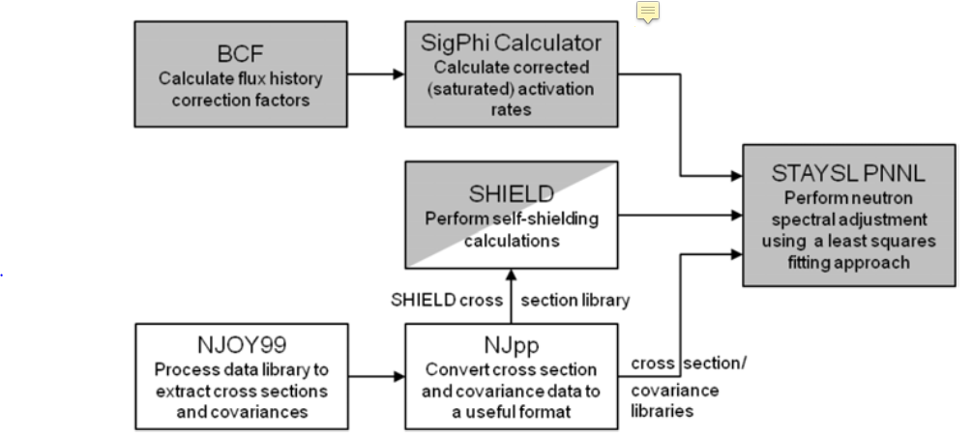

STAYSL has three main modules that users interact with. The NJOY99 and NJpp modules are used to create nuclear data libraries into a group structure. SHIELD performs neutron self-shielding calculations. BCF incorporates flux history which is used in the SigPhi Calculator as a modification. The SigPhi Calculator calculates the gamma-ray self-shielding factors from the foil or wire and calculates activation rates to be used in STAYSL.

These procedures walk through the assessment of the neutron flux spectrum for a foil activation experiment performed at the NIF. Radioactive production needs to be corrected for the decay during irradiation; however, the NIF shot is approximately 200 ps. The unfolding can be done with a simplified irradiation time of 1 second. The unfolded neutron flux results are really a fluence because the activations and irradiation time are set to 1 second. The activation foil pack that will be assessed in this laboratory was placed at the base (110 cm location) of an experimental snout shown below. The NIF source utilized was a D-T Polar Drive Exploding Pusher (PDXP) target with a nominal yield of 3.7 x 1015 neutrons. The purpose of the neutron flux unfolding is to help characterize the NIF source and for potential areas of future research.

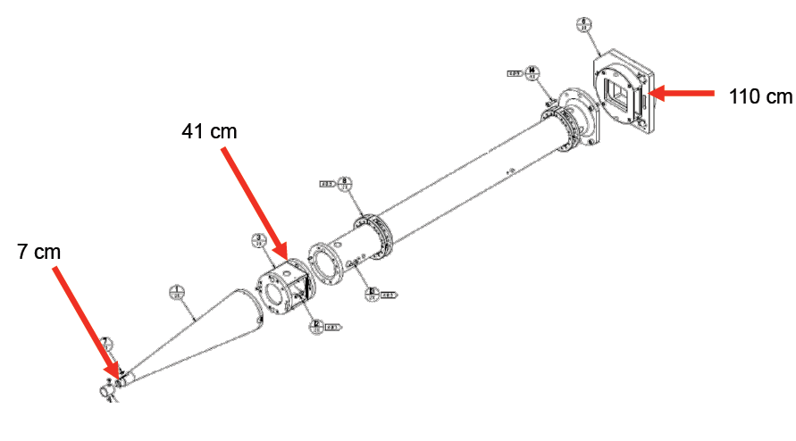

1. **Equipment / Resources**

* Computer with STAYSL (To gain access to a downloadable copy of STAYSL see <https://radiochemscieng.pnnl.gov/research_areas/research_area_description.asp?id=283>)
* STAYSLmodified.py to perform iterative STAYSL runs
* Initial guess spectrum (Guess_Spectrum.txt). Tab delimited. Columns of energy (MeV), flux, uncertainty.

1. **Preparation (Pre-lab)**

Problem Inputs

The foil pack contains four foils composed of gold, indium, zirconium, and sodium. These foils are fairly standard and cover a wide range of energies. A summary of the foil information is given below. The total number of atoms in each target is needed for the input into STAYSL. The foil thickness is also important for SHIELD.

|  |  |  |  |  |  |
| --- | --- | --- | --- | --- | --- |
| Foil | Mass [g] | Thickness [mm] | Density [g/cc] | Assumed Purity [%] | Atoms  Present [#] |
| Gold | 3.733 | 0.1 | 19.32 | 99.9 | 1.14E+22 |
| Indium | 14.35 | 1 | 7.31 | 99.9 | 7.52E+22 |
| Zirconium | 12.56 | 1 | 6.49 | 99.9 | 8.41E+22 |
| Sodium | 12.56 | 1 | 2.7 | 99.9 | 2.80E+23 |

The experimental results from a high purity germanium detector are also needed. The results of the activities, number of nuclei created, and percent error are given below. The activity and nuclei are time corrected so that they represent the value directly post-irradiation.

|  |  |  |  |
| --- | --- | --- | --- |
| Radioisotope | Activity | Nuclei Produced | Percent Error |
| Au-198 | 5.738E+02 | 4.420E+08 | 1.60 |
| Au-196 | 6.635E+02 | 2.227E+08 | 1.20 |
| In-115m | 5.571E+03 | 1.298E+08 | 1.20 |
| In-116m | 2.122E+05 | 9.972E+08 | 1.60 |
| Zr-89 | 1.131E+03 | 4.606E+08 | 1.50 |
| Na-24 | 3.628E+03 | 2.826E+08 | 7.90 |

1. **Procedure: Setting up STAYSL Input**

The required inputs for running STAYSL for this laboratory include SHIELD, SigPhi Calculator, and STAYSL. For this analysis, use the 140 group structure. The formatting of all inputs is very sensitive to spacing. You should either use the example inputs provided or reference the PNNL STAYSL manual.

* 1. SHIELD calculates the energy dependent neutron self-shielding corrections factors that are used, prior to neutron spectral adjustment, to shield the neutron activation used by the STAYSL PPNL code. SHIELD is only valid for non-threshold reactions.
     1. Identify the non-threshold reactions that created the product radioisotopes detected
        1. Au-197 (n,g)
        2. In-115 (n,g)
     2. Create the SHIELD input: **The formatted result is provided as shldinput.dat.**  The input should look like:



* + 1. Each line for the SHIELD input requires a STAYSL short name (identifiers on page 21 of manual), four letter reference name (INNG for example), thickness in mils (1 mm = 39.37 mils), and number density in atoms/cc.
    2. SHIELD is executed by running the executable SHIELD.exe in the folder of the shldinput.dat. Specify the 140-group structure when prompted.
       1. Some users experience issues running SHIELD. If SHIELD fails to execute, run command prompt as administrator and execute runExample batch file with desired input replaced.
       2. The SHIELD output file, shldinput.out, is created in the same directory. Copy this file (renamed as sshldlib.dat) and move to the STAYSL execution folder. The output should look similar to below. Verify the 140 group structure and that all expected reactions are present.

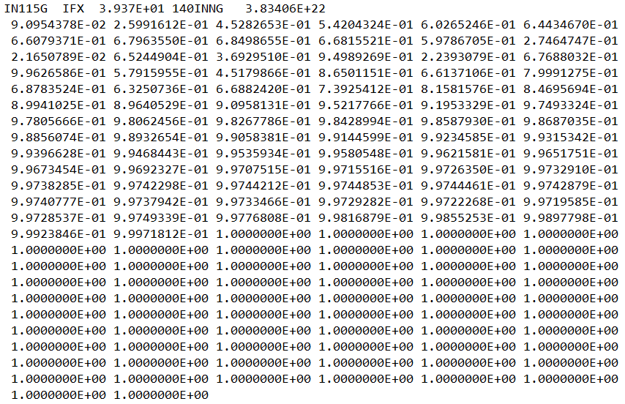

* 1. BCF is unused for the NIF example. The irradiation time is approximated as 1 second. This only has implications for the “sig-phi” term that is input into STAYSL.
  2. The Sig-Phi Calculator is used in a normal irradiation to correct for staturated neutron activation rates from the measured activities. The reaction rates (“sig-phi” values) represent the spectrally averaged neutron activation cross-section and neutron flux. For this experiment, only the gamma-ray self-absorption term in Column Q is needed as an output. **The formatted output is provided as SigPhi_Calculator_1.2.0.xlsm.** Sample ID “a” refers to the results used in this experiment.
     1. Populate the “SigPHI_Calculations” template sheet with the number of reactions used (6 reactions) using the macro “Add a Rxn”.
     2. Fill in the STAYSL PNNL Long Reaction Name. A list of reactions is available for easy copy/pasting on the “Reaction_Data” sheet within the Sig-Phi Calculator worksheet.
        1. For each reaction fill in the gamma-ray energy to be measured, weight fraction in [g/g], device [Foil], sample Thickness [mils].
     3. The linear attenuation coefficient, µ in column K, will be populated. If the box is blue, indicating the “may be user input” mode, enter the numbers manually. The values can be calculated by interpolating the attenuation factor of the gamma-ray energy in the material under the MassAttenuationCoef sheet.
     4. Save the workbook. The gamma-ray attenuation factors will be used in the creation of the sig-phi values.

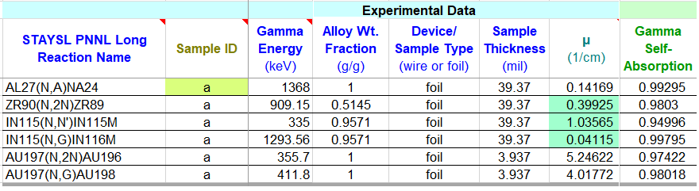

* 1. The sig-phi values are the production rate of nuclei divided by the number of atoms present. All of the information is available from Part 5 of these procedures. **The calculated sig-phi values are provided in the SigPhiCalculation.xlsx file.**



* 1. The STAYSL input is created based on the information determined by SHIELD, the SigPhi Calculator, and sig-phi values. **The formatted result is provided as stayslin.dat under the STAYSL folder.**  The input is very sensitive to formatting. An example input is provided on the next page
     1. The first line is the title.
     2. The second line describes the number of energy groups (140), number of reactions (6), ouput type (normal), output run(spectral modification) and flux structure (group flux).
     3. The third line defines the covariances. The default values are used.
     4. The fourth line describes the normalization (automatic), spectral modification technique (chi-square), flux adjustments (logarithmic), time (1 second) and normalization factor (1).
     5. The next section provides the input for the sig-phi values.
        1. The short format reaction name is used to identify the reaction.
        2. The second value is the sig-phi number which is followed by the error.
        3. The remaining spaces are padded to define the flux type (IFX is isotropic).
        4. The non-threshold reactions also have an identifier corresponding to the 4-letter identifier in sshldlib.dat followed by the thickness in mils.
     6. The following three sections describe the flux uncertainty, flux value, and mini-spectrum.
        1. The flux uncertainty is the relative error. A text identifier leads the value of the number of groups to use. The flux uncertainty first value should correspond with the energy group structure (140), although not required. The values are inserted below the group number line. These values, as well as for the flux itself, can be placed in a row under 80 characters or inserted one row at a time.
        2. The flux value (units of $\frac{n}{cm^{2}-s })$ has a similar form to the flux uncertainty. The second line describes the number of groups (140), thermal Maxwellian (no), normalization (1.0), temperature of Maxwellian (20, not used), and the energy to use thermal Maxwellian at. The values for a thermal Maxwellian are not used because the neutrons are not at thermal equilibrium. As a reminder, we are actually calculating the time integrated flux or fluence here.
        3. The last line provides binning for a mini-spectrum that is shown in the output. There is no reason to modify this line for this laboratory.

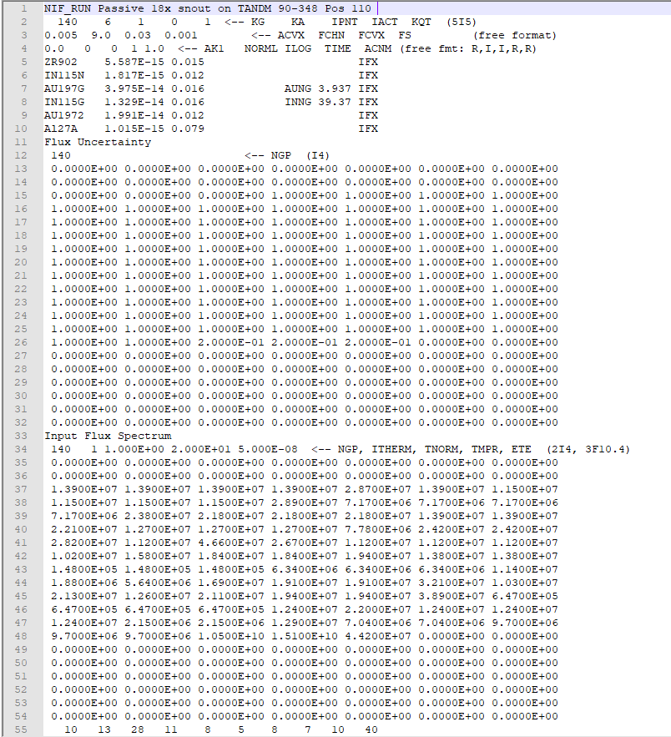

1. **Procedure: Running STAYSL**
   1. Initial Run
      1. STAYSL is executed by double clicking the STAYSL_PNNL.exe. The executable must be in the same folder with the sshldlib.dat, stayslin.dat, covarlib_140.dat, and xsectlib_140.dat. The group structure libraries are distributed with STAYSL (covarlib_140.dat and xsectlib_140.dat).
      2. A terminal will open that prompts for an input file. stayslin.dat is the default input. A warning message will appear if old results will be overwritten.
      3. What is the $χ^{2}$? Answer: 2134. A reduced chi-square or chi-square per degree of freedom ( $χ^{2}/DOF)$ of 1 is considered well fitting. The chi-square results show that the guess spectrum is not a good fit. The output, stayslin.out, displays a summary table of the results which includes chi-square values and least squares adjusted activities.

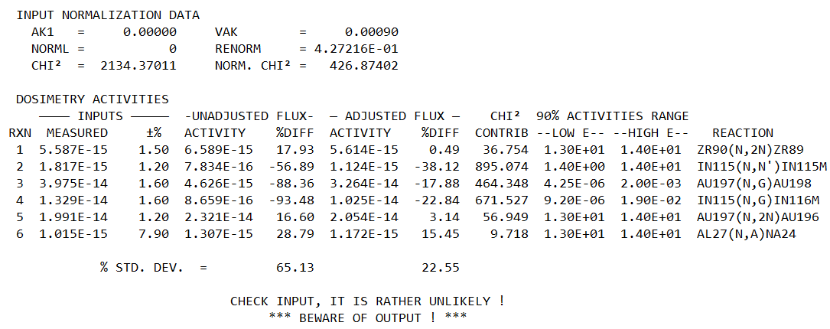

* 1. Iterative Approaches. An iterative approach to STAYSL is not necessary if the activation results have good statistics and the spectrum is well characterized. However, it is assumed that the guess spectrum is a relatively poor guess based on the first iteration. STAYSLmodified.py is a python function that iteratively runs a STAYSL input file by stripping the output and creating a new input file that is executed. There are two main options for the iterative approach: updating the flux uncertainty, and the chi-square convergence criteria. An example invocation is shown below. The IterativeSTAYSL function will run until the chi-square has changed by less than the convergence criteria. The output flux standard deviation is used in successive inputs if the update standard deviation option is used at each iteration. The results are printed if using a python environment such as Spyder.

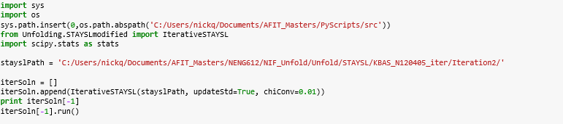

* + 1. Copy the input and output of the original STAYSL run including the required executables and data files to two new directories. One folder is for an iterative approach updating the standard deviation, and the other folder is without.
    2. Create a simple python script pointing to each of these folders and perform an iterative evaluation of the neutron environment.
    3. Execute an iterative evaluation with a chi-square convergence of 0.01. Perform the iterations with and without updating the standard deviation
    4. What is the evaluated reduced chi-square with and without? The results with updating uncertainty are 0.71 and 0.48 without updating uncertainty.
  1. Determine the chi-square test p-value of the best performing iteration (lowest chi-square). Take note that the reduced chi-square is printed from the function. A helpful tool is SciPy’s Statistics chi square function. The survival function (1 – cumulative distribution) of the chi-square distribution is the probability of obtaining a greater chi-square if the results are in fact from the expected distribution which is the null hypothesis. A common threshold p-value for rejecting the null hypothesis is 0.05. The threshold is equivalent to a significance level of rejecting the results.

