**BUU Utility:**

This utility takes the flat files received from Midas and converts it to xml for FFMs consumption. It is deployed at ProdQ(HP) and PROD(Terremark)

*Prod Q deployment:*

The script is deployed at location ‘/opt/cms/ediadmin/scripts/’ on server “ustlvcmsp1867”

New Automation location: /export/home/ediadmin/scripts/BUU_Scripts

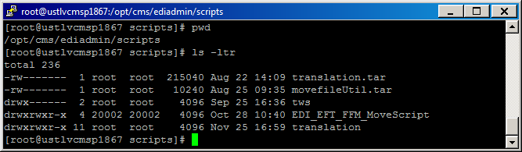

Note: To login to “ustlvcmsp1867”, one needs to have citrix access to the HP env. Once logged in, start a putty session or Reflective SFTP session from Citrix farm.

Directory “EDI_EFT_FFM_MoveScript” contains the scripts to move the flat files sent by Midas for processing folders. These scripts are also responsible to move the files to FFM shared folder on the same box and reports to EFT outbound folders. This scripts move the files if it has not changes for the last 3 minutes. The reports moved to Midas are zipped by this script. These scripts also zip the reports before they are send to Midas. The properties for the script are located at “/opt/cms/ediadmin/scripts/EDI_EFT_FFM_MoveScript/props”

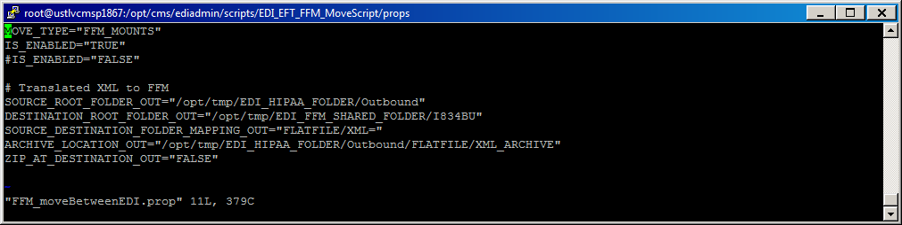

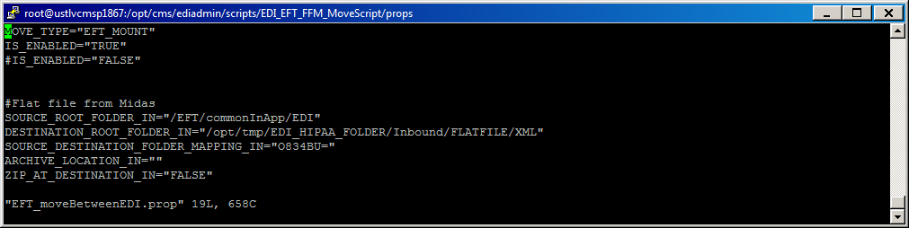

Directory “translation” contains the scripts that are used to translate the flat file to XML. The properties files are located at “/opt/cms/ediadmin/scripts/translation/properties”

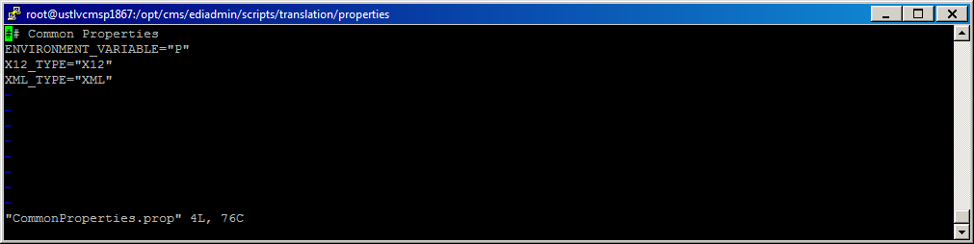

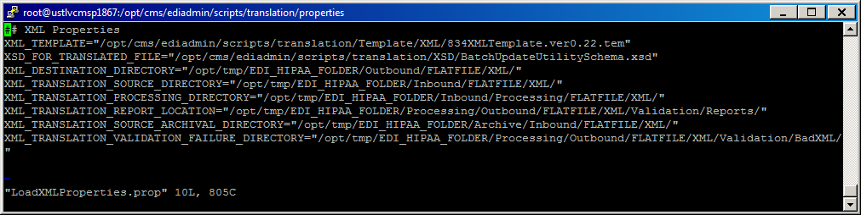

The scripts are schedules using crontab

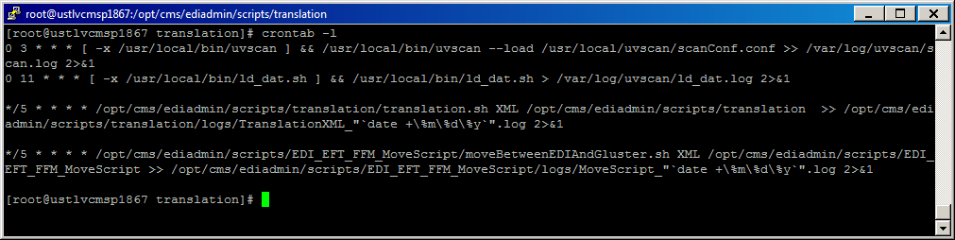

*PROD deployment:*

The script is deployed a location ‘/home/ediadmin/scripts/BUU_Scripts’ on server “tcdshp5r6da07”

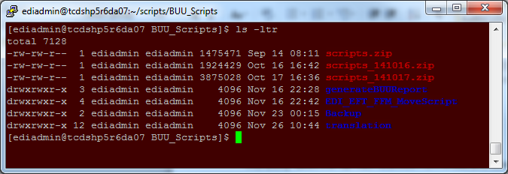

Note: To access the “tcdshp5r6da07” vm, one needs to have VPN access to terremark.

Directory “EDI_EFT_FFM_MoveScript” contains the scripts to move the flat files sent by Midas for processing folders. These scripts are also responsible to move the xml files for FFM and reports for Midas to EFT outbound folders. This scripts move the files if it has not changes for the last 3 minutes. The reports moved to Midas are zipped by this script. These scripts also zip the reports before they are send to Midas. The properties for the script are located at “/home/ediadmin/scripts/BUU_Scripts/EDI_EFT_FFM_MoveScript/props”

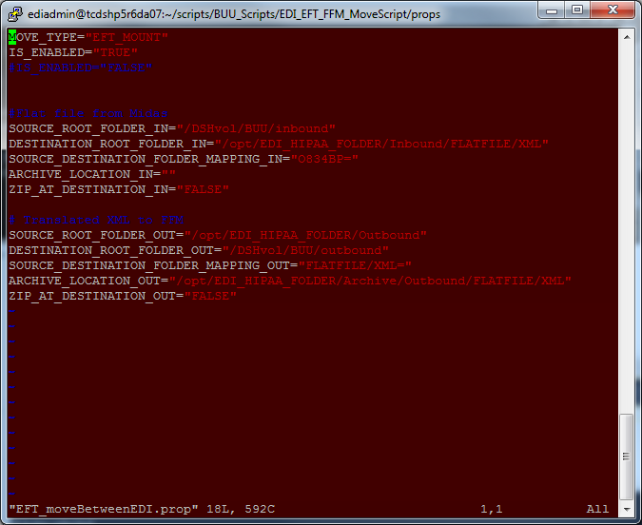

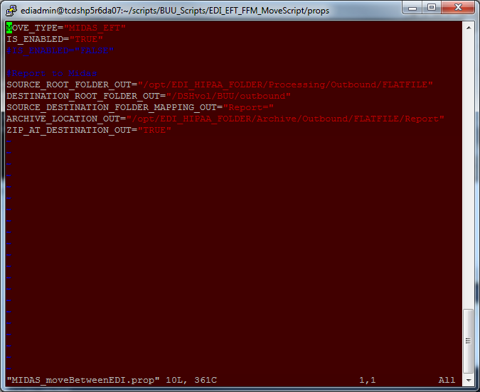

Directory “translation” contains the scripts that are used to translate the flat file to XML. The properties files are located at /home/ediadmin/scripts/BUU_Scripts/translation/properties”

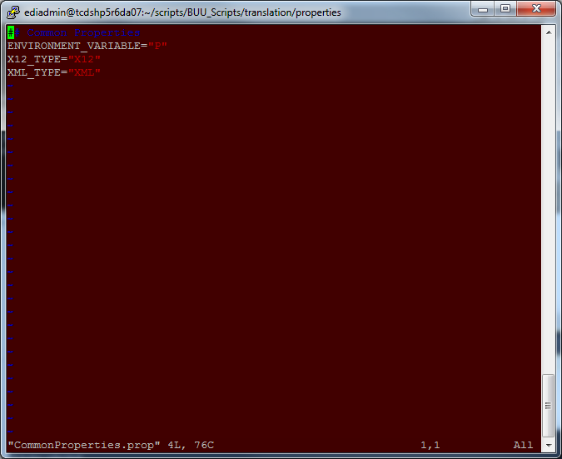

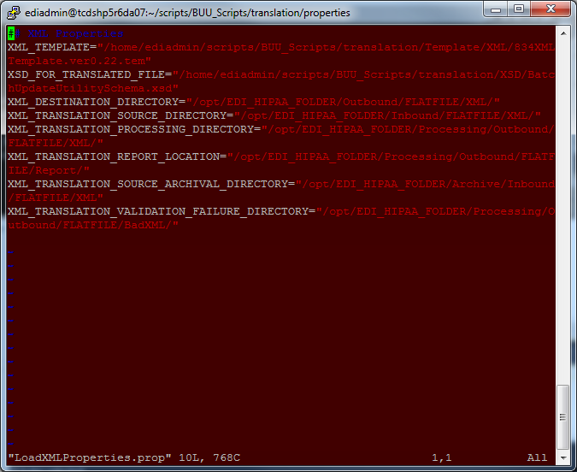

The scripts are schedules using TWS task.

The directory “generateBUUReport” is used to generate the reports for a particular day. The scripts polls the reports generated and extracts the counts from the reports. The reports are generated at “/home/ediadmin/scripts/BUU_Scripts/generateBUUReport/Report” and these reports are communicated to the BUU team. The reports are generated manually by running the script “BUU_Report.sh”